Politecnico di Milano
Dipartimento di Elettronica ed Informazione

Development Guide for Milo and Whisperer

By
Andréia Coronado Cha 749341 <andreiacha@gmail.com>
Vincenzo Ampolo 750336 <vincenzo.ampolo@gmail.com>

This guide is directed to the future developers who will keep working on Milo and Whisperer or even on related projects which might require some of the tools used during their development. Therefore, the reader should be aware that this document assumes a previous knowledge about the system implementation, basically showing some guidelines to facilitate the programmer's work. Deeper concepts of recommender systems and the tools applied are omitted here.

Tools

Programming Language
All scripts were written on Python, basic knowledge can be acquired reading online:
- “Dive into Python” by Mark Pilgrim, Chapter 1 to 7 from the 2004 edition, in http://diveintopython.org/toc/index.html
- The official's Python site documentation in http://docs.python.org/

Revision control system
Both Whisperer and Milo use git as RCS. The repositories are published in the following locations:
- Whisperer: https://github.com/goshawk/whisperer
- Milo: https://github.com/goshawk/milo
More informations in how to use git and how to get the repository can be found in the git page and directly on github.

Web Application Framework
Pyramid was the Python web application development framework used. All the documentation available can be found in:
- http://docs.pylonsproject.org/docs/pyramid.html (the Pyramid Documentation 1.0 was the last released pdf version during Milo's implementation)

Databases
Milo takes advantage of the features offered by a non-relational database, MongoDB, meanwhile Whisperer uses a traditional approach with PostgreSQL. Accessing:
- http://www.mongodb.org/display/DOCS/Home, MongoDB complete documentation can be found, being the “Getting Started” section enough to a brief outline of the DB and the MongoDB API Docs for Python in http://api.mongodb.org/python/ (the version used was 1.11);
- http://mongoengine.org/ presents MongoEngine, which permits working with MongoDB from Python;
- http://www.postgresql.org/docs/ contains links to manuals and FAQs which might be useful in case of problems related to PostgreSQL;
- http://www.sqlalchemy.org/ is the main site of SqlAlchemy, a popular library to work with relational database from python. It has many ORMs and is able to execute SQL queries directly.

Celery
Celery is an asynchronous task queue/job queue based on distributed message passing. It is focused on real-time operation, but supports scheduling as well.
In Whisperer, Celery is used to execute the model creation since it's a task that can take days to complete. A web server request cannot be on hold for days waiting for the model to be completed. Celery takes care of waiting for model creations requests and start them as soon as the system load permits the heavy computation of generating a model for a given algorithm.
The command to make celery working on milo machine is the following:
PATH=/usr/local/MATLAB/R2011a/bin/:$PATH LD_LIBRARY_PATH=/usr/local/MATLAB/R2011a/bin/glnxa64/:$LD_LIBRARY_PATH PYTHONPATH=/usr/local/lib/python2.7/dist-packages/whisperer-0.0-py2.7.egg/whisperer/:$PYTHONPATH celeryd --loglevel=INFO
The –loglevel=INFO part is not mandatory and it's used to show debug messages. A startup script have been installed on /etc/init/celery.conf that cares of starting and stopping celery on every startup and shutdown/reboot. So unless for debugging, there is no need to start celery manually.
Celery synchronizes its tasks thanks to the rabbitmq server which have been installed on the target machine.

Creating Matlab Files
As one of the main points of this development is creating a practical way to test recommendation algorithms, the next paragraphs intend to give a few clear instructions that should be helpful during the addition of new Matlab files.

Creating models
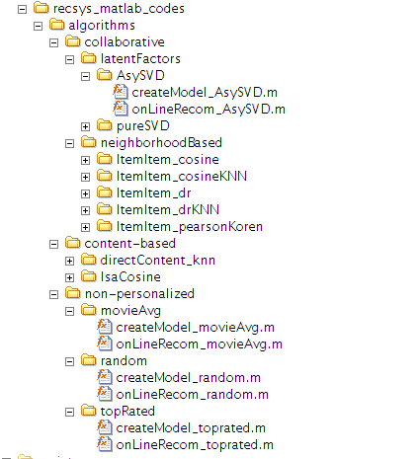Figure 2.1: Algorithms in Matlab extension .m files
The next snippet shows how from Whisperer's python code the Matlab functions are called and run in the background, generating the model:
With the command “self._put”, first Matlab is able to load the URM and ICM, already created.
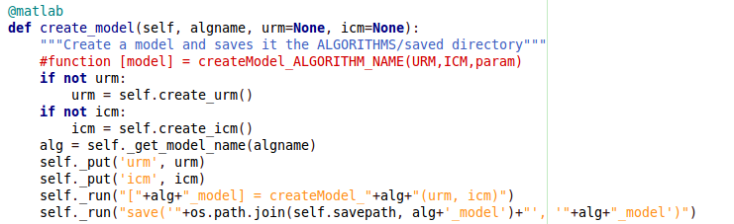Figure 2.2: Function from 'whisperer.py' that runs the create model Matlab file
The relevant part for the future developer to understand is how the function create model runs: “self._run” sends a command from the Python script to Matlab (already on the background) with the pattern:
[alg_model] = createModel_alg (urm, icm)
Where “alg” is the name of the algorithm: as seen in Figure 2.1, the Matlab tree respects a name rule to permit the Python script to get automatically the algorithm name, so the developer should always be aware to call his file as “createModel_ALGORITHMNAME.m”. Also the input (URM, ICM, param) should be respected, as the 'urm' and 'icm' is always passed to Matlab as we can see on the pattern.

Generating recommendations
A similar behaviour is seen on the _get_rec function:
When “self._run” sends a command from the Python script to Matlab (already on the background) with the pattern:
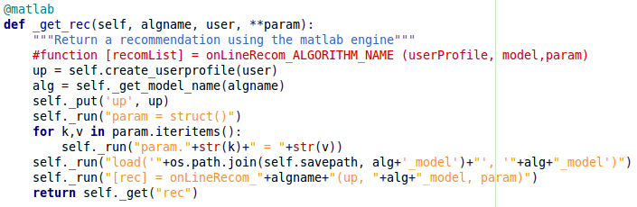Figure 2.3: Function from 'whisperer.py' that runs the online recommendation Matlab file
[rec] = onLineRecom_algname (up, alg_model, param)
Now we should be aware about the difference between “alg” and “algname”: although both reference to a algorithm name, the first is used to elaborate the algorithm model (from the “createModel_ALGORITHMNAME.m” saved file) and the second composes the function call. As one model can be used to generate different types of online recommendations, “algname” can be different from “alg” (means that in case there is just one type of online recommendation they will probably be the same).
Therefore, the developer should always be aware to name his files as “onLineRecom_algname.m” and place them in the same folder as “createModel_ALGORITHMNAME.m” that will be used for the model generation. In this case, the input to be respected is (userProfile, model, param), as 'up', 'alg_model' and 'param' are sent to the Matlab command.

Importing External Data using XPath
In Milo, to import data from the IMDb website based on the title of the movie, it was used the library lxml, used to process HTML in Python, for more details see http://lxml.de/index.html.
The first function the reader should aim to comprehend from this library is the “parse()” method (see Figure 3.1), from the package lxml.html. Its explanation is found in http://lxml.de/lxmlhtml.html.
Figure 3.1: Example of parsing and getting content using XPath
After parsing the url and getting the page, the “xpath()” method is used to get the item's url. For deeper comprehension of the function: http://lxml.de/xpathxslt.html.

Webserver
Cherokee is the chosen webserver. It has been choosen thanks to it's low latency and used resources. Cherokee have been configured with two virtualserver in order to serve both milo and whisperer on the same machine.
To make the python applications available to cherokee uwsgi has been used. To configure cherokee just type in a shell:
sudo cherokee-admin
The output will be this:
Cherokee Web Server 1.2.98 (May 26 2011): Listening on port 127.0.0.1:9090, TLS
disabled, IPv6 enabled, using epoll, 4096 fds system limit, max. 2041
connections, caching I/O, single thread

Login:
User: admin
One-time Password: Z2eotEGtpPV9ytT8

Web Interface:
URL: http://127.0.0.1:9090/
The web interface is available on localhost:9090. Just login and use the user and one-time password to log in.

Deploying
To deploy the application in the server after code modification the following command is mandatory:
sudo python setup.py install && sudo killall -9 uwsgi
This command must be executed in the same directory in which there is the setup.py file for each application (Milo or Whisperer). The command will install the desidered application in the normal python path and will rebook uwsgi which is responsible of serving the python application.
This will be enough to publish the modifications done to the source tree which is in the same machine. In case of a brand new machine, the deploy your be done in the following way:
mkdir -p /var/www/whisperer/saved
mkdir -p /var/www/milo
chmod 777 /var/www/whisperer/saved
sudo apt-get install rabbitmq-server postgresql csh python-dev cherokee build-essential git
sudo pip install sqlalchemy celery pyramid uwsgi lxml
git clone https://github.com/goshawk/whisperer
git clone https://github.com/goshawk/milo
cd milo/milo_app
sudo python setup.py install
sudo cp -a development.ini /var/www/milo/development.ini
cd ../../
cd whisperer/webapp/whisperer
sudo python setup.py install
sudo cp -a development.ini /var/www/whisperer/development.ini
sudo cherokee-admin
At this point cherokee should be configured to serve both applications using this commando for milo:
/usr/local/bin/uwsgi -s 127.0.0.1:48401 --ini-paste /var/www/milo/development.ini
and this other command for whisperer:
/bin/bash -c "PATH=/usr/local/MATLAB/R2011a/bin/:$PATH LD_LIBRARY_PATH=/usr/local/MATLAB/R2011a/bin/glnxa64/:$LD_LIBRARY_PATH /usr/local/bin/uwsgi -s 127.0.0.1:59157 --ini-paste /var/www/whisperer/development.ini"
The application should be deployed now.

