ROBOTICA
mid term 7/5/2007

Last and given name ________________________________Matricola __________

PART 1 - QUIZ - (marks 8)

1. The Denavit-Hartenberg parameters
- are four for joints with one degree of freedom T F
- are defined before the reference systems are positioned on the joints of the chain T F
- are never constant T F
2. The direct kinematics
- builds up matrix equations that connect the values of the joints to the values of the hand T F
- for a manipulator gives 6 cartesian values T F
- takes as input the values of the joint variables at the same time t T F
3. The inverse kinematics
- given the hand reference computes the values of the n joint variables T F
- is always used in the controllers of industrial robots T F
- can be solved with iterative methods only for Cartesian robots T F

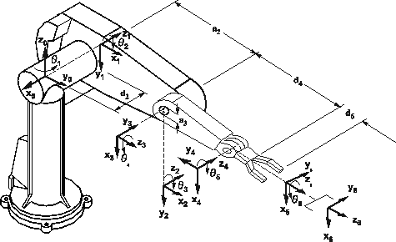

4. Given the Puma 560 and its A matrices, how to extract the wrist position?
- from matrix A6 T F
- from matrix T, take the last column and modify the z component T F
- from 4th column of matrix T take the vector p_hand, and compute p_wrist as p_hand – d6z6 T F
5. In cartesian level programming
- movements are described without using the joint values T F
- it is difficult to program articulated robots T F
- the internal representation uses matrices in homogenous coordinates T F
6. The position accuracy of a robot
- is the most important precision measure for simple robots programmed by teaching T F
- is defined from command in Cartesian space T F
- depends only on the robot mechanics T F
7. The rotations expressed in homogeneous coordinates
- have 9 component elements T F
- cannot express the same orientation of the reference system T F
- are easy to use to compose rototranslation matrices T F
8. A cylindrical robot
- is defined by joints TTR T F
- can easily orient the hand upwards T F
- can use a 3 dof wrist T F

PART 2- QUESTIONS - (marks 12)

1. Recall the representation of the orientation of a system using Euler angles, and chose the system of gyroscopic angles (relative rotations along Z, Y’, Z’’), then build the matrix in homogeneous coordinates as a function of the 3 angles Φ,θ,Ψ. Make a drawing to illustrate the process and all the reference systems.

2. Discuss the main aspects of the Paul method to compute the inverse kinematics of a robot.

3. Define how the subsystems “mechanics”, “actuators”, “control”, are organized and share information

4. Describe the following fragment of AL code and indicate which matrices in homogeneous coordinates are internally built.
AFFIX box _grasp TO box_1 AT TRANS (stand, VECTOR(box_1_lenght/2, box_1_width/2, height)) RIGIDLY;

PART 3- ESERCISES - (marks 13)

1. Given the RTR robot in Figure (in park position)

- assign the reference frames on the links according to the DH (Denavit-Hartenberg) notation.
- fill the table with the 4 DH parameters for each link.
- draw the working space of this robot after making assumptions about the range of values for each joint.
Build the rototranslation matrix that represents the direct kynematics of this manipulator (report all the computations ).

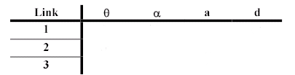
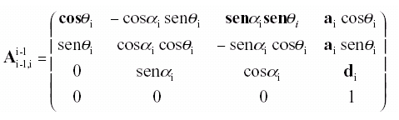
Ө₃
D₂
L₃
Ө₁
L₁

2. Model in AL language a system to load a bottle with water from a small test tube. Consider that the test tube is already filled. The arm has to grasp it from the side and move it to a position where it can be slowly oriented to reach the bottle .

Write the complete AL program .
Discuss about possible extensions, namely:
- how to use 2 hands, one to keep the bottle in position;
- how to make the movement only if the tube is not empty.


