By VAMSEEKIRAN CHOKKAM

  STUDENT ID : 2436615

**St. Petersburg Paradox Analysis using MCS**

**The code construction:**

I have developed a code that works on the St.Petersburg paradox and uses MCS to make multiple runs and considers all random results to produce accurate results.

The **flip_coin** method in my code returns random results from the combination of “**H**” (Heads) and “**T**” (Tails). I have also added a method called **double_price** which doubles the current values and returns to the main method.

The **play_game**is the main method where all logic resides. After getting the input about **entre_fee, total_games**, and **total_runs,**the loop runs the whole logic and calculates the average result of **total_runs**times. Another loop is added inside this loop that records the total earned in each iteration of total_games. In my code, I have set the **final_money** as 2 pounds. Because on getting “**H**” on the first attempt one should receive 2 pounds as default. So, on flipping a coin every time, we are checking if the result is “H” or “T”. if it's “T”, I am replacing **final_money** with the doubled value of the last **final_money** recorded and flip the coin again. So, the iteration continues until I get “**H**” as result.

After winning the money (**final_money)**, it has been added to **final_average** which results in the total money earned out of all games played. To find out if the player has got profit or loss after playing all the games, I have calculated the **total_investment** by multiplying the number of games with entry fee and by subtracting the **final_average** from **total_investment**.

The same logic has been implemented to calculate the total amount won or lost for the total runs and the result **total_run_big_average** returns the average amount earned out of the total investment, the total number of games played, and the total number of times the runs are made.

**Observations**

From the results, it's very obvious that if you invest 1 pound, you will get profit irrespective of the number of games and no of runs MCS executed and if you have paid 2 pounds to enter the game, you will get either the profit or get the same investment.

From my analysis, the reasonable amount one can pay to play the game is 7 pounds. The reason behind this conclusion is as follows

**Observations without MCS:**

If the pay-to-play amount increases, the probability of getting the profits gradually decreases. But this behavior changes if you increase the number of games to play.

In my observation, for pay to play amounts 5,6 and 7 pounds when the number of games increases from 1 to 10 and 50 the total money earned also increases and the total earned is much higher than the total investment for 50 games.

But, when the pay-to-play amount increases to 8,9,10… the total earned decreases which goes lower than the total invested and leads to loss. The same result has observed when the average number of games increased from 1 to 10 and 50. So, both the pay to play and the average number of games played are equally valuable that decides the final result.

The results change completely when MCS is involved in the process. Here MCS takes the number of runs to execute the whole process. The MCS considers all random results and the average of the results is returned with much accuracy.

**Observations with MCS**

For pay to play amounts 5,6,7 pounds and with the number of games played as 1, I have observed that the total money earned was lesser than the total invested. But with the MCS and having the total runs from 50 to 100, I have observed that the total money earned has increased and led to profit.

The MCS doesn’t provide the same results when the **pay-to-play** amount increases from 8,9,10… as tabulated.

The total number of runs and the total number of games showed a great correlation for all the pay-to-play amounts starting from 1 pound to 15 pounds in my observation. The MCS when ran with no of runs as 100 and no of games played like 50, the profit is very high because of considering the random cases where the outliers increase the overall average as plots [created from R studio] attached below.

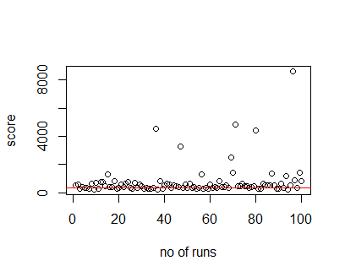 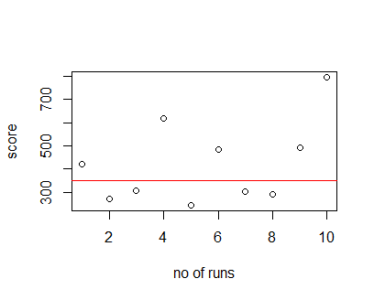

Fig – 1 fig-2

The red horizontal line in the above plots indicates the total invested which is 7 pounds *50 games= 350 in our case, the outliers are observed in the plot when the MCS is executed by providing total runs as 100. Though most of the results lie on or above the red line, the total amount earned through this execution is 751.86 which is much higher than the invested. In the fig-2, the outliers are not very far from the total money invested. The total money earned is 423.2 which is lesser than the total money earned when the MCS is executed with 100 runs.

**Conclusion:**

Thus, I can conclude that MCS has a strong positive correlation with the total number of games played. Increasing the number of games in our analysis is nothing but providing more inputs and flexibility to MCS to project outcomes with more accuracy. So, if you are paying the money higher than 7 pounds and play a smaller number of games, you will end up losing your money most of the time.