B1528 SIROCCO Current-Heading/Rudder Force Comparison — 30 deg Rudder Limit
Client review copy generated from the HTML report default view. Default schematic/chart selections: current speed 4.56 kn; Chart 1/3/4 rudder angle 0.0 deg; 30° rudder sweep limit retained for heatmap and summary tables.
Source PDF: b1528_sirocco_current_heading_rudder_30deg_limit_client_review.pdf · Pages: 11

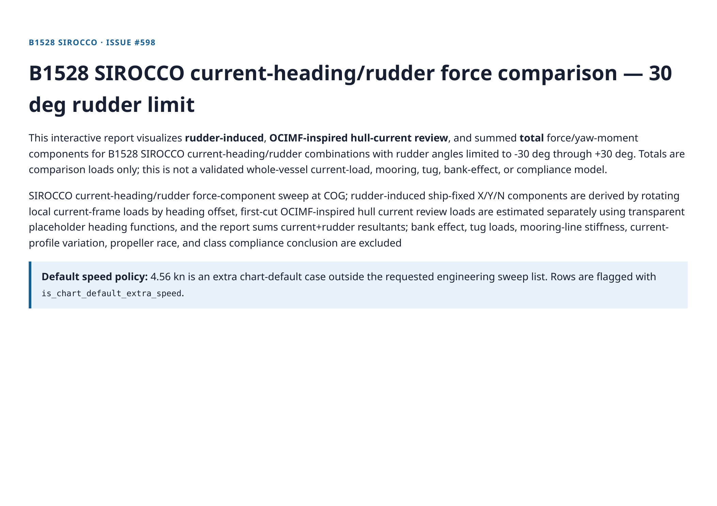
Client review copy page 1 of 11

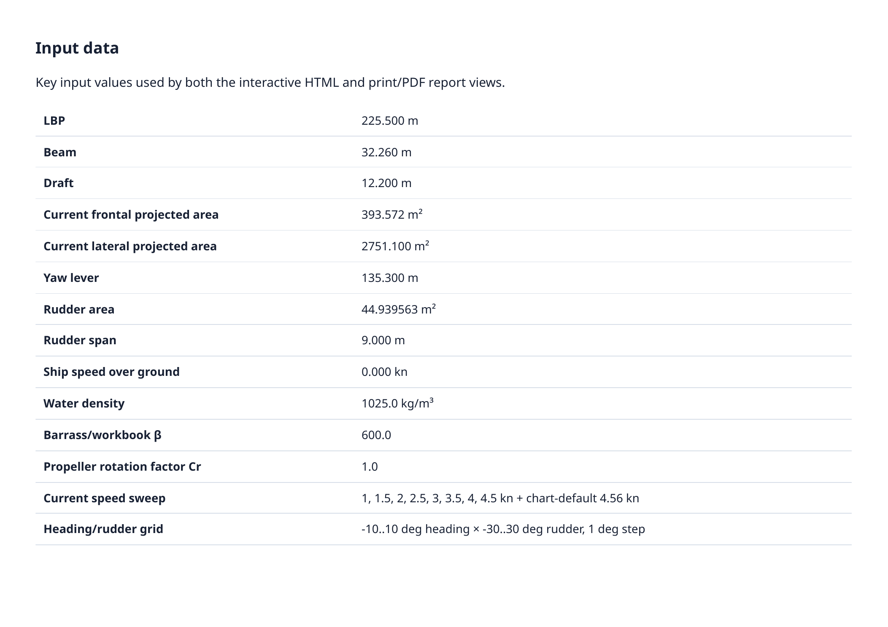
Client review copy page 2 of 11

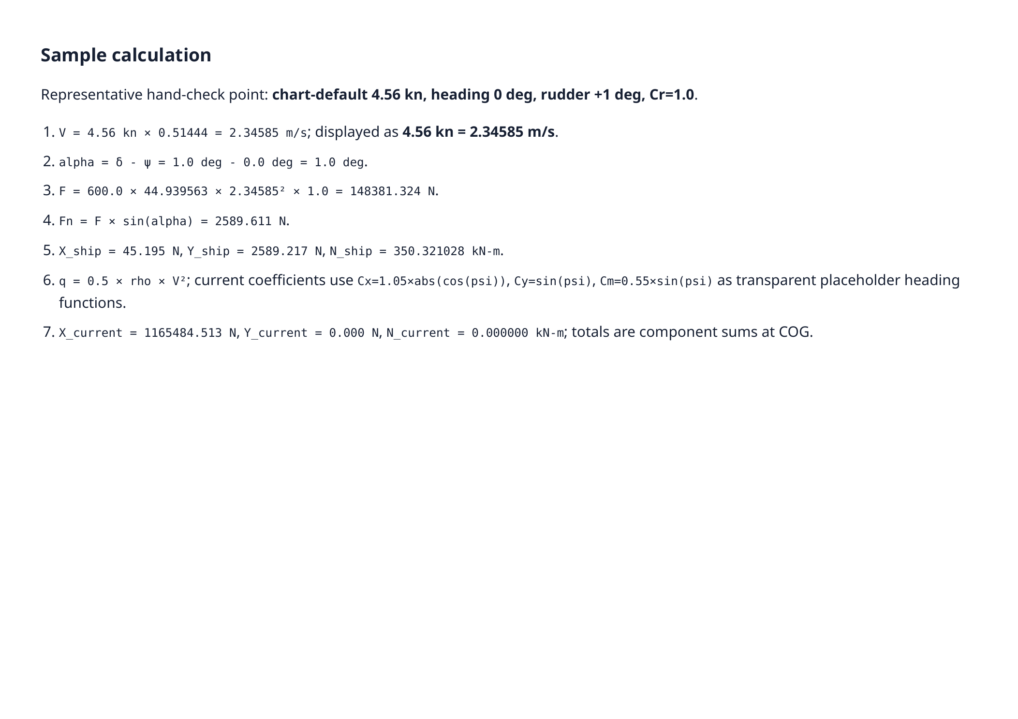
Client review copy page 3 of 11

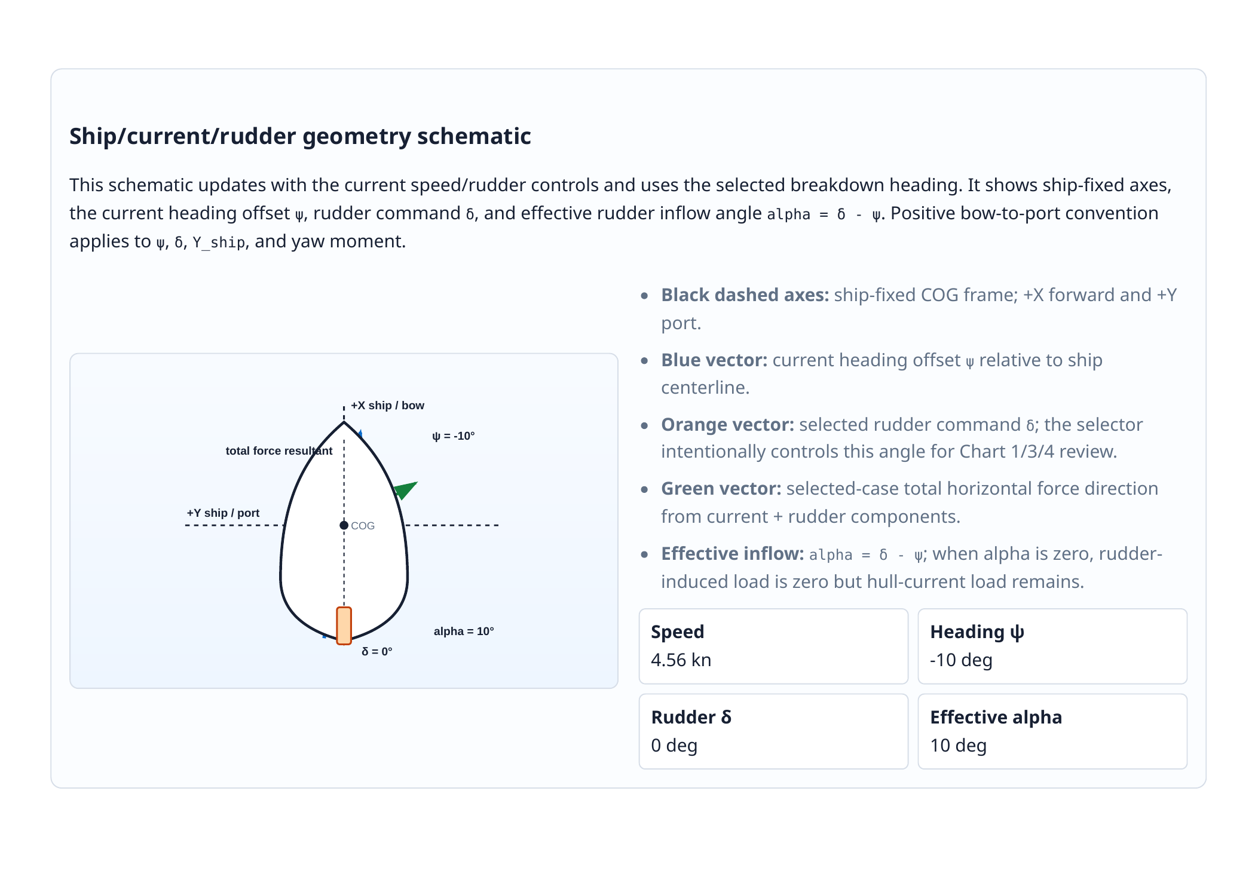
Client review copy page 4 of 11

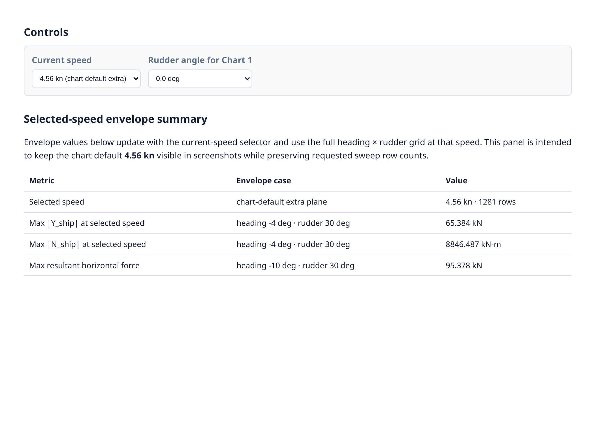
Client review copy page 5 of 11

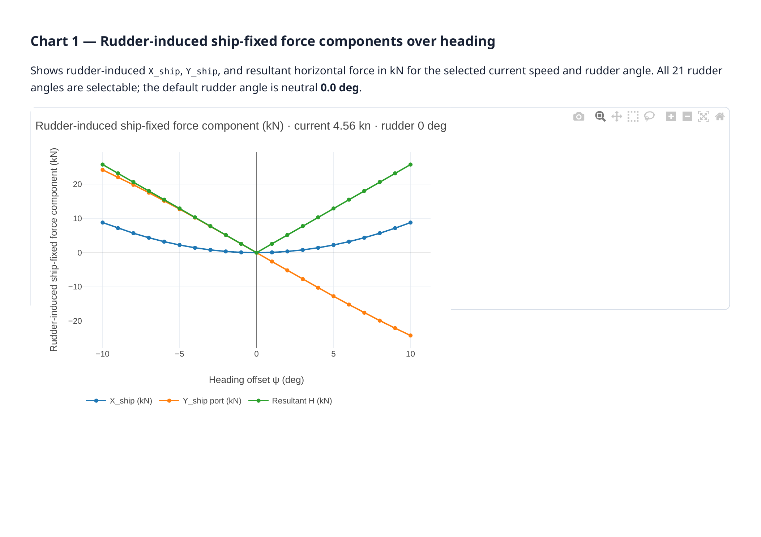
Client review copy page 6 of 11

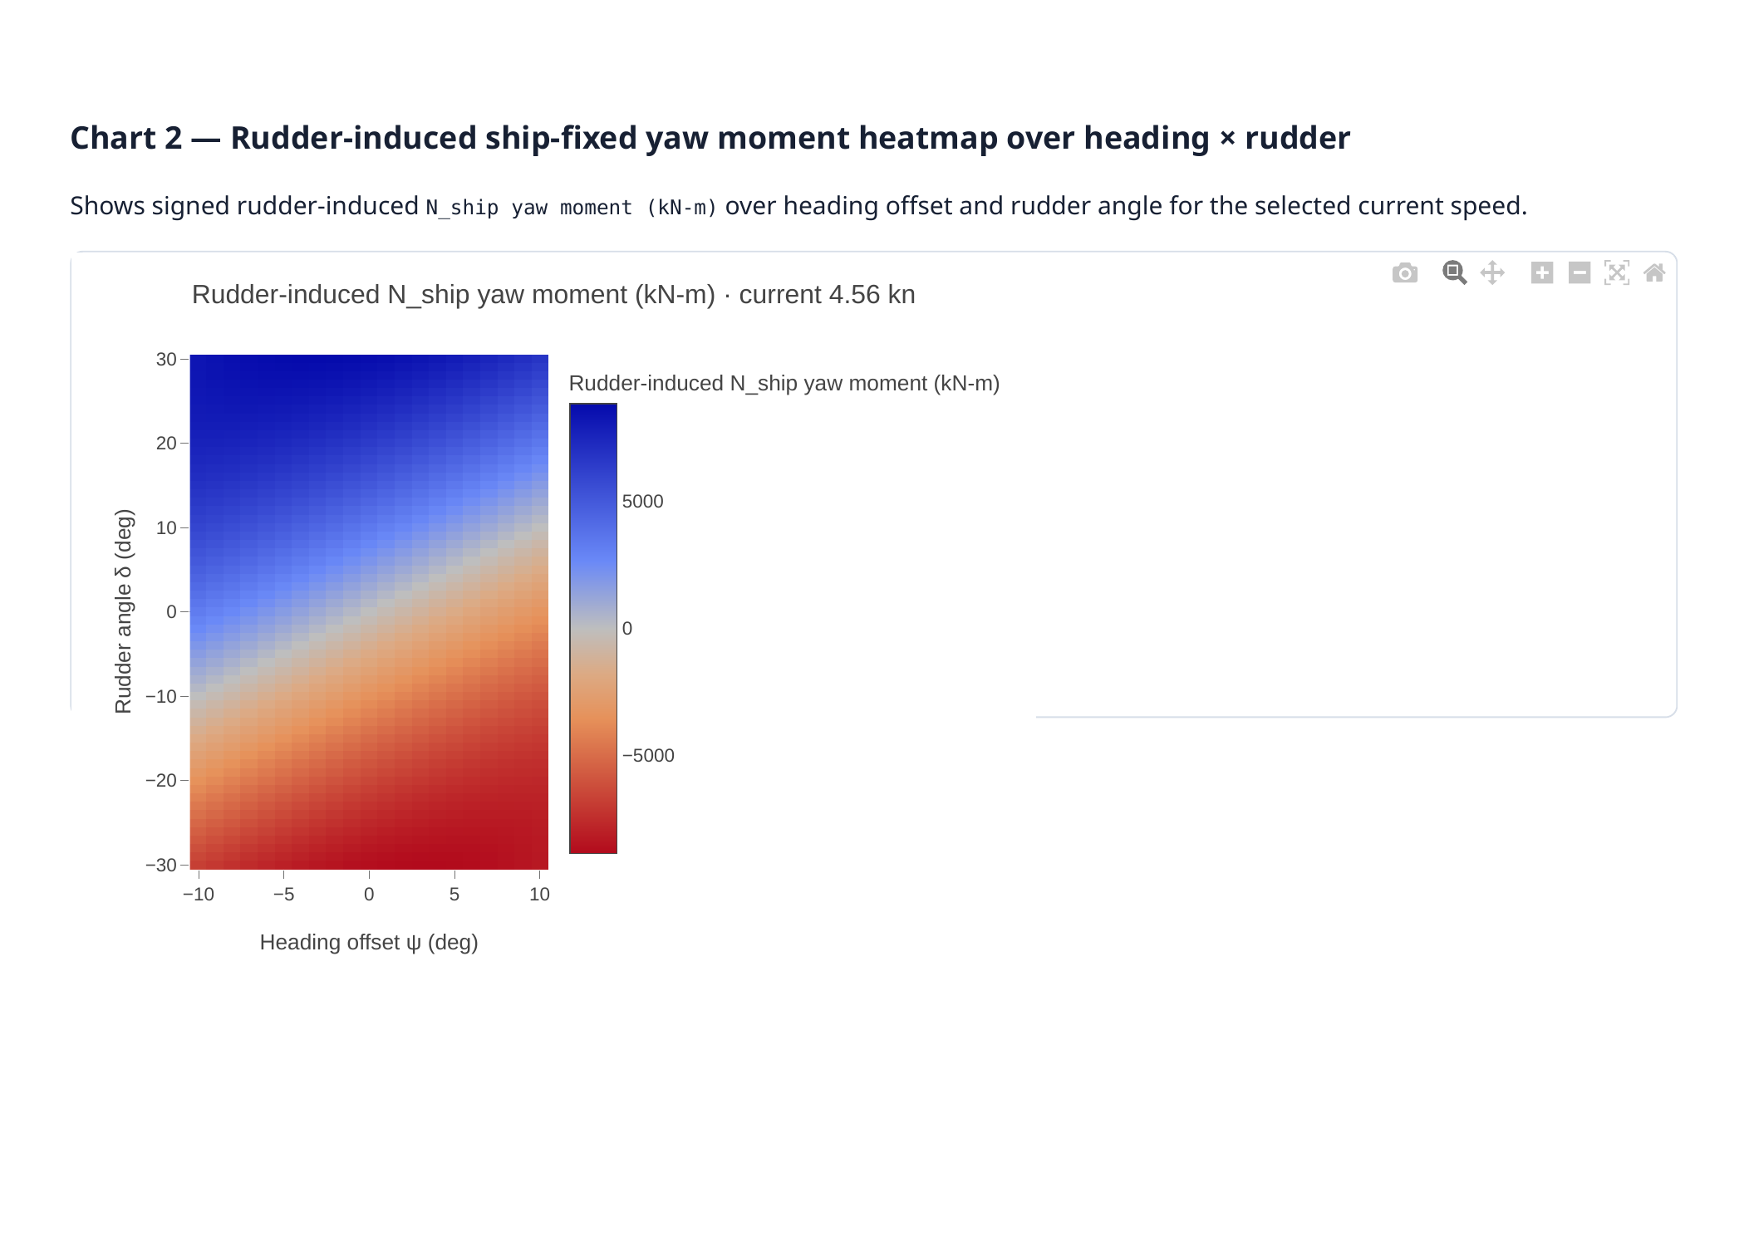
Client review copy page 7 of 11

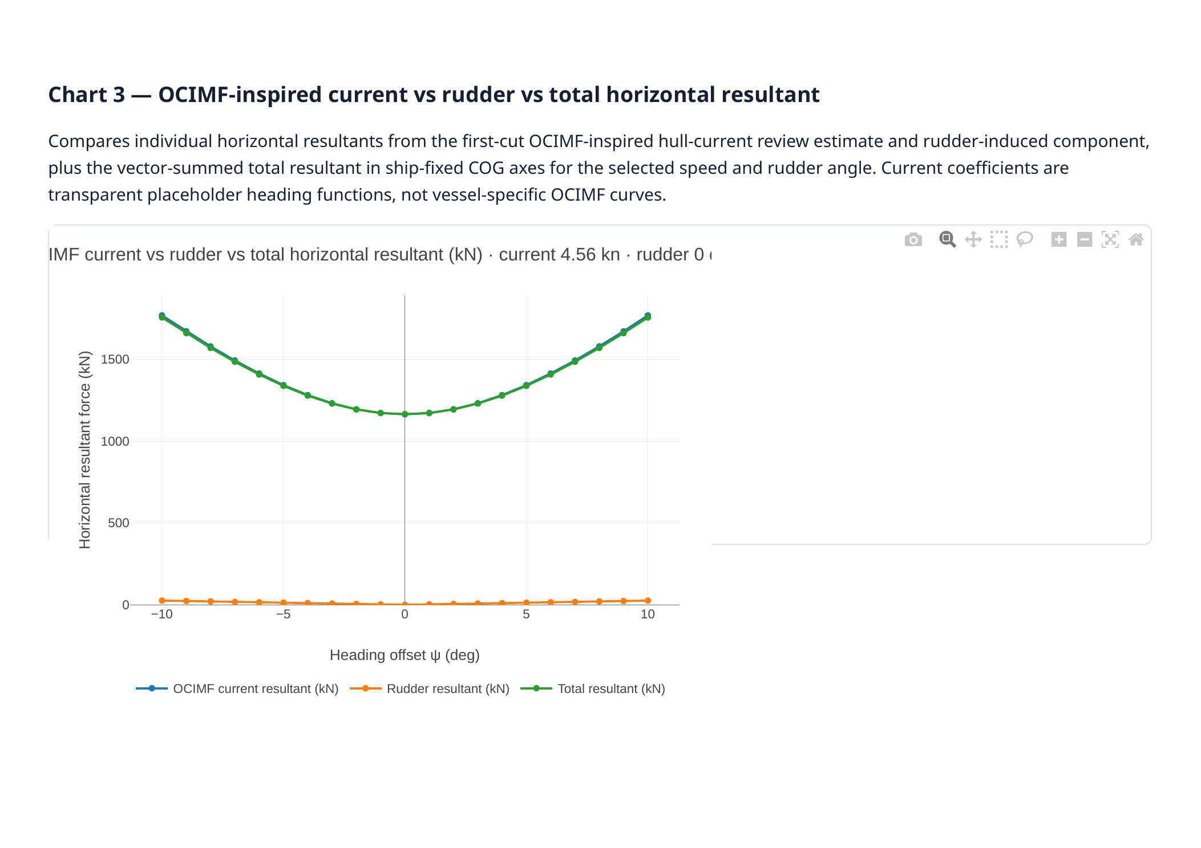
Client review copy page 8 of 11

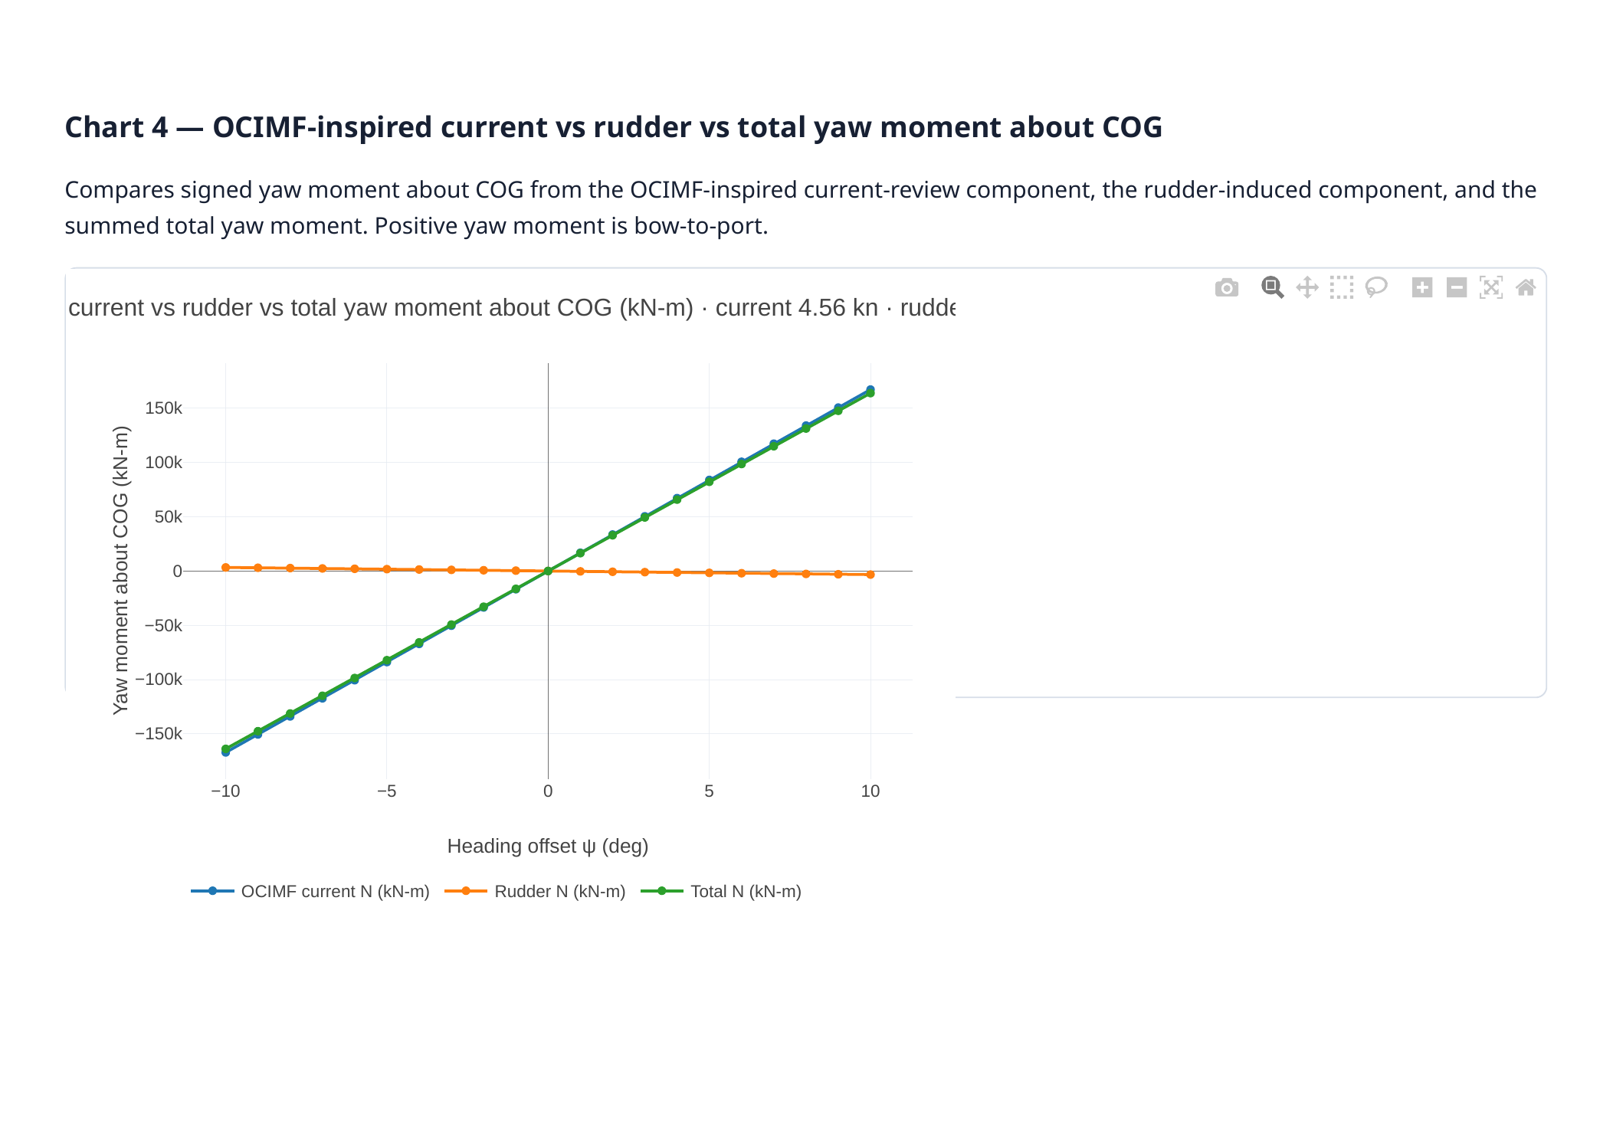
Client review copy page 9 of 11

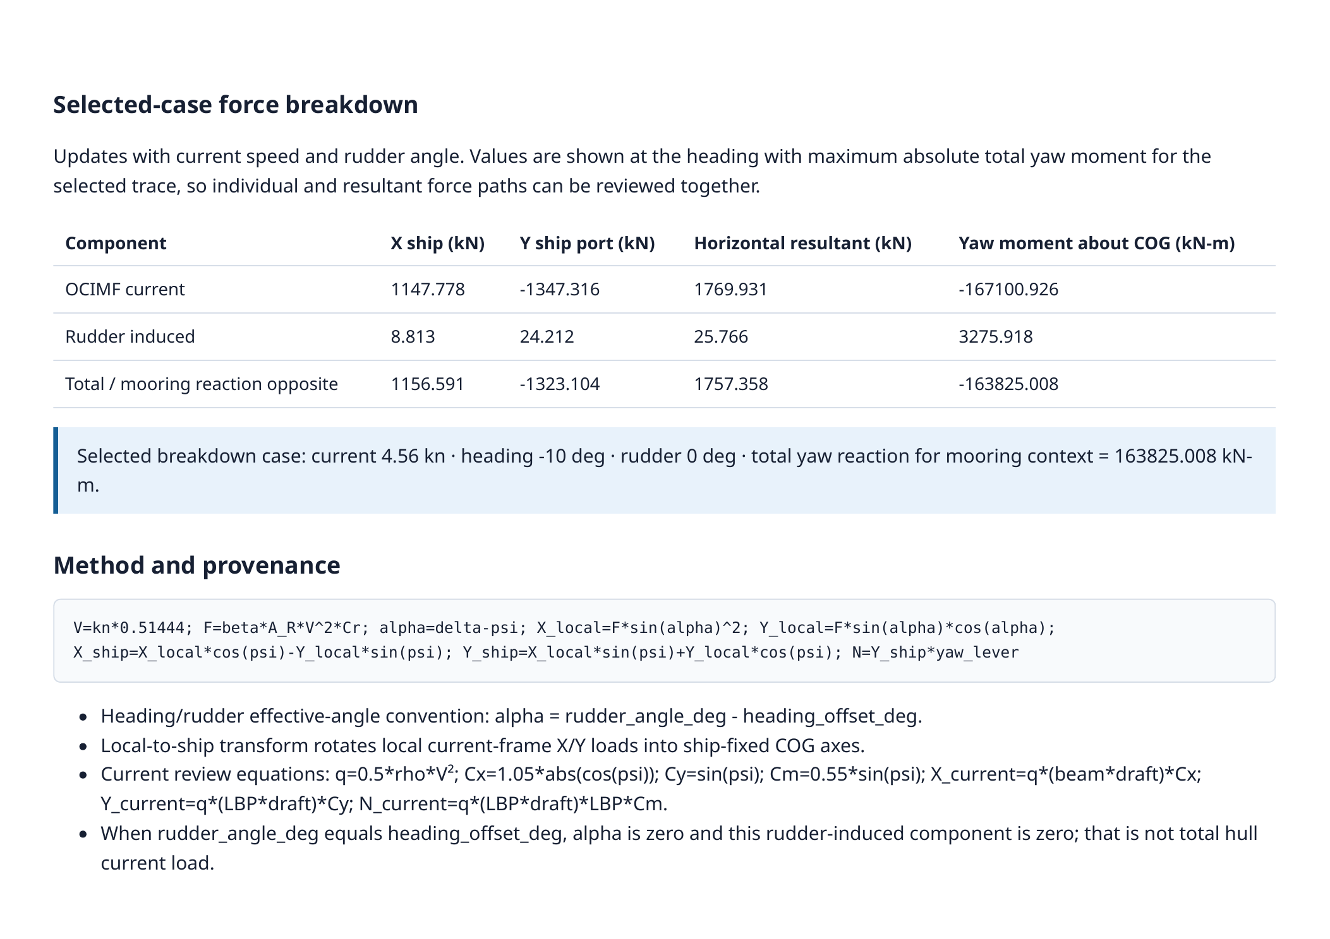
Client review copy page 10 of 11

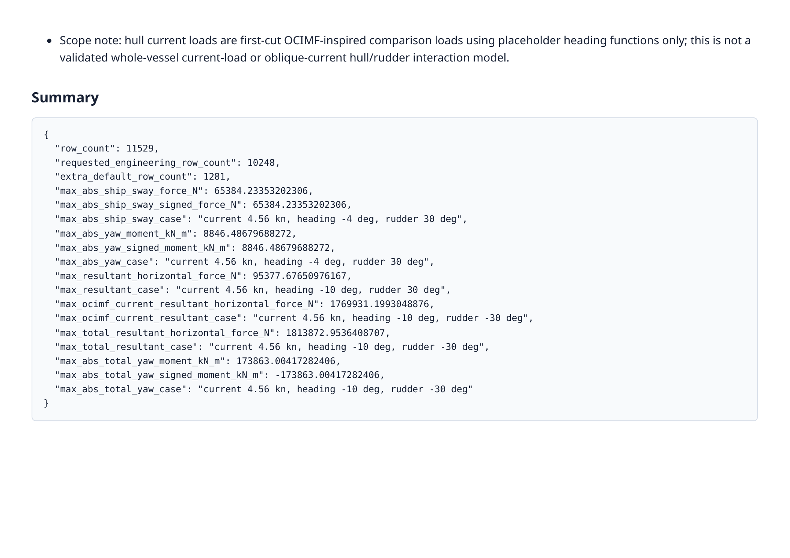
Client review copy page 11 of 11

