**The new PIANC guidelines for the design of fender systems 2022 by WG211**

**ir. E.J. Broos, Dr.ir. A.A. Roubos, Rune Iversen, P.E., M.ASCE**

1 Senior Engineer Port Development Port of Rotterdam Authority, [EJ.Broos@portofrotterdam.com](mailto:EJ.Broos@portofrotterdam.com);

2 Senior Engineer Port Development Port of Rotterdam Authority, [AA.Roubos@portofrotterdam.com](mailto:AA.Roubos@portofrotterdam.com);

3 Staff Consultant, Simpson Gumpertz & Heger, [riversen@sgh.com](mailto:riversen@sgh.com).

**SUMMARY**

Every country with a serious port has some guidance on the construction of marine Infrastructure. Quite often one of the internationally well-known design books like the ROM (Spain), EAU (Germany), BS (UK), ASCE (US) or OCDI (Japan). For vessels tons of guidance are provided by classification societies, gathered in IACS (International Association of Classification Societies) and by ship owners.

However as soon as a ship enters the port, it needs to be berthed. To protect the ship against the berth or the berth against the ship, often a fender system is installed on the berthing line to absorb the energy of the berthing ship. In 2002 PIANC MarCom Working Group 33 published the ‘Guidelines for the Design of Fenders Systems: 2002’, shortly WG33. That report is actually is the only available guidance worldwide. All other handbooks dealing with fenders on a certain point start to refer back to the PIANC WG33 report.

This WG33 report is valuable but on some aspects outdated. PIANC started a new working group in 2019, WG211, with the task to update the current fender design guidelines.

This first paper presents an overview of the task of WG211, the structure of the new guidelines and a summary of the new subjects or major changes compared to the old guidelines. Several key issues are presented in more depth in detailed publications on this conference and will be introduced in the presentation on Ports’22.

**START OF WG211**

1 June 2018 the PIANC head Quarters asked for volunteers to man the new MarCom Working Group 211 “Update of WG 33 – Guidelines for the design of fender systems”. Briefly WG211. WG211 started the works March 2019 and is intended to deliver the report at the end of 2022.

The final report is essentially a new report not an update. The WG211 guidelines when finished will supersede the previous PIANC MARCOM WG33 and WG145 working group reports, and also all fender and berthing related paragraphs in other PIANC reports.

The new report is intended to be named: ‘PIANC Fender Guidelines 2022’ in short, abbreviated as PFG22. The formal full reference is intended to become: ‘PIANC MarCom WG211 report Guidelines on Design, Manufacturing and Testing of Fender Systems 2022’

**TERMS OF REFERENCE WG211**

The full terms of reference can be found on the PIANC website [www.pianc.org](http://www.pianc.org). It asked for a general update of WG33 including:

* alignment with current practice including reliability design methods (semi) probabilistic approach;
* latest simulation software for evaluation of fender/vessel interaction;
* recent vessel trends including increases in vessel sizes, developments in hull shapes and the implications for fender engagement;
* vertical and horizontal forces on fender;
* hull pressures;
* outline consideration of special issues applying to wheel fenders and foam filled fenders;
* WG145 output regarding berthing velocities and angles, reliability design, hull flare angles on large container vessels;
* Verifying all relevant standards newer that WG33 with respect to fender design, manufacturing and testing.

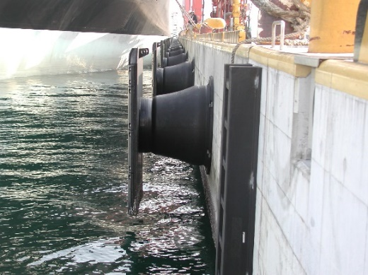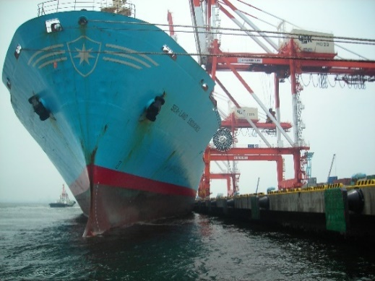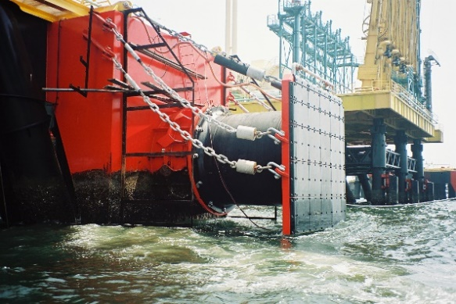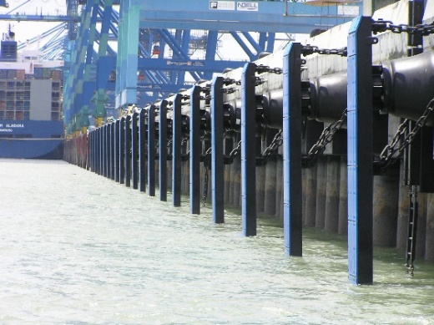

Figure 1: examples of fender systems, (courtesy PIANC Japan)

**CONTENTS OF WG211 REPORT**

The report is structured in 11 chapters. The introduction (1) and references (13) are not relevant here. The chapters are clustered by subject, and presented in figure 2. First chapter

**2** ‘Principals of Fendering’ presents an overview of common used fenders and their generic properties. Then chapter

**3** ‘Particular Aspects Regarding Design Vessels’ deals with the specific fender – vessel issues for various vessel classes. This chapter heavily leans on the work of WG235 Typical Ship Dimensions. WG235 is a spinoff of WG211 and will be separately presented on Ports’22.

After this introduction chapters the WG211 report will continue with the core, the design chapters,

**4** ‘Basis Of Design’, dealing with functional and operational requirements, site conditions and design criteria. New here is the safety approach. This will be a reliability approach that will replace the deterministic approach in WG33 with abnormal berthing factors. This subject will be presented separately at Ports’22 and is based on Orlin 2020. Then chapter

**5**: ‘Berthing Energy’ will guide the reader from the daily observations into design berthing speeds with all related factors. Here the works of WG145 are incorporated in, to the opinion of WG211, the proper way, as will be explained in a separate paper on Ports’22. There will be a separation between single fender contact, as often the case with mooring dolphins, and multiple fender contact, typically for container terminals and other facilities with flexible berths.

When the berthing energy is known, the designer can select an energy absorbing fender unit in

**6:** ‘Fender system design’, dealing with all the general and detailed design aspects with respect to fender system design. This is an extensive chapter.   
The entire guidelines focusses on berthing vessels, but in some cases the moored situation is governing above the berthing situation. Guidance to this situation will be given in chapter

**7**: “Fender Response Under Moored Conditions’.

Then the WG211 report will present chapters about manufacturing and testing. Chapter

**8** ‘Manufacturing Of Fenders Systems’ explains in brief how fender bodies (rubber and foam) are made and what ingredients can be used. This part has been reviewed by and discussed with independent rubber experts. Secondly it deals with deals with the manufacturing of panels and accessories, so mainly steel and UHMW-PE. Chapter

**9** ‘Test Procedures Of Marine Fenders’ is an important improvement and deals with testing of rubber elements primarily and accessories secondary. This chapter 9 will significantly improve the quality of fenders if used properly. Rubber fender testing is presented separately on Ports’22.

The last three chapters are important general aspects and more or less new. Chapter

**10** ‘Installation, Inspection And Maintenance’, deals with these three important subjects. Chapter

**11** ‘Sustainability of Fenders’ explains the possibilities and challenges of rubber recycling at the moment. The last chapter

**12**: ‘Specification Writing’ assist the reader in making a good specification for her or his own tendering procedure.

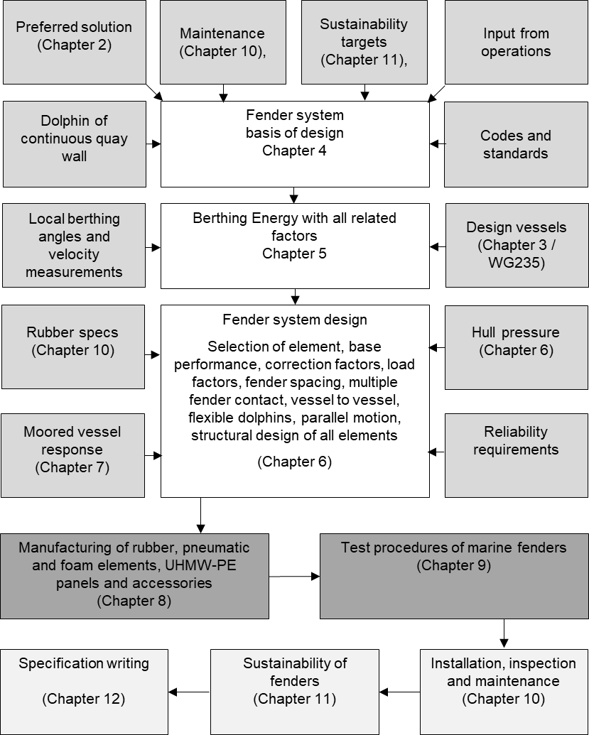

Figure 2: flowchart visualizing WG211 report

**SPECIFIC SUBJECTS OF GENERAL INTEREST**

**Hull Pressure**

Still under discussion is the subject of allowable hull pressure. The table with allowable hull pressures as is currently part of the WG33 report misses any physical base. All research despite, a real governing global valid criterion has not yet been established. IJzerman (2021) did a good attempt, but this study primarily proved that the table doesn’t makes sense. This work is being done.

**Berthing angles**

Berthing angles in WG211 will be significantly lower based on measurements done by WG145. Every port visitor can observe that ships are often berth parallel to the quay. As these angles are part of the integral philosophy these are not shared in this paper.

**Multiple fender contact**

With low berthing angles vessels will always hit more than one fender. This multiple fender contact is one of the key elements that make that severe under designed fenders still can be used by very large ships. The new guideline will provide this multiple fender contact, that will probably the standard approach for container terminals with continuous berths.

**WG33 versus WG211 outcomes**

In general one can state that fenders designed under WG33 fulfil their task pretty well. Based on research, e.g. WG145 and based on observations, designers know that the theory of WG33 does often not match the daily practise. WG211 tries to match theory with practise. But WG211 should not result in heavier fenders under normal conditions. In 2022 WG211 will execute comparison calculations before the report is send out for reviews.

**WARNING: DO NOT COMBINE WG33 AND WG145**

WG145 reports new design berthing speeds. It is very tempting to use these straight away. These berthing speeds will be incorporated in the upcoming WG211 report and presented separately at Ports’22. As the design philosophy is changed completely, designers should not combine the WG33 approach with the WG145 velocities. If WG33 is used, the berthing speeds and abnormal berthing factors of WG33 should be used.

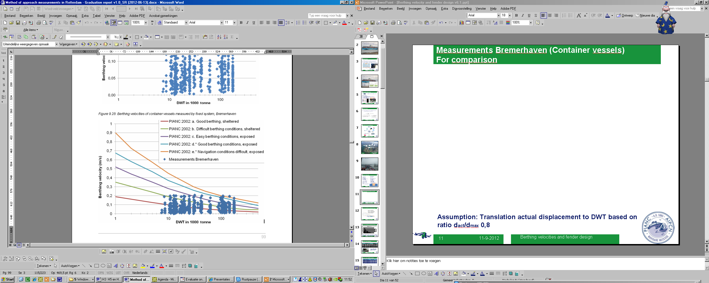

Figure 3: berthing velocities measured in Bremerhaven (PIANC WG145)

**INVOLVED PARTIES IN WG211**

The Working Group contains a broad representation of the PIANC community. The table below shows the involved members, alternating members and YP’s, their member state and their company. As one can see the list is a mixture of manufactures, consultants, research institutes, one contractor, a retired Captain and three fender owners. The list is sorted by family name. Readers with interest in the subject can contact their local representative in WG211.

|  |  |  |
| --- | --- | --- |
| **Name** | **Representing** | **Company** |
| Dr. Hitoshi Akiyama | Japan | Coastal Development Institute of Technology |
| Capt. Dennis Barber | UK | Dennis Barber Marine Consulting |
| Mr. Erik Broos (Chairman) | Platinum Partner | Port of Rotterdam |
| Mr. Marco Gaal | The Netherlands | Trelleborg |
| Mr. Gary Greene | US | Gary Green Engineers |
| Mr. Chistian Hein | Germany | Bremenports GmbH&Co.KG |
| Mr. Rune Iversen | US | Simpson Gumpertz& Heger |
| Mr. Mishra Kumar | Platinum Partner | Trelleborg |
| Mr. Patrick Lambiotte | Belgium | Besix |
| Mr. Bob Lamont-Smith | Australia | E & PI Consultants |
| Mr. Luis Lopez Gonzalez | Spain | Siport21 |
| Mr. Masamitsu Ikebe | Japan | Shibata Industrial |
| Mr. Vitomir Mihajlovic | Spain | Prosertek |
| Mrs. Prasanthi Mirihagalla | UK | AECOM |
| Mr. Svein Ove Nyvoll | Norway | Nyvoll Consult |
| Mr. Jeff Oskamp | US | Moffatt & Nichol Engineers |
| Mr. Dominique Polte | Platinum Partner | Shibata Fender Team |
| Mr. Eduardo Rodero Aristoy | Spain | ShibataFenderTeam |
| Dr. Alfred Roubos (secretary) | The Netherlands | Port of Rotterdam |
| Mr. Sergej Sergijenko | UK | Royal HaskoningDHV |
| Mr. Harvinder Singh | Australia | JACOBS |
| Dr. Ueda | Japan | IDEA Consultants, Inc. |
| Mr. Arjan Van der Weck (mentor) | MarCom | Boskalis |
| Mr. Rob Williams (editor) | UK | Waves Group |
| Mr. NG Yeow Kiat | Malaysia | ExxonMobil / OCIMF |
| Dr. Haruo Yoneyama | Japan | Port and Airport Research Institute |
| Mr. Soonhwan Yun | South Korea | Hwaseung Exwill Co. |

**CONCLUSION**

The reader familiar with the existing WG33 Guidelines must be aware that the WG211 report will be a complete new report. The major issues are explained in separate chapters at the Ports’22 conference.

**REFERENCES**

Orlin (2020) Reliability based assessment of fender systems' Master Thesis Delft University of Technology faculty of Civil Engineering and Geosciences, Delft 2020-11-26

PIANC (2002), Guidelines for the Design of Fender Systems: 2002, report of working group 33 of the Maritime Navigation Commission, Brussels 2002

PIANC (2020), MarCom WG 145: Berthing velocity analysis of seagoing vessels over 30,000 dwt (2020), Brussels 2020

IJzerman (2021), Allowable Hull Loading due to Fender Contact, Master Thesis Delft University of Technology faculty of Mechanical, Maritime and Materials Engineering, Delft, 2021-06-16. <http://resolver.tudelft.nl/uuid:75d401f9-adce-4384-8a84-15f0d6a92fe5>

,