DATA MINING (Section 001)
PROJECT 1- FINAL REPORT

Brief overview on our approach:

Initially we are given with a dataset and each team has been assigned with their respective split and seed values.

Our seed value is 25 with limit 4k and split value is 80 – 20 for training and testing.

After installing R/Rstudio and installing the initial setup we started off with implementation.

We started understanding the dataset given and we have stored the dataset in a variable so that we can reuse it throughout the project.

The dataset we have been given is not cleaned and it has some undefined values(?)

So, we started cleaning the dataset by putting NA in place of the undefined characters and we will omit the rows containing the value NA.

As the dataset is clean now, we have added the column names to the newly generated dataset with no undefined characters.

We have separated the cleaned dataset into training and testing sets using the split ratio given to us with the dataset and set the seed value to 25 as specified in the project requirement.

Classification/Comparison using Information Gain:

For this, we have got a 30k records dataset and now we will be sampling the data over the records by using the seed value given for us in the requirement into 4k values and then we are making the split in the 80-20 ratio as it is given the requirement. Now, as our training and test sets are ready.

On this training set we have we are implementing the R part package by passing these parameters – Class Attribute, and data= train set and the split parameter as Information gain.
By this a model will be generated, now we are running the predict function using the parameters – the previously generated model by Rpart and the test set. By plotting the model we will be getting a decision tree.

Now for calculating the confusion matrix we will be running the table function by passing these attributes test set’s class attribute and the output of the prediction that is done on the test set.

Generated Confusion matrix:

Information Gain
predict_set | <=50K | >50K
<=50K | 564 | 57
>50K | 66 | 113
For the above generated confusion matrix we were able to deduce the below metrics of our classification

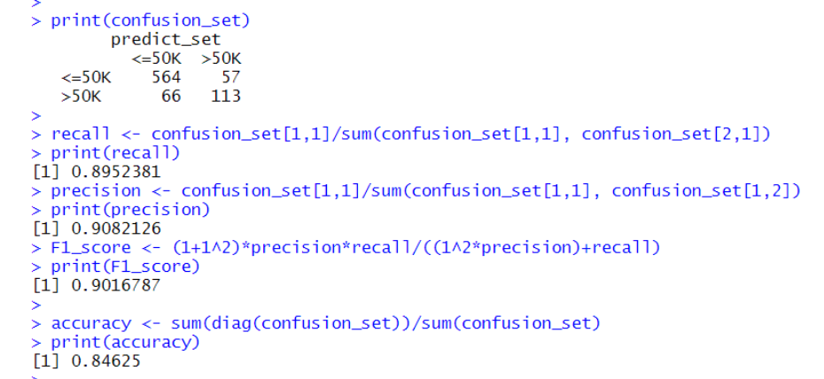

Withholding an class attribute/Comparison:
- On this train data we will be running the varImp() which will be giving the ranking based on the importance of our class attributes in our data set.
- Based on the ranking we will be removing the least ranked class attribute and calculate the confusion matrix for that.
- In this we have withheld the column Race as it has the least ranking.
- Below is the confusion matrix.

Information Gain Witholding Column
new_predict_set | <=50K | >50K
<=50K | 831 | 91
>50K | 105 | 173

Information Gain vs Information Gain Withholding Column
 | Information Gain | Information Gain Withholding Column
Accuracy | 0.84625 | 0.8366667
Precision | 0.9082126 | 0.9013015
Recall | 0.8952381 | 0.8878205
F1-Score | 0.9016787 | 0.8945102

- From the above results we don’t see any big difference. Thus, we have withheld the above column and predicted the outcome.

Classification/comparison using Gini:
For calculating the confusion matrix for GINI also we will be using the same procedure as we used for the Information gain but in the Rpart package we will be sending the split value parameter as GINI.

GINI Index
predict_set | <=50K | >50K
<=50K | 564 | 57
>50K | 66 | 113

For the above generated confusion matrix we were able to deduce the below metrics of our classification
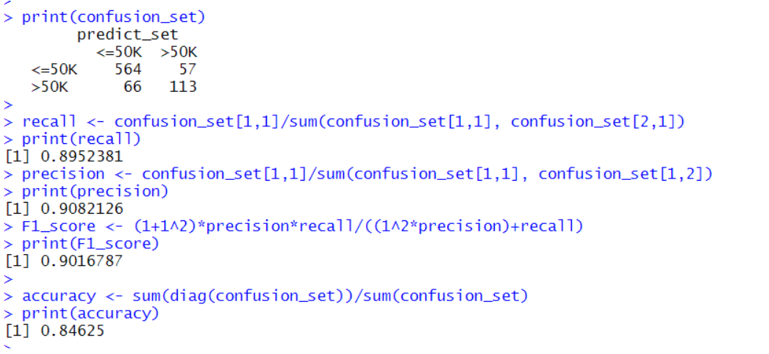
Withholding an class attribute/ Comparison:

On this also we will be running the varImp function for getting the importance and delete the class attribute with the least importance. In this we have deleted the native_country column.

Now we will again calculate the confusion matrix,

GINI Index Witholding Column
new_predict_set | <=50K | >50K
<=50K | 564 | 57
>50K | 66 | 113

GINI Index vs GINI Index Withholding Column
 | GINI Index | GINI Index Withholding Column
Accuracy | 0.84625 | 0.84625
Precision | 0.9082126 | 0.9082126
Recall | 0.8952381 | 0.8952381
F1-Score | 0.9016787 | 0.9016787

- From the above results we don’t see any big difference. Thus, we have withheld the above column and predicted the outcome.

Classification/Comparison IG,Gini and Naïve Bayes:

Now for the Naïve Bayes we will not be using the Rpart package as we used for the Information gain and Gini instead we will be using the E1071 package.

In that using the naïve bayees function by passing the parameters class attribute and data= trainset. Rest everything is the same and we will be generating the confusion matrix as we did previously

Generated confusion matrix:

Naïve Bayes
Pred_set | <=50K | >50K
<=50K | 1143 | 187
>50K | 68 | 151

For the above generated confusion matrix we were able to deduce the below metrics of our classification:

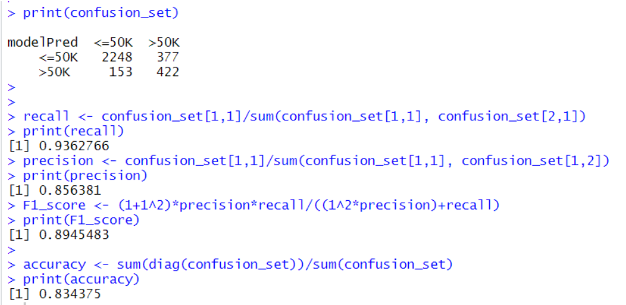

Below is the comparison,
Information Gain vs Naïve Bayes
 | Information Gain | Naïve Bayes
Accuracy | 0.84625 | 0.84
Precision | 0.9082126 | 0.8593985
Recall | 0.8952381 | 0.9430693
F-Score | 0.9016787 | 0.8992919

GINI Index vs Naïve Bayes
 | GINI Index | Naïve Bayes
Accuracy | 0.84625 | 0.84
Precision | 0.9082126 | 0.8593985
Recall | 0.8952381 | 0.9430693
F-Score | 0.9016787 | 0.8992919
Inference:

Naïve bayes is working effectively with low amounts of data compared with the Gini/IG.
Because Gini/IG are easy to understand and just need a table to classify they are good with the large amounts of data.

Comparison of IG/Gini :

Now we as we have all the metrics needed for comparison which we have derived using Information gain and Gini. We have directly put down the comparison below

GINI Index vs Information gain
 | GINI Index | Information Gain
Accuracy | 0.84625 | 0.84625
Precision | 0.9082126 | 0.9082126
Recall | 0.8952381 | 0.8952381
F-Score | 0.9016787 | 0.9016787

Here we can clearly observe that the metric derived using both the approaches are the same.
So, by the above comparison we can infer that Both the GINI and Information gain are only two approaches for working on a data set. We will arrive at the same solution using any of the approach. It’s up to the user on which approach to be used for their classification.

Division of Labour:

We have divided the work for this as Decision tree and Naïve bayes approach in getting the values and the same in take on the report also.

Three problems encountered:

- We were unable to remove the rows containing the undefined values:
We have overcome this problem by putting NA in place of ‘?’ everywhere and using the NA.omit() function we have removed all the rows containing NA.
- We have encountered errors regarding the data types of attributes in dataset
We have overcome this by converting the data type of the attribute to be a factor where ever it is required.
- We were not directly able to print the metrics such as precision, recall etc., directly.
We have overcome this by, after printing the confusion matrix, We have calculated them by using the formulas not by using pre-define d functions over the generated confusion matrix.

Overall status:
We have followed and aligned to all the requirements and conditions given with the project
and completed all the tasks and provided all the required comparisons and provided our analysis under each comparison respectively.

References:
www.rddr.io
www.rdocumentation.org
www.cran.r-project.org

