Outputs

**Lab 1: Understanding ORM with a Retail Inventory System**

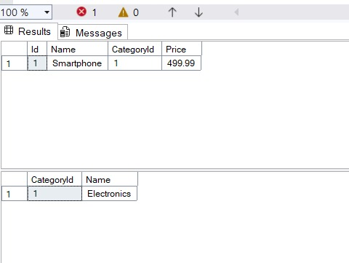

**Lab 2: Setting Up the Database Context for a Retail Store**

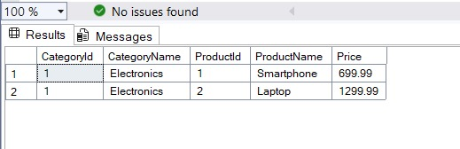

**Lab 3: Using EF Core CLI to Create and Apply Migrations**

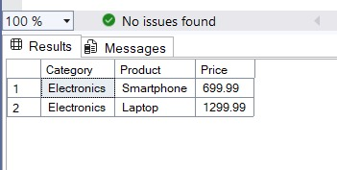

**Lab 4: Inserting Initial Data into the Database**

**Lab 5: Retrieving Data from the Database**