Connecting spring boot to dual DB:

1. In application.properties give the two datasource properties
2. Configure two Data Config, like BookDBConfig and UserDBConfig.
3. Should have different packages for both UserRepo and BookRepo and model classes as well.

@Configuration

@EnableTransactionManagement

@EnableJpaRepositories(

        entityManagerFactoryRef = "entityManagerFactory",

        basePackages = {

                "com.ashokit.user.repository"

        }

)

public class UserDBConfig {

    @Primary

    @Bean(name = "dataSource")

    @ConfigurationProperties(prefix = "spring.user.datasource")

    public DataSource dataSource() {

        return DataSourceBuilder.create().build();

    }

    @Primary

    @Bean(name = "entityManagerFactory")

    public LocalContainerEntityManagerFactoryBean entityManagerFactory(EntityManagerFactoryBuilder builder,

            @Qualifier("dataSource") DataSource dataSource) {

        HashMap<String, Object> properties = new HashMap<>();

        properties.put("hibernate.hbm2ddl.auto", "update");

        return builder.dataSource(dataSource)

                      .properties(properties)

                      .packages("com.ashokit.user.model")

                      .persistenceUnit("User")

                      .build();

    }

    @Primary

    @Bean(name = "transactionManager")

    public PlatformTransactionManager transactionManager(@Qualifier("entityManagerFactory") EntityManagerFactory entityManagerFactory) {

        return new JpaTransactionManager(entityManagerFactory);

    }

}

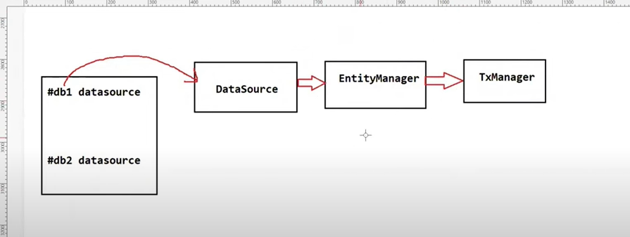

**Q) What is hot reloading and how does it work?\***

Hot reloading allows developers to make changes to their code, resources, or configuration files while an application is running, and see those changes immediately reflected without needing to **\*restart the application.* using Dev Tools.**

**Handling multiple users at the same time:**

1. Thread pool and asynchronous : using @Async annotation on the method tells spring boot that it should run in a separate thread.
2. How to synchronous two java process: shared DB and share file system
3. JVM architecture: class Loader, Run time Data areas and execution engine

Class loader loads class file into JVM, Runtime Data areas keeps memory for variables and all.. And execution engine will execute the instructions.(wrie once and run anywhere)

1. Stack and heap memory: Heap is shared across threads while the stack is for each method having thread safe
2. Java makes its engine faster by using JIT compiler, byte code to native machine code..
3. Super calls the method in parent class even if we have overridden it.
4. **Private**: The access level of a private modifier is only within the class. It cannot be accessed from outside the class.
5. **Default**: The access level of a default modifier is only within the package. It cannot be accessed from outside the package. If you do not specify any access level, it will be the default.
6. **Protected**: The access level of a protected modifier is within the package and outside the package through child class. If you do not make the child class, it cannot be accessed from outside the package.
7. **Public**: The access level of a public modifier is everywhere. It can be accessed from within the class, outside the class, within the package and outside the package.

**How does polymorphism help the Java collection framework?**

Letting it treated as sameWay, list interface we can use ArrayList or LinkedList

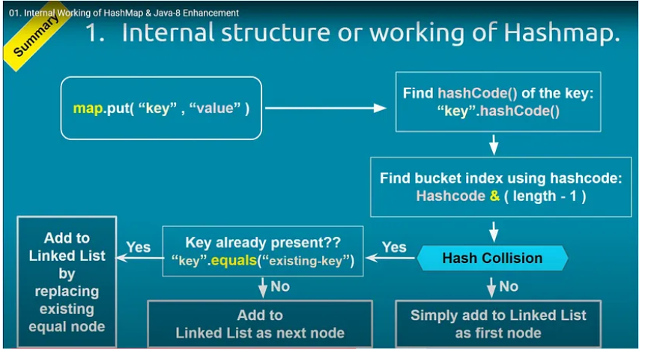

How HashCode and Equals work together in a Collection?

The Relationship Between hashCode() and equals() in Java Collections

In Java, the hashCode() and equals() methods are used in collections to store, retrieve, and identify objects efficiently. They work hand in hand to ensure fast access and accurate results in a collection.

Understanding hashCode():

The hashCode() method is a part of the Java Object class. It returns an integer representation of the object memory address. When an object is stored in a hashed data structure like a HashMap, HashSet, or Hashtable, Java uses the hashCode() method to determine where the object should be stored.

Understanding equals():

The equals() method is used to determine the equality of two objects. If equals() returns true for two objects, this means that they are equal in terms of their defined equality criteria (which can be overridden in a custom class to suit specific needs).

Working Together:

hashCode() and equals() methods work together in the following way:

1. When an object is inserted into a hashed collection, the hashCode() method is called first to determine the correct bucket location for storing the object.
2. If a collision occurs (two objects have the same hash code), the collection calls the equals() method to check if the objects are truly equal. If they are equal, the new object replaces the existing one. If they aren't, the collection resolves the collision and stores both objects.

Ensuring Consistency:

To ensure consistency and avoid misbehavior in collections, there are two important contracts:

1. If two objects are equal (as determined by the equals() method), then calling hashCode() on each of the two objects must produce the same result.
2. If two objects are unequal (as determined by the equals() method), it's not required that calling hashCode() on each of the two objects will produce distinct results. However, producing distinct results for unequal objects may improve the performance of hash tables.

In Summary:

hashCode() and equals() methods are fundamental to the correct functioning of hash-based collections in Java. They are used to determine the storage location of objects and to avoid storing duplicate objects. These two methods should be overridden together and behave consistently with each other to avoid unexpected results in collections.

**Using mutable object as key in HashMap?**

When mutable object is inserted in hashmap, it might change and hashcode might change then its difficult to retrieve the object.

**Can we build a server without using spring framework?**

We can build that using server socket connection, accepting requests from client and write code for all network connection,listening on port

**How to deploy a servlet web application without spring?**

Need to create a war file, configure web.xml file for servlet mapping and all in the end deploy and publis to tomcat server.

**AutoConfiguration:**

Add spring starter web

**Slow in production faster in Dev:**

Check logs, blue/green deployments , optimize query

**Circular Dependency:**

spring.main.allow-circular-references=true, using @Lazy annotation

SOLID Design Principles:

https://medium.com/@javatechie/solid-design-principle-java-ae96a48db97