ACTIVITY 8

Quick Find

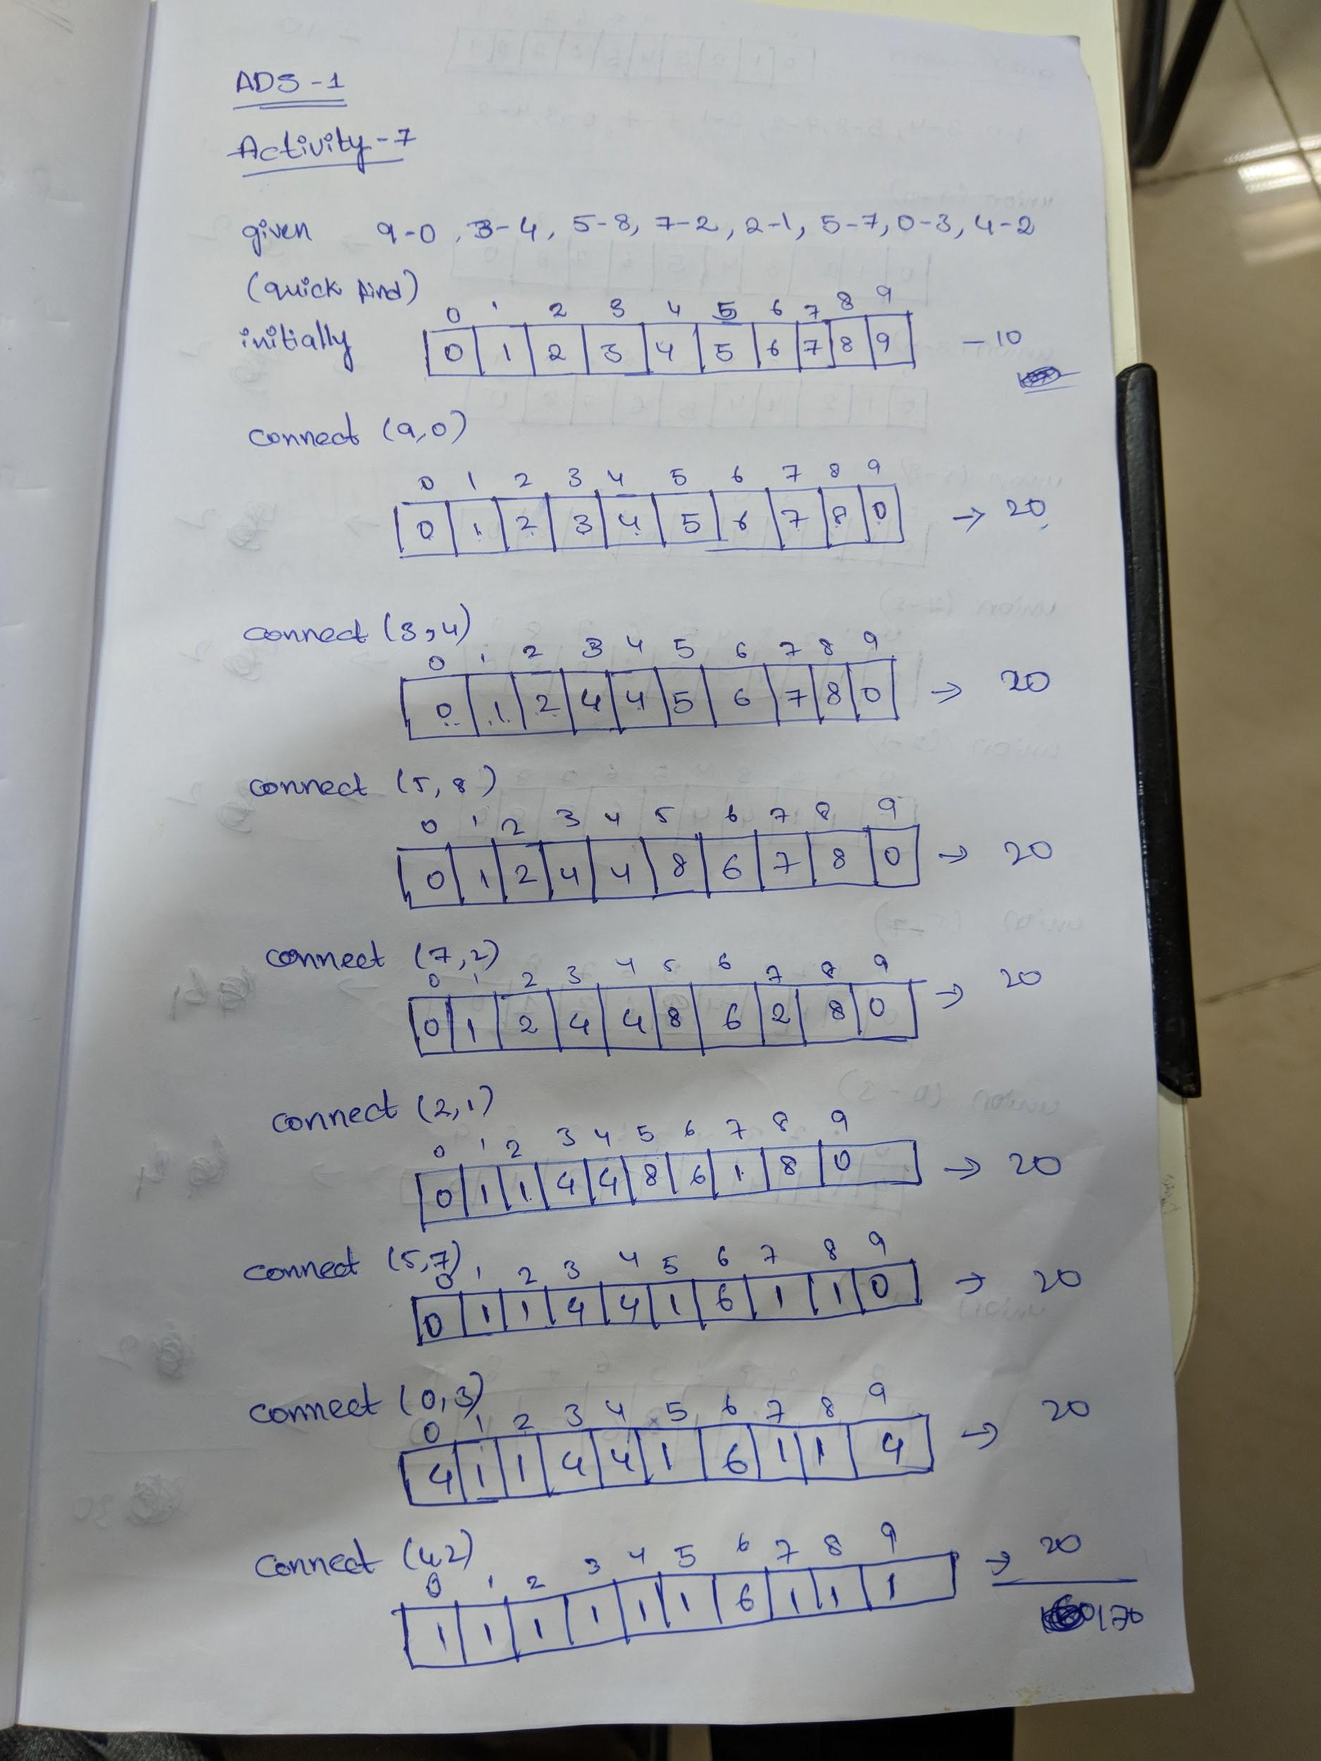

Quick union

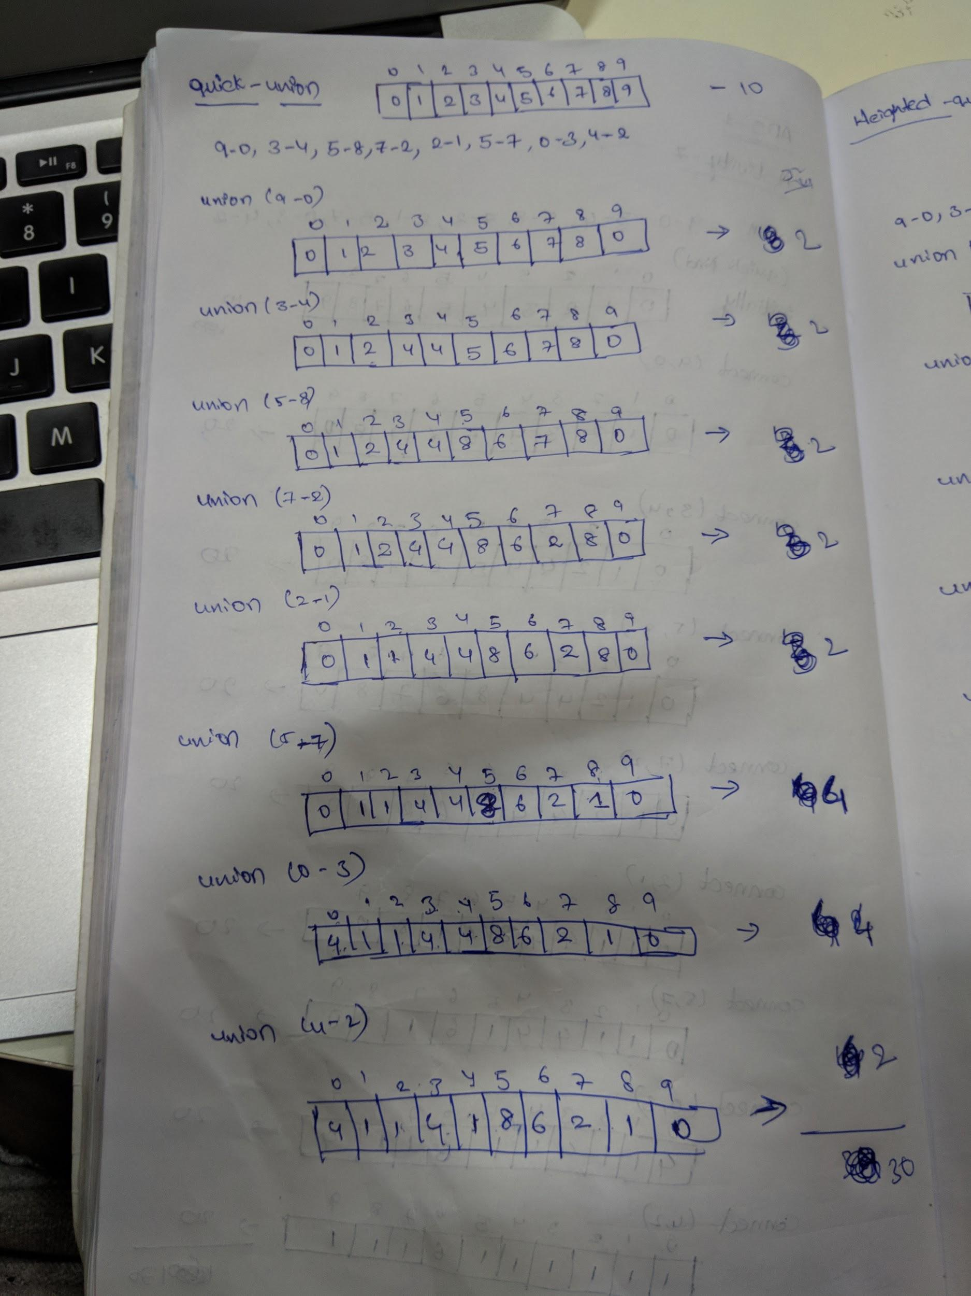

Weighted Quick union

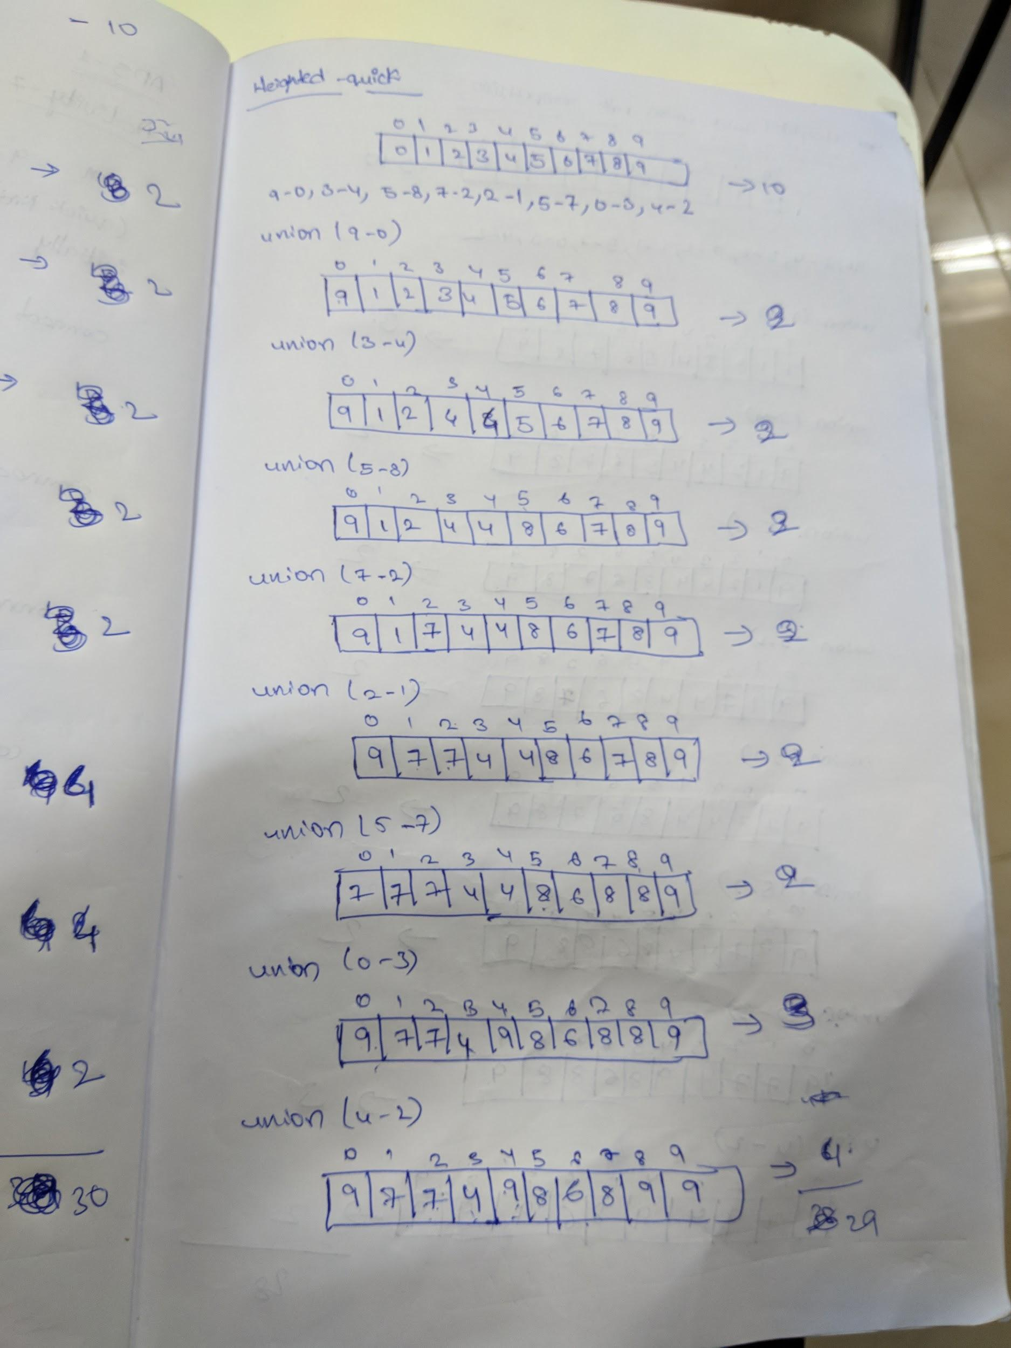

Weighted quick union compression

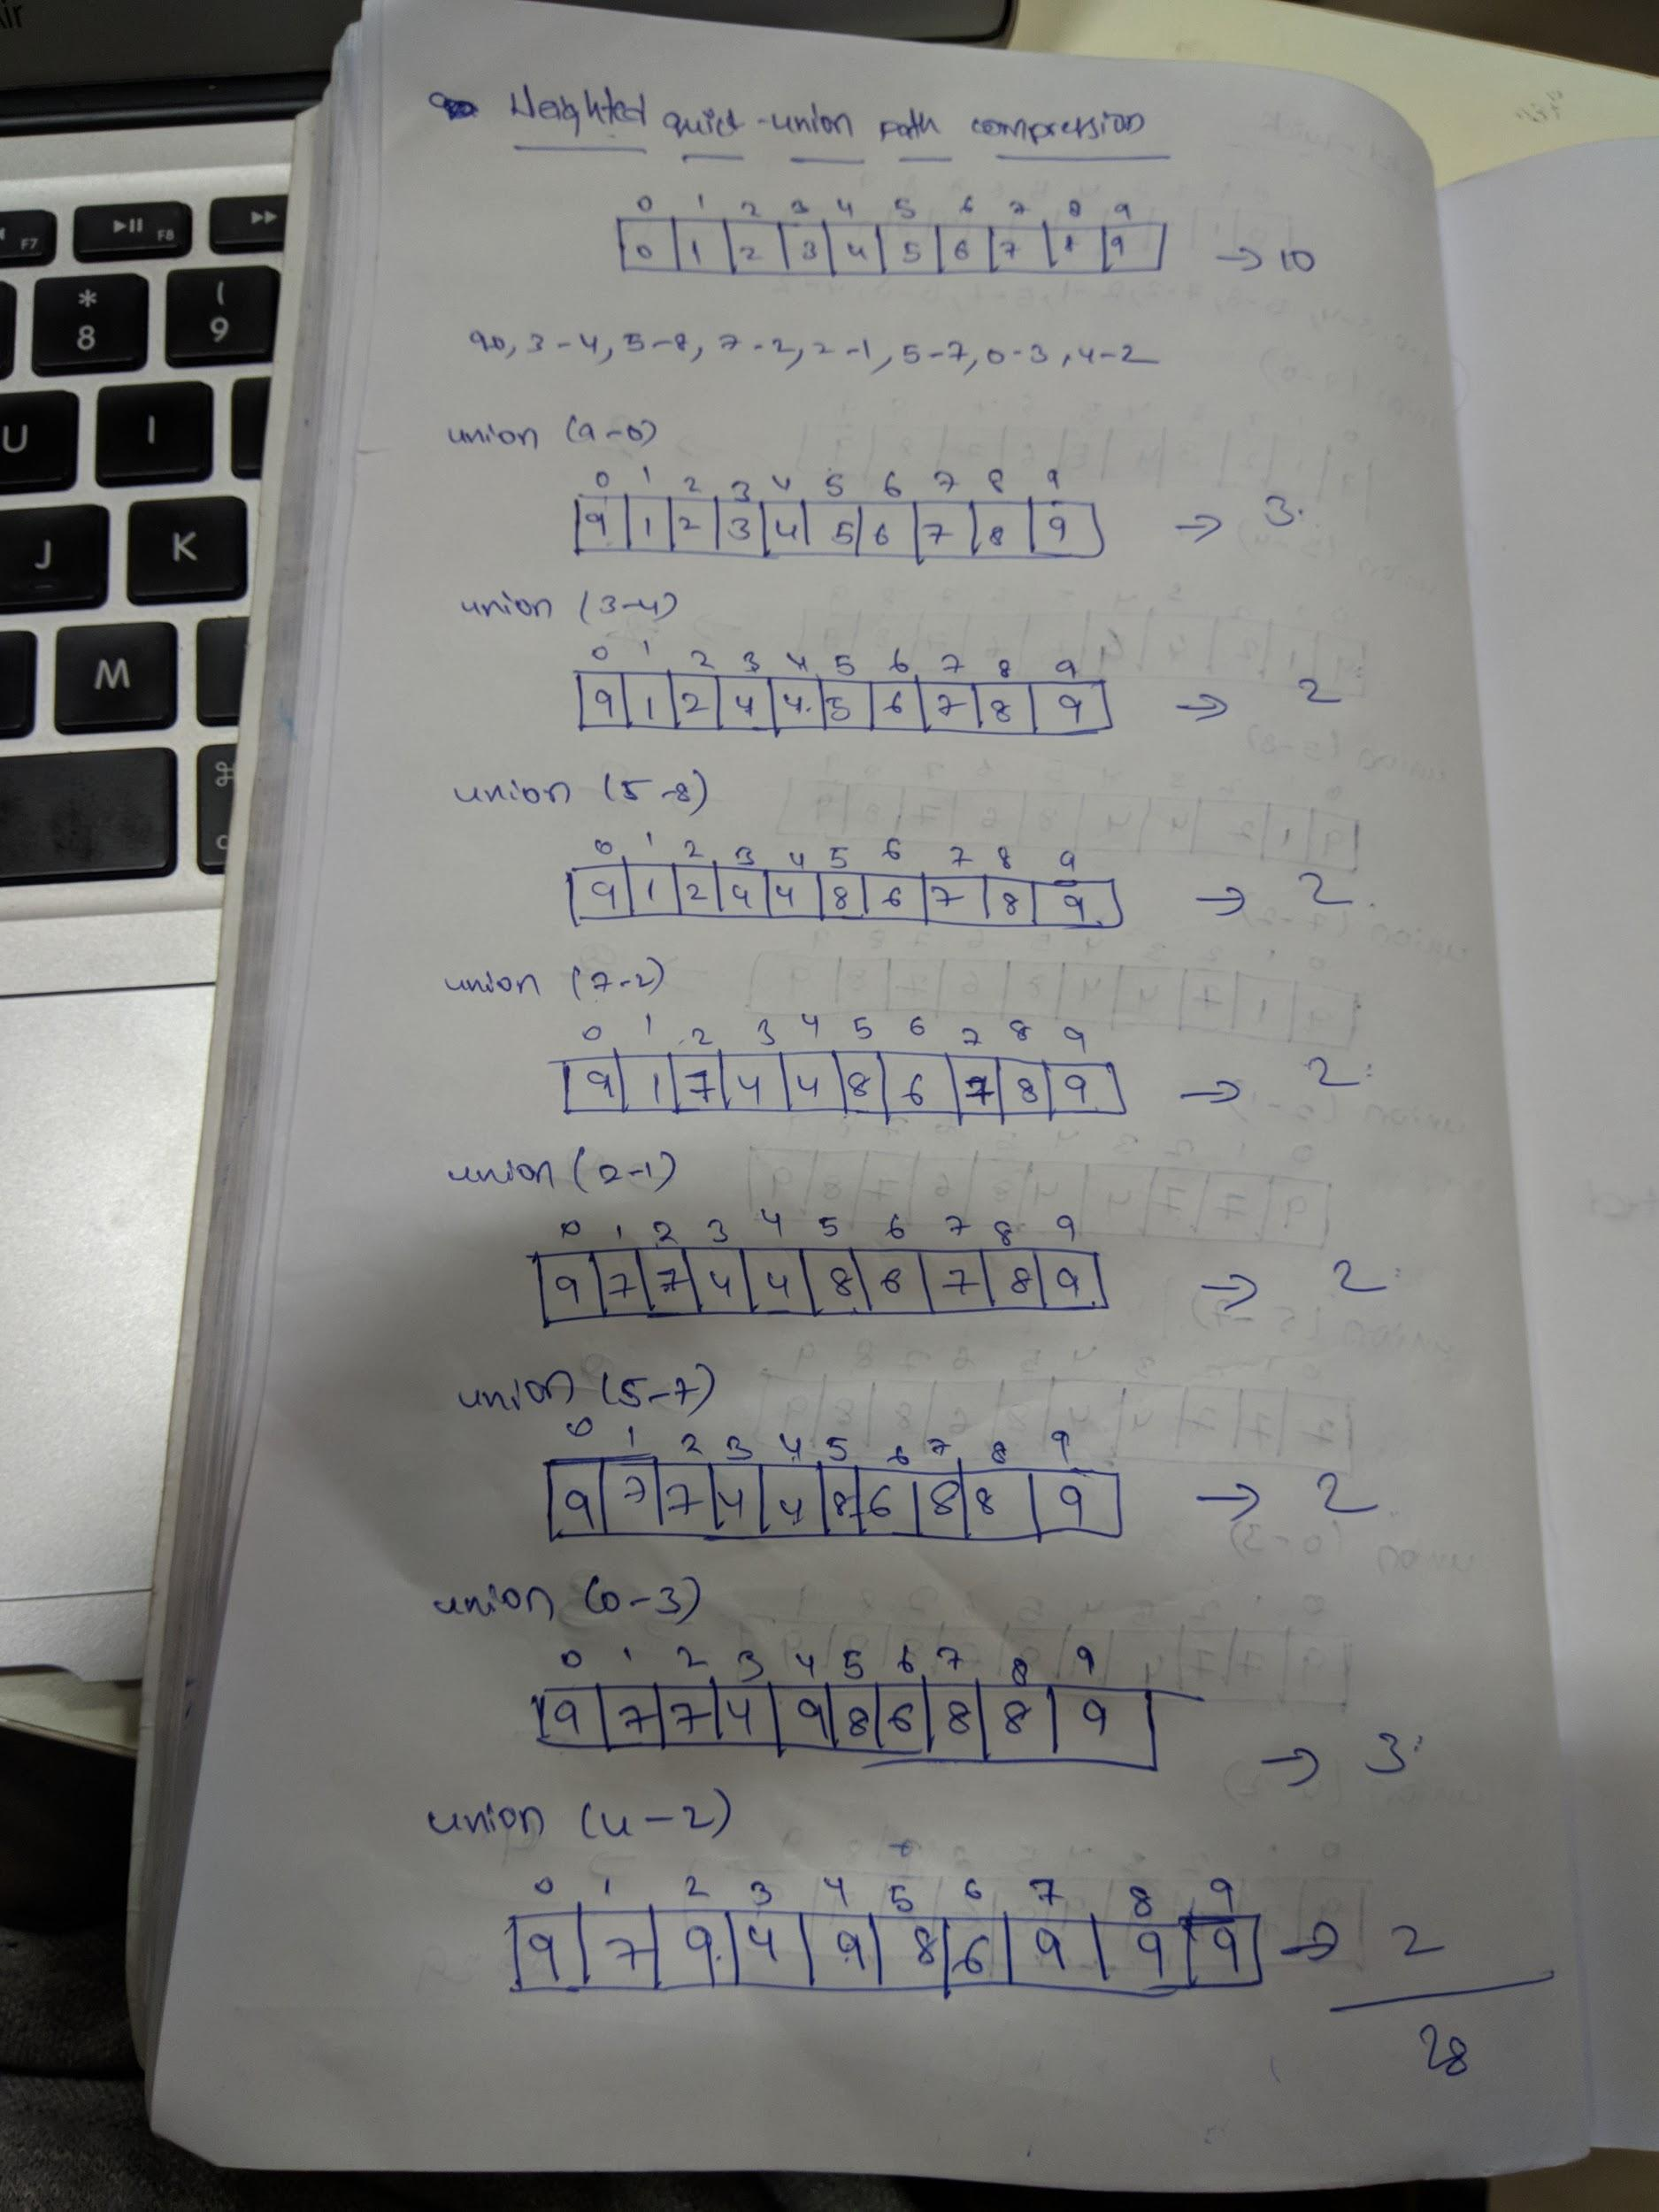

From the above four algorithms we see that the time complexity is less for the weighted quick - union path compression when compared to others. It is better than others.