Q) select top 21

concat(cus.FirstName,cus.LastName) as Name,

sum(inv.Total) as Ammount

from Customer cus

join Invoice inv on cus.CustomerId=inv.CustomerId group by

concat(cus.FirstName,cus.LastName) having

sum(inv.Total) <38 order by Ammount asc

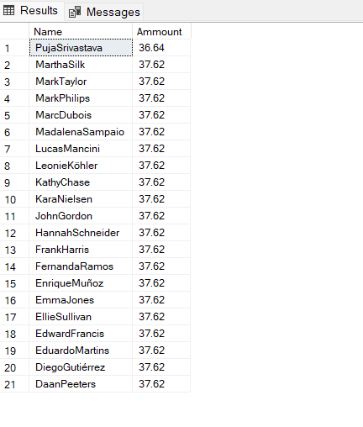

select

cus.FirstName as customer_name,

inv.InvoiceDate as Order_Date

from Customer cus

join Invoice inv on cus.CustomerId=inv.CustomerId

where year(inv.InvoiceDate) > 2011 and year(inv.InvoiceDate) <2013

select emp.FirstName,emp.LastName,

inv.InvoiceId,inv.InvoiceDate,cus.CustomerId,

inv.BillingAddress,inv.BillingCountry,BillingPostalCode,inv.Total from Employee emp join Customer cus on emp.EmployeeId=cus.SupportRepId

join Invoice inv on inv.CustomerId=cus.CustomerId where emp.FirstName='Jane' and year(inv.InvoiceDate) > 2008 and year(inv.InvoiceDate) <2010 and Month(inv.InvoiceDate) <5

and BillingCountry not in ('Canada','India')

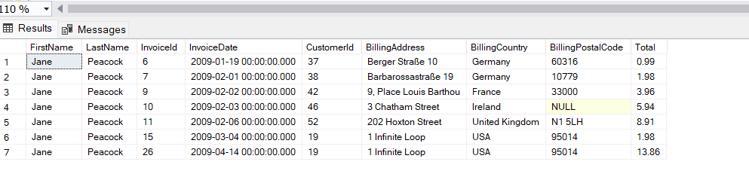

select

invl.InvoiceLineId,

invl.InvoiceId,

invl.TrackId,

invl.UnitPrice,

invl.Quantity,

trc.Name,

art.Name

from InvoiceLine invl

join Track trc on invl.TrackId=trc.TrackId

join Invoice inv on inv.InvoiceId=invl.InvoiceId

join Album ab on ab.AlbumId=trc.AlbumId

join Artist art on art.ArtistId=ab.ArtistId

where invl.TrackId < 5

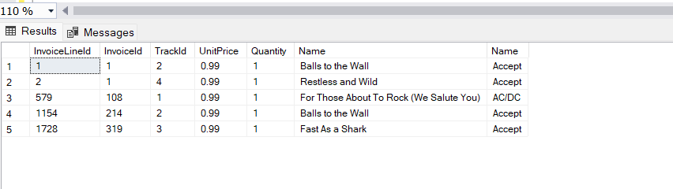

select

concat(emp.FirstName,emp.LastName),

inv.InvoiceId,inv.InvoiceDate,

cus.CustomerId,inv.BillingCity,

inv.BillingState,

inv.BillingAddress,

inv.BillingCountry,

BillingPostalCode,inv.Total

from Employee emp

join Customer cus on emp.EmployeeId=cus.SupportRepId

join Invoice inv on inv.CustomerId=cus.CustomerId

where year(inv.InvoiceDate) > 2008 and year(inv.InvoiceDate) <2010

and inv.InvoiceId < 9

select concat(cus.FirstName,cus.LastName) as FullName ,

inv.InvoiceId,

inv.InvoiceDate,

inv.BillingCountry

from Customer cus

join Invoice inv on inv.CustomerId=cus.CustomerId

where BillingCountry='Brazil'

and year(inv.InvoiceDate)>2008

and year(inv.InvoiceDate)<2011

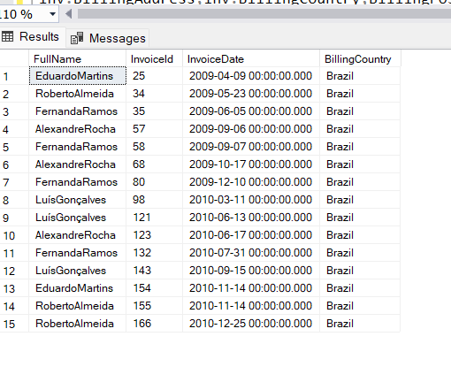

select

trc.Name,

trc.Composer,

trc.milliseconds,

trc.bytes,alb.Title,

md.Name,

gn.Name

from Track trc

join Album alb on alb.AlbumId=trc.TrackId

join Genre gn on gn.GenreId=trc.GenreId

join MediaType md on md.MediaTypeId=trc.MediaTypeId

where gn.Name='rock'

Write a SQL statement to make a list with order no, purchase amount, customer name andtheir cities for those orders which order amount between 500 and 2000.

select

ord.ord_no,

ord.purch_amt,

cus.cust_name,

cus.city

from orders ord

join customer cus on cus.customer_ID=ord.customer_id

where ord.purch_amt >500 and ord.purch_amt<2000

--Write a SQL statement to know which salesman are working for which customer.

select

cus.cust_name,

sal.NAME

from salesman sal

join customer cus on cus.salesman_id=sal.salesman_ID

--Write a SQL statement to find the list of customers who appointed a salesman

-- for their jobs who gets a commission from the company is more than 12%.

select

cus.cust_name,

cus.city,

cus.grade

from customer cus

join salesman sl on cus.salesman_id=sl.salesman_ID

where (sl.commission)*100 >12

--Write a SQL statement to find the list of customers who appointed a salesman for theirjobs who does not live in the same city where their customer lives, and gets a commission is above 12%.

Select

cus.cust_name,

cus.city,

cus.grade

from customer cus

join salesman sl on cus.salesman_id=sl.salesman_ID

where (sl.commission)*100 >12

and cus.city !=sl.city

Write a SQL statement to find the details of an order i.e. order number, order date, amount of order, which customer gives the order and which salesman works for that customer and how much commission he gets for an order.

select

ord.ord_no,

ord.purch_amt,

ord.ord_date,

cus.cust_name,

sl.commission,

sl.NAME as salesmanName

from orders ord

join customer cus on ord.customer_id=cus.customer_ID

join salesman sl on ord.salesman_id=sl.salesman_ID