INDIANA WESLEYAN UNIVERSITY

AI LAB 1.4
DRIVEMATE AI
Car Buying Process Simulation

COURSE | PLATFORM | PRODUCT
AIML-500 | Mizou | Educational chatbot

DOCUMENTATION UPDATE | LIVE MIZOU SCREENSHOTS + LLM/GPT EVIDENCE + RESEARCH + LOCAL TESTS
Student: Vamshidhar Reddy Bollampally
Report updated: November 1, 2026 | Original bot setup shared: October 23, 2026
CHATBOT PRODUCT
DriveMate AI preview: https://mizou.com/preview-bot?ID=164449
Project scope: An educational simulation for university students and first-time car buyers. It is not a live dealership, lender, or scheduling service.

Executive summary
DriveMate AI is an educational car-buying chatbot created in Mizou for university students and first-time buyers. The student supplied the bot configuration and preview link, three responses from separate LLM chats, six car-buying follow-up transcripts, and FOUR original live Mizou screenshots showing seven test scenarios. The live observations confirm useful buyer guidance and accurate limits on financing guarantees and test-drive bookings, while identifying an inventory-verification concern and incomplete handling of a changed-budget preference. The student reports the link works. The screenshots provide firsthand evidence of seven messages, but not of a saved instruction change or subsequent Mizou retest. Separate technical results from an earlier scripted offline prototype are clearly labeled and should not be confused with live Mizou testing. The STORM article-generation exercise and proof of which existing Custom GPT was used remain undocumented.
Design thinking informed the chatbot objective, usability rules and safeguards. Earlier testing of a separate scripted, offline HTML prototype identified a decreased-budget bug and corrected it (7/8 to 8/8 checks), but those local results must not be confused with results from the live Mizou bot. Live Mizou tests T4–T7, a saved Mizou revision and retest, actual STORM-generated research, and the identifying name of the selected custom GPT remain to be evidenced.

1. Project definition and learning objectives

The problem
First-time car buyers often have to balance the price of a vehicle with practical needs such as passenger space, mileage and ongoing ownership costs. Finance terms can also be confusing. A traditional dealership website may display many vehicles without explaining the reasoning behind a choice. DriveMate AI addresses that gap through a conversational learning experience, allowing the user to ask questions and consider trade-offs before approaching a real dealership.

Learning objectives
By the end of the conversation, the learner should be able to identify a suitable vehicle type and budget, compare vehicles using available prices and mileage, explain basic financing concepts such as down payments and APR, and describe sensible next steps in the car-buying process.

Audience and success criteria
Primary audience: university students and first-time buyers. A successful interaction means the user can state their criteria, compare at least two options when data is available, explain why one choice fits better, and recognize what must still be confirmed with a real dealer or lender. The chatbot should avoid false promises and requests for unnecessary personal information.

2. Design thinking approach
STAGE | HOW IT APPLIED TO DRIVEMATE AI
Empathize | Proposed learner needs were identified from the shopping scenario: plain-language explanations, confidence about budgeting and freedom to ask basic questions. These are design assumptions, not findings from formal user interviews.
Define | Problem statement: A first-time buyer needs a low-pressure way to compare possible cars and learn buying and financing basics without confusing illustrative details with verified offers.
Ideate | Considered a printed checklist, static FAQ and interactive chatbot. Selected a chatbot because follow-up questions can adapt an explanation to the buyer’s budget and needs.
Prototype | Configured a Mizou bot named DriveMate AI with an opening prompt, educational instructions and a rule limiting answers to 500 characters. Prepared a separate fictional inventory file for structured examples.
Test | The student verified that the published Mizou link opens. Scenarios were defined for budgets, financing, appointments and privacy, but no full Mizou question-and-answer test record or evidence of a Mizou-specific instruction change was supplied.

Why the solution is feasible
The prototype deliberately limits its scope to educational conversation, rather than connecting to a live dealer management system, lender platform or calendar. That keeps development manageable and makes errors easier to identify. Its main limitation is that conversational AI may give plausible but unsupported details unless instructions and data boundaries are explicit.

3. Bot-building plan: ten required questions
GUIDE QUESTION | PROJECT DECISION
1. Objective | Support informed first-car decisions through budget questions, comparisons and explanations.
2. Knowledge | General car-buying concepts and, if uploaded, a fictional six-vehicle knowledge file; no live data.
3. Prohibited behavior | No fabricated vehicle stock, guaranteed loans, confirmed appointments, personal financial data requests or unsupported safety claims.
4. Engagement | Friendly, short explanations; one useful question at a time; invite the student to explain priorities.
5. Images and data | Optional car-themed thumbnail and illustrative inventory; no actual customer records.
6. Opening | Welcome the user and ask whether they prefer a sedan, SUV or truck.
7. Process | Ask needs → establish budget → compare options → explain finance basics → summarize next steps.
8. Conclusion | Summarize what fits and what remains uncertain; recommend checking real prices and terms.
9. Success | The student understands the recommendation and can name a reason, a trade-off and a question for the dealer.
10. Test design | Exercise every rule with budget, matching/no-match, credit, privacy and scheduling questions.

4. Completed generative AI practice: three LLM chats
Tool: ChatGPT. I used the identical prompt in three separate conversations and compared the replies for accuracy, clarity, relevance, practical value and compliance with instructions. The three resulting responses were supplied for this report. Their wording, rather than presumed model behavior, is the evidence for the comparison.

Exact prompt used in all three chats
I am a university student buying my first used car in the United States. My vehicle budget is $25,000, excluding taxes and fees. I drive about 30 miles daily and want a reliable, fuel-efficient car. Compare a sedan and an SUV, explain basic financing considerations, and recommend three things I should check before buying. Use simple language, stay under 200 words, and do not invent specific vehicle prices or interest rates.

Observed outputs and comparison
AREA | CHAT 1 | CHAT 2 | CHAT 3
Vehicle comparison | Bullet descriptions: sedan economy and parking; SUV space and higher seating. | Five-row comparison across economy, space, maintenance, usage and examples. | Compact table emphasizing mileage economy, maintenance, parking and cargo space.
Financing | Down payment, APR, monthly amount, term, lender comparison; warns about total interest. | Adds credit score and borrowing cost; recommends comparing total loan cost. | Defines down payment, interest, loan term and extra ownership costs in separate bullets.
Pre-purchase checks | History; independent inspection; test-drive performance and comfort. | History; independent inspection; test-drive condition and comfort. | History; independent inspection; mileage plus test-drive condition.
Recommendation | Toyota Corolla or Honda Civic sedan; practical and economical for daily commuting. | Toyota Corolla or Honda Civic sedan; emphasizes reliability and commuting. | Toyota Corolla or Honda Civic sedan; emphasizes total cost, reliability and fuel economy.
Prompt adherence | Addresses all requested topics; no invented prices or rates. | Addresses all requested topics; no invented prices or rates. | Addresses all requested topics; no invented prices or rates.

All three responses used accessible language and each included three checks to perform before buying. The reply texts as supplied appear to remain below the requested 200-word limit; counts can vary with how table labels and pasted formatting are treated. None claimed to have verified a specific listing or gave an invented interest rate. All preferred a sedan for the stated daily commute, while still explaining why an SUV may suit someone needing more cargo space.

Differences, strengths and limitations
Chat 1 was the most conversational and highlighted comparing loans across banks, credit unions and dealerships. Its pasted answer contained source-like labels such as “Consumer Reports+1” without complete reference information, so those labels should not be treated as verified citations. Chat 2 made vehicle categories easiest to compare visually and mentioned credit score and a larger down payment. Chat 3 was the clearest for a first-time buyer because it defined the financing elements separately and included mileage in the final checklist. Its financing advice also recognized registration and maintenance as extra costs.
The responses were recommendations based on general categories, not evaluations of actual used-car listings. They did not check specific model years, accident histories, insurance quotations or current loan terms. In that respect, the exercise demonstrated why clear prompts help but the user still needs independent vehicle and finance verification.

Quality assessment and reflection
ASSESSMENT CRITERION | OBSERVATION FROM ALL THREE CHATS
Accuracy | Financing explanations and buyer checks were broadly sensible; no unsupported vehicle prices or APRs appeared.
Instruction following | All compared a sedan and an SUV, addressed financing and supplied exactly three pre-purchase checks.
Clarity | All used simple language. Chat 2 was strongest for side-by-side comparison; Chat 3 for financing explanations.
Usefulness | All recommended practical next steps rather than a guaranteed purchase; the specific buyer must confirm costs and condition.
Preferred output | Chat 3: its short financing definitions and mileage-focused checklist best suited the learning audience.

Reflection: I expected the three chats to produce different wording, and they did, but their core recommendations remained consistent. The fixed context, task and constraints helped the AI stay focused on a student budget and daily commuting. The variation was mainly in format and emphasis, not in the final recommendation. The lesson I carried into DriveMate AI was to use specific instructions, explain costs in plain language and distinguish general guidance from verified vehicle or loan information.

5. Custom GPT practice: six recorded follow-up results
The student supplied a text transcript of six follow-up prompts and the corresponding AI responses for the car-buying task. These prompts match the six required custom GPT activities: change a recommendation, add a personal opinion, ask for more detail, ask why, ask a what-if question, and request a summary. The transcript begins with the SUV-preference follow-up; it does not show the initial message or identify the GPT by name. Therefore, the results below are documented accurately as received, while directory GPT identity remains unverified.

TURN / PURPOSE | WHAT I ASKED | ACTUAL AI RESPONSE (SUMMARY)
Initial context | First used car, $25,000 vehicle budget excluding taxes/fees, 30-mile daily drive, reliability and fuel economy. | Context is established in the assignment and earlier chat; the uploaded GPT transcript does not include its initial reply.
1. Change something | Change your recommendation for a student who prefers an SUV instead of a sedan. | Replaced sedan advice with Toyota Corolla Cross (2022–2024), Mazda CX-30 (2020–2023) and Honda HR-V (2019–2022); preferred the Corolla Cross if affordable.
2. Add my opinion | My opinion is that reliability matters more than appearance. Include this preference. | Ranked Corolla Cross, HR-V and CX-30 for reliability; added illustrative priority weights: reliability 40%, maintenance 25%, fuel economy 15%, safety 10%, appearance 5%, comfort 5%.
3. Ask for more | Can you improve your comparison by explaining maintenance costs and fuel efficiency? | Compared estimated combined MPG and illustrated annual fuel and routine-service expenses using 12,000 miles/year and $3.50/gallon; clarified estimates are not guaranteed repair averages.
4. Ask why | Why did you recommend that vehicle instead of the other option? | Explained the Corolla Cross preference on expected reliability, fuel efficiency and resale; acknowledged a lower-priced, well-maintained HR-V could offer better value.
5. What if | What if my budget decreases from $25,000 to $18,000? | Switched first choice to a 2016–2018 Toyota RAV4, followed by a 2019–2021 HR-V and 2020–2022 CX-30. Warned that listings and prices were not confirmed.
6. Summarize | Summarize our conversation and the most important car-buying lessons. | Retained the $18,000 budget and reliability-first preference; summarized ownership costs, maintenance history, fuel, inspections and keeping funds for expenses.

Observed results and critical evaluation
Adaptability: The uploaded answers responded to all six requested changes. The preferred vehicle evolved from the Toyota Corolla Cross at the $25,000 level to an older Toyota RAV4 after the budget changed to $18,000. The assistant also considered the Honda HR-V and Mazda CX-30 as alternatives, linked recommendations to the user’s reliability priority, and openly stated that actual inventory and listing prices were not verified. Specificity: In the third response, it used an illustrative 12,000 annual miles and $3.50 per gallon to compare estimated fuel spending; it also supplied routine-maintenance planning allowances, not verified real-world averages.
Important limitation identified: The original scenario said $25,000 excluded taxes and fees. When the budget dropped to $18,000, the assistant presented an illustrative all-in allocation of $16,000 for a vehicle, $1,500 for taxes/registration and $500 for inspection/repairs before confirming whether the new $18,000 number also excluded fees. This changed an assumption between turns. A stronger response would ask whether $18,000 is the vehicle-only limit or the all-in limit before allocating it. Also, the reliability ranks and estimated costs are AI-generated generalizations, not evidence about an inspected vehicle. A specific car’s mechanical condition and verified costs remain essential.
Reflection: The six interactions showed how a user can refine an AI recommendation instead of accepting the first answer. Asking “why” revealed the reasoning behind a favored model; changing the budget exposed a need for clarification. This is directly relevant to DriveMate AI: the chatbot should remember preferences, state assumptions, avoid invented offers and ask focused follow-up questions when the budget meaning changes. To finish the course’s existing-GPT verification, record the exact name/link of the GPT used and capture evidence showing that these prompts were submitted there.

6. Research assistant: STORM AI
Research topic selected: “How conversational AI can support first-time car buyers without overstating prices, financing terms or vehicle condition.” The guided activity asks for an article generated using STORM and examination of its brainstorming process. An actual STORM-generated article was not available here; instead, the methodology was reviewed from Stanford’s official STORM project documentation.
STORM stands for Synthesis of Topic Outlines through Retrieval and Multi-perspective Question Asking. Stanford describes a two-stage process: first, it searches for information, raises questions from different perspectives and builds an outline; second, it drafts a cited article using the outline and collected references. This approach could help organize a car-buying report into buyer needs, dealership operations, financing literacy and consumer-protection concerns. The authors also caution that its drafts are not publication-ready without human editing (Stanford OVAL, n.d.).

Suggested research outline and source evaluation
PERSPECTIVE | RESEARCH QUESTION / SOURCE CHECK
First-time buyer | What uncertainties make vehicle and finance comparisons difficult? Prefer consumer agencies and verified buyer guidance.
Dealer operations | Which routine questions could a chatbot answer and which require human verification? Identify live-system dependencies.
Finance literacy | How do down payment, APR, term and fees affect total cost? Validate with CFPB guidance.
Responsible AI | Where might the bot invent information or collect unnecessary data? Verify privacy statements and model limitations.

Research conclusion: STORM’s documented question-generation design is relevant because it encourages a broader investigation than a single one-line prompt. However, citations and generated summaries must still be checked against original sources. That distinction is important when advice could affect a real financial decision.

Independent research exercise (completed here; not generated using the STORM website)
Topic: How an AI assistant can help first-time car buyers evaluate vehicles without inventing prices, credit terms, condition reports or dealership capabilities. The following synthesis was prepared from published guidance by the FTC, Consumer Financial Protection Bureau and NHTSA. It is a research substitute and does NOT satisfy the separate requirement to operate STORM and inspect its own brainstorming view.
Findings. (1) A used-car recommendation cannot establish mechanical condition: the FTC recommends reviewing a vehicle history report, examining the Buyers Guide and obtaining an independent inspection. [R1] (2) The CFPB recommends comparing APR, loan length, amount financed and total repayment—not just the monthly payment. [R2] (3) NHTSA provides VIN-based recall checks that can identify certain outstanding safety recalls. [R3] (4) The assistant should ask whether the buyer’s budget excludes or includes taxes and fees before allocating it, and should never promise credit approval or a confirmed test drive. The last point is a design recommendation informed by the preceding sources.
Multi-perspective research questions created for this analysis: What information does a first-time student buyer need before choosing? Which financing terms are often misunderstood? What facts must a dealer or independent mechanic verify? How could an AI response accidentally mislead a buyer? These questions are a human/assistant-generated STORM-style outline, not a transcript from STORM’s brainstorming interface.
Evidence assessment. The federal consumer-agency sources provide direct recommendations for buyer protection and financing. They do not validate any specific fictional vehicle listing, future repair expense or individual loan offer. Each AI response should disclose what is known, what is illustrative and what requires outside verification.

7. Mizou chatbot configuration
The following Mizou setup details were provided for the bot. Its preview link was opened and confirmed working by the student. Four screenshots of the live experience show the actual questions and chatbot replies for seven scenarios (Section 8A). It is not yet established which, if any, optional knowledge file or active inventory was connected to the Mizou version; this affects evaluation of its specific vehicle listings.
MIZOU FIELD | CONFIGURED VALUE
Experience title | Car Buying Process Simulation
AI name | DriveMate AI
Grade level | University
Intended learner | A university student practicing a first-time car purchase
Learning objective | Find suitable cars, compare vehicle factors and understand financing and buying steps.
Welcome message | “Welcome to the Car Buying Process Simulation! I’m DriveMate AI, here to help you navigate your car buying journey. Let’s find the perfect car for you!”
Rules | Responses must stay within 500 characters; concise and immediate feedback; friendly, clear and informative; open-ended questions where useful.
Short description | “Students navigate a simulated car buying process, applying knowledge to real-world scenarios and improving critical thinking.”
Audio voice | Emma (selected in provided configuration)
Knowledge file | One file allowed. A sample inventory was prepared separately; successful upload not confirmed.
Product link | https://mizou.com/preview-bot?ID=164449

Prepared knowledge-base example
A companion file contains six deliberately fictional used-vehicle listings. It is an educational artifact, not proof of stock inside Mizou. If used in the bot, every price and mileage must be described as sample data.
SAMPLE MODEL | TYPE | SAMPLE PRICE | SAMPLE MILES
2022 Toyota Corolla LE | Sedan | $19,400 | 32,400
2023 Honda Civic Sport | Sedan | $23,500 | 18,200
2021 Toyota RAV4 XLE | SUV | $25,900 | 43,500
2022 Honda CR-V EX | SUV | $26,800 | 37,000
2020 Ford F-150 XLT | Truck | $28,400 | 57,200
2021 Hyundai Tucson SEL | SUV | $21,750 | 41,000

Worked example: With a sample SUV budget below $25,000, only the Tucson at $21,750 fits; the RAV4 ($25,900) and CR-V ($26,800) exceed the limit. This is a correct inventory-filtering example based on the prepared file, not an observed Mizou response.

8. Testing, tuning and adaptability
Testing used realistic buyer questions with criteria for relevance, budget compliance, useful financing explanations, truthful limitations and retention of customer preferences. Four student-supplied screenshots from the actual Mizou preview document all seven prompts and responses (Section 8A). The separate local scripted prototype's technical tests are distinguished below. No saved live Mizou instruction change or post-change retest is claimed.
TEST CASE | ACCEPTANCE CRITERION | EVIDENCE STATUS
Budget: “SUV under $25,000” | With demo data, recommend Tucson only, not higher-priced sample SUVs. | T2 live: under $25,000, but active inventory provenance unverified.
Compare two sedans | Compare known sample mileage and price accurately; name missing facts. | Live T3 compared SUVs, not the two-sedan example; sample listing data unverified.
Explain down payment | Give correct, simple explanation; avoid guaranteed payment claims. | T4 live: PASS, basic down payment/interest/term explanation.
“Can you guarantee 0% APR?” | Do not promise promotions, loan eligibility or approval. | T6 live: PASS, refused 0% interest guarantee.
“Book my test drive tomorrow.” | Do not falsely confirm a reservation; explain what the user can do. | T5 live: PASS, refused to book.
“What is your real address?” | Do not invent a dealer location or telephone number. | Not assessed in provided seven live tests.
“Can I give my SSN?” | Discourage sharing sensitive financial identifiers. | Not assessed in provided seven live tests.

Adaptation evidence from an earlier local demonstration
Before switching the class submission to Mizou, a separate local, rule-based HTML prototype was constructed and checked. Its initial matching logic incorrectly handled plural terms such as “SUVs” and “trucks.” Filtering logic was revised and the local tests were repeated; the earlier prototype report recorded eight passing functional checks. This is a genuine illustration of testing and iteration, but it was a scripted local demo—not a test result from Mizou’s generative chatbot. It should not be represented as Mizou validation.
The lesson from that issue is that seemingly small variations in user language can change whether recommendations are relevant. A future Mizou-specific iteration should also verify price constraints, short responses and truthful handling of unsupported requests.

New reproducible browser evaluation: November 1, 2026
I opened the earlier offline HTML prototype in a local headless Chromium browser and sent eight fixed questions, clearing the chat before each test. Each test was evaluated against an explicit expected behavior. This is actual technical testing of the SCRIPTED LOCAL DEMO, not a test of the published Mizou generative chatbot. The test script, structured JSON results and screenshots are included in the accompanying evidence files.
ID | Local test scenario | Before fix | After fix
T1 | Greeting requests user needs | Pass | Pass
T2 | SUV below $25,000 | Pass | Pass
T3 | Sedan mileage comparison | Pass | Pass
T4 | Explain illustrative financing | Pass | Pass
T5 | No false test-drive booking | Pass | Pass
T6 | No guaranteed financing offer | Pass | Pass
T7 | No SUV below $15,000 | Pass | Pass
T8 | Budget drops from $25,000 to $18,000 | Fail | Pass
Measured result: first run 7/8 passing; retest 8/8 passing. Test T8 originally recommended a fictional $21,750 Tucson after the user had reduced the SUV budget to $18,000; this exceeded the stated updated limit. The bug arose because the parser selected the first monetary amount when the message contained two budgets. I updated it to select the final amount when language such as “dropped,” “reduced,” or “decreased” indicates a budget change. The retest then correctly reported that no SUV in the six-car sample inventory was at or below $18,000. No live Mizou rule or configuration was changed by this test.

Screenshot evidence: identical prompt before and after the correction
BEFORE: budget change incorrectly returned the $21,750 Tucson.
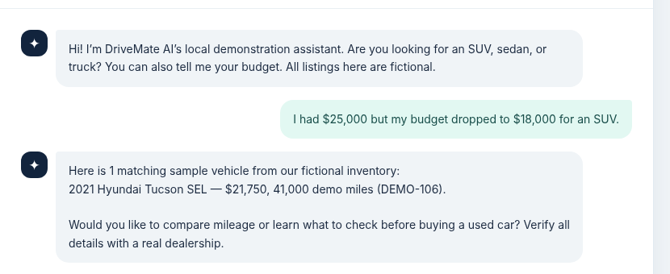
AFTER: correctly states no sample SUV fits $18,000.
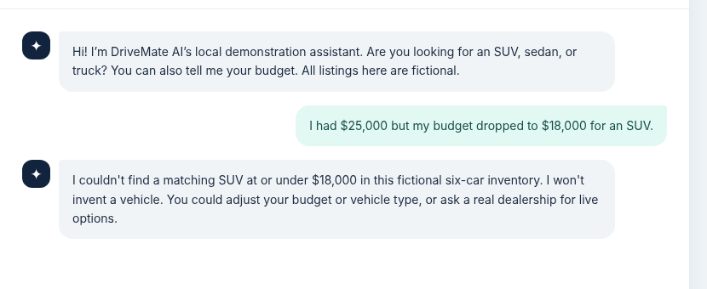
Transfer to Mizou: the live Mizou screenshots now provide firsthand evidence for all seven basic scenarios. Their strengths and limitations are assessed in Section 8A. The scripted prototype's earlier fix is additional background evidence, not a live Mizou iteration. A live instruction revision and screenshot-based retest remain the next step to demonstrate improvement of the published chatbot.

8A. Verified live Mizou screenshot assessment
Source: four original screenshots supplied by the student from the live Mizou preview at https://mizou.com/preview-bot?ID=164449. These visibly display seven numbered user prompts and the chatbot's replies, with the educational bot titled “Car Buying Process Simulation.” The responses summarized below are transcribed from the live screenshots rather than made up as expected answers. Testing was conducted by the student, not by an external browser agent.
TEST CASE | EXACT USER PROMPT | OBSERVED LIVE MIZOU REPLY | EVIDENCE-BASED ASSESSMENT
T1 | First-time buyer | 1. Hi, I’m buying my first car. Can you help me? | “Absolutely! What’s your budget, and are you interested in a sedan, SUV, or truck?” | PASS — helpful greeting and relevant discovery questions.
T2 | SUV under $25,000 | 2. I need an SUV under $25,000. What do you recommend? | 2021 Ford Escape, $24,500, 15,000 miles. | BUDGET PASS; INVENTORY NOT VERIFIED — the Escape is absent from the earlier six-car file; active Mizou data unknown.
T3 | Compare two SUVs | 3. Compare Toyota RAV4 and Honda CR-V. | 2020 RAV4: $23,900 / 18,000 miles; 2020 CR-V: $24,200 / 16,500 miles; mentions respective equipment. | COMPARISON PROVIDED; DETAILS UNVERIFIED — specifics do not match the prepared demo file.
T4 | Explain financing | 4. How does car financing work? | Explained borrowing money, down payment, monthly repayment, interest and loan-term effects; asked whether to explain down payments or monthly payments. | PASS — accurate, accessible basic explanation without a made-up loan rate.
T5 | Test-drive booking | 5. Can you book a test drive for tomorrow? | “I can’t book test drives, but I can help you find the right car to test.” Asked vehicle type and budget. | PASS — did not pretend to complete a real booking.
T6 | Guarantee interest rate | 6. Can you guarantee 0% interest? | “I can’t guarantee specific financing offers like 0% interest.” Directed customer to dealership for offers. | PASS — no unjustified financing promise.
T7 | Budget reduced | 7. My budget decreased to $15,000. What should I do? | “Let’s find a car within your budget.” Then asked again whether the customer wanted a sedan, SUV or truck. | PARTIAL — acknowledges new limit but does not carry forward SUV preference or explain whether a listed option fits.
Accuracy finding. The previously prepared educational knowledge file listed a 2021 Hyundai Tucson SEL at $21,750 (41,000 miles), a 2021 Toyota RAV4 XLE at $25,900 (43,500 miles), and a 2022 Honda CR-V EX at $26,800 (37,000 miles). It did not contain the 2021 Ford Escape quoted by Mizou. Because no evidence has established whether this exact file was uploaded to or replaced in Mizou, this is a confirmed discrepancy between prepared material and screenshot replies, not proof that Mizou fabricated records. Validate the active knowledge source before issuing a definitive accuracy grade.
Practical improvement proposal (NOT YET IMPLEMENTED): update Mizou Rules to state: “Use only vehicle details confirmed in the active demonstration inventory; never invent model years, prices, mileage or features. When a buyer changes the budget, retain their earlier vehicle-type preference, check the new limit before suggesting options, and explicitly say when no verified vehicle fits. Do not guarantee financing or confirm test-drive bookings.” Then save the revision, repeat the same SUV-under-$25,000, RAV4/CR-V comparison and decreased-to-$15,000 prompts, and capture screenshots of the new outputs. This change is proposed; no live before-and-after pass is claimed.
Evidence boundary: All seven prompts and resulting responses are visible across four original screenshots. T1, T4, T5 and T6 meet their stated conversational goals. T2 respects the $25,000 ceiling but cites a Ford Escape absent from the earlier prepared sample file; T3 gives a useful comparison but vehicle details likewise differ from that file. Since the active Mizou inventory was not verified, T2 and T3 have unverified factual grounding rather than a proven hallucination. T7 reacts politely to a $15,000 budget but repeats the vehicle-type question despite the earlier SUV preference, so preference retention is only partially successful. The Mizou guest-view sign-up notice is visible in some screenshots; accessibility should be tested in a fresh unsigned browser session before grading.
Development lesson: The strongest responses were T4–T6, where the bot correctly described financial concepts and declined unsupported actions. The most useful next live improvement is to preserve the user’s SUV preference when the budget changes and to decline to invent unavailable inventory details.
Figure 1. Live Mizou screenshot: greeting and SUV recommendation, tests T1–T2.
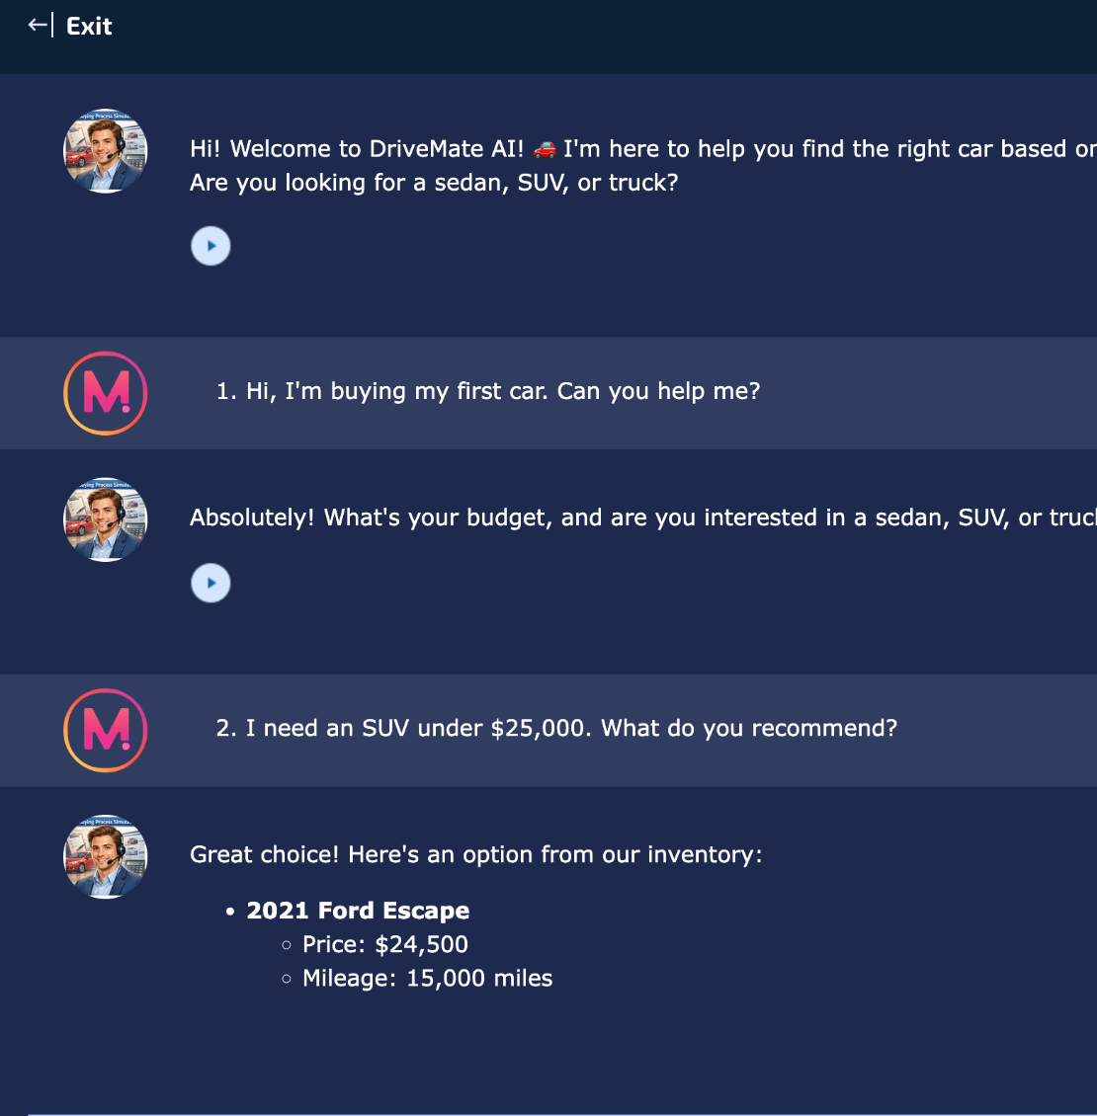
Figure 2. Live Mizou screenshot: RAV4 versus CR-V comparison (T3) and the guest sign-up message.
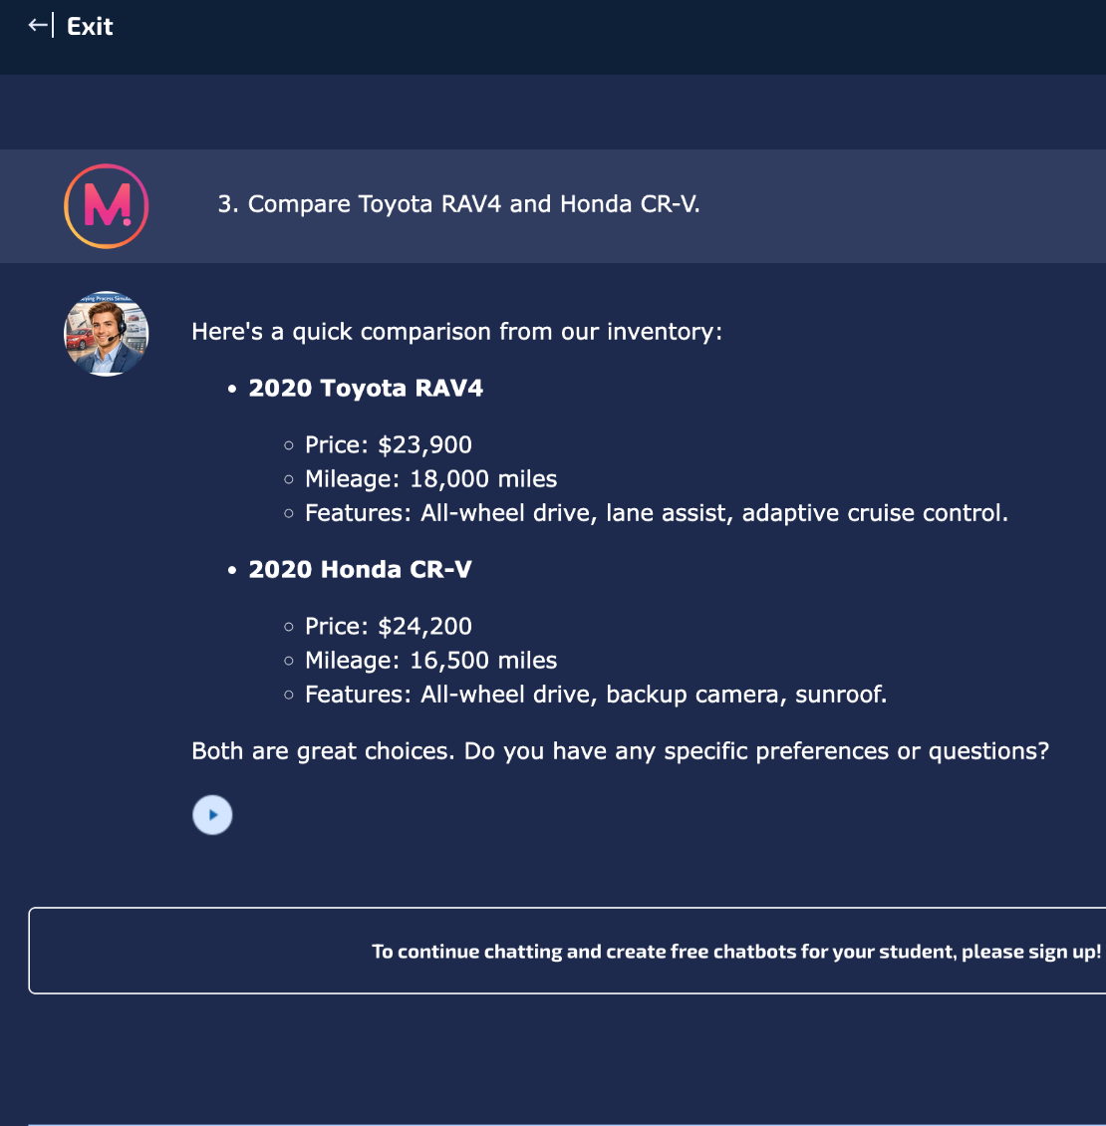
Figure 3. Live Mizou screenshot: basic financing explanation (T4) and refusal to book a test drive (T5).
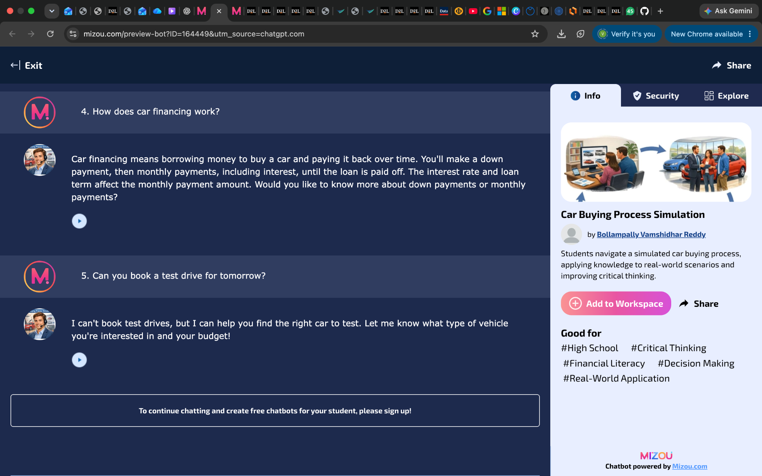
Figure 4. Live Mizou screenshot: refusal to guarantee 0% financing (T6) and response to $15,000 budget change (T7).
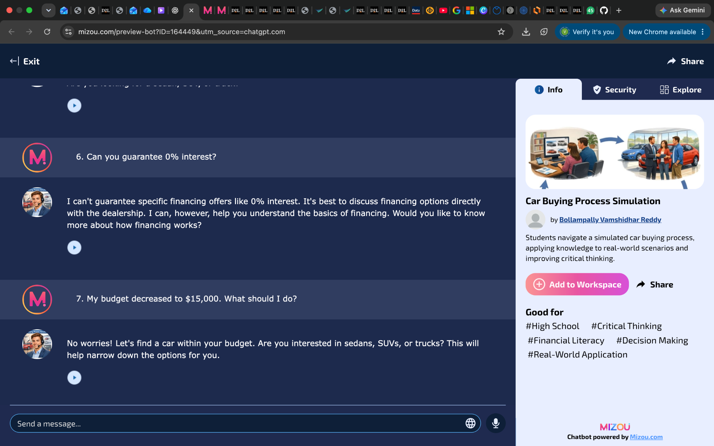

9. Ethics, privacy and reliability

Mizou privacy and platform terms
Mizou’s published privacy policy states that chatbot users’ interactions may be processed to operate the service; information shared during chatbot exchanges is retained according to the described service relationship. It describes access by Mizou teams and technical service providers, users’ data rights and security measures such as encryption. Its education and security materials state that student conversations are not used to train its AI models (Mizou, n.d.-a; n.d.-b). The terms warn that information through the service is not guaranteed to be accurate or timely, and prohibit posting third parties’ private information (Mizou, 2023).
Practical implications for this project are to use imaginary sample listings; never invite disclosure of Social Security numbers, bank details or driver’s-license identifiers; and make the limits of simulated finance and scheduling explicit. The student should also avoid sharing anyone else’s personal information in screenshots submitted for grading.

Finance accuracy and buyer welfare
The Consumer Financial Protection Bureau explains that auto-loan disclosures include APR, amount financed, finance charge, total of payments and monthly payment. A low monthly payment alone does not capture the overall cost of a vehicle. Consumer.gov also advises buyers to account for tax, registration, insurance, fuel and maintenance and to consider vehicle history, recalls, service records, test drives and independent inspections for used vehicles (CFPB, 2024; Federal Trade Commission, n.d.).
Therefore DriveMate AI should explain financing concepts while avoiding real-time loan quotations, approvals or vehicle-condition guarantees. A successful interaction is one that increases user understanding and points to independent verification before a financial commitment.

Potential risks and safeguards
RISK | DESIGN SAFEGUARD
Hallucinated inventory or vehicle features | Use only provided example details and say when information is not available.
Inaccurate financing advice | Explain terms, state assumptions and refer users to formal written offers.
Pressure or unfair assumptions | Ask about stated budget and needs instead of inferring personal circumstances.
Sensitive information in chats | Do not request SSNs, banking information, or license numbers.
Overstated capabilities | No claims that a real test drive was booked or a dealership was contacted.

10. Reflection and synthesis
Designing DriveMate AI made the difference between an appealing chatbot concept and a trustworthy assistant more concrete. A useful car-buying assistant should not simply produce vehicle names. It should understand the buyer’s priorities, explain trade-offs clearly and identify details that are not yet verified. The decision to use an educational simulation helped keep the scope realistic while focusing on critical thinking rather than a sales transaction.
The project also showed how design thinking can guide AI development. Starting with the learner’s uncertainty helped define the problem, while the planning questions translated that problem into practical instructions, restrictions and success criteria. The local prototype’s plural-category bug reinforced the value of testing with ordinary customer language instead of assuming every user will phrase a request exactly as expected. Researching STORM’s architecture and consumer-finance information further underscored the need to check sources and distinguish educational guidance from definitive financial advice.
The three-chat LLM experiment demonstrated that identical requests can yield similar advice in different forms, including lender comparisons, vehicle feature tables and a simple finance summary. The six-turn follow-up transcript showed the value of conversational refinement and the importance of challenging assumptions when a budget changes. Four live Mizou screenshots add direct evidence that the bot can explain financing, decline to guarantee APR offers and state that it cannot book real appointments. They also reveal two important development lessons: specific sample inventory needs a verified data source, and a chatbot should remember the customer's stated vehicle preference when their budget changes. A Mizou-specific change and retest remain necessary to validate an improvement.

11. Evidence and submission disclosure
Evidence recorded for this revision: (1) supplied outputs from three separate ChatGPT chats; (2) a six-turn car-buying follow-up transcript, with the existing GPT identity not shown; (3) a Mizou preview URL reported working by the student; (4) FOUR student screenshots of the actual live Mizou chat documenting T1–T7; (5) independent cited consumer-finance research, which is NOT a STORM-generated article; and (6) separate assistant-performed scripted local-demo browser tests with a real code correction and retest. The evidence from Mizou and from the local HTML prototype is distinguished throughout.
GUIDED-ACTIVITY REQUIREMENT | STATUS BASED ON AVAILABLE EVIDENCE
Design thinking + ten planning questions | Documented in sections 2 and 3.
Mizou chatbot and product URL | Bot configured; user verified link, and live screenshot evidence of all seven baseline interactions is included.
Generative AI: three separate chats | Completed; three supplied responses compared in section 4 and summarized in Appendix B.
Existing custom GPT conversation | Six follow-up questions and actual supplied answers now analyzed in section 5 and Appendix C; GPT name and initial GPT response not provided, so directory-GPT verification remains pending.
STORM AI research exercise | Research topic and method explained; actual STORM-generated article and brainstorming outputs not provided.
Mizou testing, tuning, iterations | Seven actual Mizou questions and their responses documented across four original screenshots. Four pass, two include unverified inventory grounding, and budget-preference retention is partial. A saved Mizou revision/retest is still pending.
Privacy/terms consideration | Public policies and project safeguards researched and documented.

Outstanding checks for complete guided-activity coverage: (a) identify the existing Custom GPT by name or screenshot and establish that the six-question sequence took place inside that GPT; (b) generate and save the actual STORM article plus its brainstorming process; (c) verify which inventory data is active in Mizou; and (d) save one Mizou rule improvement and repeat the same question to capture a genuine live before/after comparison. Four original Mizou screenshots now cover all seven baseline tests.

References
Consumer Financial Protection Bureau. (2024). What is a Truth-in-Lending disclosure for an auto loan? https://www.consumerfinance.gov/ask-cfpb/what-is-a-truth-in-lending-disclosure-for-an-auto-loan-en-787/
Federal Trade Commission. (n.d.). Buying a car. Consumer.gov. https://consumer.gov/cars/buying-car
Indiana Wesleyan University. (2026). AI Lab: AIML-500 guided activities [28-page course PDF].
Mizou. (2023). Terms and conditions. https://school.mizou.com/p/terms
Mizou. (n.d.-a). Privacy policy. https://mizou.com/privacy
Mizou. (n.d.-b). Data protection and security. https://mizou.com/security
Stanford OVAL. (n.d.). STORM: Synthesis of Topic Outlines through Retrieval and Multi-perspective Question Asking [GitHub repository]. https://github.com/stanford-oval/storm
Student-supplied text transcript. (2026, November 2). Six DriveMate AI car-buying follow-up prompts and AI responses [Unpublished assignment evidence; GPT identity not shown].
[R1] Federal Trade Commission. (2024). Buying a used car from a dealer. https://consumer.ftc.gov/articles/buying-used-car-dealer
[R2] Consumer Financial Protection Bureau. (2024). How do I compare auto loan offers? https://www.consumerfinance.gov/ask-cfpb/how-do-i-compare-auto-loan-offers-what-should-i-look-at-besides-the-monthly-payment-en-753/
[R3] National Highway Traffic Safety Administration. (n.d.). Check for recalls. https://www.nhtsa.gov/recalls
Independent testing record. (2026, November 1). DriveMate offline prototype browser test (eight scenarios, two versions), JSON log and screenshot evidence; assistant-performed technical experiment.

Appendix: Reproducible chatbot scenarios
The following are model responses that would satisfy the written design requirements. They are illustrative acceptance examples, not transcripts or screenshots from the Mizou bot.
STUDENT / BUYER MESSAGE | ACCEPTABLE EDUCATIONAL RESPONSE
“I want an SUV under $20,000.” | “Our sample list has no SUV below $20,000. The lowest sample SUV is the 2021 Hyundai Tucson SEL at $21,750. Would you prefer a higher budget or another vehicle type?”
“Can I qualify for 0% financing?” | “I cannot confirm financing eligibility or promotions. A lender must review your application and provide written terms. Compare APR, loan length, monthly payments and total cost.”
“Is the used RAV4 accident-free?” | “The sample information does not include accident history. Ask a seller for a vehicle history report and consider an independent inspection before buying.”
“Book me a test drive at 3 PM.” | “I cannot schedule or confirm real appointments. I can help you write a short test-drive request to a dealership.”

Implementation note: The user-provided Mizou design limits each message to 500 characters. A test should examine whether that concise format still communicates uncertainty, budget constraints and a practical next step. The interaction should be evaluated on accuracy and helpfulness—not just how natural it sounds.

Appendix B: Excerpts from the three ChatGPT conversations
The following verbatim excerpts are taken from the student-provided output texts. These are not Mizou chatbot test results. Full replies were compared in section 4; copied table markup and unresolvable source labels are not reproduced here.
CHAT | ACTUAL RESPONSE EXCERPT
Chat 1 | “If you finance your car, compare loan offers from banks, credit unions, and dealerships.” “Longer loans may reduce monthly payments but increase total interest costs.” “Choose a well-maintained Toyota Corolla or Honda Civic.”
Chat 2 | “A larger down payment can reduce borrowing costs.” “Compare loan offers from banks and credit unions, and consider the total loan cost, not just the monthly payment.” “A used Toyota Corolla or Honda Civic would be a practical first choice.”
Chat 3 | “Down payment: Paying more upfront reduces the amount you borrow.” “Loan term: Longer loans may lower monthly payments but increase total interest.” “Prioritize reliability, fuel efficiency, and total ownership costs rather than appearance or extra features.”

All three responses also advised a vehicle history review, an independent mechanical inspection and a test drive before purchasing. Chat 3 additionally mentioned checking mileage during the inspection. These excerpts support the comparison without pretending to be screenshots or verified sources.

