Lab_Assignment_2.1
2303A51868
Batch-28
Task 1:
#prompt: “Write a Python function that takes a list of numerical survey responses and calculates the mean, minimum, and maximum values. Also show sample output.”
Code:
def statistical_summary(data):
total = sum(data)
mean = total / len(data)
minimum = min(data)
maximum = max(data)
return mean, minimum, maximum
# Sample data
survey_data = [12, 45, 23, 67, 34, 89, 10]
mean, minimum, maximum = statistical_summary(survey_data)
print("Mean:", mean)
print("Minimum:", minimum)
print("Maximum:", maximum)
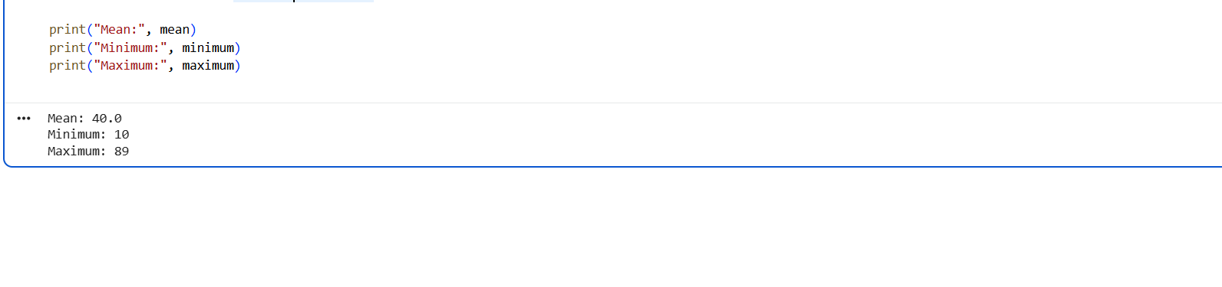
Explanation: The statistical_summary() function takes a list of numerical survey responses and computes basic statistics.
It calculates the mean by dividing the total sum of values by the number of elements.
The function also finds the minimum and maximum values and returns all three results for display.
Task 2:
# prompt : Write a program to check whether a given number is an Armstrong number or not.
#code:
def is_armstrong_number(num):
# Convert the number to string to easily iterate over digits
str_num = str(num)
num_digits = len(str_num)
# Calculate the sum of the cubes of each digit
sum_of_cubes = sum(int(digit) ** num_digits for digit in str_num)
# Check if the sum of cubes is equal to the original number
return sum_of_cubes == num
# Test the function
number = int(input("Enter a number: "))
if is_armstrong_number(number):
print(f"{number} is an Armstrong number.")
else:
print(f"{number} is not an Armstrong number.")

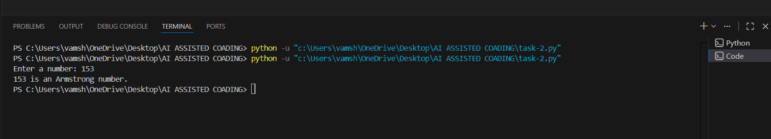
Explanation: The function converts the given number into a string to easily access each digit and counts the total number of digits.
Each digit is raised to the power of the number of digits and summed to calculate the Armstrong value.
If this calculated sum equals the original number, the function confirms it as an Armstrong number.

Task 3: Cursor AI
#prompt: Generate a Python program that checks whether a given year is a leap year.
#code:
def is_leap_year(year):
if year % 4 == 0:
if year % 100 == 0:
if year % 400 == 0:
return True
else:
return False
else:
return True
else:
return False

year = int(input("Enter a year: "))
if is_leap_year(year):
print(f"{year} is a leap year.")
else:
print(f"{year} is not a leap year.")

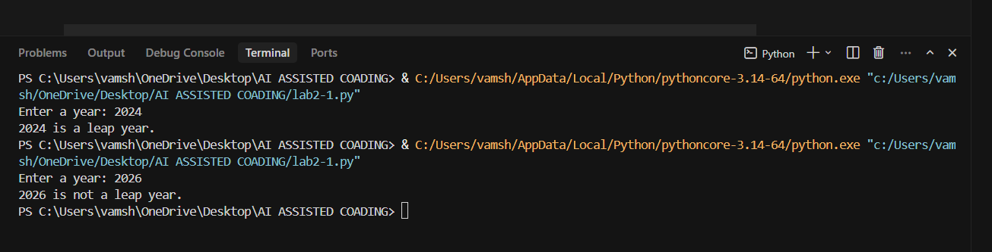
Explanation: The function checks if a year is divisible by 4, which is the first condition for a leap year.
If the year is divisible by 100, it must also be divisible by 400 to qualify as a leap year.
The function returns True if all conditions are met, otherwise False, and prints the result accordingly.

Task 4:
# prompt: Write a Python program that calculates the sum of odd and even numbersin a tuple, then refactor
Code:
def sum_odd_even(numbers):
sum_odd = 0
sum_even = 0

for num in numbers:
if num % 2 == 0:
sum_even += num
else:
sum_odd += num

return sum_odd, sum_even
# Test the function
numbers = (1, 2, 3, 4, 5, 6)
odd_sum, even_sum = sum_odd_even(numbers)
print(f"Sum of odd numbers: {odd_sum}")
print(f"Sum of even numbers: {even_sum}")
# Refactored version using list comprehensions
def sum_odd_even_refactored(numbers):
sum_odd = sum(num for num in numbers if num % 2 != 0)
sum_even = sum(num for num in numbers if num % 2 == 0)
return sum_odd, sum_even
# Test the refactored function
odd_sum_ref, even_sum_ref = sum_odd_even_refactored(numbers)
print(f"Refactored - Sum of odd numbers: {odd_sum_ref}")
print(f"Refactored - Sum of even numbers: {even_sum_ref}")
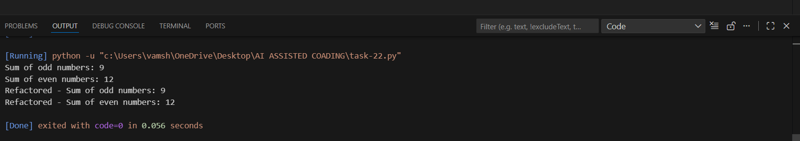
Explanation: The function separates numbers into odd and even by checking the remainder when divided by 2 and sums them separately.
It returns the sum of odd and even numbers, which are then printed for verification.
The refactored version uses list comprehensions to calculate the sums more concisely while producing the same results.

