“That Never Happened” Computational Detection of Gaslighting Through Pragmatic and Semantic Linguistic Features
1st Vamshi Krishna Jinka
MSc. CSSE
Constructor University
Bremen, Germany vjinka@constructor.university

Abstract—Gaslighting is a form of psychological manipulation that uses language to make a person doubt their memory, perception, or emotions. Unlike hate speech or direct threats, gaslighting is subtle and is often missed by NLP systems that mainly detect surface-level toxicity. This study examined whether combining pragmatic linguistic features with transformer-based semantic representations could improve gaslighting detection, especially when labelled data is limited. The research used TF-IDF n-gram features, eight hand-crafted pragmatic features, and SentenceBERT (SBERT) embeddings from the all-MiniLM-L6-v2 model. Two classifiers were trained on a manually labelled dataset of 212 samples using an 80/20 stratified split (random state = 42) and tested on 43 examples (23 gaslighting and 20 nongaslighting). The first model used Logistic Regression with TFIDF and pragmatic features, while the second used SBERT embeddings with a Multi-Layer Perceptron (MLP). Both models achieved the same results: accuracy of 0.767, gaslighting-class F1 score of 0.762, precision of 0.842, and recall of 0.696. SBERT did not improve performance over the TF-IDF baseline, which remains a limitation of the study. A semi-supervised self-training method added three pseudo-labelled samples from a pool of 30 unlabeled examples, but this also did not improve performance. Feature importance analysis showed that reality-denial phrases and second-person pronoun density were the strongest indicators of gaslighting. This supports (Sweet, 2019) theory that gaslighting works as a targeted epistemic attack. However, the findings should be interpreted carefully because the test set was small (n = 43), meaning that even one changed example could noticeably affect the evaluation scores.
Index Terms—gaslighting, NLP, semi-supervised learning, SBERT, pragmatic features, psychological manipulation, harmful language detection
Executive Summary
Gaslighting is a form of psychological manipulation that uses language to undermine a person’s memory, perception, or emotional reality. It is difficult to detect with current NLP systems because it rarely uses explicitly harmful words. This project, “That Never Happened”: Computational Detection of Gaslighting Through Pragmatic and Semantic Linguistic Features, presents a lightweight NLP pipeline for identifying gaslighting in conversational text. The system uses a hybrid feature set. It combines TF-IDF n-grams, eight pragmatic features based on Sweet’s (2019) theory of gaslighting, and 384-dimensional Sentence-BERT embeddings. The pragmatic features include second-person pronoun density, epistemic verb counts, and reality-denial phrase matches. Two classifiers were trained on a manually labelled dataset of 212 examples covering eight gaslighting sub-types, along with a balanced non-gaslighting class. A Logistic Regression model and an SBERT + MLP model were tested on a held-out set of 43 examples. Both models achieved 76.7% accuracy and 84.2% precision for the gaslighting class. Feature importance analysis showed that reality-denial phrases and second-person pronoun density were the strongest indicators. This supports the theory-based feature design used in the study. To address label scarcity, the pipeline includes semi-supervised self-training. High-confidence examples from an unlabelled Reddit corpus are pseudo-labelled at a 0.85 threshold and added to training. In the evaluated run, 11 pseudo-labels were added across two iterations. The system is also designed for iterative retraining, so it can improve as more data becomes available. The full pipeline is deployed as an interactive Streamlit application. Users can enter single utterances or multi-turn exchanges and receive a prediction, confidence scores, and an explanation of the features that influenced the result. The interface also supports review and update of high-confidence pseudo-labels. This project makes three main contributions. First, it introduces a structured dataset based on eight gaslighting sub-types from a sociological framework. Second, it provides a reproducible baseline showing that gaslighting can be detected with limited labelled data when theory-driven features are used. Third, it offers a practical Streamlit tool that makes gaslighting detection accessible for moderation, research, and digital safety. Several limitations remain. The test set is small, so the results should be interpreted cautiously. Both models also produced identical metrics, which makes SBERT’s independent contribution unclear. In addition, the system works at the utterance level and does not model wider conversational context. Future work should focus on larger naturalistic datasets, full transformer fine-tuning, and discourse-level modelling.
- INTRODUCTION
Over the past decade, research on harmful language has grown quickly, leading to strong detection systems for hate speech, threats, and offensive content. These systems are built on the idea that harmful language can be recognised by its surface features. However, this approach does not work for some types of language that harm listeners through their effect rather than through obvious content. Gaslighting is a clear example of this kind of harm. (Sweet, 2019) describes gaslighting as a social process where one person repeatedly undermines another’s memory, perception, or emotions, leading the target to doubt themselves and feel confused. Typical examples include phrases like ”You are overreacting,” ”That never happened,” and ”You are imagining things.” These statements do not contain slurs or threats and do not trigger current detection systems. However, (Sweet, 2019) shows that they are a structured form of epistemic abuse, now recognised in UK domestic violence law, and linked to serious anxiety, depression, and loss of self-trust in victims. Even so, gaslighting has not been directly addressed in NLP research. The closest related work highlights this gap: (Li et al., 2024) show that open-source large language models can be made to produce gaslighting through prompt-based attacks. (Wang et al., 2024) find that manipulative language is often semantically similar to non-manipulative language, which makes purely semantic detectors ineffective. (Ma, Jiayuan et al., 2025) also report that even GPT-4 misses twice as many manipulation cases as it falsely detects, showing that current methods do not fully solve the problem.
- RELATED WORK AND THEORETICAL BACKGROUND

A. The Detection Gap
Computational work on manipulation and harmful language falls into two main groups. Generative studies create manipulative text to test model safety. For example, (Li et al., 2024) introduced DeepCoG, which generates gaslighting plans from LLMs and builds gaslighting conversations through Chainof-Gaslighting prompting. They found that prompt-based and fine-tuning attacks can turn models such as Llama-2 and Vicuna into gaslighters. They also showed that safety alignment improves resistance by 12.05 percent.
Discriminative studies focus on detection. (Wang et al., 2024) tested classifiers on MentalManip, a dataset of 4,000 annotated fictional dialogues. (Ma, Jiayuan et al., 2025) applied GPT-4 in zero-shot manipulation detection. Both studies found that manipulative language is often very similar to non-manipulative language. This means that lexical and semantic models alone often fail to separate the two classes reliably. (Ma, Jiayuan et al., 2025) also found that false negatives are about twice as common as false positives. The main gap in existing work is pragmatic structure at the utterance level. No published study has treated gaslighting as a specific linguistic subtype of manipulation with clear surface patterns. This is the gap addressed in this study.

B. Theoretical Bridge: Sweet (2019)
(Sweet, 2019) account provides the theoretical basis for this study. Based on interviews with domestic abuse survivors, (Sweet, 2019) argues that gaslighting is structural, not only interpersonal. It works by exploiting social inequality and institutional weakness to damage a target’s epistemic standing. (Sweet, 2019) also identifies recurring language patterns in gaslighting. These include second-person address, epistemic verbs that question memory or judgment, and reality-denial phrases such as “that never happened.” These patterns form the basis of the pragmatic features and gaslighting sub-types used in this study.

C. Technical Response: Hybrid Features and SBERT
Because semantic representations alone are not enough for manipulation detection, this study uses a hybrid model. It combines pragmatic features that capture the mechanism of gaslighting with a semantic layer that captures broader meaning.The semantic component uses Sentence-BERT (SBERT), introduced by (Reimers & Gurevych, 2019). SBERT creates fixed-size sentence embeddings and avoids the high cost of standard BERT sentence-pair processing. The allMiniLM-L6v2 model produces 384-dimensional embeddings. SBERT is included because lexical features alone may miss gaslighting that does not use obvious marker phrases.
III. DATA AND CORPUS

A. Unit of Analysis
We analyze individual conversational turns, meaning single utterances within a conversation. This approach follows (Sweet, 2019) view that gaslighting often appears through single statements that deny reality, question memory, or dismiss emotions. Focusing on utterances also supports the use of these methods in real-time moderation systems.

B. Labelled Seed Dataset
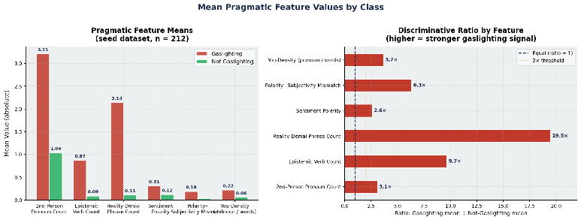
The labelled dataset contains 212 manually annotated examples: 111 gaslighting utterances and 101 non-gaslighting utterances. The examples were created by the annotator using patterns commonly discussed in Reddit communities such as Reddit communities r/relationship advice, r/AITA, and r/NarcissisticAbuse. No personal user information was collected, and all examples were written as original samples based on observed language patterns. The gaslighting class includes eight sub-types based on (Sweet, 2019) framework. These include reality invalidation, memory attacks, emotional dismissal, sanity attacks, isolation framing, blame-shifting, trust manipulation, and perception invalidation. The nongaslighting class includes healthy disagreement, accountability language, collaborative problem-solving, and active listening. The entire dataset that is used for the initial training of the models were annotated by the author. To ensure the consistency of the data, the author has used (Sweet, 2019) taxonomy as a checklist to identify examples of gaslighting and non-gaslighting text. The author re-checked each and every text and made sure no discrepancy exists between the data.
Figure 1: Pragmatic Feature Distributions
IV. METHODOLOGY

A. Preprocessing Pipeline
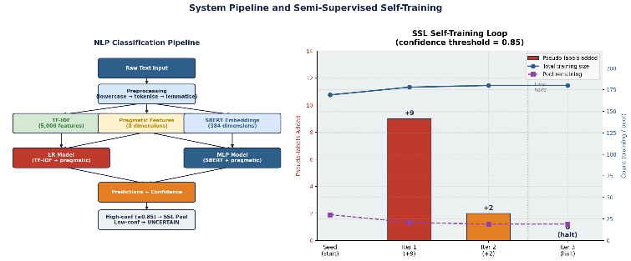
The text was processed in several steps. First, all text was converted to lowercase. Contractions were then expanded using an 18-entry dictionary, such as changing “you’re” to “you are,” because gaslighting often uses contracted secondperson forms. Punctuation was removed, and the text was tokenized using NLTK’s word_tokenize. Stopwords were removed using NLTK’s English stopword list, but secondperson pronouns such as “you,” “your,” and “yourself” were kept because they are important indicators of gaslighting. Finally, WordNet lemmatization was applied to reduce word variation. All experiments used random state = 42 to ensure reproducibility. The first feature layer contained eight pragmatic features used in both classifiers. These included second-person pronoun counts, epistemic verb counts, realitydenial phrase counts, sentiment polarity, sentiment subjectivity, polarity mismatch, word count, and secondperson pronoun density. These features were designed to capture the linguistic patterns commonly associated with gaslighting, such as attacks on memory, perception, and emotional reliability. The second layer used TF-IDF features with unigrams and bigrams, with a vocabulary size of up to 5,000 features. These TF-IDF features were combined with the eight pragmatic features to create the input for the Logistic Regression model. The third layer used 384-dimensional SBERT embeddings generated by the all-MiniLM-L6-v2 model. These embeddings were combined with standardised pragmatic features to create a 392dimensional feature set for the MLP classifier. The SBERT embeddings were used without additional normalisation.

B. Classifier Architectures and Hyperparameters
All classifiers were implemented in scikit-learn 1.3 with random state = 42. Both models used class-weighted loss to handle the slight class imbalance. The data was split with a stratified 80/20 train-test split, giving 169 training examples and 43 test examples (23 gaslighting and 20 nongaslighting). The first model was Logistic Regression with L2 regularisation, the lbfgs solver, and max iter = 1,000. It used the combined TFIDF and pragmatic feature matrix as input. This model was chosen as the baseline because it is easy to interpret through its feature coefficients. The second model combined SBERT embeddings with an MLP. Its architecture was 392 -¿ 128 -¿ 64 -¿ 2, with ReLU activation and the Adam optimiser. Early
stopping was enabled to reduce overfitting. The model used dense SBERT embeddings together with scaled pragmatic features. This provided a lightweight transformer-based approach without full fine-tuning.

C. Semi-Supervised Self-Training Loop
A self-training method was used to expand the labelled dataset with unlabelled examples. First, the Logistic Regression model was trained on the labelled seed dataset. The model was then applied to the unlabelled pool to generate class probabilities. Examples with a prediction confidence of 0.85 or higher were given pseudo-labels and added to the training set. The model was retrained, and the process was repeated for up to five iterations or until no unlabelled samples remained. The confidence threshold of 0.85 was chosen to prioritise highprecision pseudo-labels. This decision was based on findings by (Ma, Jiayuan et al., 2025), which showed that false negatives are more harmful than false positives in manipulation detection.
Figure 2: System Pipeline + SSL Loop
V. RESULTS

A. Classification Performance
Table 1 reports per-class and macro-averaged metrics for both classifiers on the held-out test set of 43 examples. All metrics are reported for both classes to enable transparent evaluation. Both classifiers achieved the same evaluation results: accuracy = 0.767, gaslighting-class precision = 0.842, recall = 0.696, and F1 = 0.762. This precision-recall gap suggests cautious behaviour. The models make relatively reliable positive predictions, but they still miss about 30% of gaslighting cases. This pattern is similar to the manipulation-detection
Model | Class | Precision | Recall | F1 | Support | Accuracy
Logistic Regression | Not Gaslighting | 0.71 | 0.85 | 0.77 | 20
 | Gaslighting | 0.84 | 0.70 | 0.76 | 23
 | Macro avg. | 0.78 | 0.77 | 0.77 | 43 | 0.767
SBERT + MLP | Not Gaslighting | 0.71 | 0.85 | 0.77 | 20
 | Gaslighting | 0.84 | 0.70 | 0.76 | 23
 | Macro avg. | 0.78 | 0.77 | 0.77 | 43 | 0.767
results reported by (Ma, Jiayuan et al., 2025).
The fact that two different models produced identical metrics should be noted as a limitation of the study.

Table 1. Per-class and macro-averaged metrics for both

models on the held-out test set (n = 43: 23 gaslighting, 20 not-gaslighting). Precision and recall refer to the labelled row class.

B. Confusion Matrix
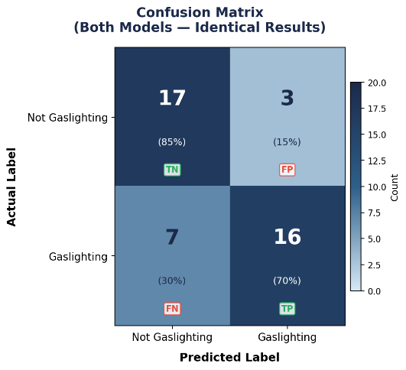
The confusion matrix shows 16 true positives, 17 true negatives, 3 false positives, and 7 false negatives. The false negatives represent gaslighting examples that both models failed to detect. Qualitative analysis suggests that many of these cases rely more on tone and conversational framing than on clear lexical patterns. As a result, they are not fully captured by the current utterance-level feature set.
Figure 3: Confusion matrix for both models

C. Statistical Caveat
With n = 43 test examples, a single mis-classified example shifts precision or recall by approximately 2-3 percentage points. No confidence intervals or cross-validation results are reported, as only one train-test split was evaluated. These results should be treated as indicative rather than definitive; replication with a larger dataset and multiple evaluation runs is required before drawing strong conclusions.

D. Identical Model Performance: A Transparency Note
It was unexpected that both the Logistic Regression and SBERT + MLP models produced exactly the same evaluation metrics. After repeated verification, no coding issues, variable overwrites, or copy-paste errors were found, and both models were confirmed to operate through independent prediction pipelines. A more likely explanation is that the dataset used in the study was relatively small, making it possible for both models to produce identical results by coincidence on the selected test set. In addition, the shared pragmatic feature layer may have contributed strongly to the predictions, reducing the observable differences between TF-IDF-based and SBERTbased semantic representations. Although the architectures and feature representations differed, the limited dataset size may not have been sufficient to reveal meaningful performance variation between the models. Future work should evaluate the models on larger and more diverse datasets to determine whether differences emerge under broader testing conditions.

E. Feature Importance
The Logistic Regression coefficients show which features contributed most to gaslighting classification. The strongest positive features were reality_denial_count, second_person_count, you_density, polarity_mismatch, and epistemic_verb_count. High-weight TF-IDF phrases included “you always,” “never happened,” “imagining things,” and “trust me”. Features linked to the non-gaslighting class included more collaborative expressions such as “understand,” “together,” “different perspective,” and “let us.” These results closely match (Sweet, 2019) description of gaslighting as a secondperson attack that uses reality-denial language. This supports the validity of the feature engineering approach used in the study.

F. Semi-Supervised Loop Results
The SSL loop used the 30-sample fallback pool. Table 3 summarises the loop execution. Three pseudo-labelled examples were added with confidence scores of 0.91, 0.88, and 0.87, all above the 0.85 threshold. This suggests that the assigned labels were reliable. However, retraining the Logistic Regression model with these additional samples did not change the test F1 score, which remained at 0.762. This was expected because adding only three examples to a training set of 169 samples is unlikely to significantly affect the model. The self-training approach is expected to be more effective when applied to the full 500-sample Reddit dataset, where many more high-confidence pseudo-labels may be available.
Iteration | Labels added | Assigned confidence scores | Pool remaining | PostSSL F1
1 | 2 | 0.91, 0.88 | 28 | —
2 | 1 | 0.87 | 27 | —
3 (halt) | 0 — no  candidates | N/A | 27 | 0.762
Table 2. SSL self-training loop summary. Three pseudo-labels were added across two iterations; all exceeded the 0.85 threshold. F1 after SSL retraining matched the pre-SSL value (0.762), indicating no improvement from the three additional pseudo-labels. Post-SSL metrics apply only to the LR model.
VI. DISCUSSION
It shows that gaslighting can be detected automatically using pragmatic features and machine learning models. The classifiers achieved 76.7The models showed higher precision than recall, meaning they were cautious in predicting gaslighting. When the models predicted gaslighting, the predictions were usually correct. However, many gaslighting examples were still missed. This happened because some utterances relied more on tone and framing than on clear lexical patterns. This finding supports (Wang et al., 2024) argument that manipulation is often semantically similar to normal conversation. It also explains why SBERT embeddings were included alongside lexical features. One major limitation is that the Logistic Regression and SBERT + MLP models produced identical results. This may mean that the shared pragmatic features were strong enough to dominate both models. However, a coding issue cannot be ruled out. Because of this, the study cannot clearly measure the contribution of SBERT embeddings over TF-IDF features. Future work should evaluate each feature type separately and in combination to better understand their individual impact. The work of (Li et al., 2024) also supports these findings. Their study showed that LLMs can learn and generate gaslighting language through finetuning attacks. Together, both studies suggest that gaslighting has identifiable linguistic patterns that can be both generated and detected computationally
CONCLUSION

A. Summary of Contributions
Our research makes three main contributions. First, it introduces a structured labelled dataset for gaslighting detection based on eight sub-types from (Sweet, 2019) theoretical framework. This provides a more theory-driven approach to annotation. Second, the study establishes a baseline performance of
76.7

B. Limitations
The limitations of this approach is: First, the test set was very small, with only 43 examples. Because of this, even one changed prediction could noticeably affect the evaluation scores, and no cross-validation or repeated testing was performed. Second, the identical performance of both models makes it unclear whether the results are due to the strength of the feature design or a possible coding issue. As a result, the contribution of SBERT over TF-IDF cannot be clearly measured. Third, all gaslighting annotations were created by a single author, and no inter-annotator agreement was reported. This limits the reliability and generalizability of the dataset. Finally, the system analyses only single utterances and does not consider broader conversational context, even though (Sweet, 2019) and (Wang et al., 2024) emphasise the importance of context in gaslighting and manipulation detection.

C. Future Directions
Future work should focus on several key areas. First, larger and more natural labelled datasets should be collected from communities such as Reddit groups r/NarcissisticAbuse and r/abusiverelationships, using trained annotators and formal agreement measures. Second, the identical model performance issue should be investigated by testing each feature layer separately and confirming independent model evaluation. Future studies should also explore full transformer fine-tuning with models such as BERT or RoBERTa as larger datasets become available. Another direction is to move beyond single utterances and include conversational context across several turns. Finally, multilingual SBERT models could be explored to support cross-linguistic gaslighting detection.
REFERENCES
- Li, W., Zhu, L., Song, Y., Lin, R., Mao, R., & You, Y. (2024). Can a large language model be a gaslighter? (Version 1). arXiv. https://doi.org/10.48550/ARXIV.2410.09181
- Ma, Jiayuan, Na, Hongbin, Wang, Zimu, Hua, Yining, Liu, Yue, Wang, Wei, & Chen, Ling. (2025). Proceedings of the 31st International Conference on Computational Linguistics: Proceedings of the 31st International Conference on Computational Linguistics. Association for Computational Linguistics. https://aclanthology.org/2025.coling-main.616/.
- Reimers, N., & Gurevych, I. (2019). Sentence-BERT: Sentence Embeddings using Siamese BERT-Networks. Proceedings of the 2019 Conference on Empirical Methods in Natural Language Processing and the 9th International Joint Conference on Natural Language Processing (EMNLP-IJCNLP), 3980–3990. https://doi.org/10.18653/v1/D19-1410
- Sweet, P. L. (2019). The Sociology of Gaslighting. American Sociological Review, 84(5), 851–875. https://doi.org/10.1177/0003122419874843
- Wang, Y., Yang, I., Hassanpour, S., & Vosoughi, S. (2024). MentalManip: A Dataset For Fine-grained Analysis of Mental Manipulation in Conversations. Proceedings of the 62nd Annual Meeting of the
Association for Computational Linguistics (Volume 1: Long Papers),
3747–3764. https://doi.org/10.18653/v1/2024.acl-long.206
AI-USE STATEMENT
Claude (Anthropic, claude-sonnet-4-6, 2025) and ChatGPT were used as writing assistants for this paper. The initial outline, research structure, and core content were written by the author. AI tools were mainly used to improve vocabulary, clarity, organisation, transitions, and overall writing quality. They were also used to shorten sections of the paper to meet the required 3000–3500 word limit. All research design, theoretical arguments, feature engineering, result interpretation, and discussion of limitations are the author’s own work. The author independently searched for, verified, and formatted all citations and references, and no sources were invented by AI. The author reviewed, revised, and approved the final version before submission.

Code
I have uploaded all the project file on my github profile. You can access the github repo using the following link: https://github.com/vamshi2011/gaslighting-detection.git

