Disposition of Participants
 | Placebo |  | Xanomeline Low Dose |  | Xanomeline High Dose
 | n | (%) | n | (%) | n | (%)
Participants in population | 86 |  | 84 |  | 84
Completed | 58 | 67.4 | 25 | 29.8 | 27 | 32.1
Discontinued | 28 | 32.6 | 59 | 70.2 | 57 | 67.9
Adverse Event | 8 | 9.3 | 44 | 52.4 | 40 | 47.6
Death | 2 | 2.3 | 1 | 1.2 | 0 | 0.0
I/E Not Met | 1 | 1.2 | 0 | 0.0 | 2 | 2.4
Lack of Efficacy | 3 | 3.5 | 0 | 0.0 | 1 | 1.2
Lost to Follow-up | 1 | 1.2 | 1 | 1.2 | 0 | 0.0
Physician Decision | 1 | 1.2 | 0 | 0.0 | 2 | 2.4
Protocol Violation | 1 | 1.2 | 1 | 1.2 | 1 | 1.2
Sponsor Decision | 2 | 2.3 | 2 | 2.4 | 3 | 3.6
Withdrew Consent | 9 | 10.5 | 10 | 11.9 | 8 | 9.5

ANCOVA of Change from Baseline Glucose (mmol/L) at Week 24
LOCF
Efficacy Analysis Population
 | Baseline |  | Week 24 |  | Change from Baseline
Treatment | N | Mean (SD) | N | Mean (SD) | N | Mean (SD) | LS Mean (95% CI)ª
Placebo | 79 | 5.7 ( 2.23) | 57 | 5.7 ( 1.83) | 57 | -0.1 ( 2.68) | 0.07 (-0.27, 0.41)
Xanomeline Low Dose | 79 | 5.4 ( 0.95) | 26 | 5.7 ( 1.26) | 26 | 0.2 ( 0.82) | -0.11 (-0.45, 0.23)
Xanomeline High Dose | 74 | 5.4 ( 1.37) | 30 | 6.0 ( 1.92) | 30 | 0.5 ( 1.94) | 0.40 ( 0.05, 0.75)
Pairwise Comparison |  |  | Difference in LS Mean (95% CI)ª |  |  |  | p-Value
Xanomeline Low Dose - Placebo |  |  | -0.17 (-0.65, 0.30) |  |  |  | 0.757
Xanomeline High Dose - Placebo |  |  | 0.33 (-0.16, 0.82) |  |  |  | 0.381
ªBased on an ANCOVA model after adjusting baseline value. LOCF approach is used to impute missing values.
ANCOVA = Analysis of Covariance, LOCF = Last Observation Carried Forward
CI = Confidence Interval, LS = Least Squares, SD = Standard Deviation

Kaplan-Meier Plot for Time to First Dermatologic Event by Treatment Group
All Participants
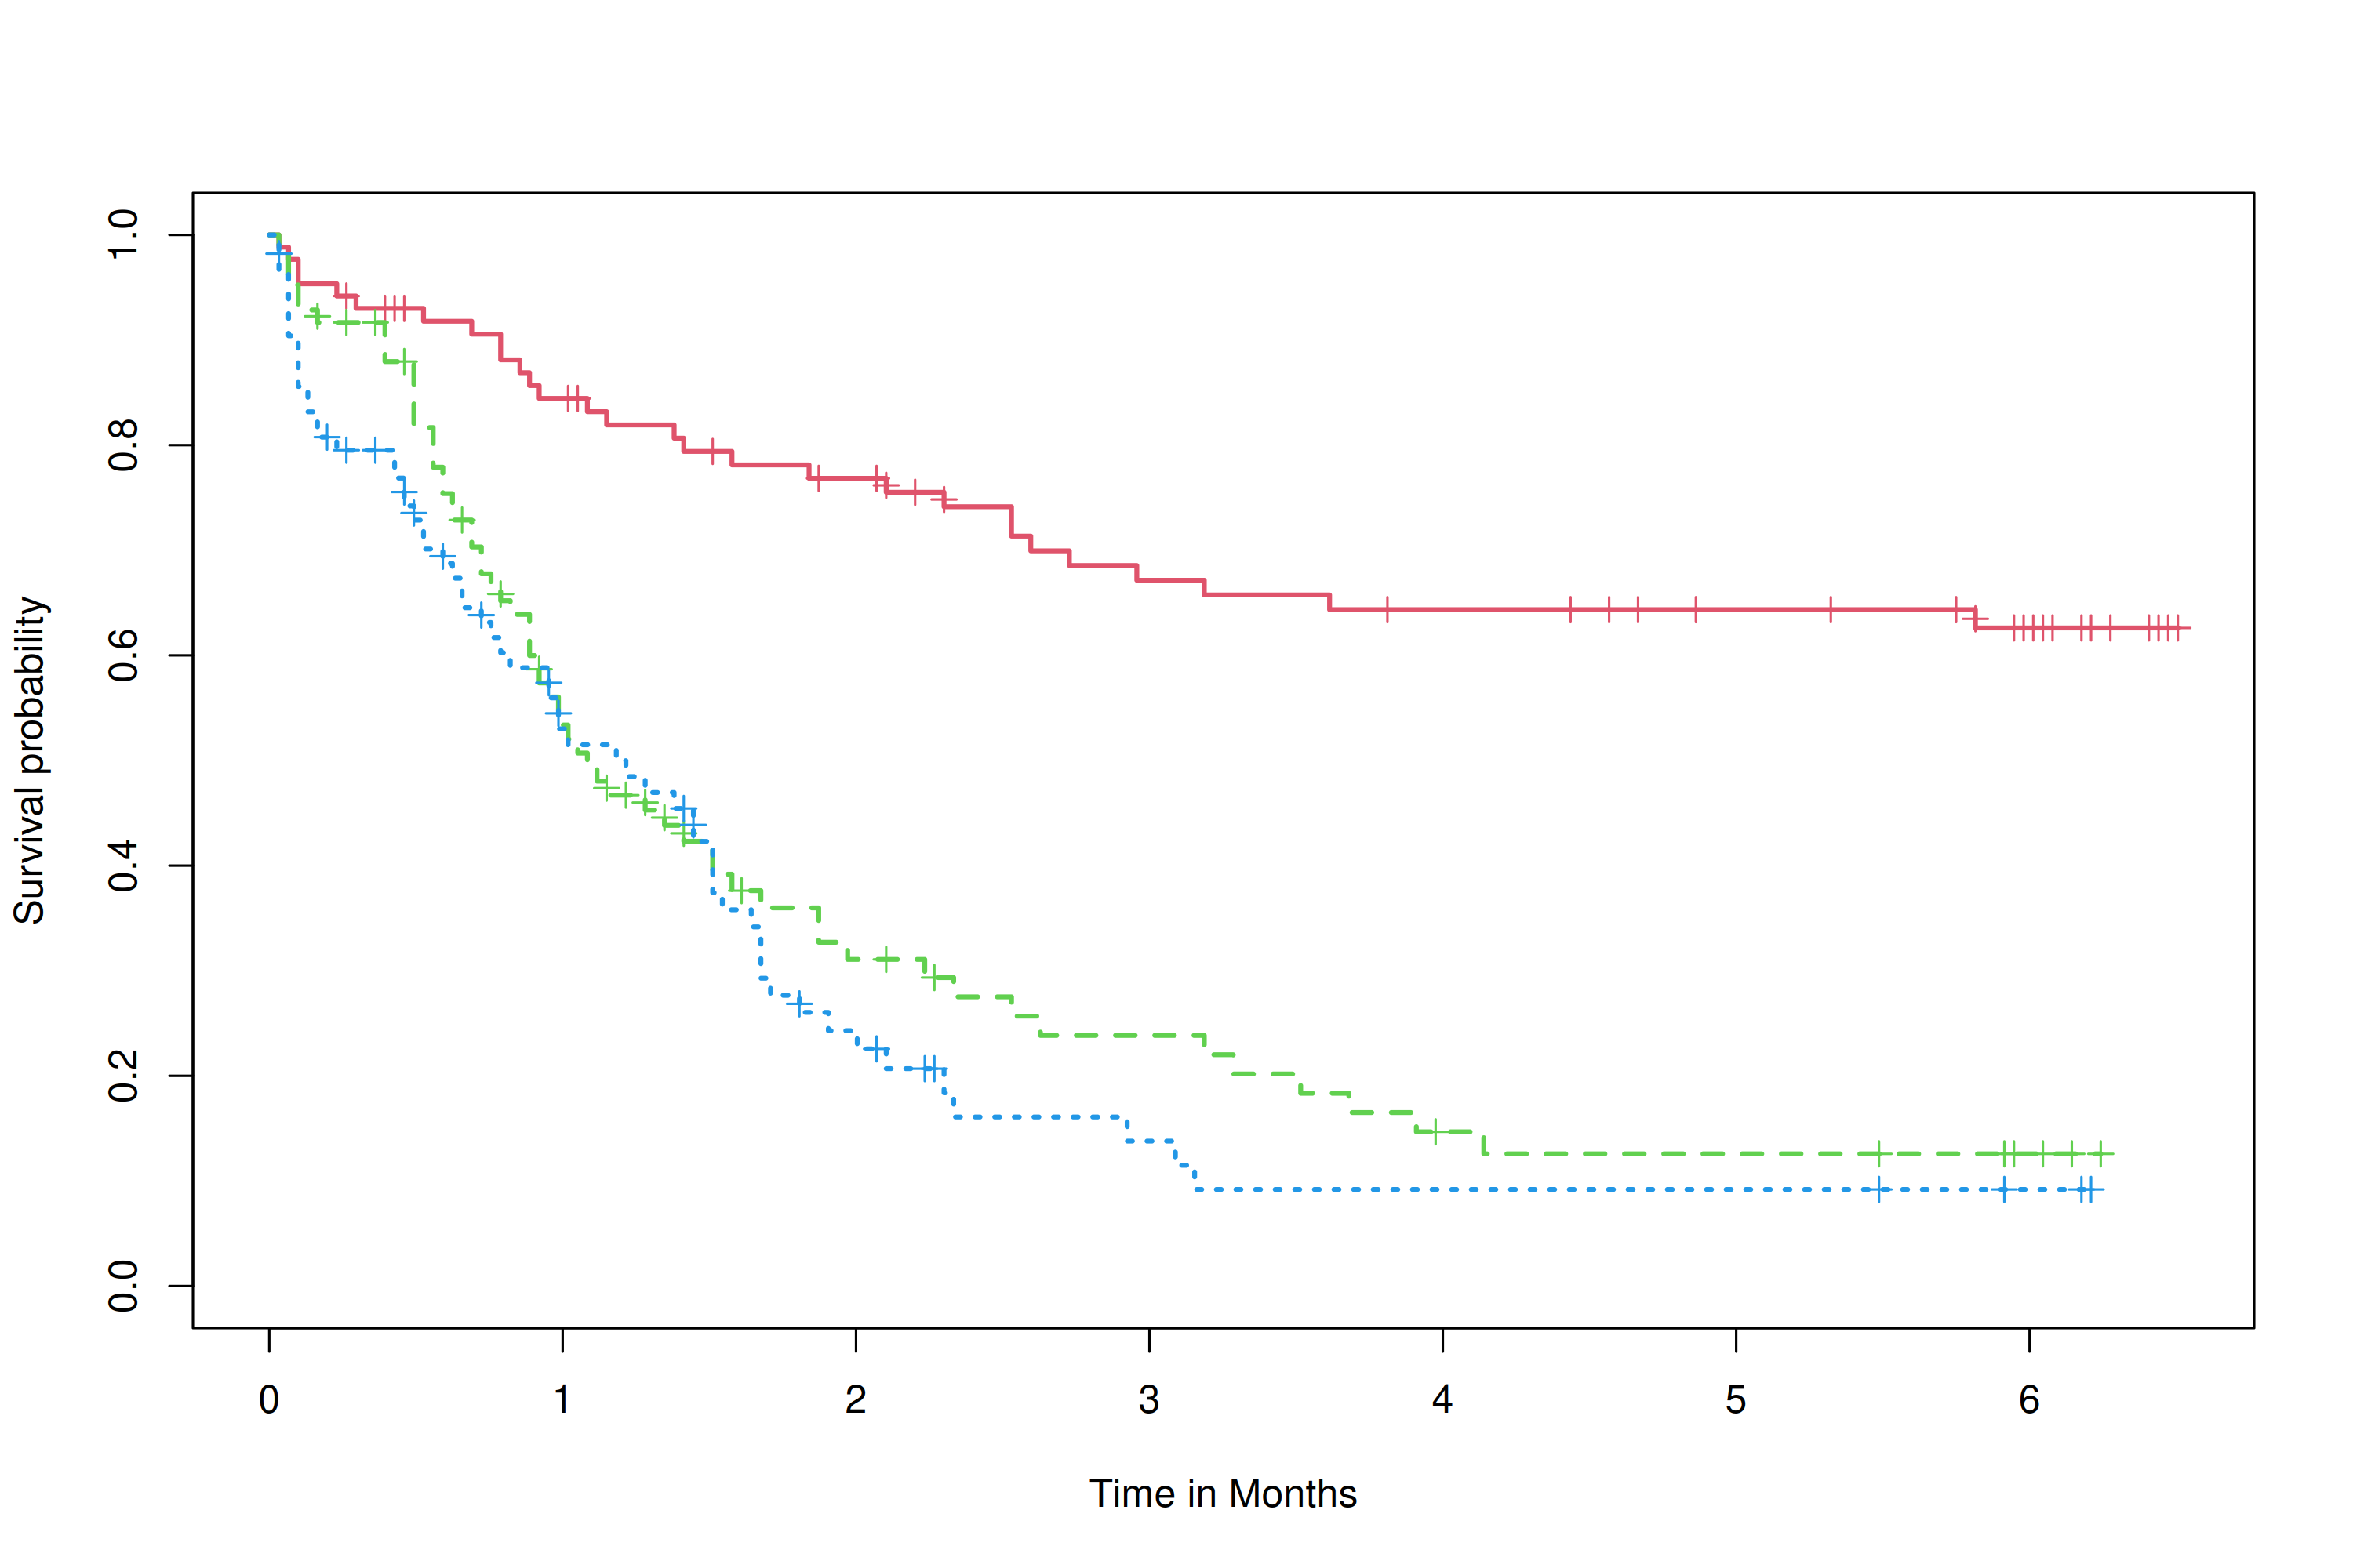

footnote
[datasource: adam-adtte]

