Displaying Emoji Based Facial Expressions

In this project we are detecting facial expression from images and then based on expression we are displaying emoji’s to user. To implement this project we have designed following modules

1. Upload Image With Face: using this module we will upload images
2. Preprocess & Detect Face in Image: using this module we will preprocess image and then look for presence of human face and if face detected then only it will predict facial expression
3. Detect Facial Expression: upon detecting face this module will predict facial expression and based on expression emoji will be displayed

SCREEN SHOTS

To run project double click on ‘run.bat’ file to get below screen

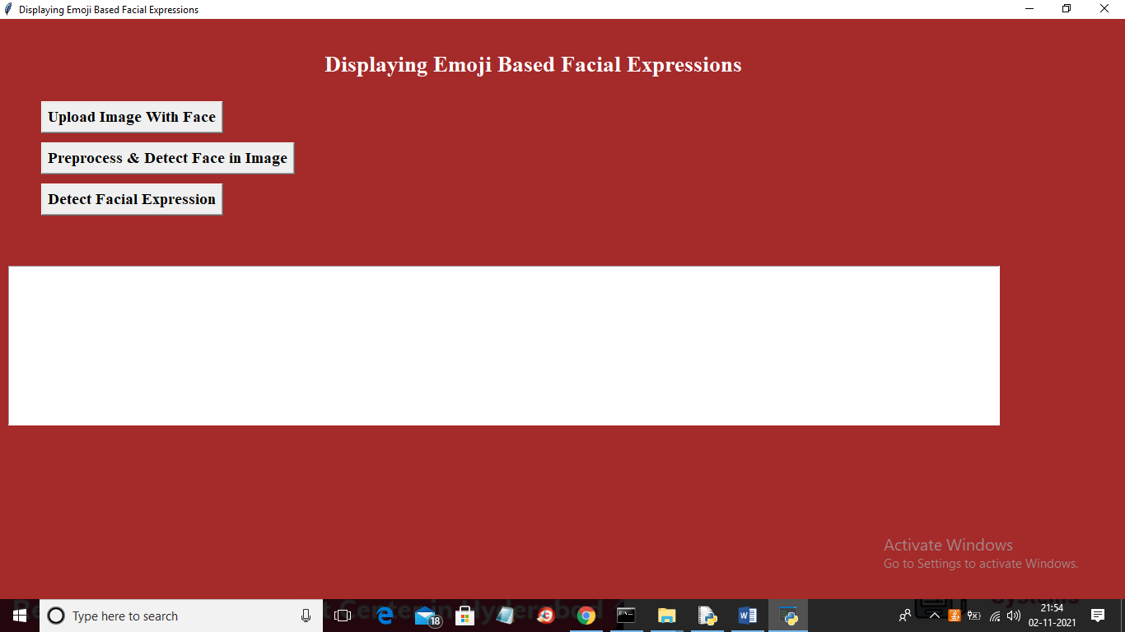

In above screen click on ‘Upload Image with Face’ button to upload image

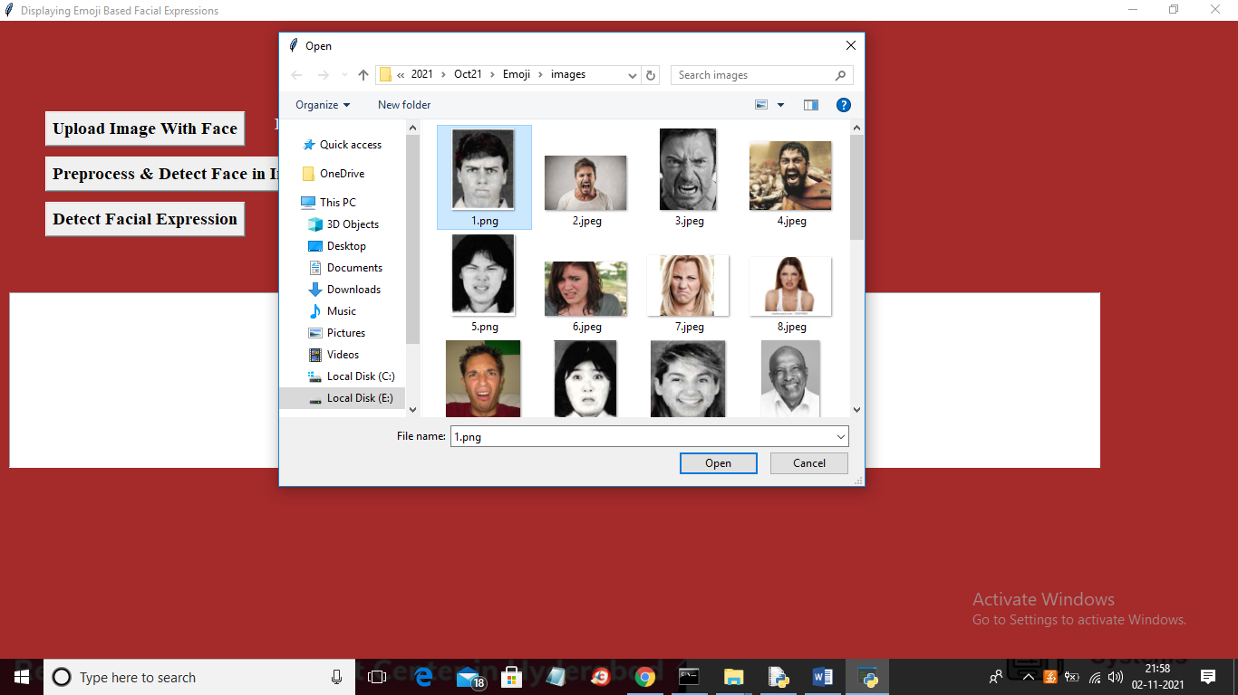

In above screen selecting and uploading ‘1.png’ file and then click on ‘Open’ button to load image and to get below output

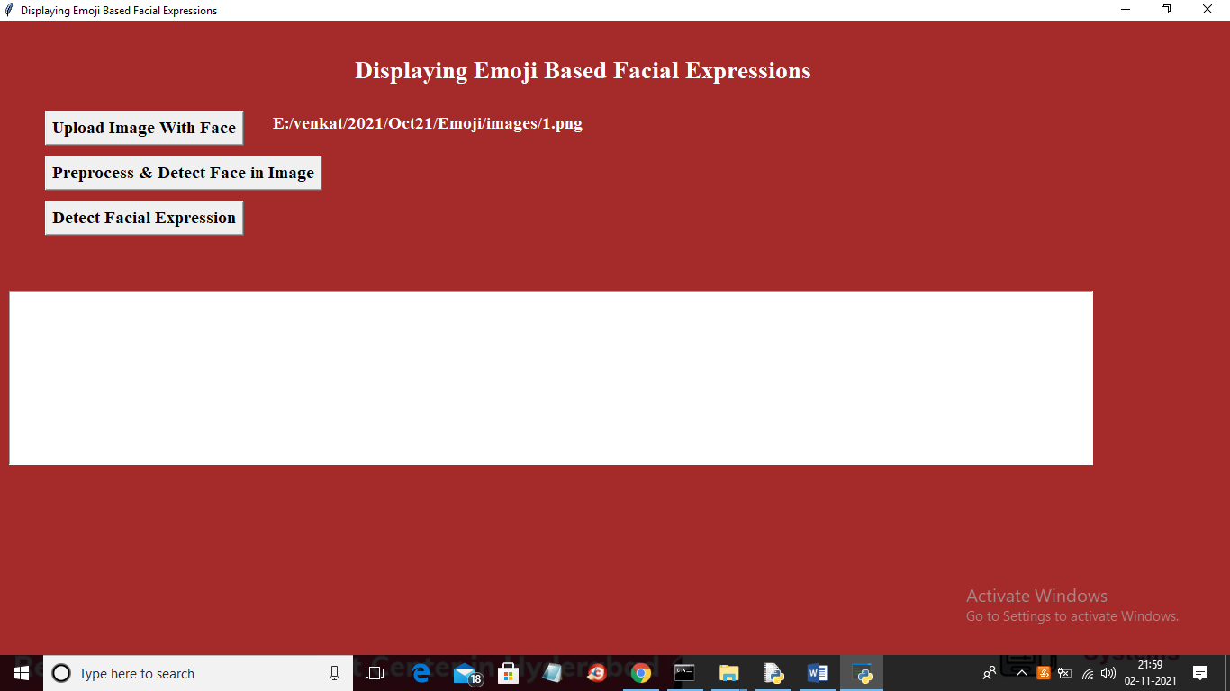

In above screen image is loaded and now click on ‘Preprocess & Detect Face in Image’ button to check whether image contains human face or not

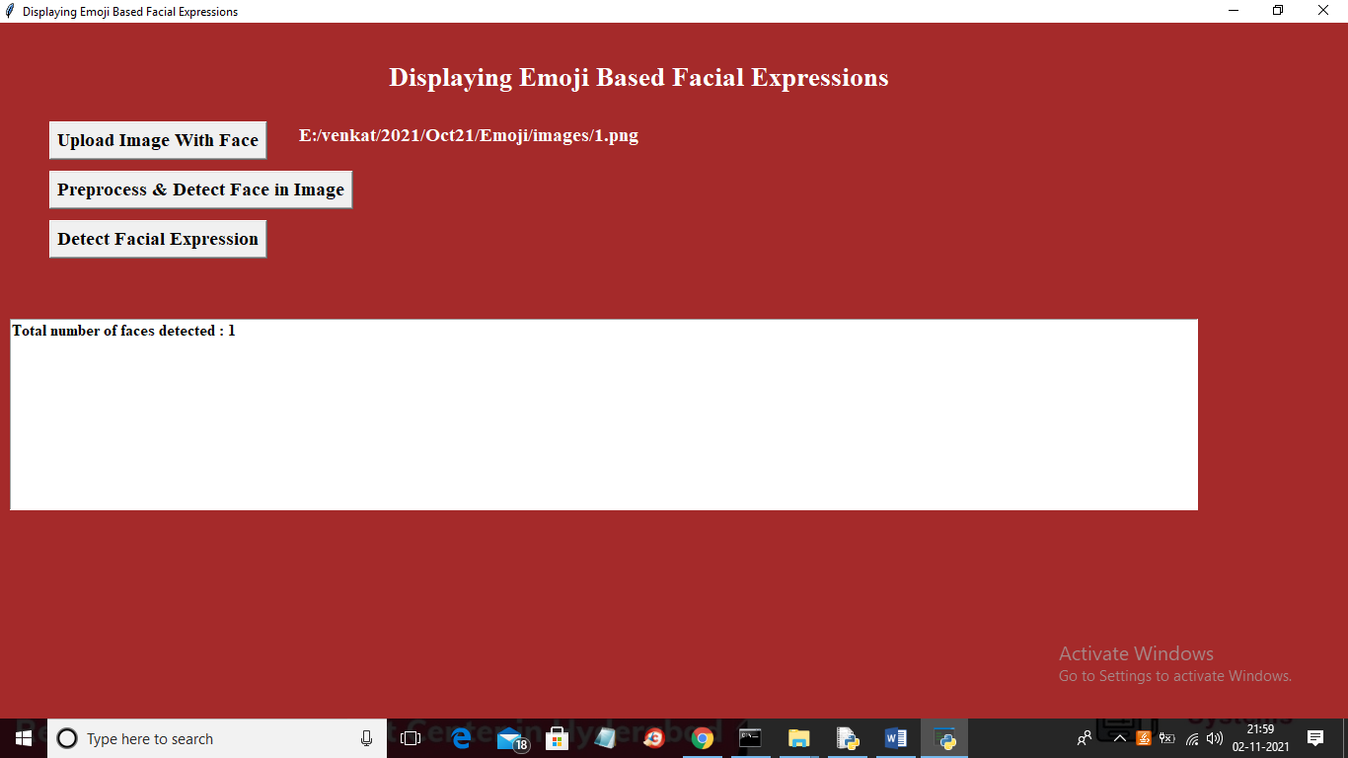

In above screen in text are we can see one face is detected and now click on ‘Detect Facial Expression’ button to detect facial expression and to get below output

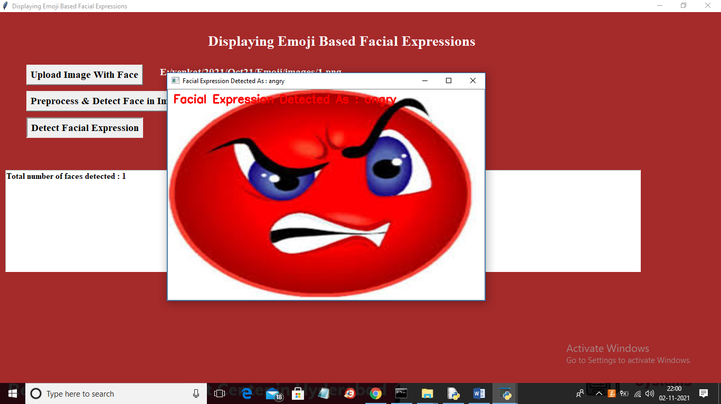

In above screen in uploaded image expression detected as ANGRY and then ANGRY Emoji is displayed and below is the other output

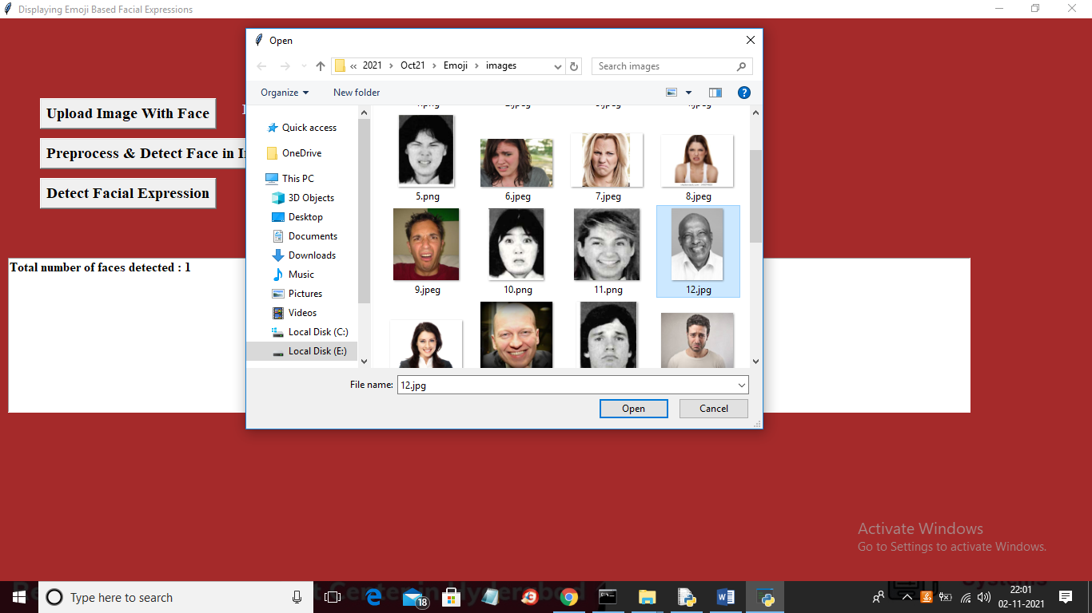

In above screen uploading 12.jpg file and then preprocess image and then click on ‘Detect Facial Expression’ button to get below output

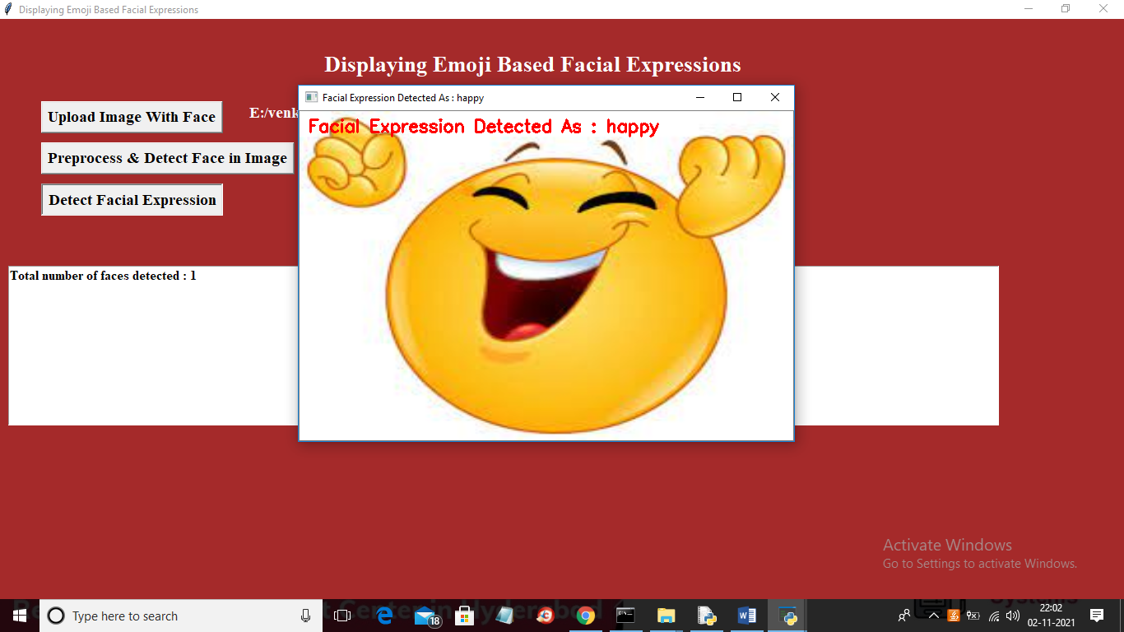

In above screen facial expression detected as HAPPY and same HAPPY EMOJI is displayed. Similarly you can upload other images and test it