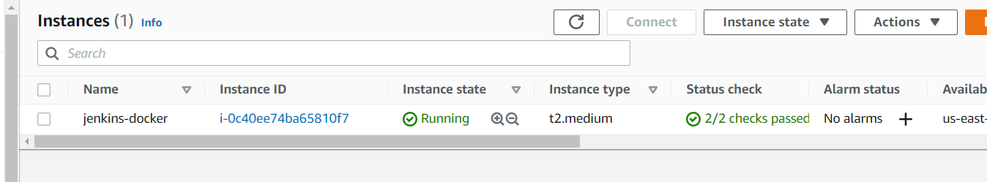

Install Jenkins with java dependency

Then configure Jenkins and install below plugins

1.Cloud Bees AWS Credentials: is needed to communicate to aws with credentials

2. Docker pipeline: needed to communicate to docker

3. Amazon ECR: generates docker authentication tocken from amazon credentials to access amazon ecr

Install docker on Jenkins server

Create a repository on github to push our code to it

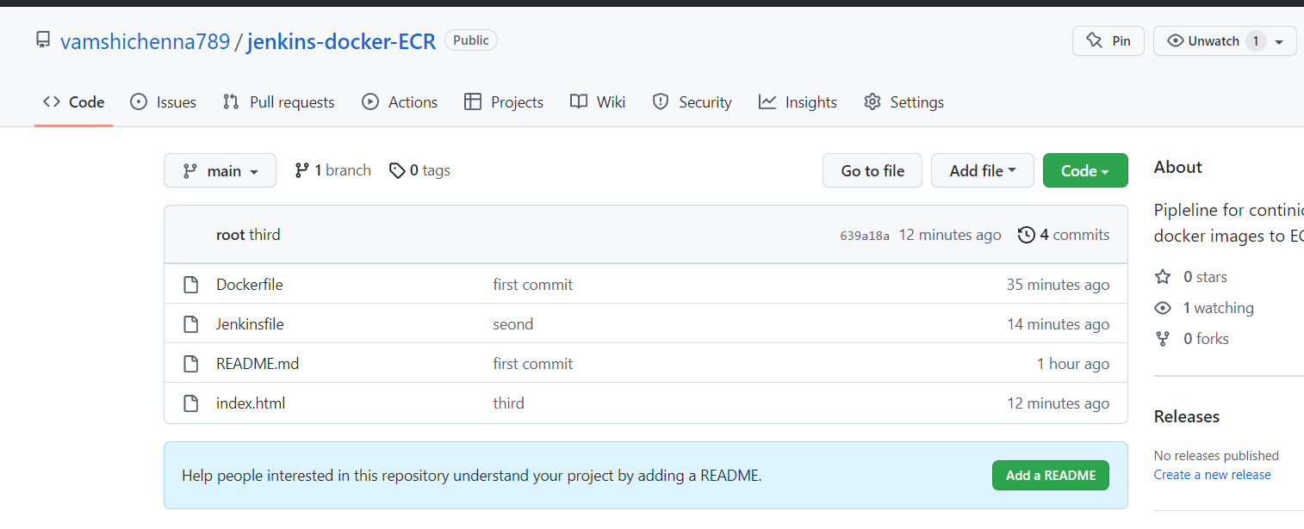

Go to Jenkins

Give Iam user credentials to access aws under manage credentials option

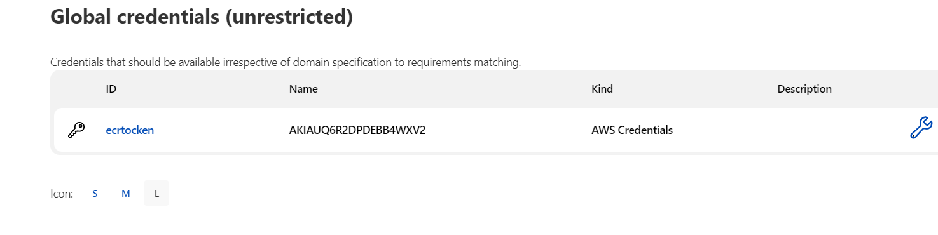

Go to Jenkins 🡪 New Items selct Pipeline

Give name

Enable Build trigger for github hook trigger scm

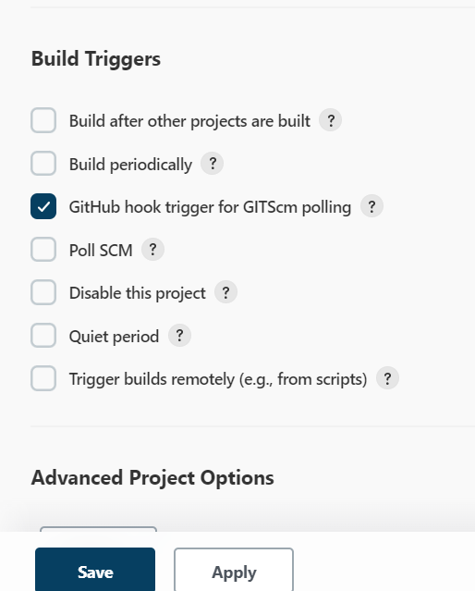

Give repo url and give branch main

Now go to github and add webhook for same

Wirte the Jenkins pipeline accordingly as shown below

pipeline {

agent any

options {

skipStagesAfterUnstable()

}

stages {

stage('Clone repository') {

steps {

script{

checkout scm

}

}

}

stage('Build') {

steps {

script{

app = docker.build("docker-demo:${env.BUILD_ID}")

}

}

}

stage('Test'){

steps {

sh 'trivy image docker-demo:latest || exit 0'

}

}

stage('Deploy') {

steps {

script{

docker.withRegistry('https://017187748261.dkr.ecr.us-east-1.amazonaws.com', 'ecr:us-east-1:ecrtocken') {

app.push()

}

}

}

}

}

}

Write your docker file and push them to git repo

Click on initial build and after that for every push it will triger the pipeline

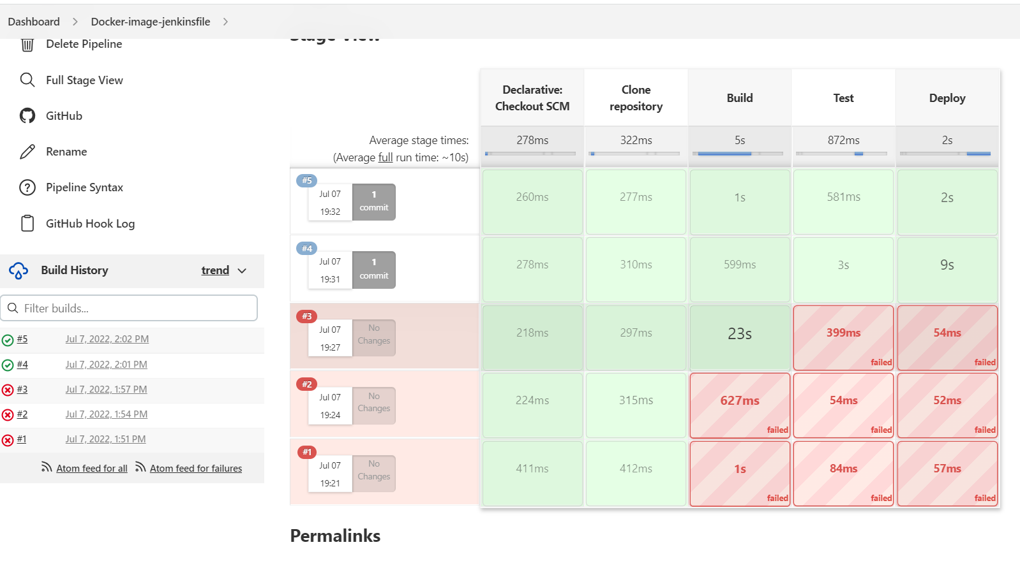

Images are uploaded tp ecr as below