**FEE MANAGEMENT SYSTEM**

**Data Base Name: dbFMS**

**2. tblFeeInstallmet**

**tblFeeInstallmetid**

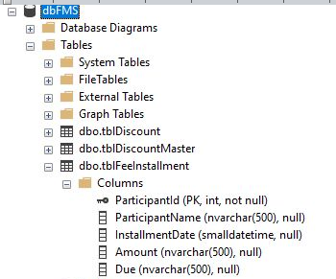

**1. tblDiscount**

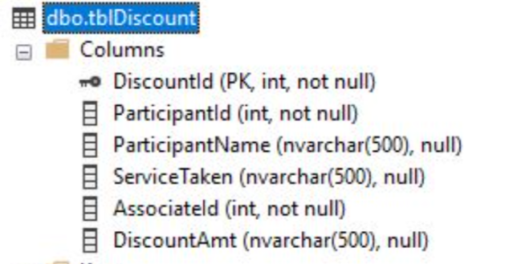

**3. tblDiscountMaster**

