REQUIREMENT TEMPLATE

Date :

Proposed by :

Module :

Challenge :

Requirement ID:

Requirement Description:

Current Pages Involved - URL

Current / NEW Page Layout

Changes Required

Search features to be enabled on ___ Data

DB - Tables involved

Current / New Table Structure

Changes Required

Reports Required

Each Report Structure

Business Logic to implement in CODE

Use case Diagram

Activity Diagram

Development work divided into __ Tasks

Task Details -

Task ID, Task Description, User Story , Task assigned to, Assigned on, Delivery Date , Status

Developer Acknowledgement - Understood n Signed

---

REQUIREMENT TEMPLATE

Date : 23 May 2023

Proposed by : Venkat

Module : Fees Mgmt System

Challenge :

1. Student fees paid, Pending fees, Scheduled Fees, Bad debts, Registered+No batch -

We do not have correct information - In excel sheets - It is confusing to understand and Manage.

2. Pending fees Collection

3. Coepd Portal access as per the service opted - as of now, we do not know whether the student have taken Placement Services or not - We have to depend on Excel sheet info

Requirement ID:230523FEE001

Requirement Description: This Fees Mgmt System is a new feature in the portal- Where we can tag a student to admission of course - Service, capture Discounts given, understand the agreed Fees, take commitment on installments and follow up on the fees and dues

Master Data entry for

Services

Discounts given

Installments given

New Page is proposed

<https://www.coepd.com/Admin/ParticipantFeeMappingSearch.aspx>

<https://www.coepd.com/Admin/ParticipantFeeMapping.aspx>

Enter student Name

Search By Student Name

select the Student

Batch can be mapped

Location can be mapped

After Services

Cost of Services - Should be Displayed

Discount Button

Discount Functionality

Associate Name - Discount Amount

Agreed Fees

Company Name

GST Option

Fees Amount

GST Amount

Installment Button

Capture 4 Installments

Receipt

Capture Payment

generate Receipt - Download

Service Owner

Lead Owner

Associate - user

Current Pages Involved - URL

Current / NEW Page Layout

Changes Required

**DB - Tables involved**

Current / New Table Structure

Changes Required

**Installment table**

We have to add columns

Status Active - boolean

Payment Flag - boolean

Status Active - boolean

By default at the time of entry it will be 0

It becomes 1

When 1. Date Expired

or

2. Student over ruled this installment

When re-structuring Installments

Old over ruled installments

Status Active - 1

New installments

Status Active - 0

Payment Flag - boolean

By default at the time of entry it will be NULL

When student pays against this installment , it becomes 1

It becomes zero

When 1. Date Expired and

2. Student not paid the installment

Lead - existing - Lead Id - Number

Lead Service Owner - New Table proposed

Participant fee mapping -

Discount

Installment

Receipt

**Business Logic to implement in CODE**

1. Collections - Revenue

Payment status =1

Receipt Date and Fees Amount

2. Pending Payments

Pending Status =1 and

Bad Debts status =0

Installment Date < 45 days

Installment Pending amount

3.Schedule Payments

Installment Status Active =1

Installment Date>= today

4.Bad Debts

Pending Status =1 and

Bad Debts status =1

Installment Date <=45 Days

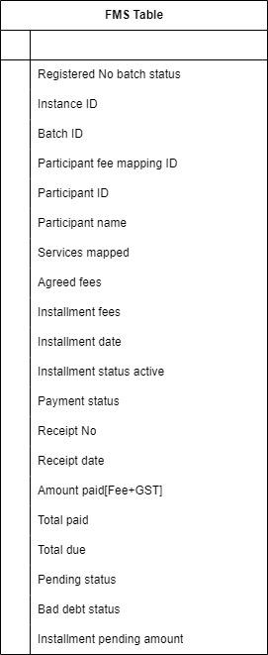

Use case Diagram

Activity Diagram

Development work divided into __ Tasks

Task Details -

Task ID, Task Description, User Story , Task assigned to, Assigned on, Delivery Date , Status

Developer Acknowledgement - Understood n Signed

Date :

Proposed by :

Module :

Challenge :

Requirement ID:

Requirement Description:

Current Pages Involved - URL

Current / NEW Page Layout

Changes Required

Search features to be enabled on ___ Data

DB - Tables involved

Current / New Table Structure

Changes Required

Reports Required

Each Report Structure

Business Logic to implement in CODE

Use case Diagram

Activity Diagram

Development work divided into __ Tasks

Task Details -

Task ID, Task Description, User Story , Task assigned to, Assigned on, Delivery Date , Status

Developer Acknowledgement - Understood n Signed