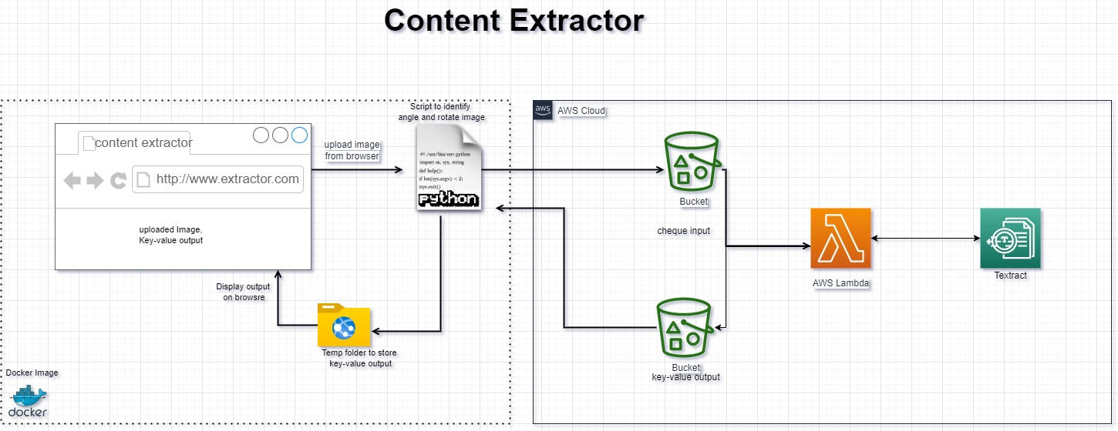

**Explaining the components and architecture:**

* AWS Cloud, S3 bucket, AWS Lambda, AWS Textract, Boto3
* Docker, Flask Application, Image rotation
* Explaining the architecture

**AWS Cloud: (Purpose: Using cloud-based services to store images and extract data from images)**

* The full form of AWS is Amazon Web Services. It is a platform that offers flexible, reliable, scalable, easy-to-use and, cost-effective cloud computing solutions.
* AWS is a comprehensive, easy to use computing platform offered Amazon.

**S3 bucket: (Purpose: Used to store images we upload in the application)**

* Amazon Simple Storage Service (Amazon S3) is an object storage service offering industry-leading scalability, data availability, security, and performance.
* Customers of all sizes and industries can store and protect any amount of data for virtually any use case, such as data lakes, cloud-native applications, and mobile apps.
* With cost-effective storage classes and easy-to-use management features, you can optimize costs, organize data, and configure fine-tuned access controls to meet specific business, organizational, and compliance requirements.

**AWS Lambda: (Purpose: To pass images from aws s3 to aws Textact we write code in lambda using boto3 sdk)**

* AWS Lambda is a serverless, event-driven compute service that lets you run code for virtually any type of application or backend service without provisioning or managing servers.
* You can trigger Lambda from over 200 AWS services and software as a service (SaaS) applications, and only pay for what you use.

**AWS EC2: (Purpose: To host the container using the docker image or to run the web application)**

* An Amazon EC2 instance is a virtual server in Amazon's Elastic Compute Cloud (EC2) for running applications on the Amazon Web Services (AWS) infrastructure.
* AWS is a comprehensive, evolving cloud computing platform.
* EC2 is a service that enables business subscribers to run application programs in the computing environment.
* It can serve as a practically unlimited set of virtual machines (VMs).

**AWS Textract: (Purpose: To predict content from the image, similar to OCR)**

* Amazon Textract is a machine learning (ML) service that automatically extracts text, handwriting, and data from scanned documents.
* It goes beyond simple optical character recognition (OCR) to identify, understand, and extract data from forms and tables.
* Today, many companies manually extract data from scanned documents such as PDFs, images, tables, and forms, or through simple OCR software that requires manual configuration (which often must be updated when the form changes). To overcome these manual and expensive processes, Textract uses ML to read and process any type of document, accurately extracting text, handwriting, tables, and other data with no manual effort.
* You can quickly automate document processing and act on the information extracted, whether you’re automating loans processing or extracting information from invoices and receipts.
* Textract can extract the data in minutes instead of hours or days.

**AWS Boto3: (Purpose: To call one service from another service in python)**

Use the AWS SDK for Python (Boto3) to create, configure, and manage AWS services, such as Amazon Elastic Compute Cloud (Amazon EC2) and Amazon Simple Storage Service (Amazon S3).

The SDK provides an object-oriented API as well as low-level access to AWS services.

**Docker: (Purpose: To host the created application anywhere using simple commands without any installations)**

* Docker takes away repetitive, mundane configuration tasks and is used throughout the development lifecycle for fast, easy and portable application development - desktop and cloud
* Docker, a subset of the Moby project, is a software framework for building, running, and managing containers on servers and the cloud.
* The term "docker" may refer to either the tools (the commands and a daemon) or to the Dockerfile file format.
* It used to be that when you wanted to run a web application, you bought a server, installed Linux, set up a LAMP stack, and ran the app.

**Flask: (Purpose: To create a web application using python)**

* Flask is a web development framework developed in Python.
* Flask is known as a micro-framework because it is lightweight and only provides components that are essential.
* It only provides the necessary components for web development, such as routing, request handling, sessions, and so on

**Image rotation: (Purpose: To fix the image if it is not in the correct angle)**

* Binarized the raw image, find edges and find tilt angle.
* Used PIL library to rotate the image from the angle found from above step.

**Explaining the architecture:**

* Click on upload image to extract details from an image. When submit button is clicked, the image gets uploaded to S3 bucket. Using event triggering on AWS, the image gets pushed to Lambda function from which the details are extracted using AWS Textract service.
* The extracted details are converted into key-value pairs using NER (Named entity recognition) and then stored in the form of a text/json file back to another S3 bucket.
* Using the logic in main.py the text/json file is downloaded when the file is available and the contents in it are read and displayed on the web page.
* Using rotation.py file the image angle is detected and rotated to landscape format and it is displayed on the web page.
* All these files are deployed on an EC2 instance using Docker. Docker image is converted using the Dockerfile. And finally the container is run using docker command on a 5000 port, using which we can access the webpage from anywhere.