**Software Requirements Specification**

**for**

**Ranker’s Choice**

**Prepared By:**

B.Geeta Sree (197Z1A0521)

CH.Vamshi Krishna Reddy (197Z1A0534)

D.Supraja (197Z1A0546)

**Table Of Contents**

**1.Introduction**…………………………………………………………………..1

1.1 Purpose ……………………………………………………………………………………1

1.2 Product Scope……………………………………………………………………………...1

**2. Overall Description**………………………………………………………….1

2.1 Product Perspective………………………………………………………………………..1

2.2 Product Functions………………………………………………………………………….1

2.3 User Classes and Characteristics…………………………………………………………..1

2.4 Operating Environment……………………………………………………………………1

2.5 Design and Implementation Constraints…………………………………………………..2

2.6 Assumptions and Dependencies…………………………………………………………...2

**3. External Interface Requirements**…………………………………………..2

3.1 User Interfaces……………………………………………………………………………..2

3.2 Hardware Interfaces……………………………………………………………………….2

3.3 Software Interfaces………………………………………………………………………...2

3.4 Communication Interfaces………………………………………………………………...2

**4. Functional Requirements**……...……………………………………………2

**5. Non-Functional Requirements**……………………………………………...3

5.1 Security Requirements…………………………………………………………………….3

5.2 Software Quality Attributes……………………………………………………………….3

**6. Appendices**…………………………………………………………………...3

6.1 Definitions and Abbreviations…………………………………………………………….3

6.2 References…………………………………………………………………………………4

**1.Introduction**

This project focuses on providing many useful resources online along with some additional features like blogging & Q&A page for students.

**1.1 Purpose**

The purpose of the document is to share the resources like study materials, syllabus copies, question papers etc. which are useful for students in an organized way.

* 1. **Product Scope**

Through the ranker’s choice users can easily access study materials, syllabus copies, question papers etc. and can also post some blogs and rise some questions to clarify the doubts.

**2. Overall Description**

* 1. **Product Perspective**

The system will store all the resources like enotes, syllabus papers, blogs etc. in the database along with the user & admin information.

Users have a system for obtaining all the required notes. But there is no system that provides all the blogging, posing questions features in the same place. Some users access the notes, question papers, syllabus via various message sharing apps but there are chances of losing those. The proposed system solves these problems by enabling all the features at one platform in an organized way.

* 1. **Product Functions**

This system will perform following functions :

* Login
* Register
* Providing all the resources in various pages of the application.
* User can post, delete, pose a question, reply to question.

* 1. **User Classes and Characteristics**
* User A – New User – This user can register by filling all the required details and then login to the website to use the blog and Q&A pages efficiently. He can fetch the data directly also.
* User B – Existing User – This user can login to the website and use blog & Q&A pages, he/she can fetch the resources provided, edit their profiles.
* User C – Admin – Admin can login and manage the pages and resources in the pages, add or delete the blogs, provide access to some users.
  1. **Operating Environment**

Operating environment for this web application is:

* Operating System – Any Operating System
* Database –
* Languages – Python, HTML, CSS, JavaScript

**2.5 Design and Implementation Constraints**

The major constraints of this web application are as follows: a) Less Scalable - the ability of the computing process to be used in a range of capability b) Managing traffic

* 1. **Assumptions and Dependencies**

**3. Interface Requirements**

**3.1 User Interfaces**

* The interface provided for the user should be user friendly.
* Login screen is provided in the beginning for the entering the required username and password.
* The successful login leads to a new page.
* The new page or home consists of the various services provided by the website.

**3.2** **Hardware Interfaces**

Memory : 2GB RAM

Processor : Intel Core i2 and above

**3.3** **Software Interfaces**

In order to perform various functions, the software need to interact with various other software. Database stores the information about the user, admin, blogs and various details about the resources that are provided for the users.

**3.4 Communication Interfaces**

The communication interface used is web browser and communication protocol used is HTTP.

**4. Functional Requirements**

System enables users to access the required materials, question papers and syllabus papers, users can login to the website manage their accounts, blogs. User gets a login page first after successful login it redirects to the Ranker’s Choice home page where user gets various services provided by the system.

Enotes enables to access study materials. Q&A page allows users to pose questions and reply to questions. Blog allows users to post, delete, update their blogs. Question papers page provides question papers, syllabus copies. Admin can manage all the modules and edit any information provided in the application.

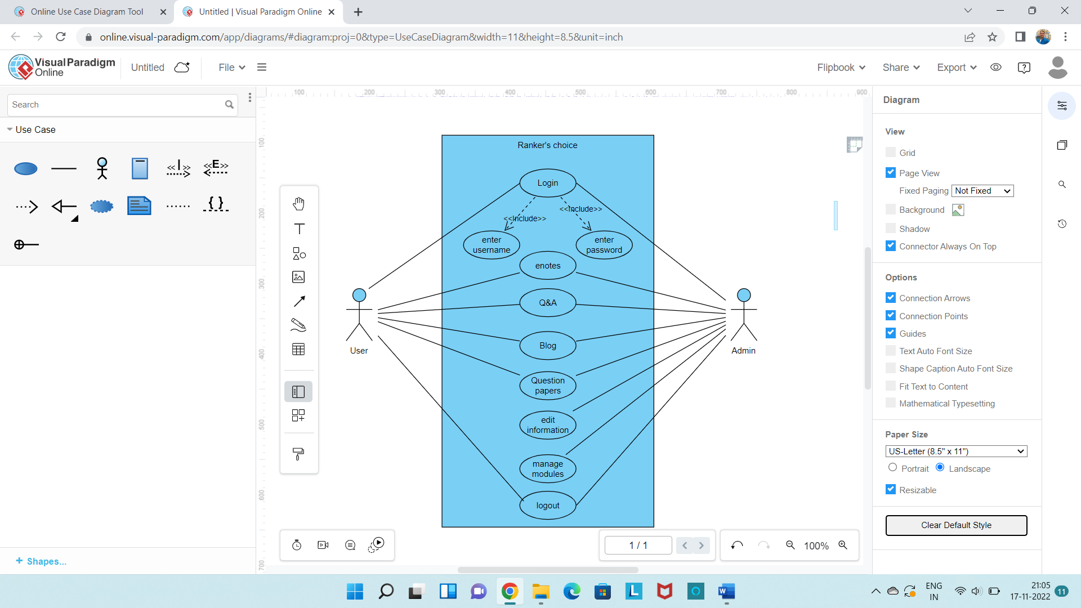

**5. Non-Functional Requirements**

**5.1 Security Requirements**

Login is used to provide authentication to the website, only after entering the correct credentials the users or admins can login access their accounts. Only admins are allowed to edit any information which is provided by the application, users can perform modifications only for their accounts.

**5.2 Software Quality Attributes**

* Availability: The users can access the application anytime and anywhere.
* Maintainability: The system can be maintained well and modifications in the system can be done easily due to its modularity.
* Usability: The web application’s interface has to be user-friendly and easy to use.

**6. Appendices**

**6.1 Definitions, abbreviations**

HTML – Hyper Text Markup Language

CSS – Cascading Style Sheet

Q&A – Question and Answer

HTTP – Hyper Text Transfer Protocol

Blog - A blog is where entries are made in journal style, it can be used as an additional communication channel to share informationwith students.

**6.2 References**

[www.wikipedia.com](http://www.wikipedia.com)

[www.youtube.com](http://www.youtube.com)

[www.google.com](http://www.google.com)

geeks for geeks

studyglance.in