School of Computer Science and Artificial Intelligence
Lab Assignment # 15.2
Program : B. Tech (CSE)
Specialization : -
Course Title : AI Assisted Coding
Course Code : 23CS002PC304
Semester : II
Academic Session : 2025-2026 Name of student :A.Vamshikrishna
Enrollment No. : 2403A51L47 Batch No : 52
Date : 17/03/26

Task 1: Setup Fast-API Backend (VS Code) Install:
Prompt: Create a basic FastAPI app with one GET endpoint "/" that returns a welcome message.

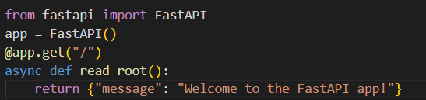
Code:

Run: python -m uvicorn main:app --reload
Output:http://127.0.0.1:8000/
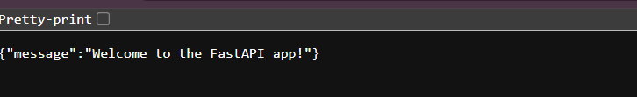
Explanation: This code sets up a basic FastAPI application with endpoints to create, read, update, and delete items in a list, along with docstrings for Swagger documentation.

Task 2: API – Create and Read Items

Prompt: Add GET "/items" and POST "/items" endpoints in FastAPI using a list to store items.

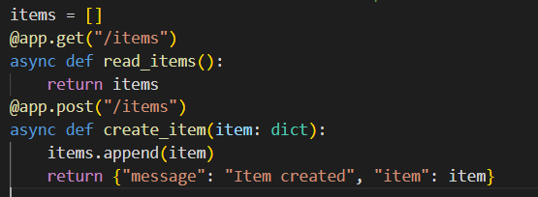
Code:
Output:
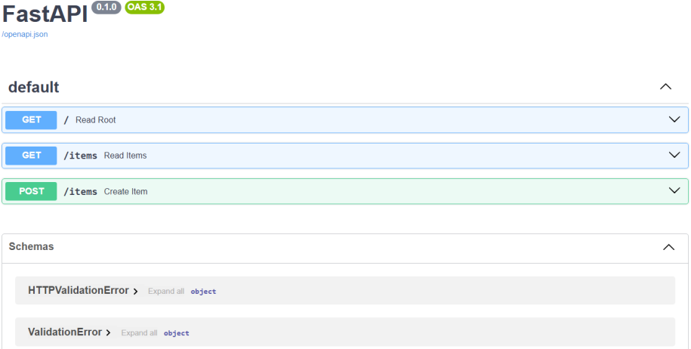

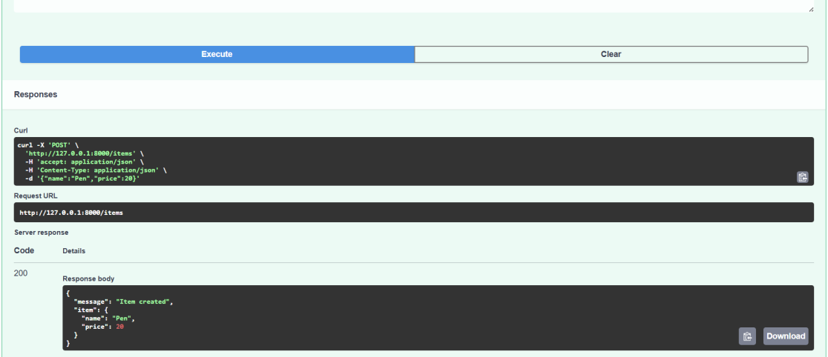

Explanation: This code defines two endpoints in a FastAPI application to manage a list of items, allowing users to retrieve all items and add new items to the list.

Task 3: Update Existing Item

Prompt: Add a PUT "/items/{index}" endpoint to update an item in a list by index.

Code:
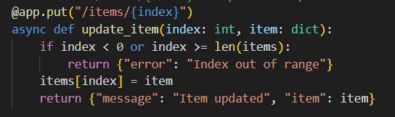

Output:
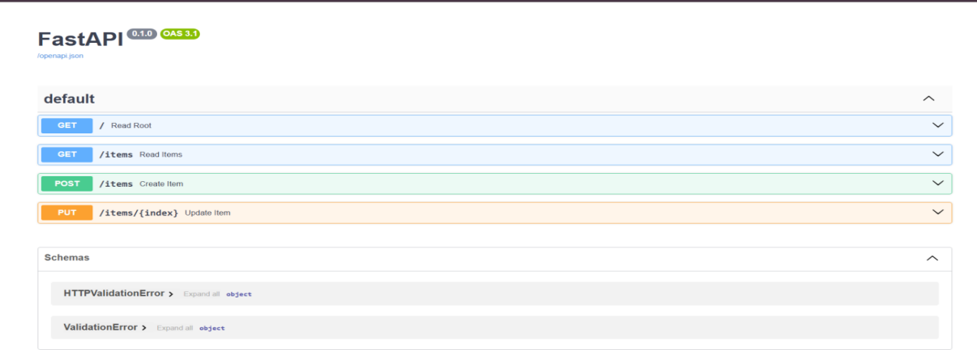
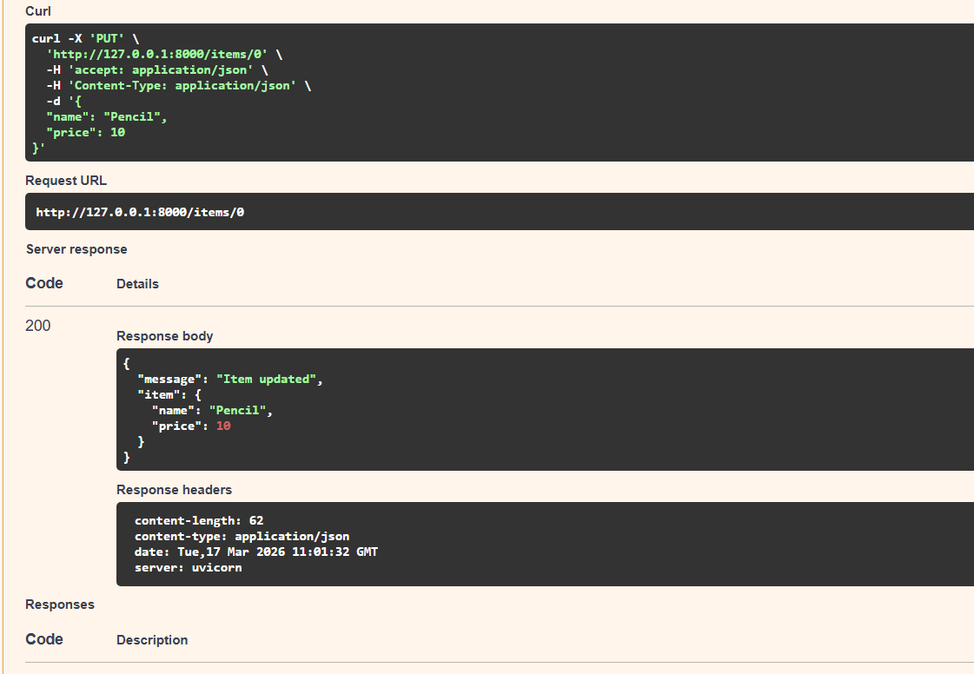

Explanation: This code adds a PUT endpoint to the FastAPI application that allows
users to update an existing item in the list by specifying its index, with error handling for out-of-range indices.

Task 4: Delete Item

Prompt: Add a DELETE "/items/{index}" endpoint to remove an item from a list.

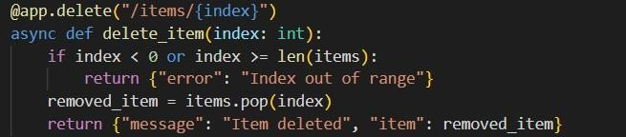
Code:
Output:
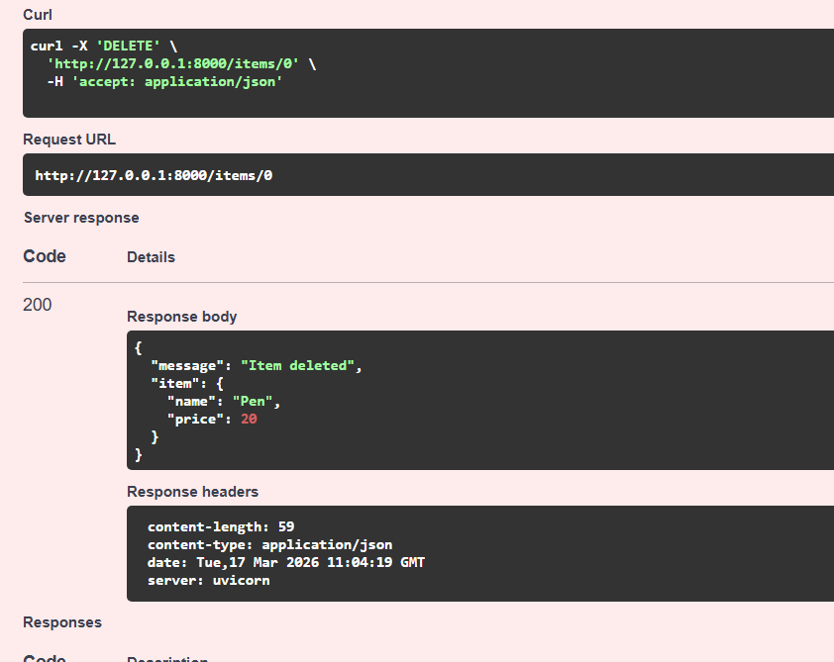

Explanation: This code adds a DELETE endpoint to the FastAPI application that allows users to remove an item from the list by specifying its index, with error handling for
out-of-range indices.

Task 5: Auto-Generated Documentation
Prompt: Add docstrings to all FastAPI endpoints so they appear in Swagger documentation.

Code:
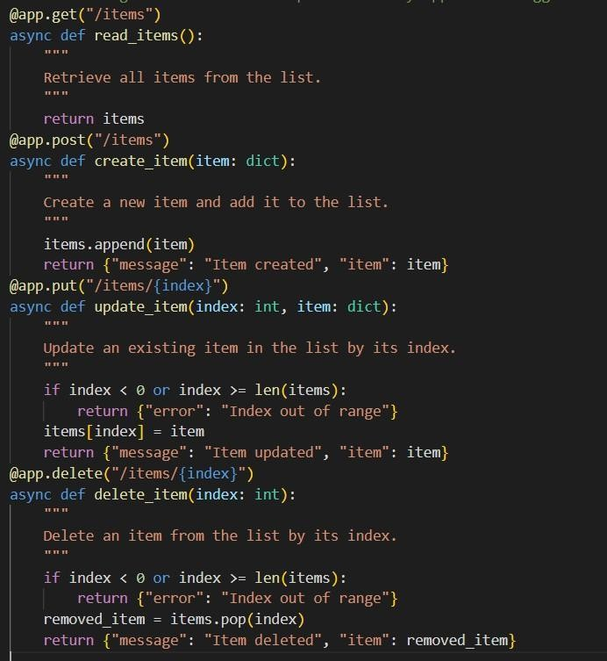

Open:
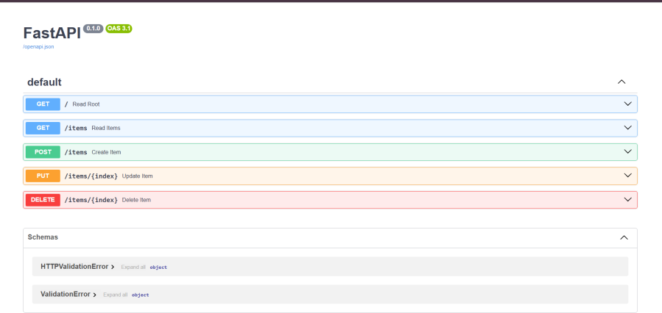
- http://127.0.0.1:8000/docs (Swagger UI) Output:

Explanation: This code adds docstrings to each endpoint in the FastAPI application, providing descriptions that will be displayed in the Swagger UI for better documentation and understanding of each endpoint's functionality.

