School of Computer Science and Artificial Intelligence
Lab Assignment # 9.2
Program : B. Tech (CSE)
Specialization : CSE
Course Title : AI Assisted coding
Course Code : 23CS002PC304
Semester ; II
Academic Session : 2025-2026 Name of Student : A VamshiKrishna Enrollment No. : 2403A51L47 Batch No. : 52
Date : 06-02-2026

Task -1 (Documentation – Function Summary Generation):
Use AI to generate concise functional summaries for each Python function in a given script.

Prompt:
“Analyze the following Python script and generate a concise functional summary for each function. The summary should describe the purpose of the function only. Do not include implementation details.

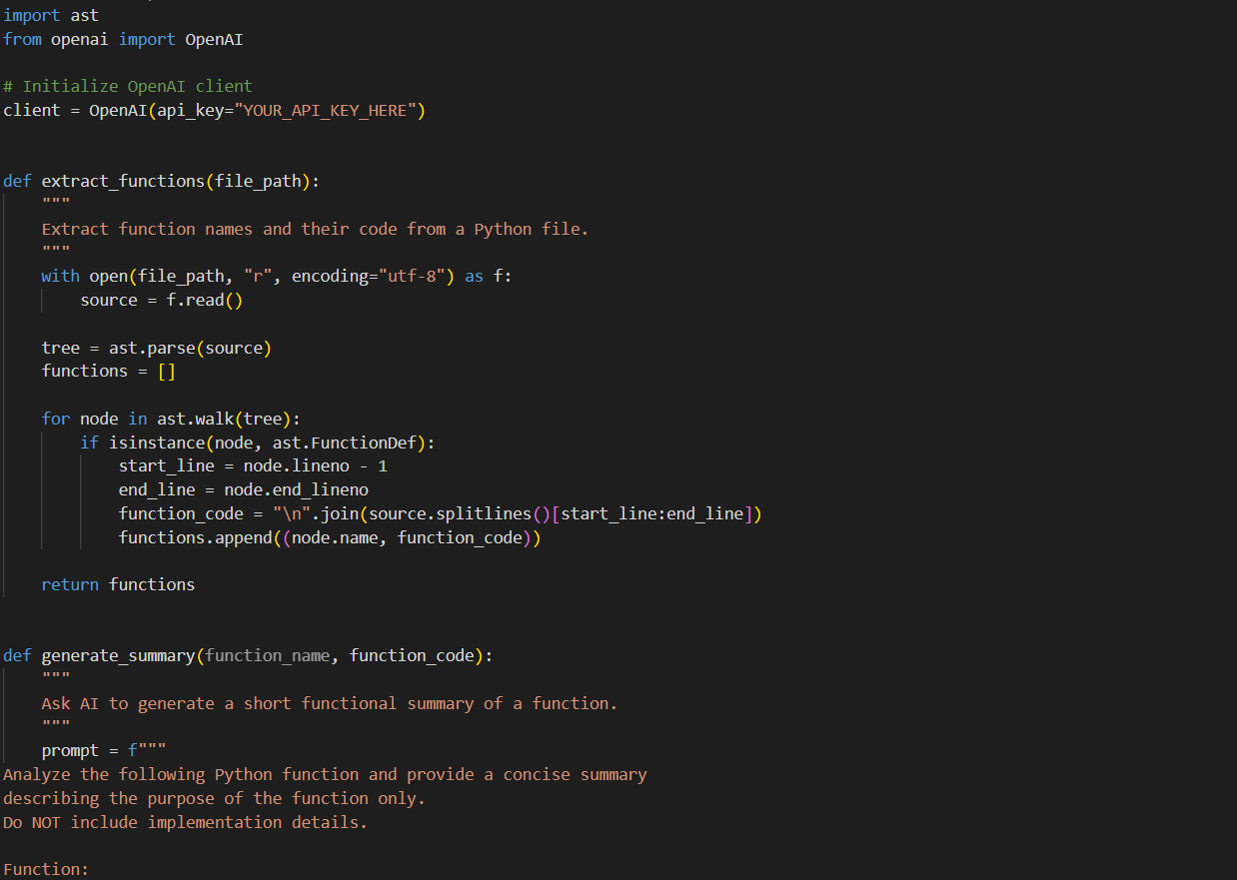

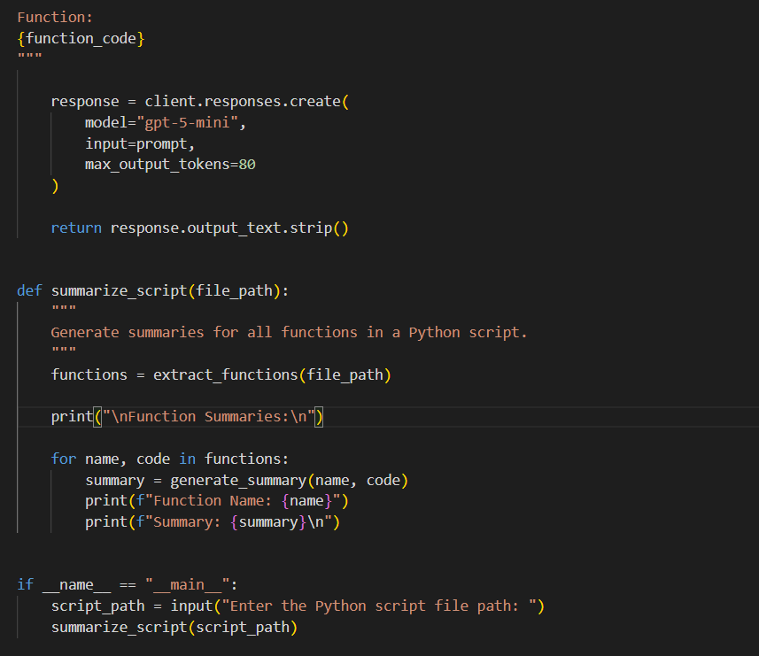

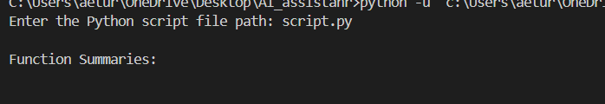

Explaination:
- This code reads a Python script and identifies all the functions defined in it using the AST module.
- It then sends each function to an AI model to generate a short summary describing the purpose of that function.
- Finally, it prints concise functional summaries for documentation

Task 2:
Use AI to document the logic behind conditional statements and loops ina Python program.

Prompt:
Analyze the following Python program and document the logic behind the conditional statements and loops. Explain only the decision-making logic and loop behavior in clear and concise language. Do not explain basic Python syntax and do not modify the code. Provide the output as the original Python code followed by short explanations describing how the conditions and loops work.

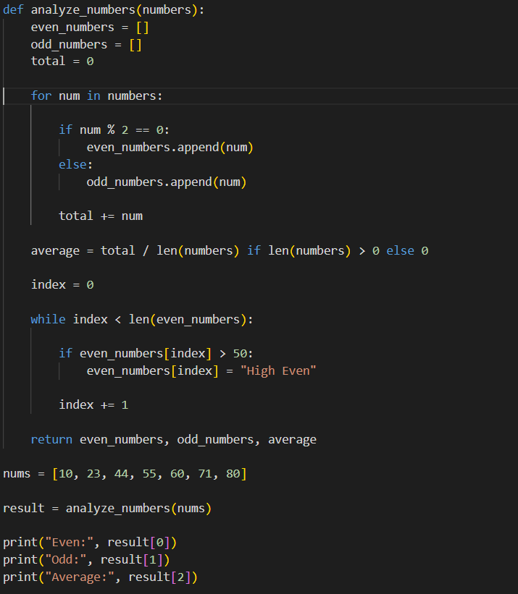

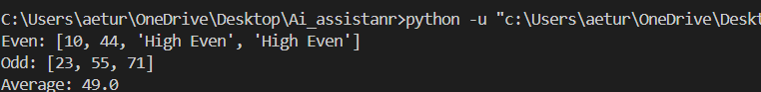

Explaination:
- This program uses a for loop to go through each number in the list and a condition to separate numbers into even and odd groups.
- Another condition ensures the average is calculated only when the list is not empty.
- A while loop then checks the even numbers and marks those greater than a certain value.

Task 3 (Documentation – File-Level Overview):
Use AI to generate a high-level overview describing the functionality of an entire Python file.

Prompt:
Analyze the following complete Python file and generate a brief high-level overview describing the overall purpose and functionality of the program. The overview should summarize what the entire file does, not individual implementation details. Place the overview as a documentation comment at the top of the Python file.

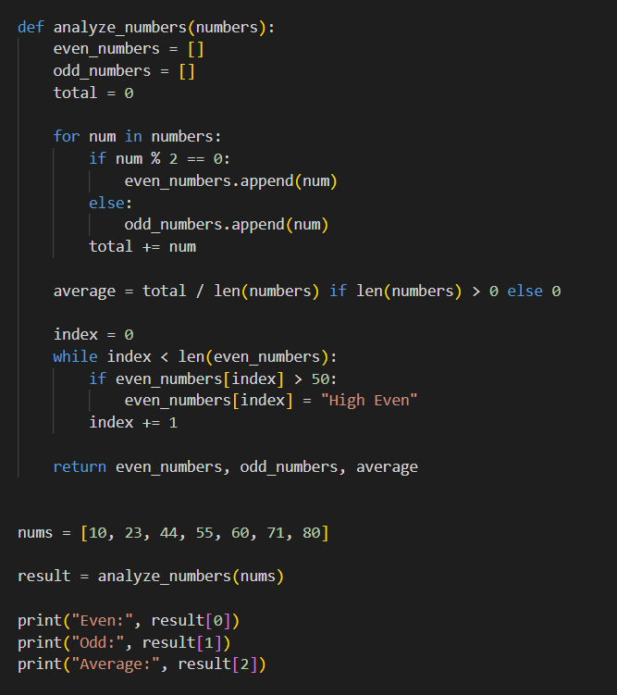

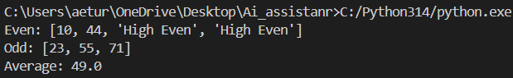

Explaination:
- The overview at the top of the file explains the overall purpose of the program before the code starts.
- It summarizes what the entire Python file does instead of explaining individual functions or logic. This helps readers quickly understand the program.

T ask -4 (Documentation – Refine Existing Documentation):
Use AI to improve clarity and consistency of existing documentation in Python code.

Prompt:
Improve the existing documentation in the following Python code. Rewrite the comments and docstrings to make them clearer, more consistent, and professional while keeping the original technical meaning unchanged. Do not modify the program logic or code structure. Return the complete Python code with refined documentation.

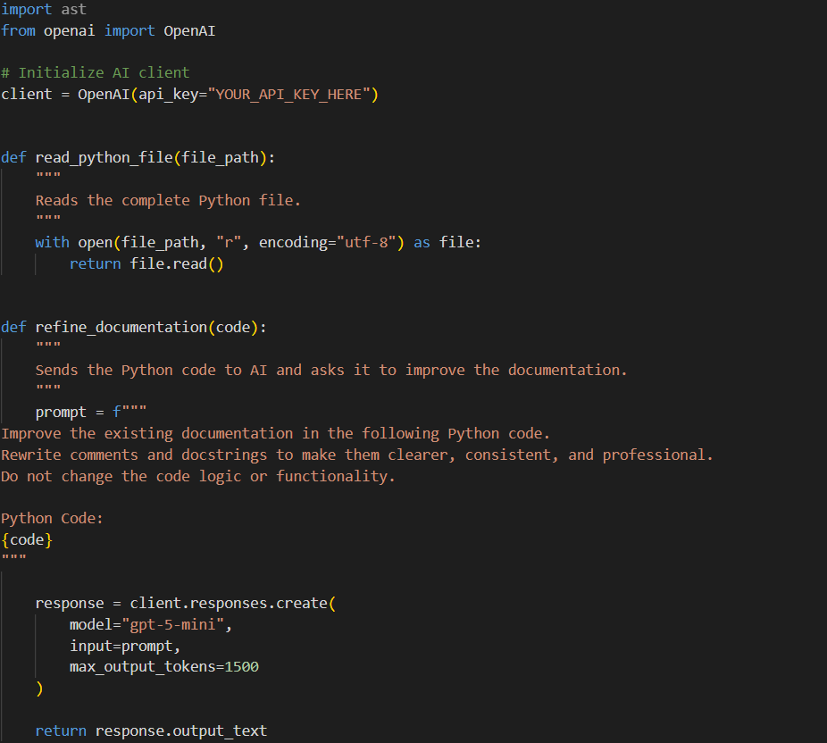

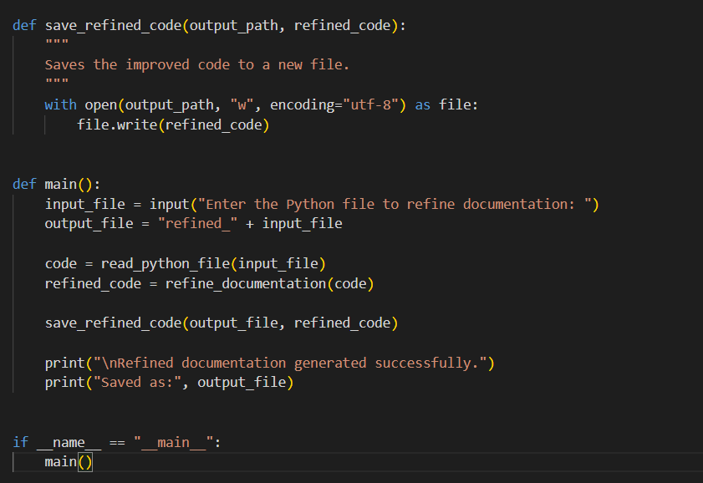

Explaination:

- This script reads a Python file, sends its content to an AI model to improve the documentation, and saves the refined code to a new file.
- It uses the OpenAI API to process the code and enhance the comments and docstrings without altering the logic.

Task-5 (Documentation – Prompt Detail Impact Study):
Study the impact of prompt detail on AI-generated documentation quality.

Prompt:
Analyze the following Python function and write clear documentation explaining its purpose, input, and output. Focus on what the function does logically and ensure the explanation is precise and technically accurate.

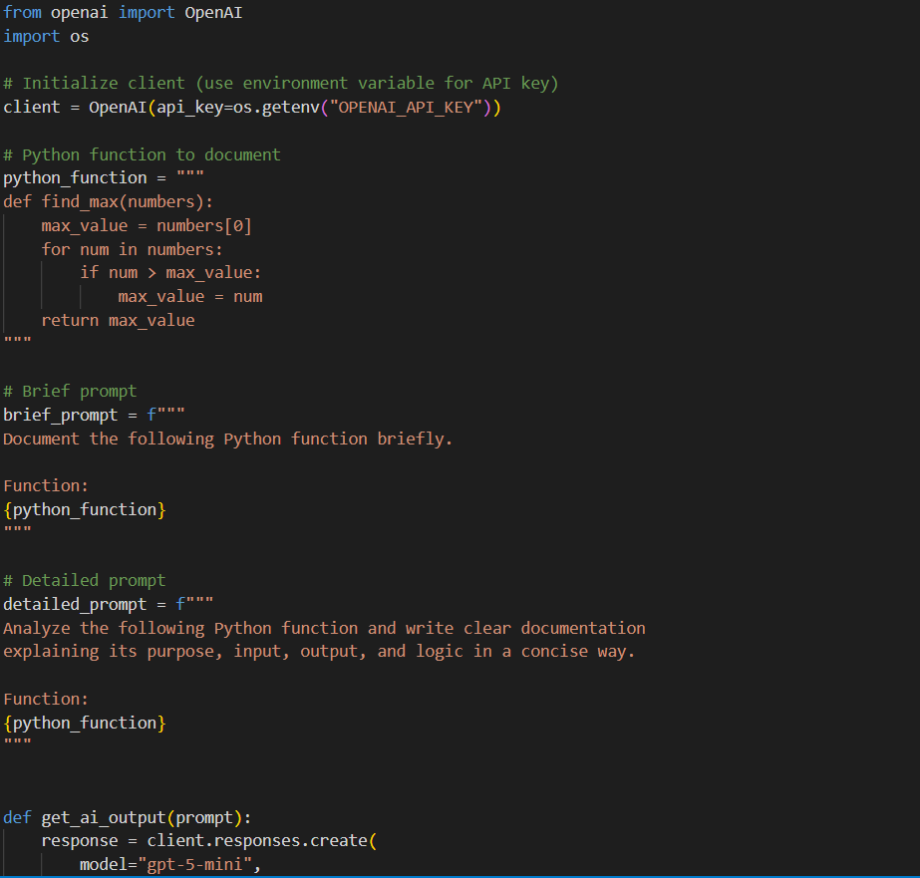
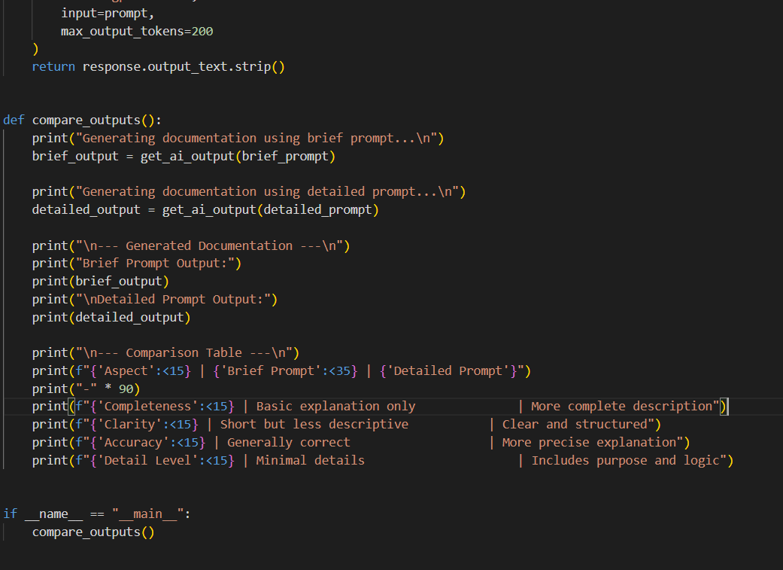

Explaination :
- This code studies how the level of detail in a prompt affects AI-generated documentation.
- It sends the same Python function to the AI using a brief prompt and a detailed prompt.
- The outputs are then displayed and compared in a table based on completeness, clarity, and accuracy.

