School of Computer Science and Artificial Intelligence
Lab Assignment # 11.1
Program : B. Tech (CSE)
Specialization : CSE
Course Title : AI Assisted coding
Course Code : 23CS002PC304
Semester ; II
Academic Session : 2025-2026 Name of Student : A VamshiKrishna Enrollment No. : 2403A51L47 Batch No. : 52
Date : 24-02-2026

Task -1 : SR University’s student club requires a simple Contact Manager Application
to store members’ names and phone numbers. The system should support
efficient addition, searching, and deletion of contacts

Prompt: Welcome to Smart Contact Manager!
Choose implementation:
1. Array-Based
2. Linked List-Based
Enter 1 or 2:

--- Menu ---
1. Add Contact
2. Search Contact
3. Delete Contact
4. Display All Contacts
5. Exit
Choose an option (1-5):

Enter name:
Enter phone number:

Enter name to search:
Found: Alice - 12345
Contact not found.

Enter name to delete:
Contact 'Alice' deleted.
Contact 'Alice' not found.

No contacts found.
Exiting Smart Contact Manager. Goodbye!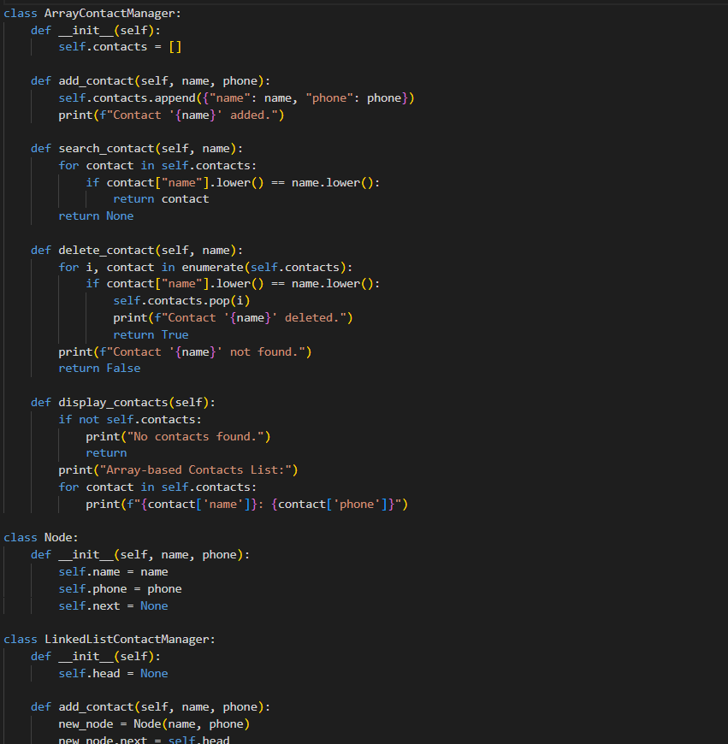

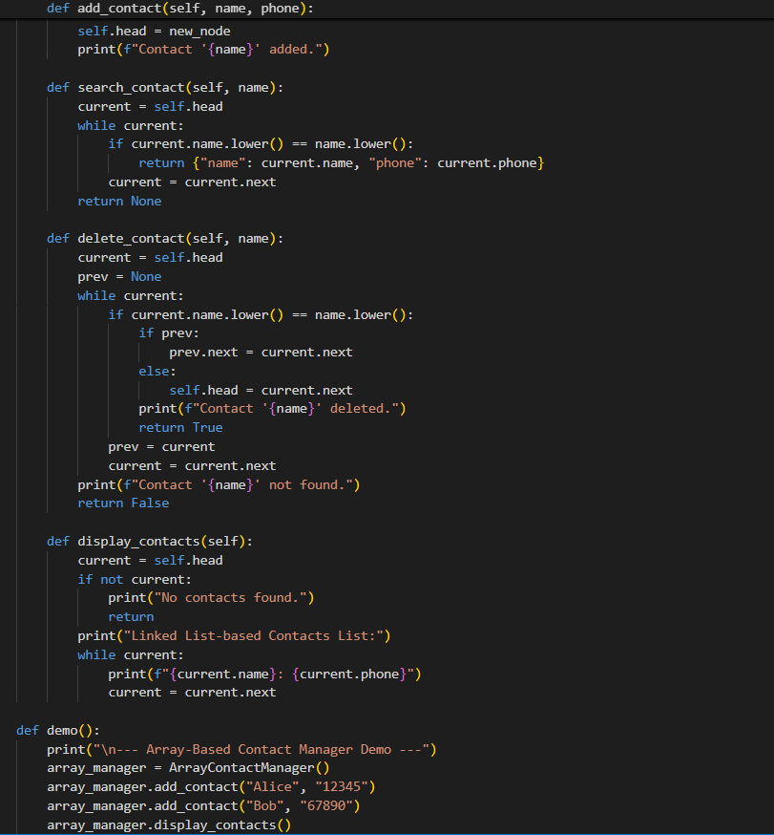
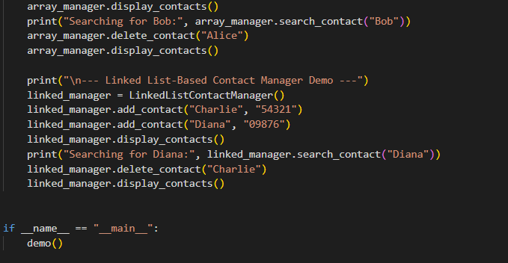

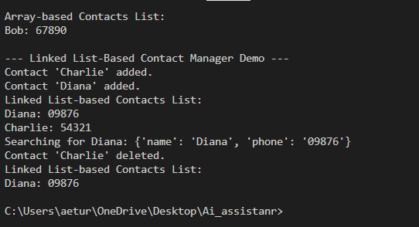

Explaination :
- This code defines two contact manager classes: ArrayContactManager and LinkedListContactManager.
- Each class provides methods to add, search, delete, and display contacts. The demo function demonstrates the functionality of both implementations.

Task 2:
1. Implement a Queue (FIFO) to manage book requests.
2. Extend the system to a Priority Queue, prioritizing faculty requests.
3. Use GitHub Copilot to assist in generating:
- enqueue() method
- dequeue() method
4. Test the system with a mix of student and faculty requests.

prompt: Implement a queue data structure to manage book requests in a library. Each request should include the requester's name, type (student or faculty), and the book title. The queue should follow the First-In-First-Out (FIFO) principle. Include methods to enqueue a request, dequeue a request, and display the current queue.

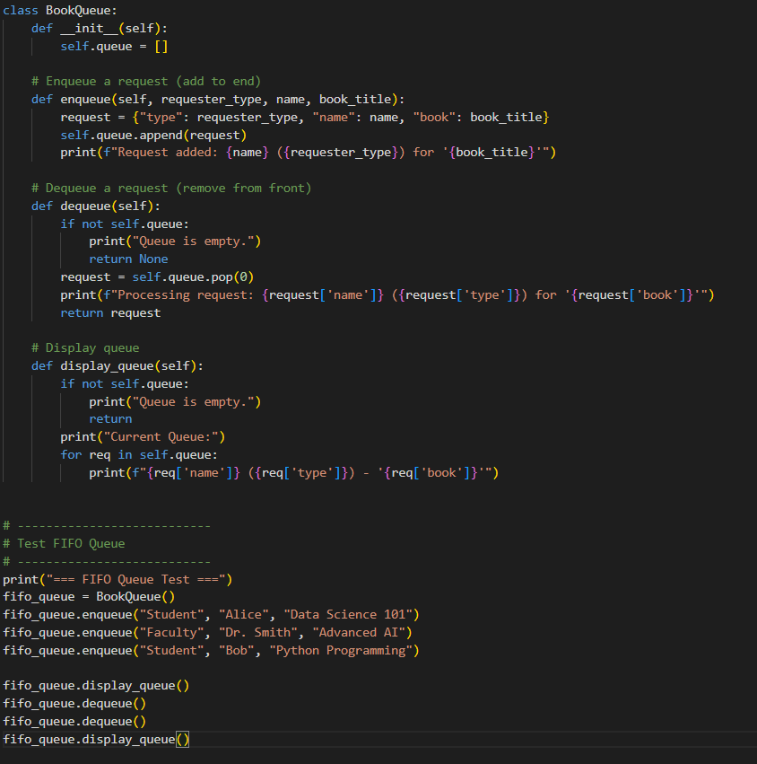

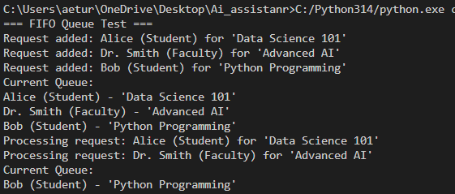

Explaination :
- The FIFO (First In, First Out) queue ensures that requests are processed in the order they were added.
- In this example, Alice's request is processed first, followed by Dr. Smith's request.
- Bob's request remains in the queue and is processed last.

Task 3:
Emergency Help Desk (Stack Implementation)
Scenario
SR University’s IT Help Desk receives technical support tickets from students
and staff. While tickets are received sequentially, issue escalation follows a
Last-In, First-Out (LIFO) approach.

Prompt:
1. Implement a Stack to manage support tickets.
2. Provide the following operations:
- push(ticket)
- pop()
- peek()
3. Simulate at least five tickets being raised and resolved.
4. Use GitHub Copilot to suggest additional stack operations such as:
o Checking whether the stack is empty
o Checking whether the stack is full (if applicable)

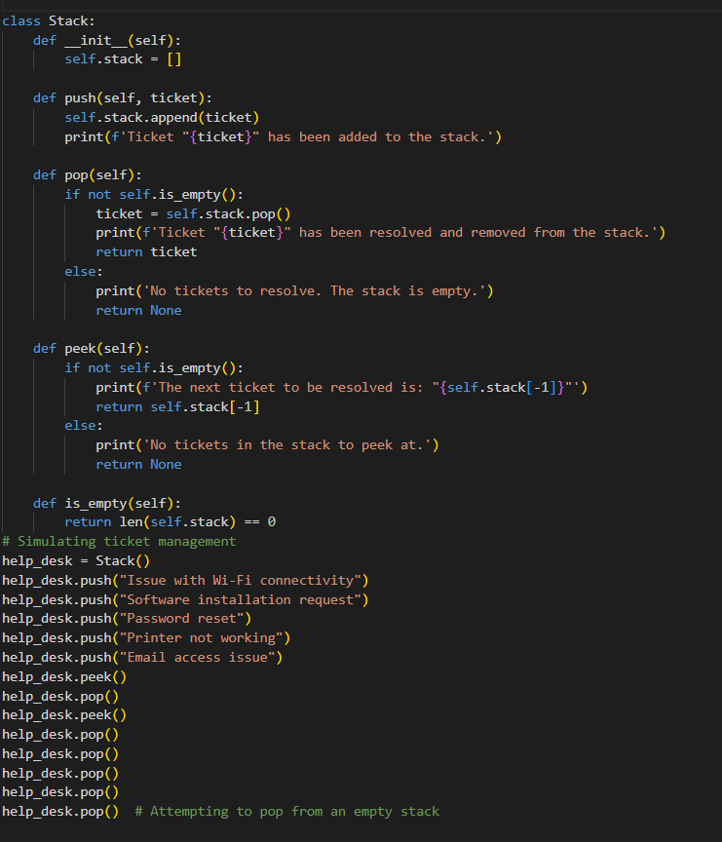

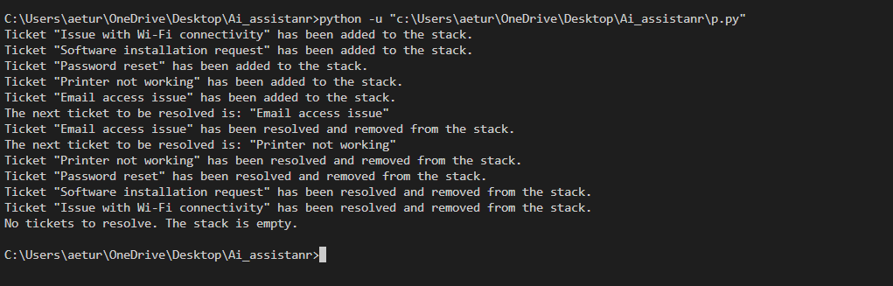Explaination:
- This code defines a Stack class to manage help desk tickets using a Last In, First Out (LIFO) approach.
- The Stack class includes methods to push new tickets, pop resolved tickets, peek at the next ticket, and check if the stack is empty.

Task 4: Hash Table
Objective
To implement a Hash Table and understand collision handling.

Prompt: Implement a hash table in Python that supports insert, search, and delete operations. Use chaining to handle collisions. Provide well-commented code for each method.

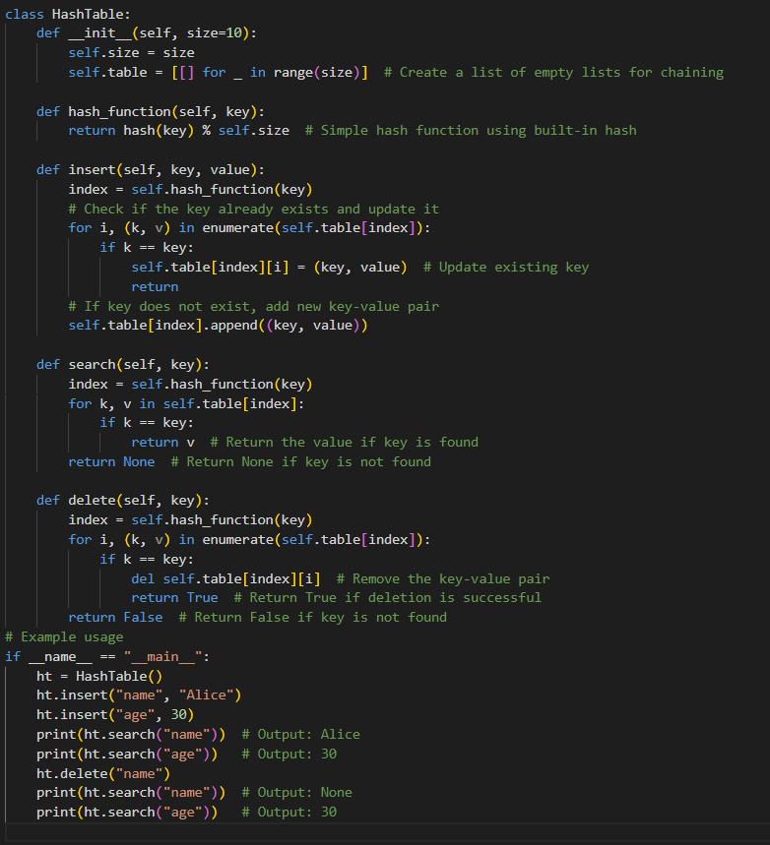

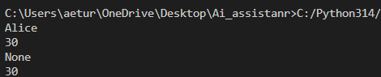

Explanation:
- The HashTable class implements a hash table using chaining to handle collisions.
- The insert, search, and delete methods allow for adding, retrieving, and removing key-value pairs from the hash table.

Task 5:
Real-Time Application Challenge
Scenario
Design a Campus Resource Management System with the following
features:
• Student Attendance Tracking
• Event Registration System
• Library Book Borrowing
• Bus Scheduling System
• Cafeteria Order Queue

Prompt :
1. Choose the most appropriate data structure for each feature.
2. Justify your choice in 2–3 sentences.
3. Implement one selected feature using AI-assisted code generation.
Expected Outcome
• Mapping table: Feature → Data Structure → Justification
• One fully working Python implementation
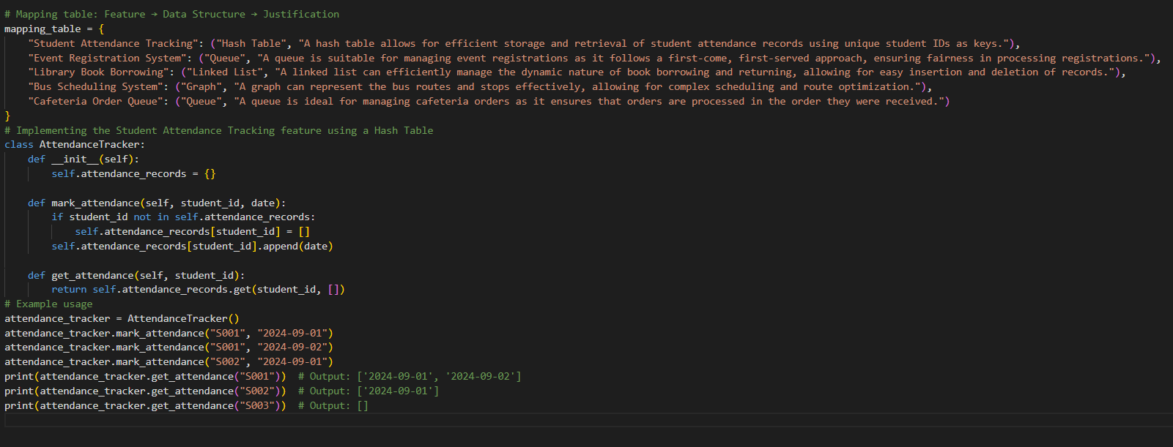

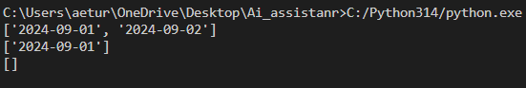

Explanation:
- The hash table (dictionary) is efficient for storing and retrieving attendance records.
- It allows O(1) average time complexity for both marking and retrieving attendance data.

