ASSIGNMENT 1
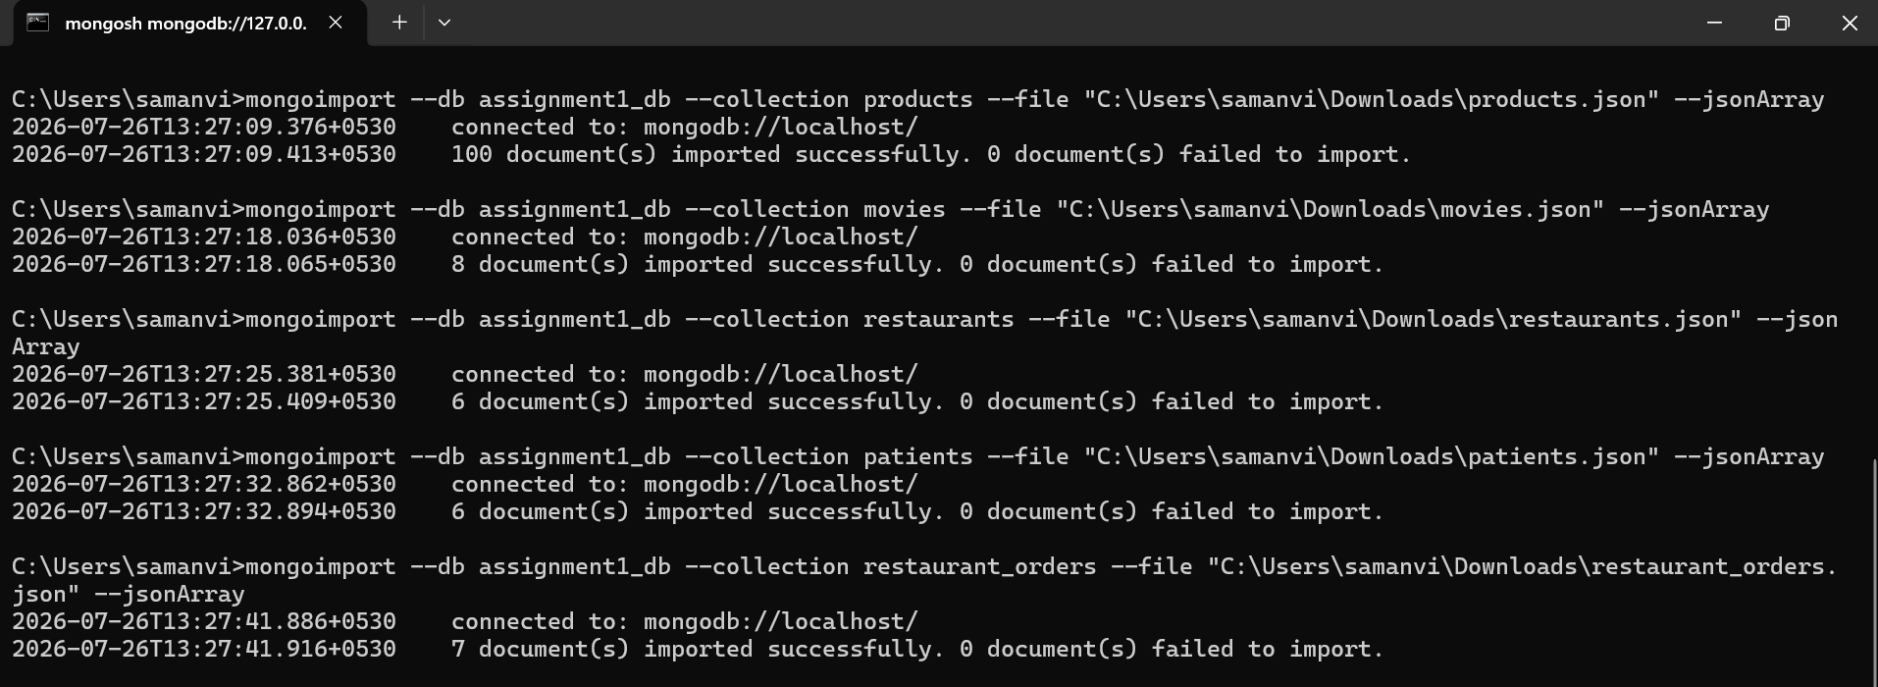
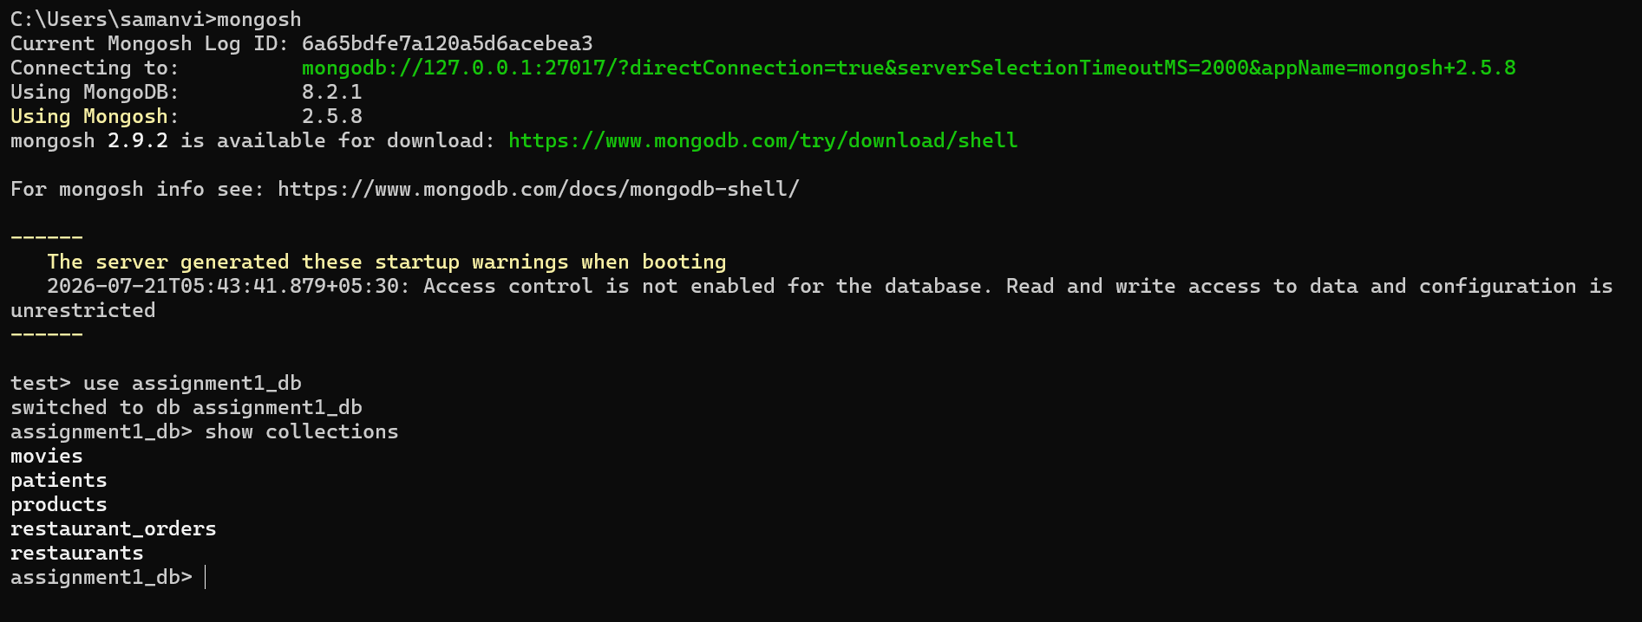
Basic CRUD Operations
Assignment Exercises: -
Amazon Product Management System(products.json)
Scenario 1 – Low Stock Products
The warehouse manager wants to restock products that are running low. Your task is to display all products whose stock is less than 20. The manager requires the Product ID, Product Name, Stock, and Brand.
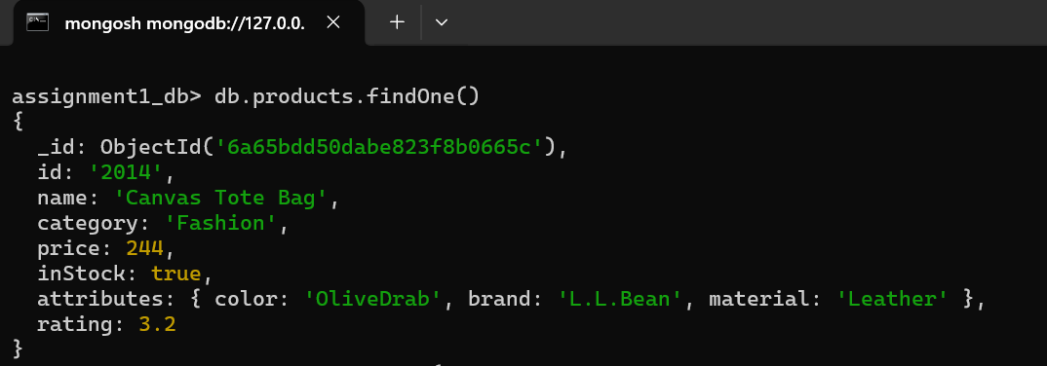
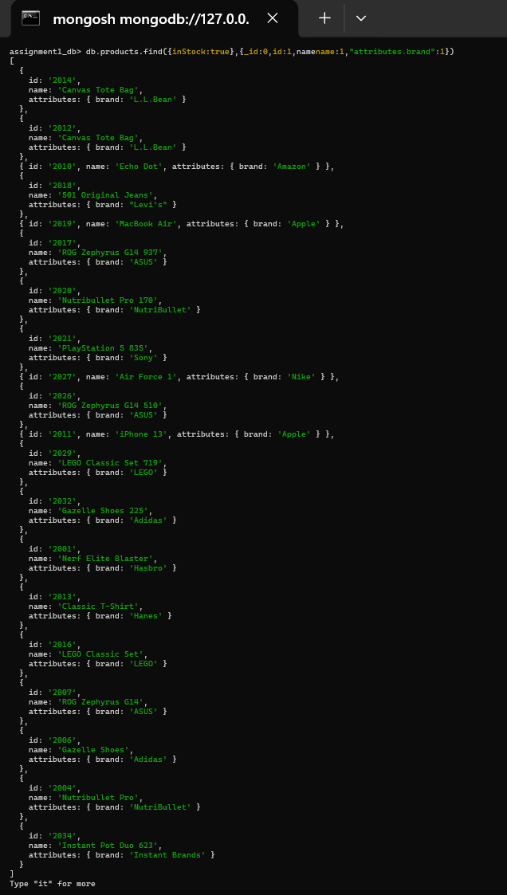

Scenario 2 – Premium Product Listing
The marketing team is preparing a premium product catalogue. Display all products costing more than ₹10,000. The results should be arranged from the most expensive to the least expensive.
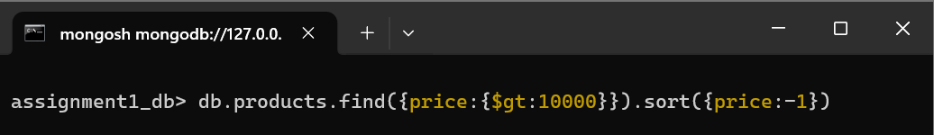
Scenario 3 – Homepage Display
The Amazon homepage displays only the first five featured products. Retrieve only the first five products from the collection.
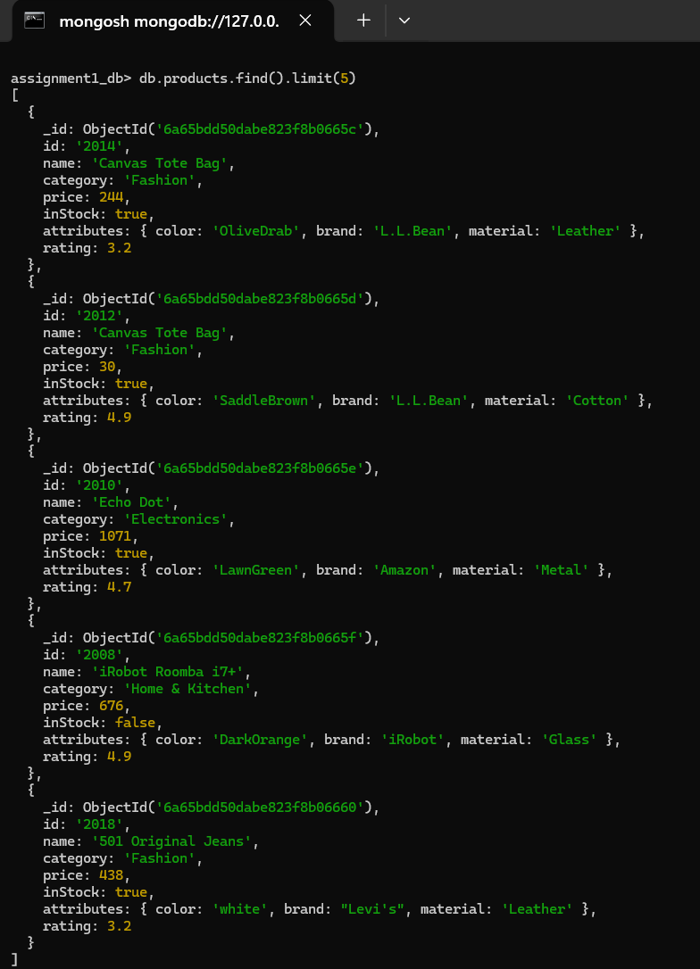

Scenario 4 – Product Pagination
Customers are viewing the second page of products. Each page displays five products. Retrieve only the products that should appear on the second page.
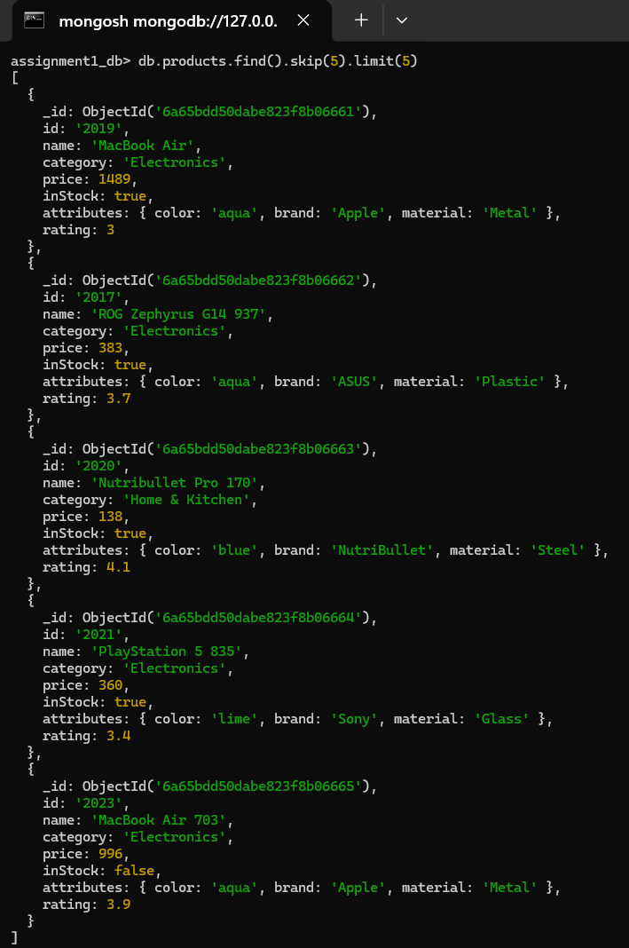

Scenario 5 – Electronics Search
A customer searched for all Electronics products. Display only the Product Name, Price, and Rating.
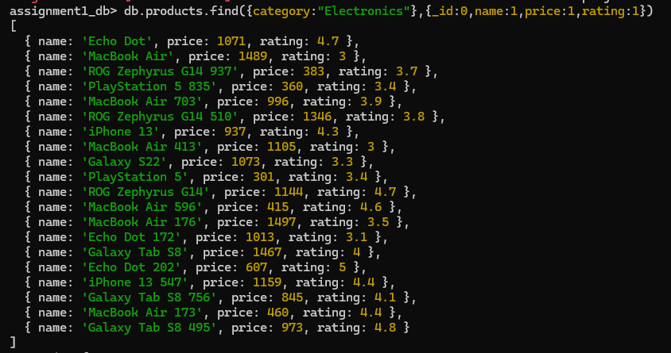

Scenario 6 – Brand Search
A customer remembers that the brand starts with "S" but cannot recall the full name. Retrieve all products whose brand starts with the letter S.
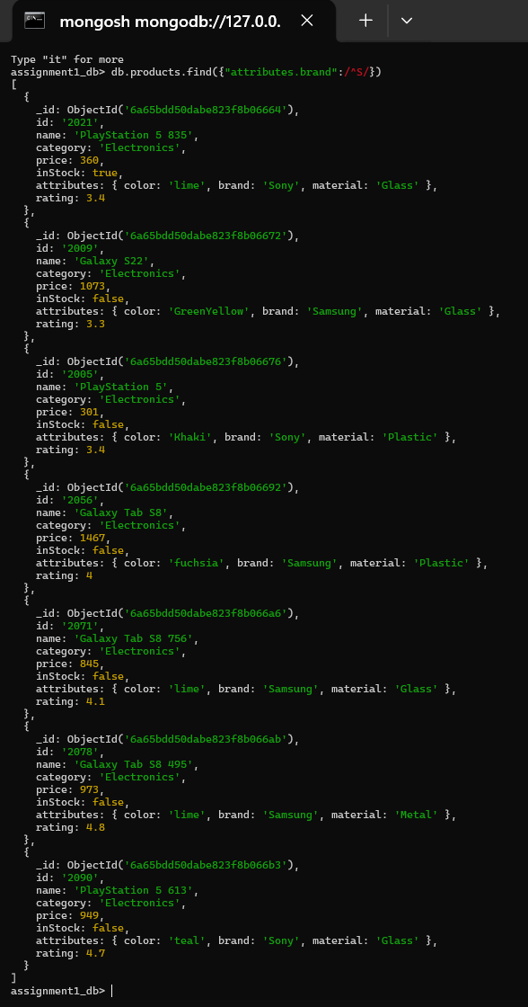

Netflix Movie Database(movies.json)
Scenario 1 – Trending Movies
Netflix wants to promote only highly rated movies. Display all movies with ratings greater than 8.5.
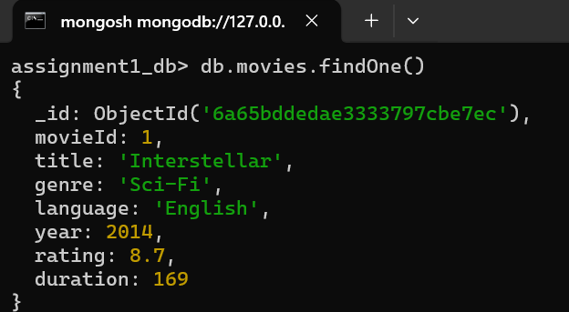
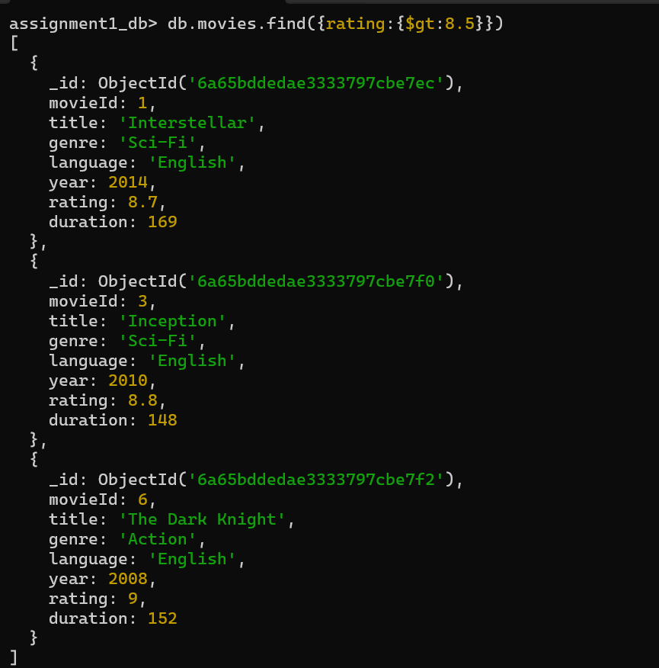
Scenario 2 – Latest Releases
The homepage should display the five most recently released movies.

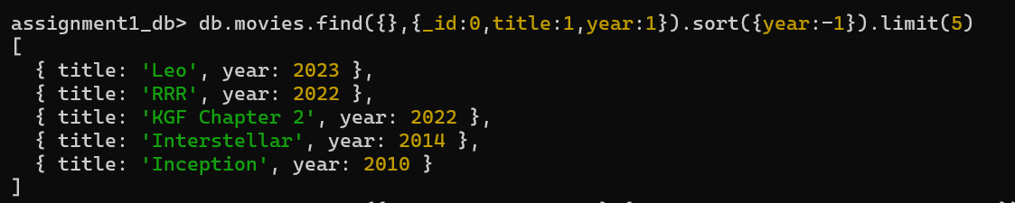
Scenario 3 – English Collection
A user selected the English language filter. Display the movie title, release year, and rating.
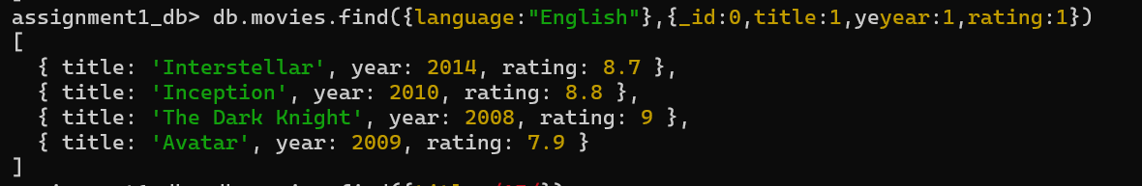
Scenario 4 – Search by Title
A subscriber remembers only that the movie title starts with "I". Retrieve all matching movies.
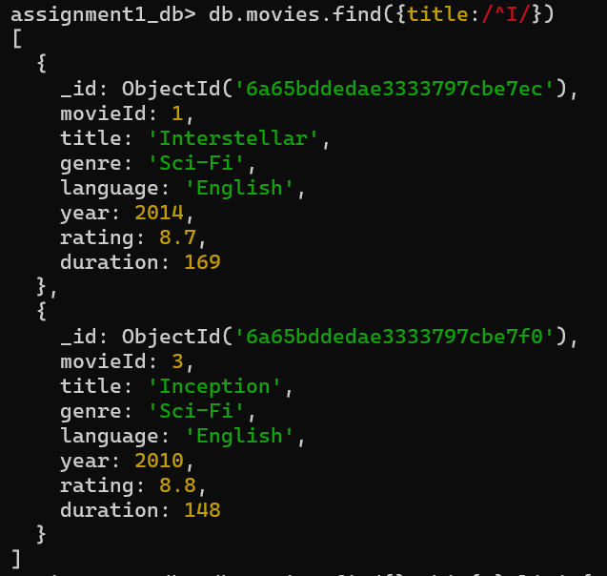
Scenario 5 – Movie Pagination
The Netflix library displays four movies per page. Display the movies shown on Page 3.
Swiggy Restaurant Database(restaurants.json)
Scenario 1 – Fast Delivery
Customers want restaurants delivering within 30 minutes. Display the restaurant name, category, and delivery time.
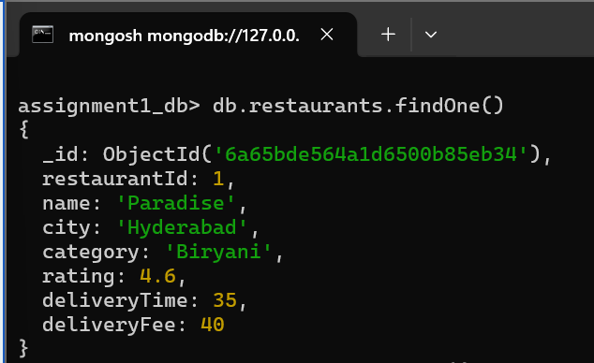
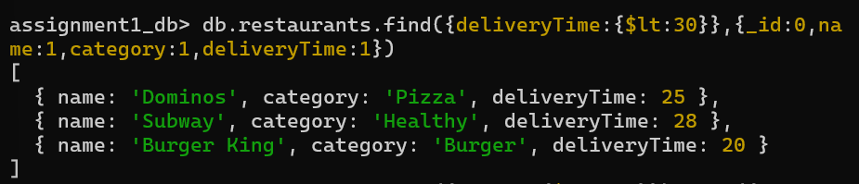
Scenario 2 – Highly Rated Restaurants
Swiggy wants to highlight restaurants with ratings above 4.5. Sort the results from the highest-rated restaurant to the lowest-rated restaurant.
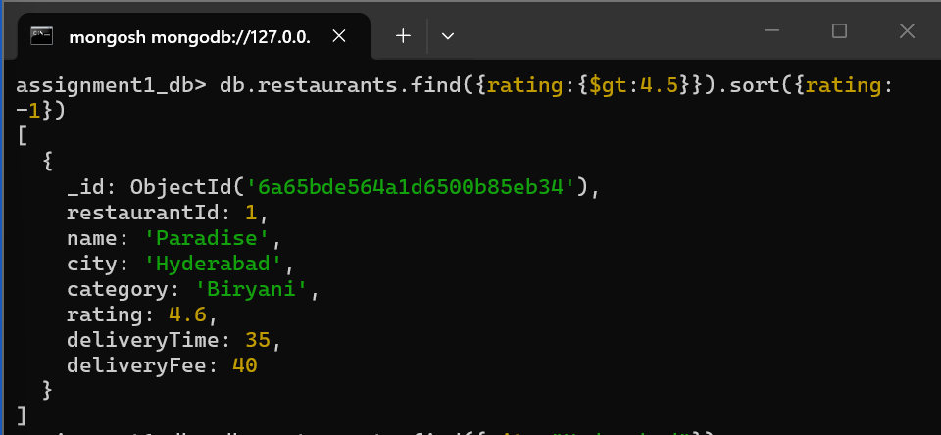

Scenario 3 – Hyderabad Food Search
A customer searches for restaurants available in Hyderabad. Display only the restaurant name and category.

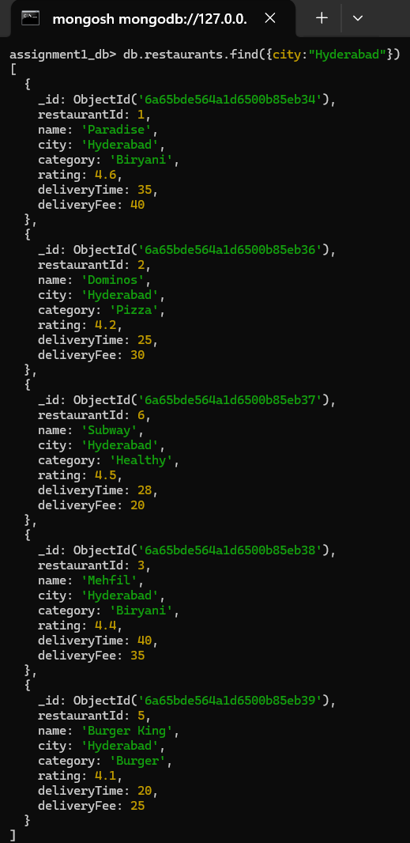
Scenario 4 – Restaurant Pagination
Swiggy displays four restaurants on each page. Retrieve the restaurants that appear on Page 2.

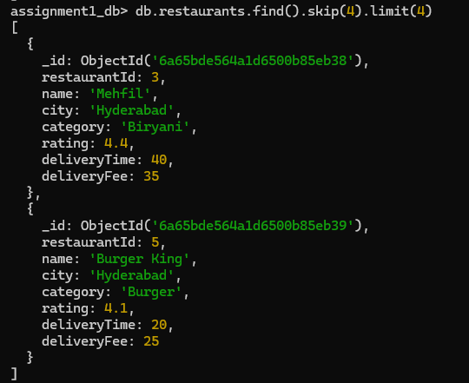

Scenario 5 – Restaurant Name Search
A customer remembers that the restaurant name begins with "P". Retrieve all matching restaurants.

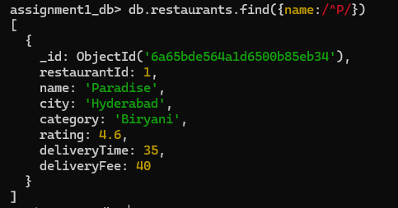
Hospital Management System(patients.json)

Scenario 1 – Senior Patients
The hospital administration wants to review the records of patients aged above 40 years. Display the patient's name, age, disease, and consulting doctor.
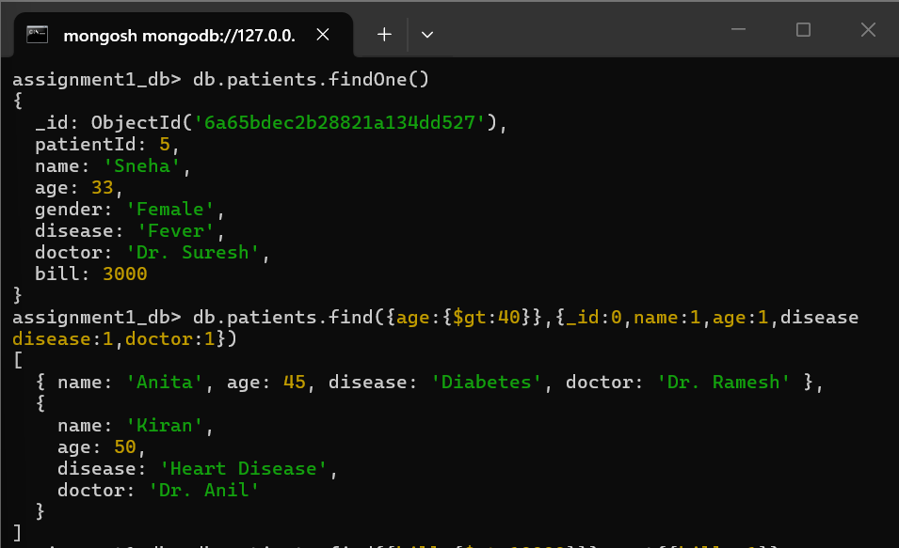

Scenario 2 – Expensive Treatments
The finance department wants to identify patients whose treatment bill exceeds ₹10,000. Arrange the results from the highest bill to the lowest bill.
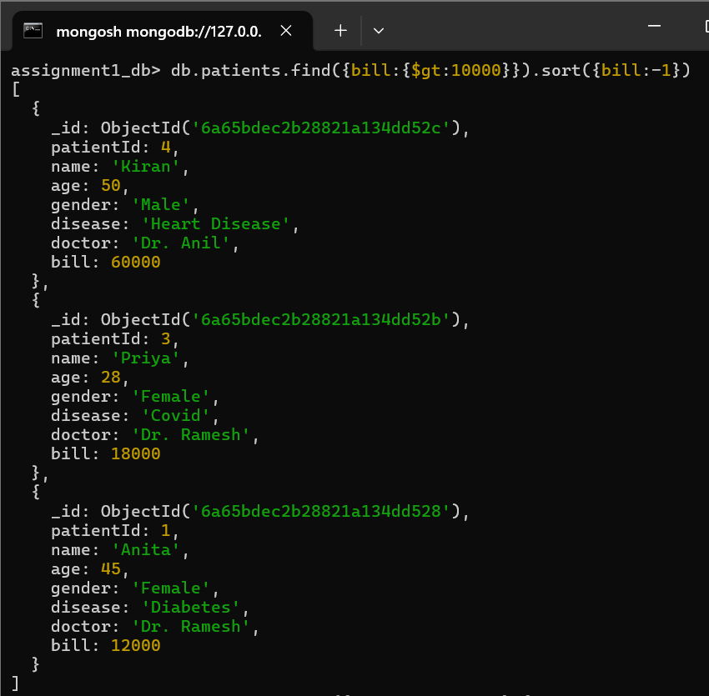

Scenario 3 – Fever Cases
The medical superintendent wants a report of all patients diagnosed with Fever. Display only the patient name and consulting doctor.

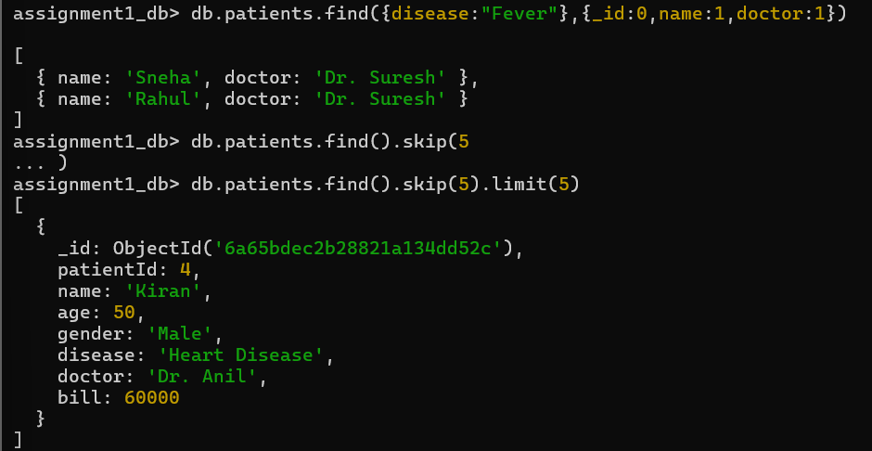
Scenario 4 – Patient Record Pagination
The receptionist displays five patient records per page. Retrieve the records shown on Page 2.
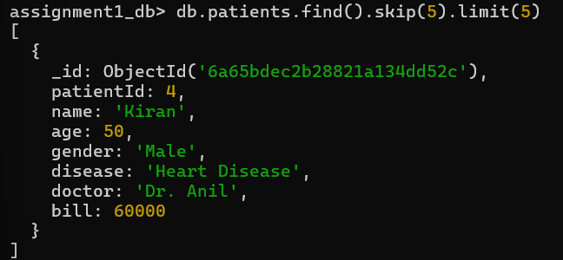

Scenario 5 – Doctor Search
The receptionist remembers that the doctor's name begins with "Dr. R". Retrieve all patients treated by doctors whose names start with Dr. R.

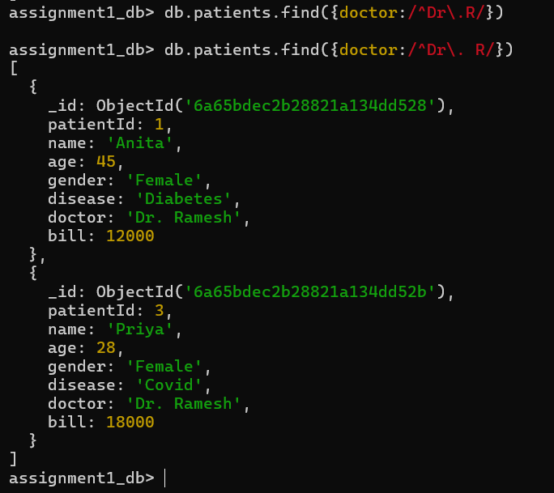

Online Food Delivery System(restaurant_orders.json)
Scenario 1 – High-Value Orders
The finance team wants to analyse high-value orders above ₹800. Display the customer name, restaurant name, city, and order amount.
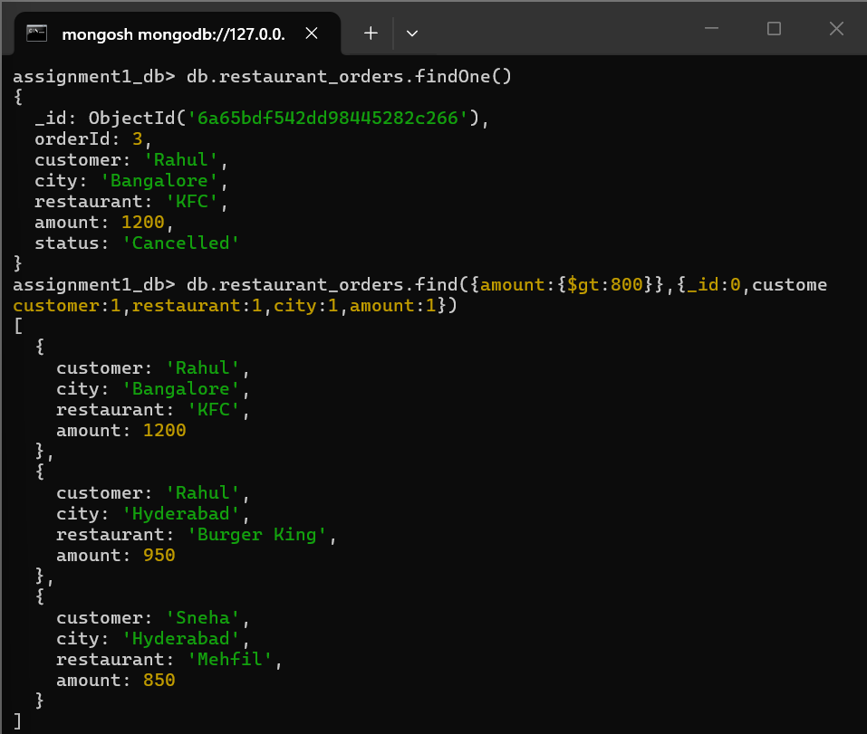

Scenario 2 – Recent Delivered Orders
The operations team wants to review the first five delivered orders.

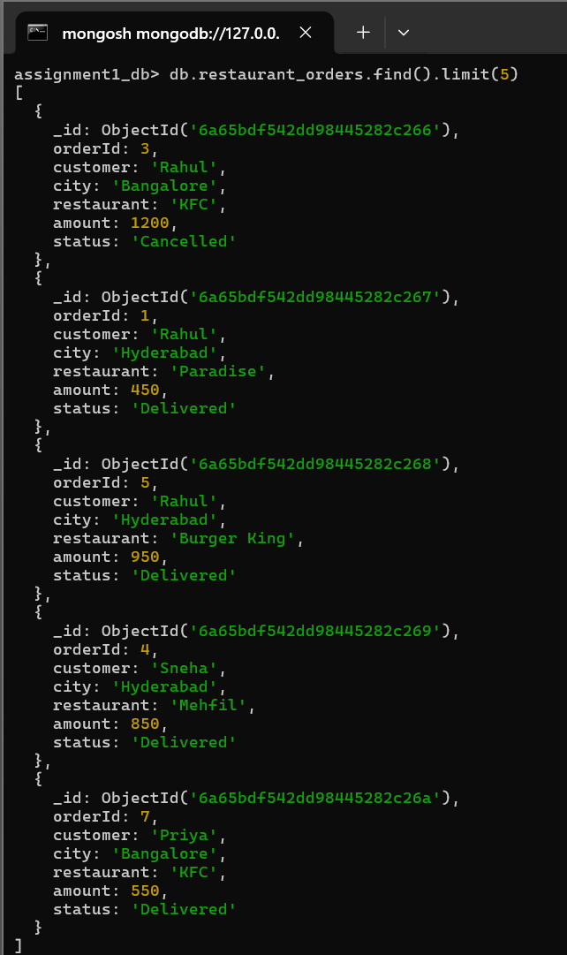

Scenario 3 – Hyderabad Orders
The regional manager wants to view all orders placed from Hyderabad.
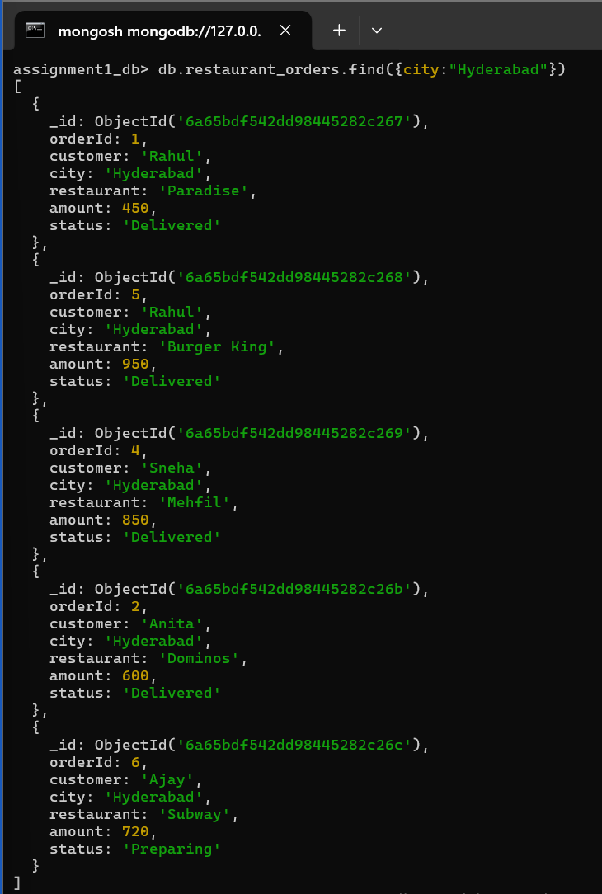

Scenario 4 – Order Pagination
The order history page displays three orders per page. Retrieve the orders shown on Page 3.
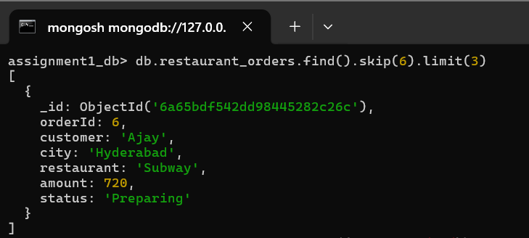

Scenario 5 – Customer Search
Customer support remembers only that the customer's name starts with "R". Retrieve all matching customer records.
