  - STAR UML – for software design and modelling
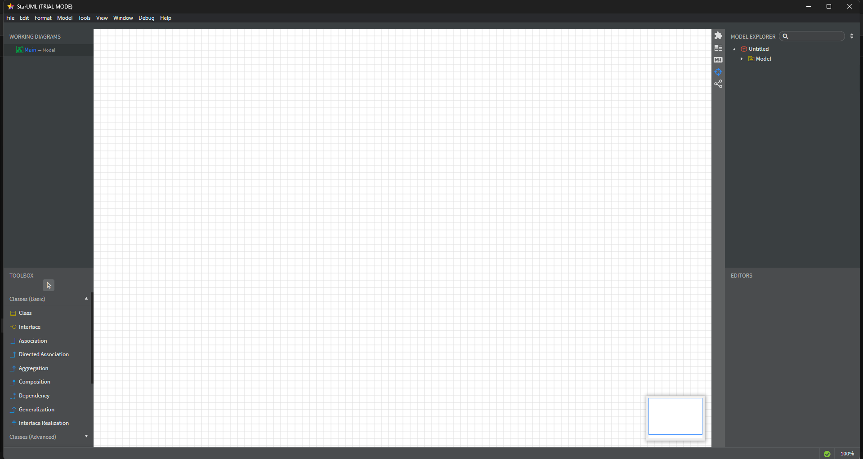
  - Git Bash – for version control and Git command-line usage
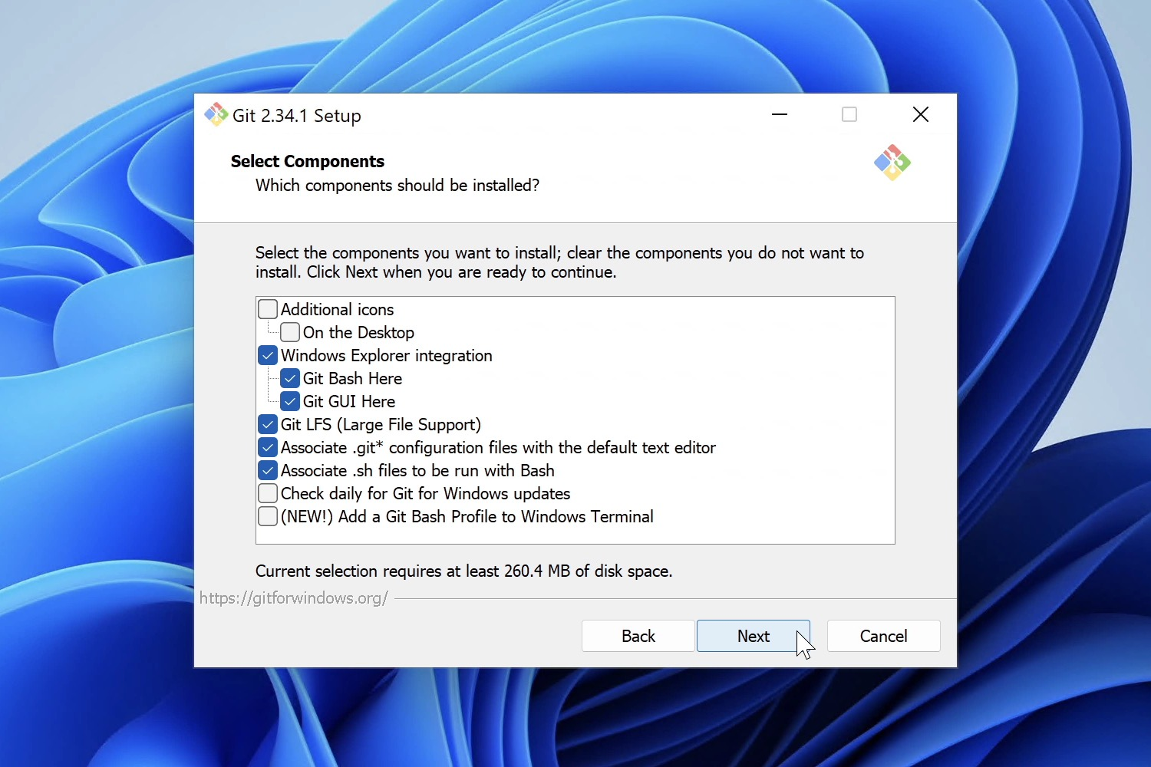
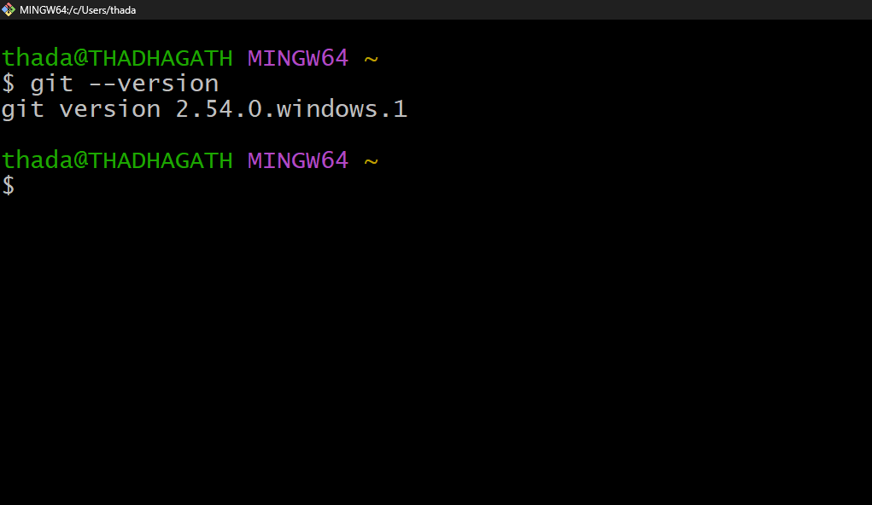
  - Eclipse IDE – for Java and web development
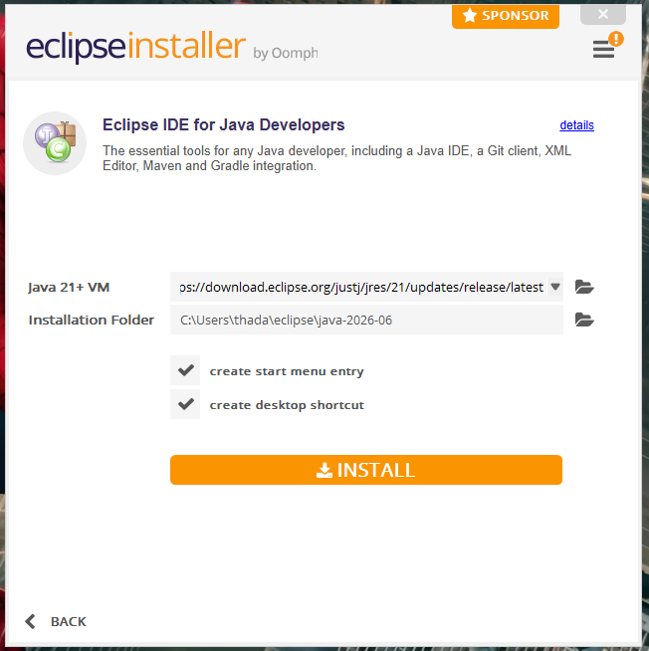

  - Apache Tomcat – as a servlet container for web applications
  - Java Development Kit (JDK) – versions 11, 17, or 21 as required
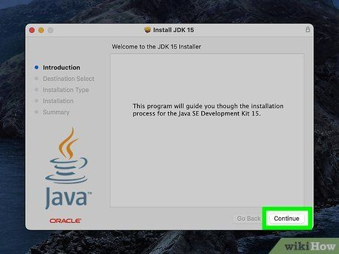
  - Docker Desktop – for containerization
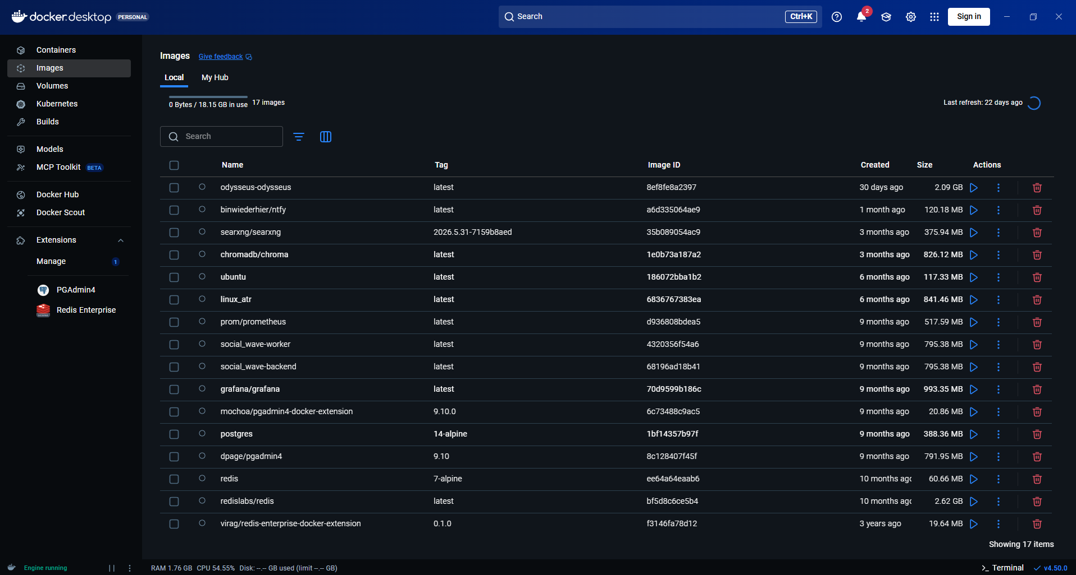
  - Jenkins – for continuous integration/continuous delivery (CI/CD)
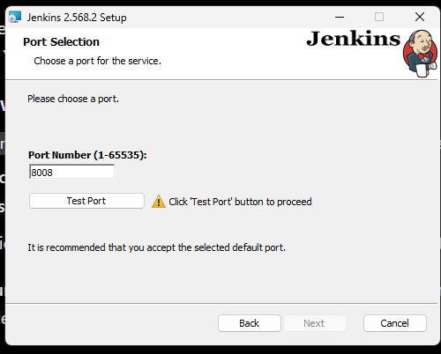
  - Minikube – to run Kubernetes locally
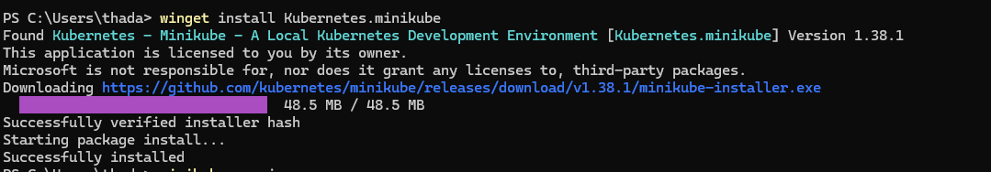
  - Nagios – for system and network monitoring

  - Apache Maven to manage project dependencies and build automation.

