LAB ACTION PLAN
Objective:
To set up a complete development and deployment environment by performing the following tasks:
- Install essential software and DevOps tools including:
  - STAR UML – for software design and modelling
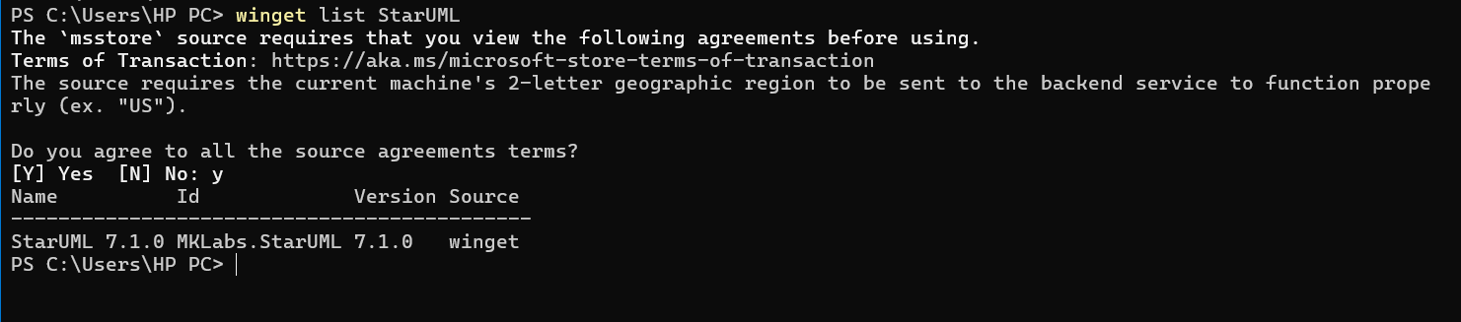
  - Git Bash – for version control and Git command-line usage
  - Eclipse IDE – for Java and web development

  - Apache Tomcat – as a servlet container for web applications
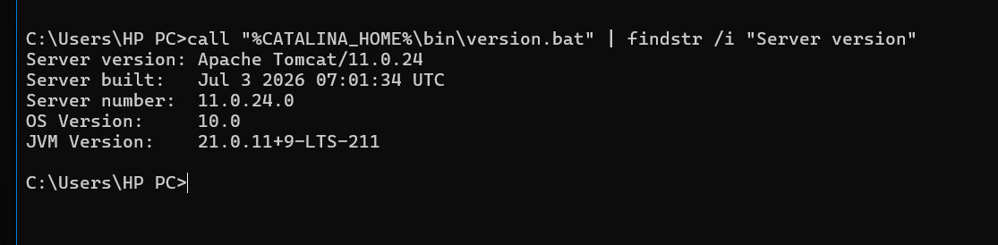
  - Java Development Kit (JDK) – versions 11, 17, or 21 as required
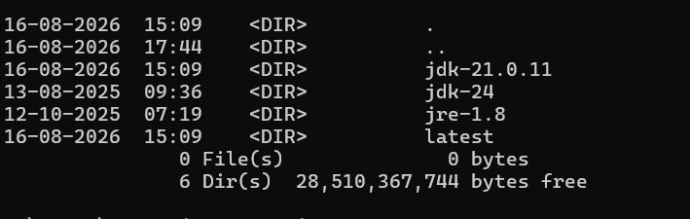
  - Docker Desktop – for containerization
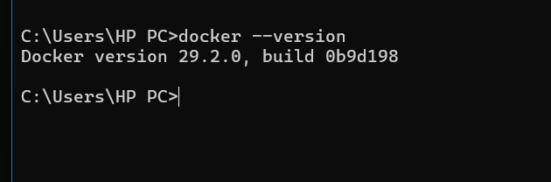
  - Jenkins – for continuous integration/continuous delivery (CI/CD)
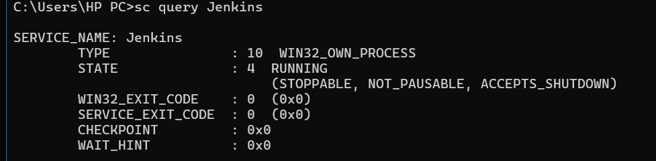
  - Minikube – to run Kubernetes locally
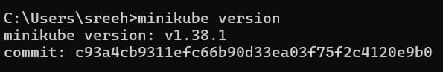
  - Nagios – for system and network monitoring
  - Apache Maven to manage project dependencies and build automation.
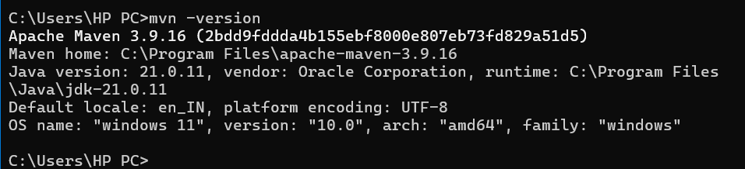
- To prepare for the III/I project by completing the following essential components of the project documentation and design:
Generative AI Assisted Telemedicine Platform for Personalized Gut Microbiome Analysis
- Abstract :-
Metabolic diseases are influenced by multiple interconnected factors, including an individual’s gut microbiome, clinical characteristics, and continuously changing physiological conditions. Conventional disease prediction approaches often rely on a single or limited set of data sources, which may not provide a comprehensive representation of an individual’s health status. This project proposes an AI-driven platform for integrating gut microbiome profiles, clinical data, and wearable sensor data to support personalized metabolic disease prediction and decision-making.
The proposed system combines these heterogeneous data sources through a unified data processing and fusion framework and applies machine learning techniques to identify patterns associated with metabolic diseases. To improve the transparency and trustworthiness of the predictions, Explainable Artificial Intelligence (XAI) techniques are incorporated to provide understandable reasons behind the model’s predictions. Based on the predicted health condition and individual characteristics, the system generates personalized recommendations. In addition, Generative AI is used to transform prediction and analysis results into concise, clinician-friendly summaries that can support healthcare decision-making.
The platform also supports continuous remote monitoring by incorporating periodically collected wearable and health-related data, enabling changes in an individual’s health status to be observed over time. By combining multimodal health data, predictive analytics, explainability, personalized recommendations, and generative reporting within a unified framework, the proposed system aims to provide a more comprehensive and interpretable approach to metabolic disease prediction and decision support.
- Functional Requirements –
The proposed AI-driven platform shall provide the following functional requirements:
- Data Collection
  - The system shall collect gut microbiome data, clinical data, and wearable sensor data from the respective data sources.
  - The system shall accept health-related data in appropriate structured formats for further processing.
- Data Preprocessing
  - The system shall preprocess the collected data to handle missing values, inconsistent values, noise, and irrelevant features.
  - The system shall perform appropriate normalization, encoding, feature selection, and transformation for different types of input data.
- Multimodal Data Integration
  - The system shall integrate gut microbiome, clinical, and wearable sensor data into a unified representation.
  - The system shall align and combine relevant features from the different data modalities before prediction.
- Metabolic Disease Prediction
  - The system shall use machine learning models to predict the likelihood of relevant metabolic diseases or health conditions.
  - The system shall generate a prediction based on the integrated multimodal data.
- Prediction Confidence
  - The system shall provide an appropriate confidence or probability score associated with the generated prediction.
  - The system shall distinguish between different prediction outcomes based on the model's output.
- Explainable AI
  - The system shall explain the factors that contribute to the generated prediction.
  - The system shall identify important features from clinical, microbiome, and wearable data that influence the prediction.
  - The explanations shall be presented in an understandable form rather than providing only a black-box prediction.
- Personalized Recommendations
  - The system shall generate recommendations based on the individual's predicted condition, health-related characteristics, and relevant contributing factors.
  - The recommendations shall be personalized according to the available multimodal health information.
- Generative AI-Based Clinical Summary
  - The system shall generate a concise, clinician-friendly summary of the individual's prediction and analysis results.
  - The summary shall incorporate relevant prediction results, important contributing factors, explanations, and personalized recommendations.
  - The generated summary shall be presented in an understandable format to support clinical decision-making.
- Continuous Remote Monitoring
  - The system shall process periodically collected wearable and health-related data.
  - The system shall identify meaningful changes in monitored health parameters over time.
  - The system shall support updating the prediction and recommendations when new relevant data becomes available.
- Data and Prediction History
- The system shall maintain relevant historical health data and prediction results.
- The system shall allow changes in prediction-related information to be analyzed over time.
- Result Visualization
- The system shall present prediction results, important contributing factors, monitoring information, and recommendations in an understandable manner.
- The system shall provide suitable visual representations where required to assist interpretation of the results.
- System Integration
- The system shall provide communication between the data processing, multimodal fusion, prediction, explainability, recommendation, generative AI, and monitoring components.
- The system shall ensure that the output of one processing stage can be appropriately utilized by the subsequent stage.
Non-Functional Requirements .
The proposed AI-driven platform shall satisfy the following non-functional requirements:
- Performance
  - The system should process the integrated health data within a reasonable response time.
  - Prediction and explanation results should be generated efficiently without unnecessary processing delays.
  - The system should maintain acceptable performance as the amount of input data increases.
- Accuracy and Reliability
  - The prediction model should provide reliable and consistent results.
  - The system should minimize errors during data preprocessing, integration, prediction, and result generation.
  - The system should provide consistent outputs when the same valid input data is processed under the same conditions.
- Scalability
  - The system should be capable of handling increasing volumes of microbiome, clinical, and wearable sensor data.
  - The architecture should allow additional data sources, machine learning models, and processing components to be incorporated in the future.
- Security
  - The system should protect sensitive health-related data from unauthorized access.
  - Data should be securely handled during storage, processing, and communication.
  - Access to system resources and data should be appropriately controlled.
- Privacy
  - The system should maintain the privacy and confidentiality of individual health data.
  - Personally identifiable information should be minimized or protected wherever applicable.
  - Health data should not be exposed to unauthorized users or components.
- Usability
  - Prediction results, explanations, recommendations, and generated summaries should be presented in a clear and understandable manner.
  - The system should provide an intuitive interface for users interacting with the platform.
  - Important health information should be easy to identify and interpret.
- Explainability and Transparency
  - The system should provide understandable explanations for its predictions.
  - The explanation mechanism should clearly identify important contributing factors.
  - The system should avoid presenting AI predictions as unexplained or purely black-box outputs.
- Maintainability
  - The system should be modular so that individual components can be modified or replaced without significantly affecting the entire system.
  - The software should follow a structured architecture and maintainable coding practices.
  - Machine learning models and processing components should be replaceable or updatable when required.
- Interoperability
  - The system should support the integration of data originating from different sources and formats.
  - The architecture should allow communication between the data processing, fusion, prediction, XAI, recommendation, generative AI, and monitoring components.
- Availability
- The system should remain available for processing health data and generating results whenever required.
- The monitoring component should be capable of processing newly available data without requiring complete system reinitialization.
- Extensibility
- The system should allow additional metabolic diseases, health parameters, wearable devices, and data modalities to be incorporated in future versions.
- New AI models and explanation techniques should be incorporable without redesigning the entire system.
- Data Integrity
- The system should preserve the correctness and consistency of data throughout collection, preprocessing, integration, storage, and analysis.
- Invalid or corrupted input data should be identified and appropriately handled.
- Fault Tolerance
- The system should handle missing, incomplete, or temporarily unavailable data sources without causing complete system failure.
- Failures in an individual processing component should be handled gracefully wherever possible.
Identification of Users –
The proposed AI-driven platform involves the following users and stakeholders:
1. Clinician / Healthcare Professional
The clinician is the primary decision-support user of the system. The clinician can review the patient's integrated health information, metabolic disease prediction, prediction explanations, personalized recommendations, and Generative AI-based clinical summary. The system provides these outputs to assist the clinician in making informed decisions.
2. Patient / Individual
The patient is the individual whose health-related data is analyzed by the system. The patient's gut microbiome data, clinical information, and wearable sensor data are used for prediction and monitoring. The patient can benefit from personalized recommendations and continuous monitoring of relevant health information.
3. System Administrator
The system administrator is responsible for maintaining the operational aspects of the platform. This may include managing system configuration, monitoring system components, maintaining data and model services, and ensuring that the platform operates correctly.
4. Machine Learning / AI Model
The AI model acts as an internal system component rather than a human user. It processes the integrated multimodal health data and produces metabolic disease predictions and associated confidence scores.
5. External Data Sources / Wearable Devices
Wearable devices and other health-data sources act as data providers to the system. They provide continuously or periodically collected physiological and activity-related information that can be incorporated into the monitoring and prediction pipeline.
Primary Human Users: Clinician / Healthcare Professional and Patient / Individual.
Supporting Stakeholders/Components: System Administrator, AI/ML models, and external wearable/data sources.
Modules in the Application –
The proposed AI-driven platform is divided into the following major modules:
1. Data Collection Module
This module collects the required data from different sources, including gut microbiome profiles, clinical records, and wearable sensor data. It acts as the initial entry point for the multimodal health information.
2. Data Preprocessing Module
This module prepares the collected data for analysis. It performs operations such as data cleaning, missing-value handling, normalization, encoding, noise handling, and feature selection according to the requirements of each data type.
3. Multimodal Data Fusion Module
This module combines the processed gut microbiome, clinical, and wearable sensor features into a unified representation. The fusion mechanism enables the prediction system to utilize information from multiple health-data modalities simultaneously.
4. Metabolic Disease Prediction Module
This module applies the trained machine learning model to the fused representation and generates the predicted metabolic disease or health condition along with an associated prediction probability or confidence score.
5. Explainable AI (XAI) Module
This module interprets the prediction generated by the machine learning model. It identifies the important features and factors that contributed to the prediction and converts them into understandable explanations.
6. Personalized Recommendation Module
This module generates individualized recommendations based on the prediction results, important contributing factors, and available patient-specific health information. The recommendations are intended to provide actionable decision-support information.
7. Generative AI Clinical Summary Module
This module uses Generative AI to transform the prediction, explanation, and recommendation outputs into a concise and clinician-friendly summary. It presents the important findings in a structured and understandable form.
8. Continuous Remote Monitoring Module
This module processes newly available wearable and health-related data over time. It tracks relevant changes in the individual's health information and supports updating predictions, explanations, and recommendations when sufficient new data becomes available.
9. Data Storage and Management Module
This module manages the storage and retrieval of relevant health data, processed features, prediction results, explanations, recommendations, and historical monitoring information.
10. User Interface and Visualization Module
This module presents the system outputs in an understandable format. It provides visualization of relevant health information, prediction results, explanations, recommendations, and monitoring trends for the intended users.
Overall Module Flow
Data Collection → Data Preprocessing → Multimodal Data Fusion → Metabolic Disease Prediction → Explainable AI → Personalized Recommendations → Generative AI Clinical Summary
Continuous Remote Monitoring continuously supplies new health-related data back into the processing pipeline, while Data Storage and Management supports the required data throughout the system.
Use Case Diagram –
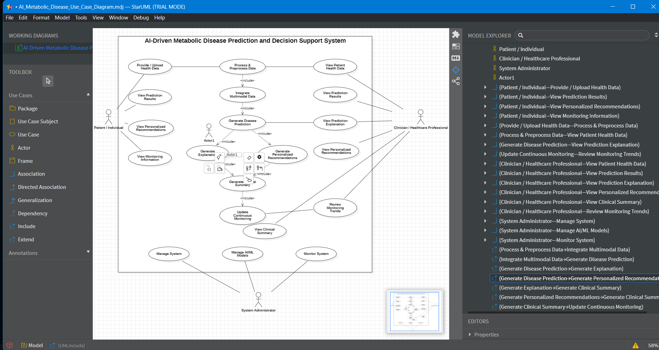
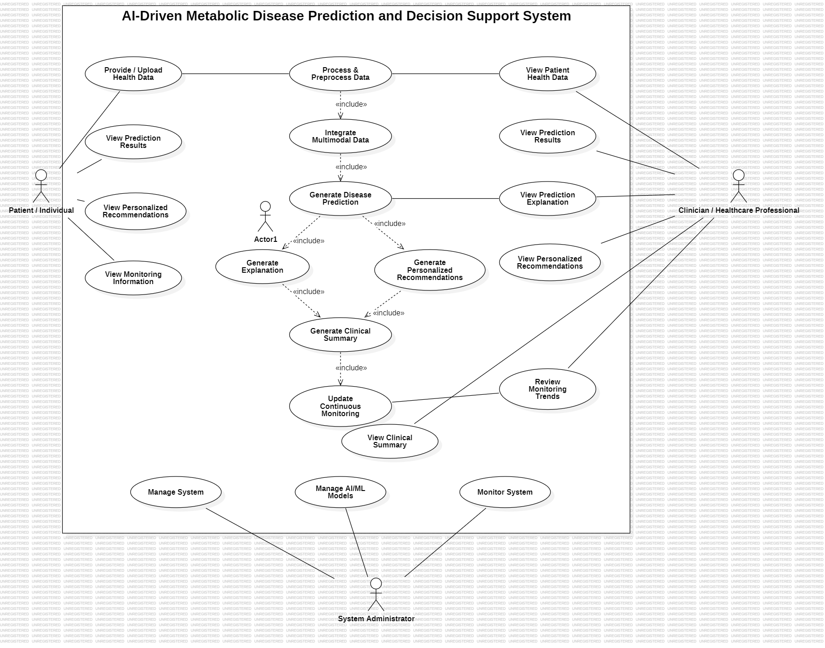
Class Diagram –
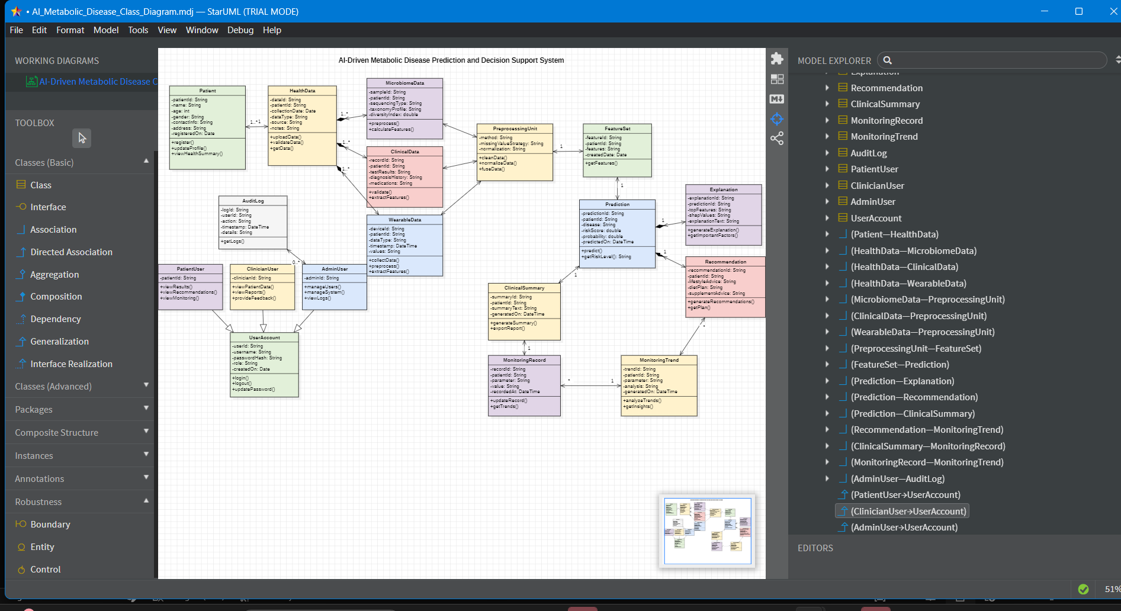
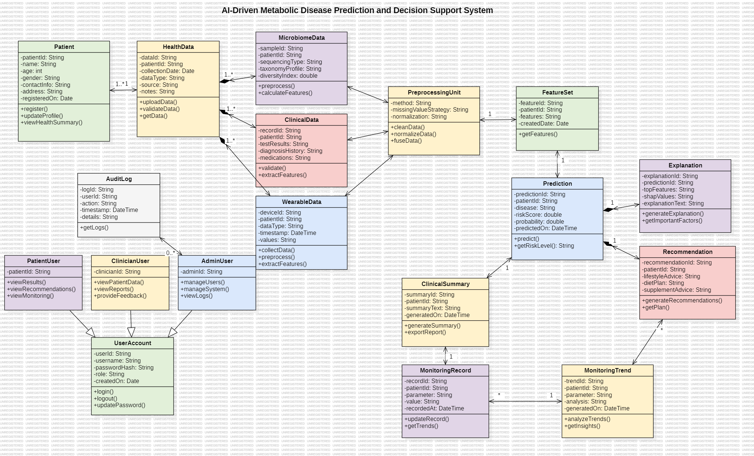
Sequence Diagram –
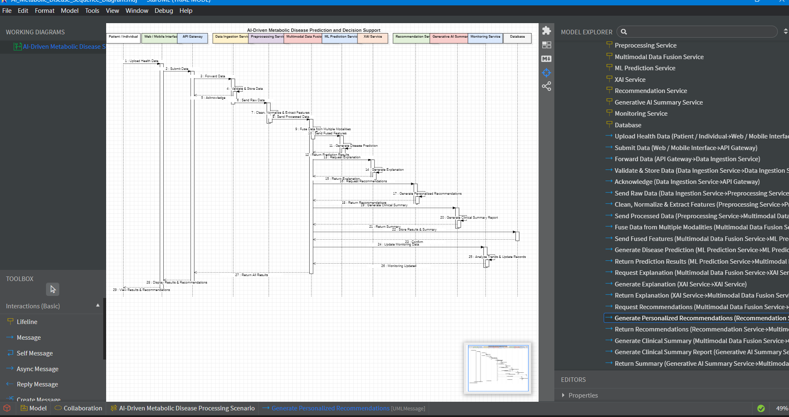
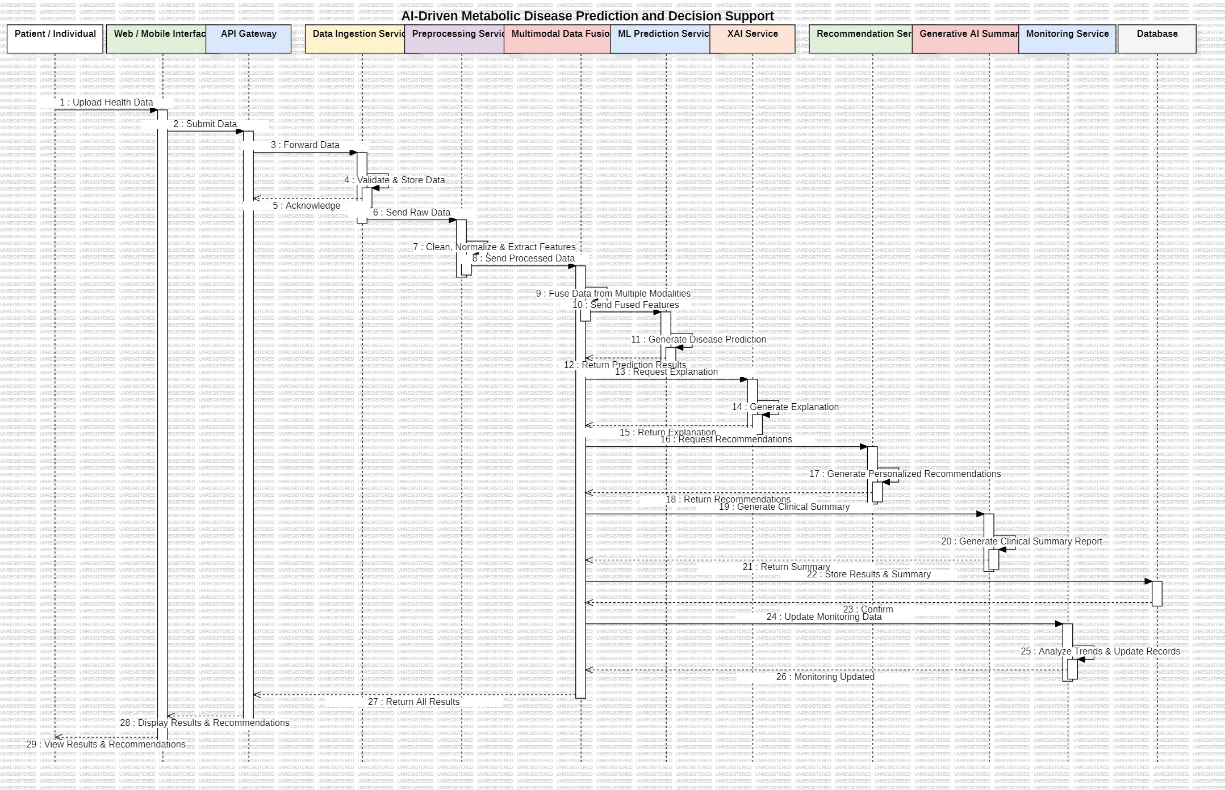
Component Diagram –
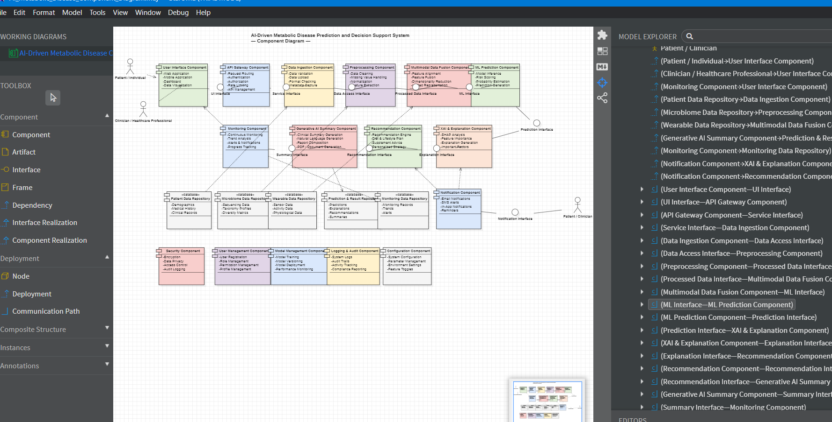

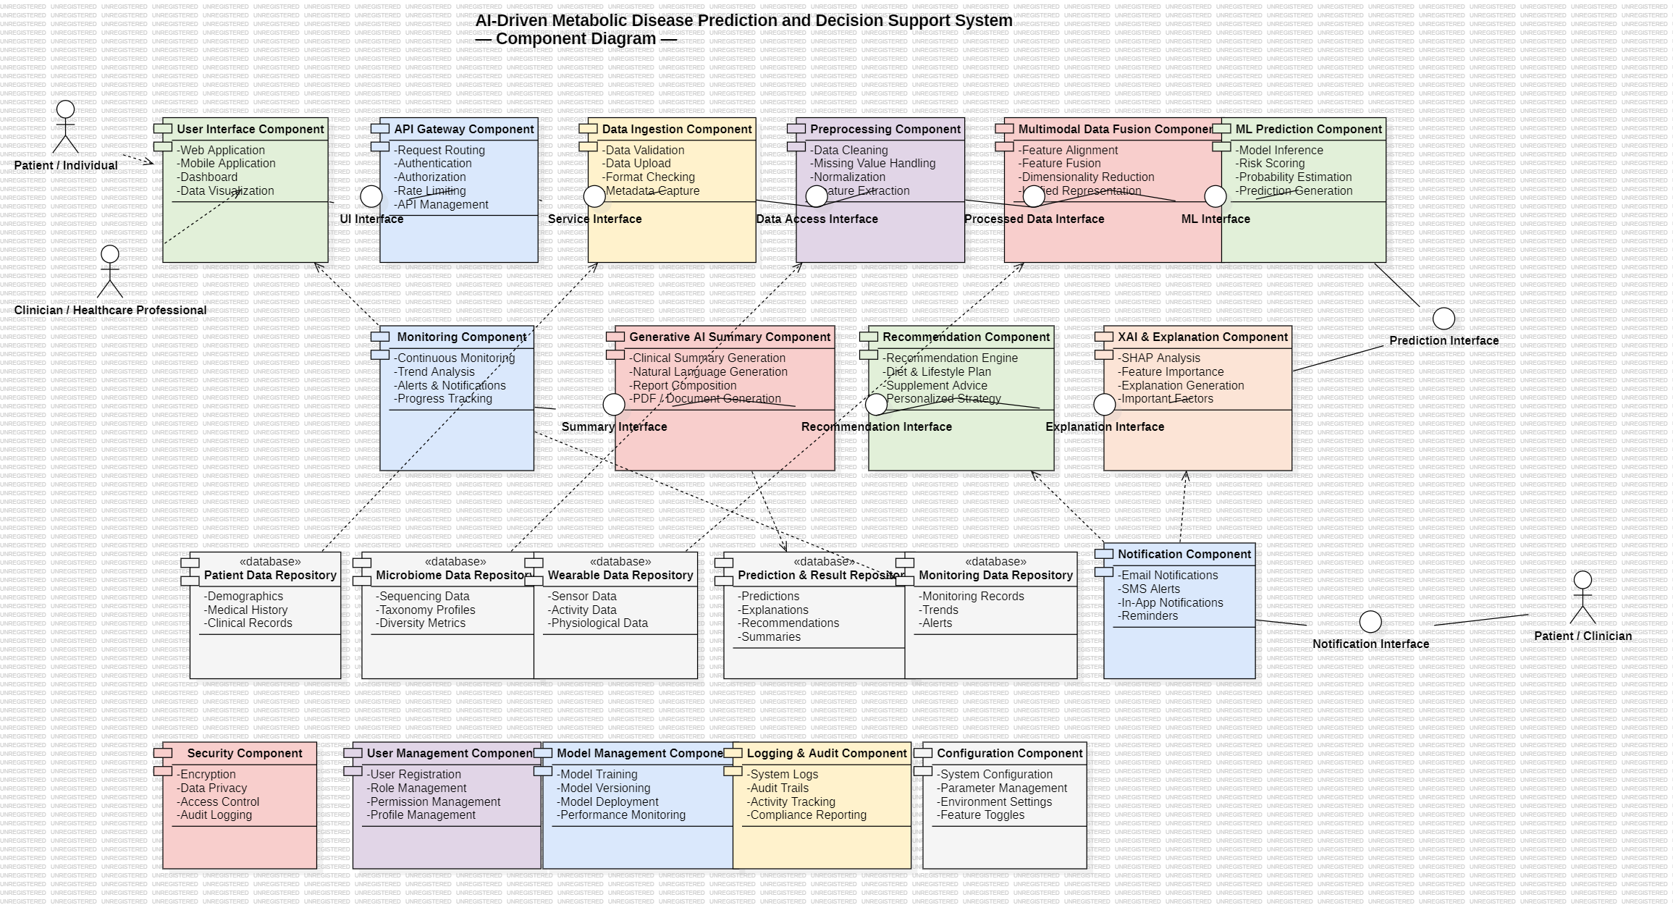
Conclusion:
This objective supports establishing a fully functional environment for end-to-end software development, testing, deployment, and monitoring, laying a strong foundation for project execution and DevOps practices.
Completing the essential components of project documentation and design provides a clear and structured foundation for the successful development of the III/I project. Students gain a thorough understanding of the project’s scope, user interaction, and system behaviour. It also strengthens planning, communication, and problem-solving skills needed for critical competencies for future software engineers and developers.

