**Experiment 1** : REALISATION OF LOGIC GATES

**AIM:** TO simulate all gates using gate level modelling.

**Apparatus:** A Pc running windows with Xilinx Ise design suite installed in it.

**Verilog Program:**

module g_311(

input a_311,

input b_311,

output or_311,

output and_311,

output nand_311,

output nor_311,

output xor_311,

output not_311,

output xnor_311

);

not(not_311,a_311);

or(or_311,a_311,b_311);

and(and_311,a_311,b_311);

nand(nand_311,a_311,b_311);

nor(nor_311,a_311,b_311);

xor(xor_311,a_311,b_311);

xnor(xnor_311,a_311,b_311);

endmodule

**Testbench :**

module tb_g_311;

// Inputs

reg a_311;

reg b_311;

// Outputs

wire or_311;

wire not_311;

wire and_311;

wire nand_311;

wire nor_311;

wire xor_311;

wire xnor_311;

// Instantiate the Unit Under Test (UUT)

g_311 uut (

.a_311(a_311),

.b_311(b_311),

.not_311(not_311),

.or_311(or_311),

.and_311(and_311),

.nand_311(nand_311),

.nor_311(nor_311),

.xor_311(xor_311),

.xnor_311(xnor_311)

);

initial begin

// Initialize Inputs

a_311 = 0;

b_311 = 0;

#20

a_311 = 0;

b_311 = 1;

#30

a_311 = 1;

b_311 = 0;

#40

a_311 = 1;

b_311 = 1;

// Wait 100 ns for global reset to finish

#100;

// Add stimulus here

$finish;

end

initial begin

// Initialize Inputs

$monitor($time,"ns a=%b b=%b not=%b or=%b and=%b nand=%b nor=%b xor=%b xnor=%b",a_311,b_311,not_311,or_311,and_311,nand_311,nor_311,xor_311,xnor_311);

end

endmodule

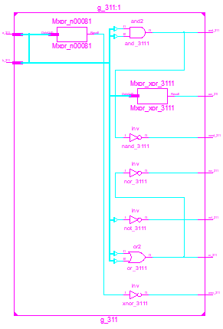

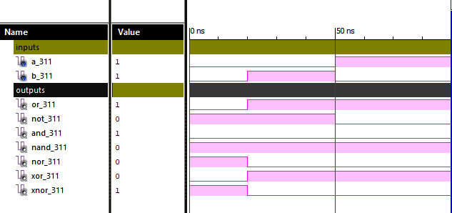

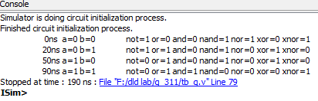

**Result:** Realisation and simulation of all gates are done.

**Experiment 2** : ADDERS AND SUBSTRACTORS

**AIM:** To Write a Verilog HDL program for various adders and Substractors using gate level and data flow modelling and simulate synthesis using Xilinx Ise design suite.

**Apparatus:** A Pc running windows with Xilinx Ise design suite installed in it.

**Verilog Program:**

1. **Half adder using data flow modelling:**

**Data flow**

module ha_311(

input a_311,

input b_311,

output s_311,

output c_311

);

assign s_311= a_311 ^ b_311;

assign c_311= a_311 & b_311;

endmodule

**Test Bench :**

module tb_ha;

// Inputs

reg a_311;

reg b_311;

// Outputs

wire s_311;

wire c_311;

// Instantiate the Unit Under Test (UUT)

ha_311 uut (

.a_311(a_311),

.b_311(b_311),

.s_311(s_311),

.c_311(c_311)

);

initial begin

// Initialize Inputs

a_311 = 0;

b_311 = 0;

#50

a_311 = 0;

b_311 = 1;

#50

a_311 = 1;

b_311 = 0;

#50

a_311 = 1;

b_311 = 1;

// Wait 100 ns for global reset to finish

#100;

$finish;

end

initial begin

$monitor($time," a=%b b=%b c=%b then sum=%b carry=%b",a_311,b_311,c_311,s_311,c_311);

end

endmodule

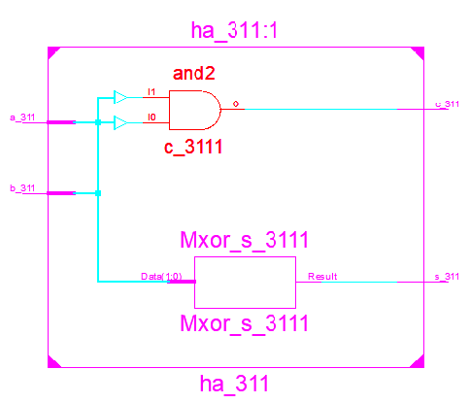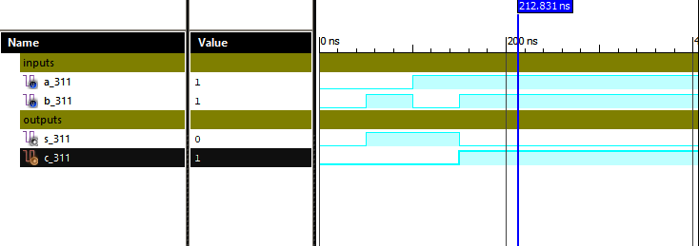

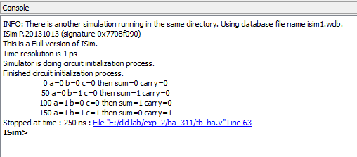

1. **Half subtractor using data flow modelling:**

**Verilog program:**

**Data flow**

module hs_311(

input x_311,

input y_311,

output d_311,

output b_311

);

assign d_311= x_311 ^ y_311;

assign b_311= (~x_311)& y_311;

endmodule

**Test Bench :**

module tb_hs;

// Inputs

reg x_311;

reg y_311;

// Outputs

wire d_311;

wire b_311;

// Instantiate the Unit Under Test (UUT)

hs_311 uut (

.x_311(x_311),

.y_311(y_311),

.d_311(d_311),

.b_311(b_311)

);

initial begin

// Initialize Inputs

x_311 = 0;

y_311 = 0;

#50

x_311 = 0;

y_311 = 1;

#50

x_311 = 1;

y_311 = 0;

#50

x_311 = 1;

y_311 = 1;

// Wait 100 ns for global reset to finish

#100;

// Add stimulus here

$finish;

end

initial begin

$monitor($time," a=%b b=%b then diff=%b borrow=%b",x_311,y_311,d_311,b_311);

end

endmodule

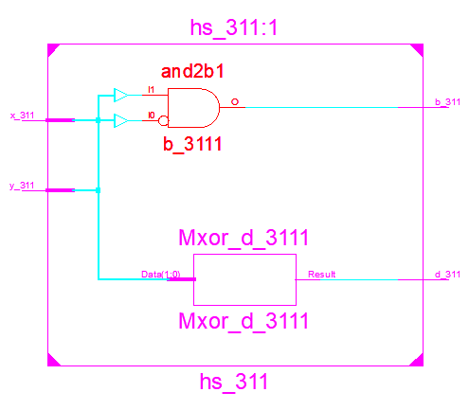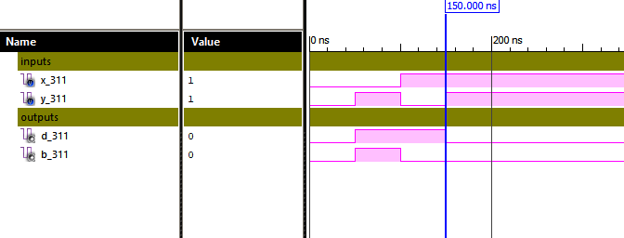

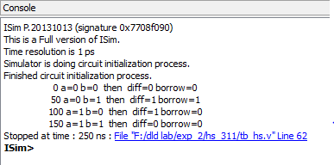

1. **Full adder using Gate level modelling:**

**Verilog program:**

**Gate level**

module fa_311(

input a_311,

input b_311,

input c_311,

output s_311,

output cy_311,

inout x_311,

inout y_311,

inout z_311

);

xor g1(s_311,a_311,b_311,c_311);

and a1(x_311,a_311,c_311);

and a2(y_311,a_311,b_311);

and a3(z_311,b_311,c_311);

or o1(cy_311,x_311,y_311,z_311);

endmodule

**Test Bench :**

module tb_fa;

// Inputs

reg a_311;

reg b_311;

reg c_311;

// Outputs

wire s_311;

wire cy_311;

wire x_311;

wire y_311;

wire z_311;

// Instantiate the Unit Under Test (UUT)

fa_311 uut (

.a_311(a_311),

.b_311(b_311),

.c_311(c_311),

.s_311(s_311),

.cy_311(cy_311),

.x_311(x_311),

.y_311(y_311),

.z_311(z_311)

);

initial begin

// Initialize Inputs

a_311 = 0; b_311 = 0; c_311 = 0;

#50

a_311 = 0; b_311 = 0; c_311 = 1;

#50

a_311 = 0; b_311 = 1; c_311 = 0;

#50

a_311 = 0; b_311 = 1; c_311 = 1;

#50

a_311 = 1; b_311 = 0; c_311 = 0;

#50

a_311 = 1; b_311 = 0; c_311 = 1;

#50

a_311 = 1; b_311 = 1; c_311 = 0;

#50

a_311 = 1; b_311 = 1; c_311 = 1;

// Wait 100 ns for global reset to finish

#100;

// Add stimulus here

$finish;

end

initial begin

$monitor($time," a=%b b=%b c=%b then sum=%b carry=%b",a_311,b_311,c_311,s_311,cy_311);

end

endmodule

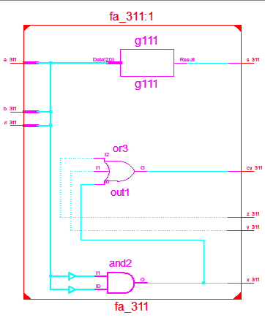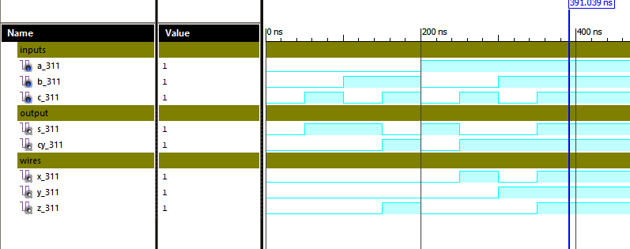

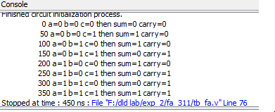

1. **Full substractor using data flow modelling:**

**Verilog program:**

**Data flow**

module fs_311(input x_311, input y_311,input z_311,output d_311,output b_311 );

assign d_311= x_311^y_311^z_311;

assign b_311= ((~x_311)&y_311) | (y_311&z_311) | ((~x_311)&z_311);

endmodule

**Test Bench :**

module tb_fs;

// Inputs

reg x_311;

reg y_311;

reg z_311;

// Outputs

wire d_311;

wire b_311;

// Instantiate the Unit Under Test (UUT)

fs_311 uut (

.x_311(x_311),

.y_311(y_311),

.z_311(z_311),

.d_311(d_311),

.b_311(b_311)

);

initial begin

// Initialize Inputs

x_311 = 0; y_311 = 0; z_311 = 0;

#50

x_311 = 0; y_311 = 0; z_311 = 1;

#50

x_311 = 0; y_311 = 1; z_311 = 0;

#50

x_311 = 0; y_311 = 1; z_311 = 1;

#50

x_311 = 1; y_311 = 0; z_311 = 0;

#50

x_311 = 1; y_311 = 0; z_311 = 1;

#50

x_311 = 1; y_311 = 1; z_311 = 0;

#50

x_311 = 1; y_311 = 1; z_311 = 1;

// Wait 100 ns for global reset to finish

#100;

// Add stimulus here

$finish;

end

initial begin

$monitor($time," a=%b b=%b c=%b then diff=%b borrow=%b",x_311,y_311,z_311,d_311,b_311);

end

endmodule

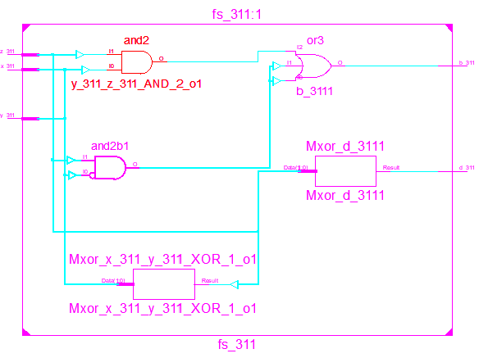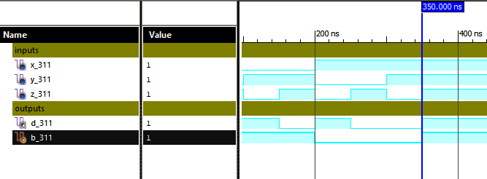

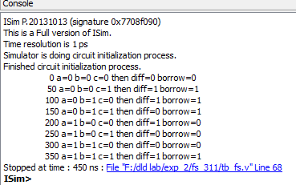

1. **Full adder using two half adders:**

**Verilog program:**

module fa_2ha_311(

input a,

input b,

input c,

output s_311,

wire w1,w2,w3,

output cy_311

);

ha_311 g1(a,b,w1,w2);

ha_311 g2(c,w1,s_311,w3);

or g3(cy_311,w2,w3);

endmodule

**Test Bench :**

module tb_fa_2ha_311;

// Inputs

reg a;

reg b;

reg c;

// Outputs

wire s_311;

// Instantiate the Unit Under Test (UUT)

fa_2ha_311 uut (

.a(a),

.b(b),

.c(c),

.s_311(s_311),

.cy_311(cy_311)

);

initial begin

// Initialize Inputs

a = 0; b = 0; c = 0;

#50

a = 0; b = 0; c = 1;

#50

a = 0; b = 1; c = 0;

#50

a = 0; b = 1; c = 1;

#50

a = 1; b = 0; c = 0;

#50

a = 1; b= 0; c= 1;

#50

a = 1; b = 1; c= 0;

#50

a = 1; b = 1; c = 1;

#100;

// Add stimulus here

$finish;

end

initial begin

$monitor($time," a=%b b=%b c=%b then sum=%b carry=%b",a,b,c,s_311,cy_311);

end

endmodule

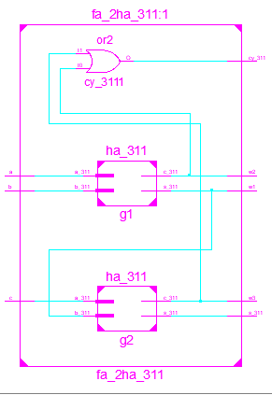

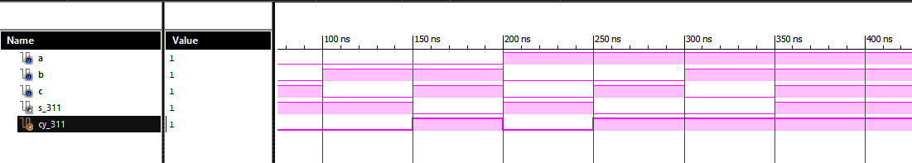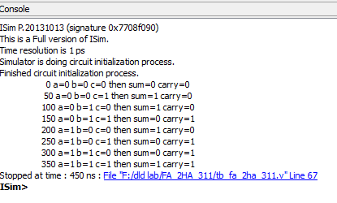

1. **4 bit adder using 4 Full adder:**

**Verilog program:**

module bitadder_4fa_311(

input [3:0] a,

input [3:0] b,

input cin,

output cout_311,

output [3:0] s_311,

inout w1,

inout w2,

inout w3

);

fa_311 g1(a[0],b[0],cin,s_311[0],w1);

fa_311 g2(w1,a[1],b[1],s_311[1],w2);

fa_311 g3(w2,a[2],b[2],s_311[2],w3);

fa_311 g4(w3,a[3],b[3],s_311[3],cout_311);

endmodule

**Testbench:**

module tb_bitadder_4fa_311;

reg [3:0] a;

reg [3:0] b;

reg cin;

wire cout_311; wire [3:0] s_311;

wire w1; wire w2; wire w3;

bitadder_4fa_311 uut (

.a(a),

.b(b),

.cin(cin),

.cout_311(cout_311),

.s_311(s_311),

.w1(w1),

.w2(w2),

.w3(w3)

);

initial begin

$monitor($time,"a=%b b=%b cin=%b sum=%b cout=%b ",a,b,cin,s_311,cout_311);

// Initialize Inputs

a = 0; b = 0; cin = 0;

#10

a = 0; b = 1; cin = 0;

#10 // Wait 100 ns for global reset to finish

a = 1; b = 0; cin = 0;

#10

a = 1; b = 1; cin = 0;

#100;

end

endmodule

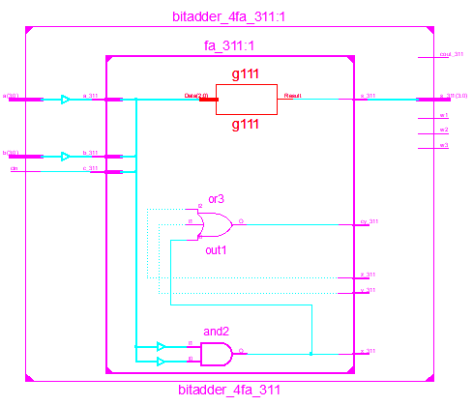

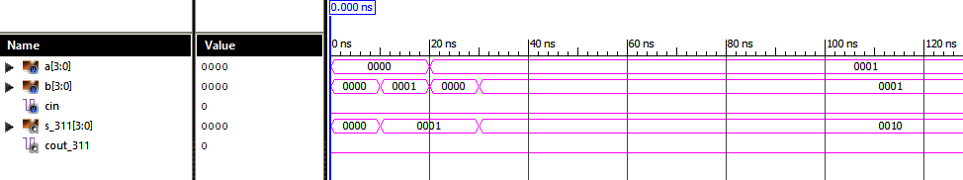

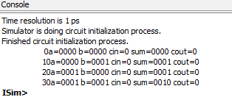

**Experiment 3** : MULTIPLEXERS AND DEMULTIPLEXERS

**AIM:** TO simulate and synthesize the multiplexers and demultiplexers using Verilog hdl.

**Apparatus:** A Pc running windows with Xilinx Ise design suite installed in it.

1. **2x1 mux:**

**Verilog Program:**

module mux2x1(

input i0_311,

input i1_311,

output y_311,

input s_311

);

assign y_311=((i0_311)*(~s_311)|(i1_311)*(s_311));

endmodule

**Testbench:**

module tb_mux2x1_311;

reg i0_311;

reg i1_311;

reg s_311;

wire y_311;

mux2x1 uut (

.i0_311(i0_311),

.i1_311(i1_311),

.y_311(y_311),

.s_311(s_311)

);

initial begin

i0_311 = 0; i1_311 = 0; s_311 = 0;

#10

i0_311 = 1; i1_311 = 0; s_311 = 0;

#10

i0_311 = 0; i1_311 = 1; s_311 = 1;

$finish;

end

initial begin

$monitor($time,"i0=%b i1=%b s=%b then output=%b",i0_311,i1_311,s_311,y_311);

end

endmodule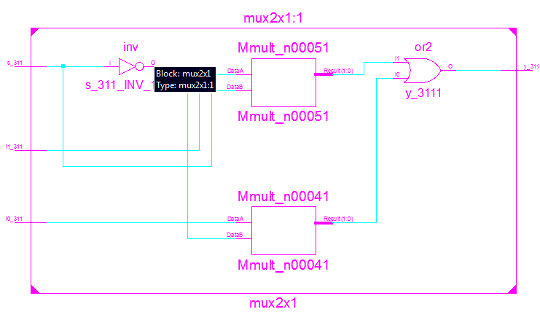

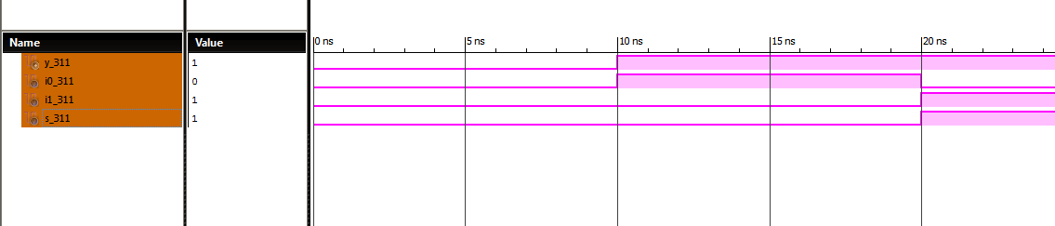

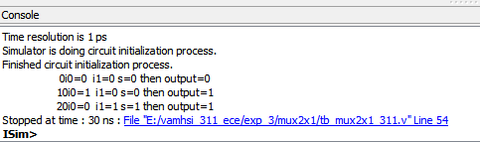

**b) 4x1 mux:**

**Verilog program:**

module mux4x1_311(

input i0_311,

input i1_311,

input i2_311,

input i3_311,

input s0_311,

input s1_311,

output y_311

);

assign y_311=(((i0_311)&(~s1_311)&(~s0_311))

|((i1_311)&(~s1_311)&(s0_311))

|((i2_311)&(s1_311)&(~s0_311))

|((i3_311)&(s1_311)&(s0_311)));

Endmodule

**Testbench:**

module tb_mux4x1_311;

reg i0_311;

reg i1_311;

reg i2_311;

reg i3_311;

reg s0_311;

reg s1_311;

wire y_311;

mux4x1_311 uut (

.i0_311(i0_311),

.i1_311(i1_311),

.i2_311(i2_311),

.i3_311(i3_311),

.s0_311(s0_311),

.s1_311(s1_311),

.y_311(y_311)

);

initial begin

i0_311 = 1; i1_311 = 0; i2_311 = 1; i3_311 = 0; s0_311 = 0; s1_311 = 0;

#10

i0_311 = 1; i1_311 = 0; i2_311 = 1; i3_311 = 0; s0_311 = 1; s1_311 = 0;

#10

i0_311 = 1; i1_311 = 0; i2_311 = 1; i3_311 = 0; s0_311 = 0; s1_311 = 0;

#10

i0_311 = 1; i1_311 = 0; i2_311 = 1; i3_311 = 0; s0_311 = 1; s1_311 = 1;

#100;

$finish;

end

initial begin

$monitor($time," i0=%d i1=%d i2=%d i3=%d s1=%d s0=%d then output= %d",i0_311,i1_311,i2_311,i3_311,s1_311,s0_311,y_311);

end

endmodule

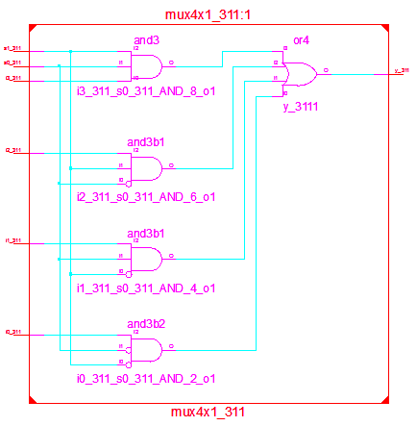

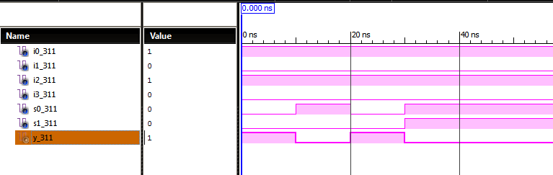

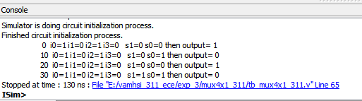

**8x1 mux using 4x1 mux:**

**Verilog program :**

module mux_8by1_311(

input d0_311,d1_311,d2_311,d3_311,d4_311,d5_311,d6_311,d7_311,

input s0_311,s1_311,s2_311,

output y_311

);

wire w1,w2;

mux_4by1_311 g1(d0_311,d1_311,d2_311,d3_311,s1_311,s0_311,w1);

mux_4by1_311 g2(d4_311,d5_311,d6_311,d7_311,s1_311,s0_311,w2);

mux_2by1_311 g3(w1,w2,s2_311,y_311);

endmodule

**Test bench :**

module test_mux_8by1_311;

reg d0_311;

reg d1_311;

reg d2_311;

reg d3_311;

reg d4_311;

reg d5_311;

reg d6_311;

reg d7_311;

reg s0_311;

reg s1_311;

reg s2_311;

wire y_311;

mux_8by1_311 uut (

.d0_311(d0_311),

.d1_311(d1_311),

.d2_311(d2_311),

.d3_311(d3_311),

.d4_311(d4_311),

.d5_311(d5_311),

.d6_311(d6_311),

.d7_311(d7_311),

.s0_311(s0_311),

.s1_311(s1_311),

.s2_311(s2_311),

.y_311(y_311)

);

initial begin

$monitor($time,"ns s2=%b s1=%b s0=%b d0=%b d1=%b d2=%b d3=%b d4=%b d5=%b d6=%b d7=%b y=%b",s2_311,s1_311,s0_311,d0_311,d1_311,d2_311,d3_311,d4_311,d5_311,d6_311,d7_311,y_311);

d0_311 = 1; d1_311 = 0; d2_311 = 0; d3_311 = 0; d4_311 = 0;

d5_311 = 0; d6_311 = 0; d7_311 = 0; s0_311 = 0 s1_311 = 0;

s2_311 = 0;

#10

d0_311 = 0;

d1_311 = 1;

d2_311 = 0;

d3_311 = 0;

d4_311 = 0;

d5_311 = 0;

d6_311 = 0;

d7_311 = 0;

s0_311 = 1;

s1_311 = 0;

s2_311 = 0;

#10

d0_311 = 0;

d1_311 = 0;

d2_311 = 1;

d3_311 = 0;

d4_311 = 0;

d5_311 = 0;

d6_311 = 0;

d7_311 = 0;

s0_311 = 0;

s1_311 = 1;

s2_311 = 0;

#10

d0_311 = 0;

d1_311 = 0;

d2_311 = 0;

d3_311 = 1;

d4_311 = 0;

d5_311 = 0;

d6_311 = 0;

d7_311 = 0;

s0_311 = 1;

s1_311 = 1;

s2_311 = 0;

#10

#100;

end

endmodule

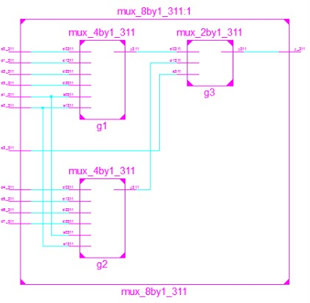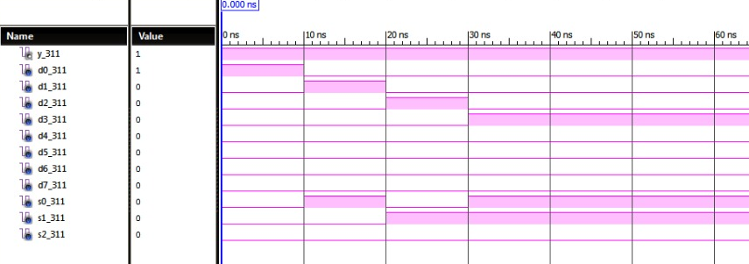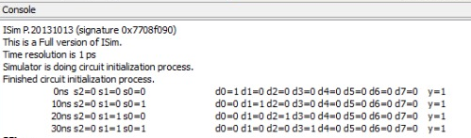

**1x4 De-mux:**

**Verilog program :**

module demux1x4_311(

input i,

input s0,

input s1,

output y0_311,

output y1_311,

output y2_311,

output y3_311

);

assign y0_311=((~s1)&(~s0)&(i));

assign y1_311=((~s1)&(s0)&(i));

assign y2_311=((s1)&(~s0)&(i));

assign y3_311=((s1)&(s0)&(i));

endmodule

**Test bench :**

module tb_demux4x1_311;

reg i;

reg s0;

reg s1;

wire y0_311;

wire y1_311;

wire y2_311;

wire y3_311;

demux1x4_311 uut (

.i(i),

.s0(s0),

.s1(s1),

.y0_311(y0_311),

.y1_311(y1_311),

.y2_311(y2_311),

.y3_311(y3_311)

);

initial begin

$monitor($time,"i =%b s0=%b s1=%b then y0=%b y1=%b y2=%b y3=%b",i,s0,s1,y0_311,y1_311,y2_311,y3_311);

i = 1; s0 = 0; s1 = 0;

#5

i = 1; s0 = 0; s1 = 1;

#5

i = 1; s0 = 1; s1 = 0;

#5

i = 1; s0 = 1; s1 = 1;

#5;

end

endmodule

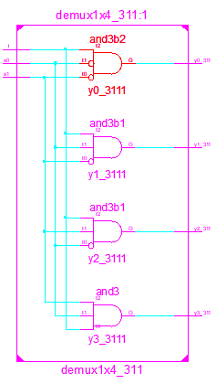

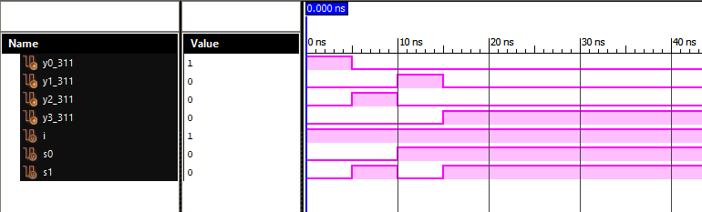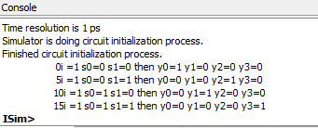

**Experiment 4** : ENCODERS DECODERS ,PRIORITY AND COMPAEATOR

**AIM:** TO simulate and synthesize the encoder and decoder using Verilog hdl also priority encoder,comparator.

**Apparatus:** A Pc running windows with Xilinx Ise design suite installed in it.

1. **4 to 2 encoder :**

**Verilog Program:**

module encoder4to2(

input d0,

input d1,

input d2,

input d3,

output a_311,

output b_311

);

assign a_311 =((~d3)&(d2)&(~d1)&(~d0)|(d3)&(~d2)&(~d1)&(~d0));

assign b_311 =((~d3)&(~d2)&(d1)&(~d0)|(d3)&(~d2)&(~d1)&(~d0));

endmodule

**Test bench :**

module tb_encoder4to2_311;

reg d0; reg d1;

reg d2; reg d3;

wire a_311; wire b_311;

encoder4to2 uut (

.d0(d0),

.d1(d1),

.d2(d2),

.d3(d3),

.a_311(a_311), .b_311(b_311)

);

initial begin

$monitor($time,"d0=%b d1=%b d2=%b d3=%b a=%b b=%b",d0,d1,d2,d3,a_311,b_311);

d0 = 1; d1 = 0; d2 = 0; d3 = 0;

#10 d0 = 0; d1 = 1; d2 = 0; d3 = 0;

#10 d0 = 0; d1 = 0; d2 = 1; d3 = 0;

#10 d0 = 0; d1 = 0; d2 = 0; d3 = 1;

#100 ; end

endmodule

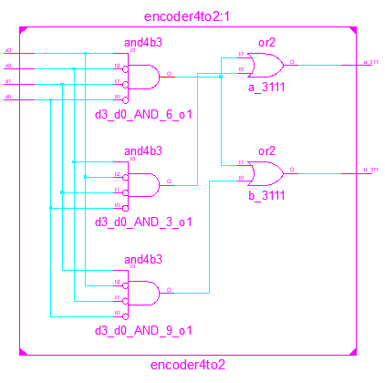

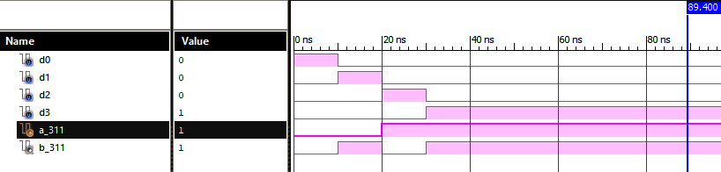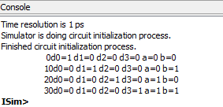

1. **2 to 4 decoder :**

**Verilog Program:**

module enable2to4decoder_311(

input e,

input a,

input b,

output yo_311,

output y1_311,

output y2_311,

output y3_311

);

assign yo_311=((!e)&(!a)&(!b));

assign y1_311=((!e)&(a)&(!b));

assign y2_311=((!e)&(!a)&(b));

assign y3_311=((!e)&(a)&(b));

endmodule

**Test bench :**

module tb_enable2to4decoder_311;

reg e;

reg a;

reg b;

wire yo_311;

wire y1_311;

wire y2_311;

wire y3_311;

enable2to4decoder_311 uut (

.e(e),

.a(a),

.b(b),

.yo_311(yo_311),

.y1_311(y1_311),

.y2_311(y2_311),

.y3_311(y3_311)

);

initial begin

e = 1; a = 0; b = 0;

#5

e = 1; a = 0; b = 1;

#5

e = 1; a = 1; b = 0;

#5

e = 1; a = 1; b = 1;

#5

e = 0; a = 0; b = 0;

#5

e = 0; a = 0; b = 1;

#5 e = 0; a = 1; b = 0;

#5 e = 0; a = 1; b = 1;

#10

$finish;

end

initial begin

$monitor($time,"e=%b a=%b b=%b y0=%b y1=%b y2=%b y3=%b",e,a,b,yo_311,y1_311,y2_311,y3_311);

End

endmodule

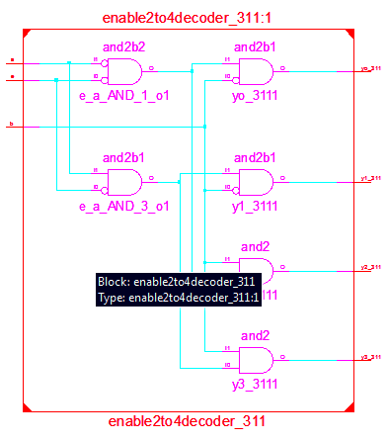

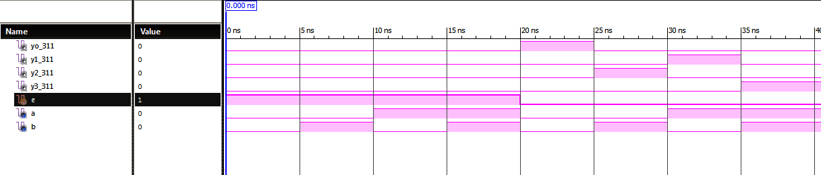

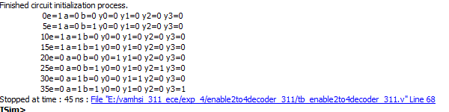

1. **3 to 8 decoder :**

**Verilog Program:**

module decoder3to8_311(

input a,

input b,

input c,

output y0_311,

output y1_311,

output y2_311,

output y3_311,

output y4_311,

output y5_311,

output y6_311,

output y7_311

);

wire w1;

not g1(w1,a);

enable2to4decoder_311 g2(a,b,c,y0_311,y1_311,y2_311,y3_311);

enable2to4decoder_311 g3(w1,b,c,y4_311,y5_311,y6_311,y7_311);

endmodule

**Test bench :**

module tb_decoder3x8_311;

reg a;

reg b;

reg c;

wire y0_311;

wire y1_311;

wire y2_311;

wire y3_311;

wire y4_311;

wire y5_311;

wire y6_311;

wire y7_311;

decoder3to8_311 uut (

.a(a),

.b(b),

.c(c),

.y0_311(y0_311),

.y1_311(y1_311),

.y2_311(y2_311),

.y3_311(y3_311),

.y4_311(y4_311),

.y5_311(y5_311),

.y6_311(y6_311),

.y7_311(y7_311)

);

initial begin

$monitor($time," e=%d b=%b c=%b yo=%b y1=%b y2=%b y3=%b y4=%b y5=%b y6=%b y7=%b",a,b,c,y0_311,y1_311,y2_311,y3_311,y4_311,y5_311,y6_311,y7_311);

a = 0; b = 0; c = 0;

#10

a = 0; b = 0; c = 1;

#10

a = 0; b = 1; c = 0;

#10

a = 0; b = 1; c = 1;

#10

a = 1; b = 0; c = 0;

#10

a = 1; b = 0; c = 1;

#10

a = 1; b = 1; c = 0;

#10

a = 1; b = 1; c = 1;

#10 ;

end

endmodule

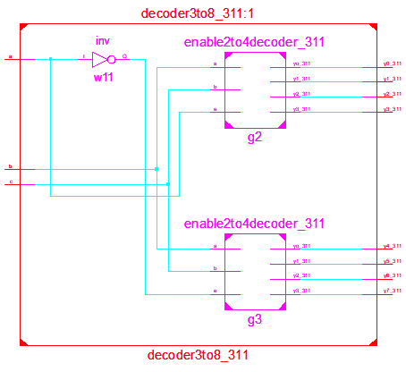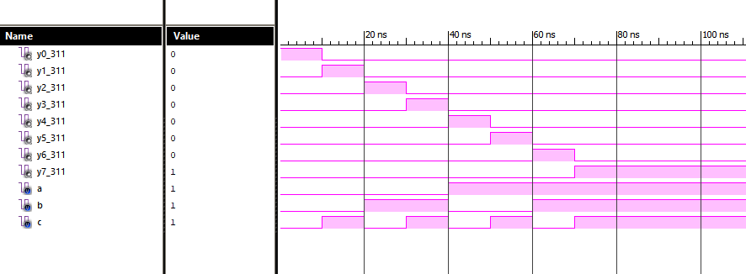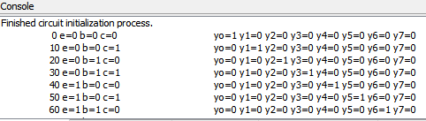

1. **priority encoder:**

**Verilog program :**

module ptiority_311(

input d0_311,d1_311,d2_311,d3_311,

output a_311,b_311,v_311

);

wire w1,w2;

or g1(a_311,d2_311,d3_311);

or g2(w1,~d2_311,d3_311);

or g3(w2,d1_311,d3_311);

and g4(b_311,w1,w2);

or g5(v_311,d0_311,d1_311,d2_311,d3_311);

endmodule

**Test bench :**

module tb_priority_311;

// Inputs

reg d0_311;

reg d1_311;

reg d2_311;

reg d3_311;

// Outputs

wire a_311;

wire b_311;

wire v_311;

// Instantiate the Unit Under Test (UUT)

ptiority_311 uut (

.d0_311(d0_311),

.d1_311(d1_311),

.d2_311(d2_311),

.d3_311(d3_311),

.a_311(a_311),

.b_311(b_311),

.v_311(v_311)

);

initial begin

$monitor($time,"ns d0=%b d1=%b d2=%b d3=%b a=%b b=%b v=%b",d0_311,d1_311,d2_311,d3_311,a_311,b_311,v_311);

// Initialize Inputs

d0_311 = 0;

d1_311 = 0;

d2_311 = 0;

d3_311 = 0;

#10

d0_311 = 1;

d1_311 = 0;

d2_311 = 0;

d3_311 = 0;

#10

d0_311 = 0;

d1_311 = 1;

d2_311 = 0;

d3_311 = 0;

#10

d0_311 = 0;

d1_311 = 0;

d2_311 = 1;

d3_311 = 0;

#10

d0_311 = 0;

d1_311 = 0;

d2_311 = 0;

d3_311 = 1;

#10

// Wait 100 ns for global reset to finish

#100;

// Add stimulus here

end

endmodule

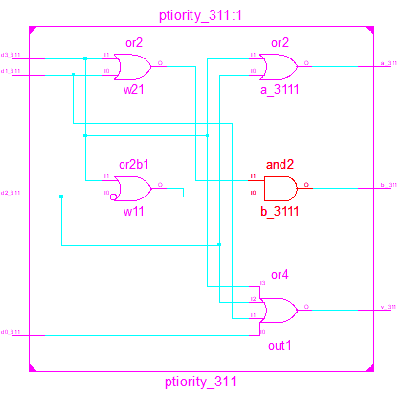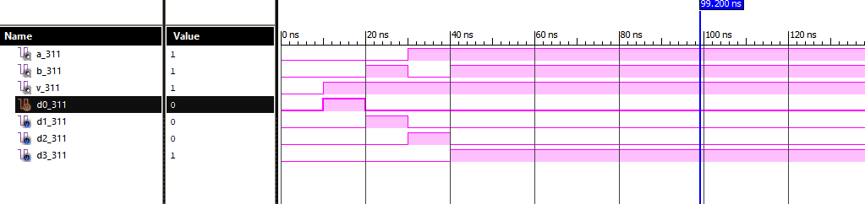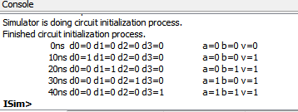

1. **1-bit comparator:**

**Verilog program :**

module comparator_311(

input a311,b311,gt311,lt311,eq311,

output aGTb311,aLTb311,aEQb311

);

assign aGTb311 = (gt311&(~b311))|(gt311&a311)|(a311&(~b311));

assign aLTb311 = (lt311&(~a311))|(lt311&b311)|((~a311)&b311);

assign aEQb311 = ((eq311)&(~a311)&(~b311))|((eq311)&(a311)&(b311)) ;

endmodule

**Test bench :**

module tb_comparator_311;

// Inputs

reg a311;

reg b311;

reg gt311;

reg lt311;

reg eq311;

// Outputs

wire aGTb311;

wire aLTb311;

wire aEQb311;

// Instantiate the Unit Under Test (UUT)

comparator_311 uut (

.a311(a311),

.b311(b311),

.gt311(gt311),

.lt311(lt311),

.eq311(eq311),

.aGTb311(aGTb311),

.aLTb311(aLTb311),

.aEQb311(aEQb311)

);

initial begin

$monitor($time,"a=%b b=%b agtb=%b altb=%b aeqb=%b",a311,b311,aGTb311,aLTb311,aEQb311);

a311 = 0; b311 = 0; gt311 = 0; lt311 = 0; eq311 = 1;

#10

a311 = 0; b311 = 1; gt311 = 0; lt311 = 1; eq311 = 0;

#10

a311 = 1; b311 = 0; gt311 = 1; lt311 = 0; eq311 = 0;

#10

a311 = 1; b311 = 1; gt311 = 0; lt311 = 0; eq311 = 1;

#10;

end

endmodule

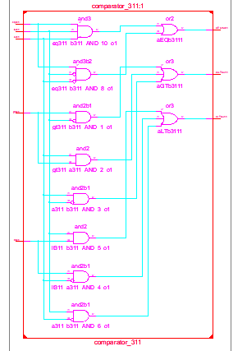

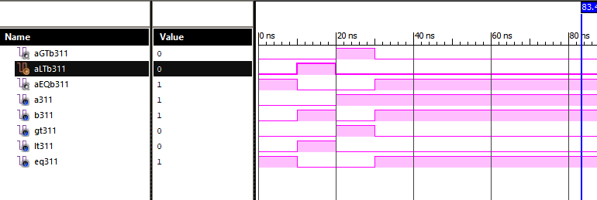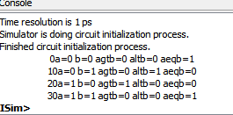

1. **4-bit comparator using 1-bit comparator:**

**Verilog program :**

module comparator4bit_311(

input [3:0]a_311,b_311,

input gt_311,lt_311,eq_311,

output aGTb_311,aLTb_311,aEQb_311

);

wire gt1,gt2,gt3,lt1,lt2,lt3,eq1,eq2,eq3;

comparator_311 C1(a_311[0],b_311[0],gt_311,lt_311,eq_311,gt1,lt1,eq1);

comparator_311 C2(a_311[1],b_311[1],gt1,lt1,eq1,gt2,lt2,eq2);

comparator_311 C3(a_311[2],b_311[2],gt2,lt2,eq2,gt3,lt3,eq3);

comparator_311 C4(a_311[3],b_311[3],gt3,lt3,eq3,aGTb_311,aLTb_311,aEQb_311);

endmodule

**Test bench :**

module tb_comparator4bit_311;

// Inputs

reg [3:0] a_311;

reg [3:0] b_311;

reg gt_311;

reg lt_311;

reg eq_311;

// Outputs

wire aGTb_311;

wire aLTb_311;

wire aEQb_311;

// Instantiate the Unit Under Test (UUT)

comparator4bit_311 uut (

.a_311(a_311),

.b_311(b_311),

.gt_311(gt_311),

.lt_311(lt_311),

.eq_311(eq_311),

.aGTb_311(aGTb_311),

.aLTb_311(aLTb_311),

.aEQb_311(aEQb_311)

);

initial begin

$monitor($time,"ns a=%b b=%b gt=%b lt=%b eq=%b aGTb=%b aLTb=%b aEQb=%b",a_311,b_311,gt_311,lt_311,eq_311,aGTb_311,aLTb_311,aEQb_311);

// Initialize Inputs

a_311 = 1;

b_311 = 2;

gt_311 = 0;

lt_311 = 0;

eq_311 = 1;

#10

a_311 = 2;

b_311 = 1;

gt_311 = 0;

lt_311 = 0;

eq_311 = 1;

#10

a_311 = 2;

b_311 = 2;

gt_311 = 0;

lt_311 = 0;

eq_311 = 1;

#10

a_311 = 0;

b_311 = 0;

gt_311 = 0;

lt_311 = 0;

eq_311 = 1;

#10

a_311 = 1;

b_311 = 2;

gt_311 = 0;

lt_311 = 0;

eq_311 = 0;

#10

a_311 = 2;

b_311 = 1;

gt_311 = 0;

lt_311 = 0;

eq_311 = 0;

#10

a_311 = 2;

b_311 = 2;

gt_311 = 0;

lt_311 = 0;

eq_311 = 0;

#10

a_311 = 0;

b_311 = 0;

gt_311 = 0;

lt_311 = 0;

eq_311 = 0;

#10

// Wait 100 ns for global reset to finish

#100;

// Add stimulus here

end

endmodule

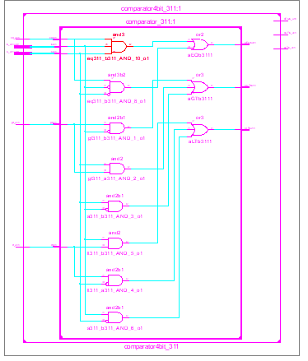

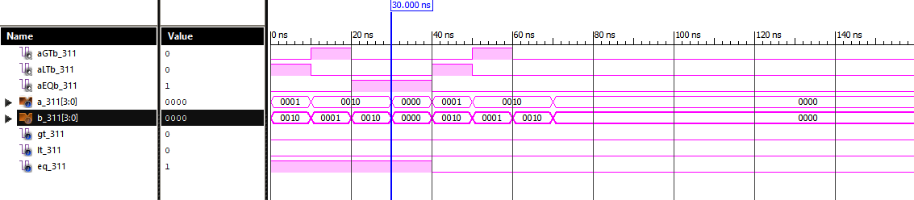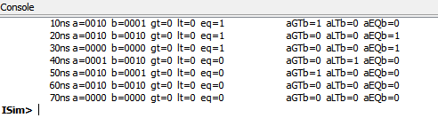

1. **4-bit comparator using 1-bit comparator:**

**Verilog program :**

module comp4311(

input a0,a1,a2,a3,

input b0,b1,b2,b3,

input gt,

input lt,

input eq,

output agtb,

output altb,

output aeqb

);

wire [8:0]w;

comp1bit c0(a0,b0,gt,lt,eq,w[0],w[1],w[2]);

comp1bit c1(a1,b1,w[0],w[1],w[2],w[3],w[4],w[5]);

comp1bit c2(a2,b2,w[3],w[4],w[5],w[6],w[7],w[8]);

comp1bit c3(a3,b3,w[6],w[7],w[8],agtb,altb,aeqb);

endmodule

**Test bench :**

module tb_comp4311;

reg a0;

reg a1;

reg a2;

reg a3;

reg b0;

reg b1;

reg b2;

reg b3;

reg gt;

reg lt;

reg eq;

wire agtb;

wire altb;

wire aeqb;

comp4311 uut (

.a0(a0),

.a1(a1),

.a2(a2),

.a3(a3),

.b0(b0),

.b1(b1),

.b2(b2),

.b3(b3),

.gt(gt),

.lt(lt),

.eq(eq),

.agtb(agtb),

.altb(altb),

.aeqb(aeqb)

);

initial begin

a0 = 1;

a1 = 1;

a2 = 1;

a3 = 0;

b0 = 1;

b1 = 0;

b2 = 0;

b3 = 1;

gt = 0;

lt = 1;

eq = 0;

#10

a0 = 1;

a1 = 1;

a2 = 1;

a3 = 1;

b0 = 1;

b1 = 1;

b2 = 0;

b3 = 1;

gt = 1;

lt = 0;

eq = 0;

#10

a0 = 1;

a1 = 0;

a2 = 1;

a3 = 0;

b0 = 1;

b1 = 0;

b2 = 1;

b3 = 0;

gt = 0;

lt = 0;

eq = 1;

#10

$finish;

end

initial begin

$monitor($time, " a0=%b,a1=%b,a2=%b,a3=%b,b0=%b,b1=%b,b2=%b,b3=%b,agtb=%b,altb=%b,aeqb=%b",a0,a1,a2,a3,b0,b1,b2,b3,agtb,altb,aeqb);

end

endmodule

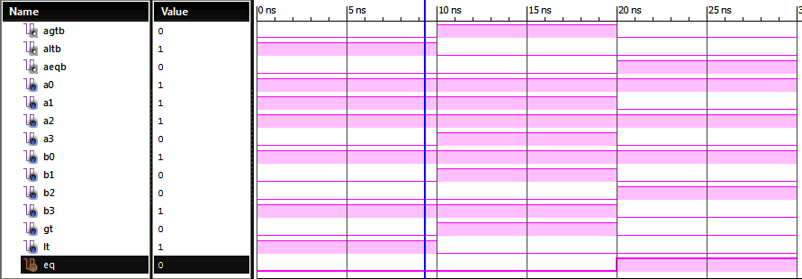

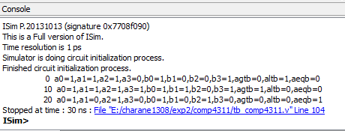

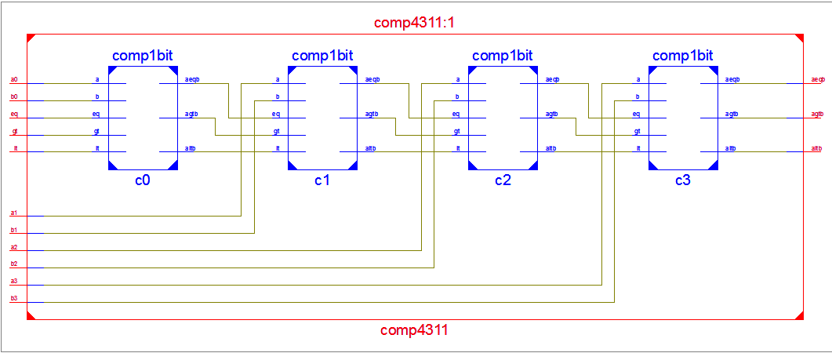

**Logical functions realisation using mux and decoders**

1. **Full adder using 3 to 8 decoder:**

**Verilog program :**

module fa_decoder_311(

input a,

input b,

input c,

inout y0_311,

inout y1_311,

inout y2_311,

inout y3_311,

inout y4_311,

inout y5_311,

inout y6_311,

inout y7_311,

output s_311,

output cy_311

);

decoder3to8_311 g1(a,b,c,y0_311,y1_311,y2_311,y3_311,y4_311,y5_311,y6_311,y7_311);

or g2(s_311,y1_311,y2_311,y4_311,y7_311);

or g3(cy_311,y3_311,y5_311,y6_311,y7_311);

endmodule

**Test bench :**

module tb_fa_decoder_311;

reg a;

reg b;

reg c;

wire s_311;

wire cy_311;

wire y0_311;

wire y1_311;

wire y2_311;

wire y3_311;

wire y4_311;

wire y5_311;

wire y6_311;

wire y7_311;

fa_decoder_311 uut (

.a(a),

.b(b),

.c(c),

.y0_311(y0_311),

.y1_311(y1_311),

.y2_311(y2_311),

.y3_311(y3_311),

.y4_311(y4_311),

.y5_311(y5_311),

.y6_311(y6_311),

.y7_311(y7_311),

.s_311(s_311),

.cy_311(cy_311)

);

initial begin

$monitor($time,"a=%b b=%b c=%b : sum=%b,carry=%b",a,b,c,s_311,cy_311);

a = 0; b = 0; c = 0;

#20 a = 0; b = 0; c = 1;

#20 a = 0; b = 1; c = 0;

#20 a = 0; b = 1; c = 1;

#20 a = 1; b = 0; c = 1;

#20 a = 1; b = 1; c = 0;

#30 a = 1; b = 1; c = 1;

end

endmodule

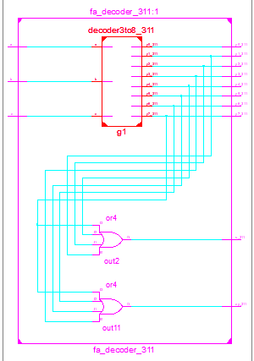

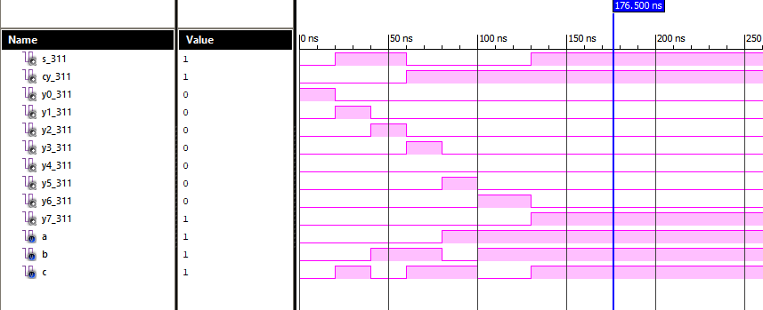

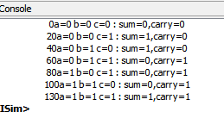

1. **Full adder using mux:**

**Verilog program :**

module fa_mux_311(

input a,

input b,

input c,

inout c1,

output s_311,

output cy_311

);

not g3(c1,c);

mux4x1_311 g1(c,c1,c1,c,a,b,s_311);

mux4x1_311 g2(0,c,c,1,a,b,cy_311);

endmodule

**Test bench :**

module tb_fa_mux_311;

reg a;

reg b;

reg c;

wire s_311;

wire cy_311;

wire c1;

fa_mux_311 uut (

.a(a),

.b(b),

.c(c),

.c1(c1),

.s_311(s_311),

.cy_311(cy_311)

);

initial begin

$monitor($time,"a=%b b=%b c=%b : sum=%b,carry=%b",a,b,c,s_311,cy_311);

a = 0;

b = 0;

c = 0;

#20

a = 0;

b = 0;

c = 1;

#20

a = 0;

b = 1;

c = 0;

#20

a = 0;

b = 1;

c = 1;

#20

a = 1;

b = 0;

c = 1;

#20

a = 1;

b = 1;

c = 0;

#30

a = 1;

b = 1;

c = 1;

#100;

end

endmodule

