**2. Capture TCP Packets and:**

**a. Analyse the three-way handshake during the establishment of the communication.**

**b. Identify if there are any retransmitted segments**

**A)**

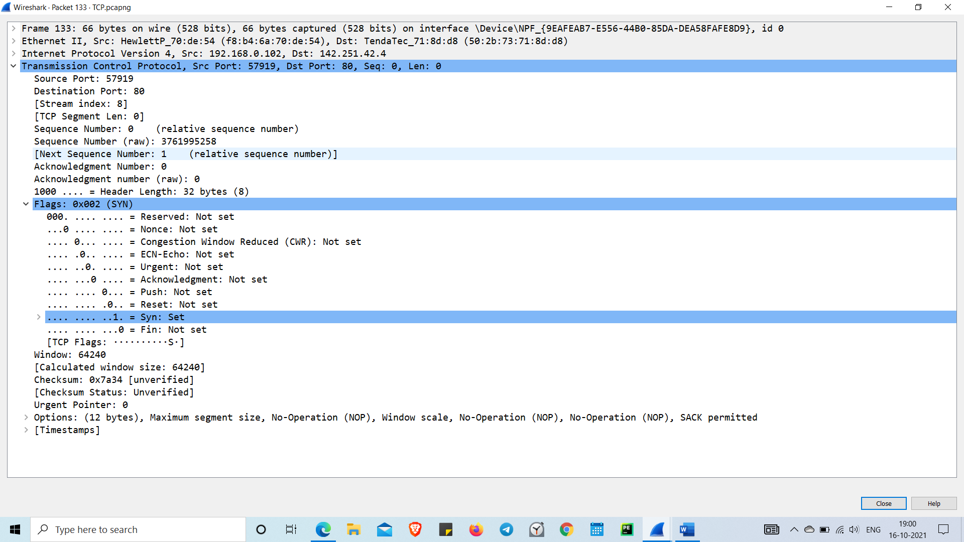

In the 1st phase,the client establishes a connection with a server. It sends a segment with SYN and informs the server about the client should start communication, and with what should be its sequence number..

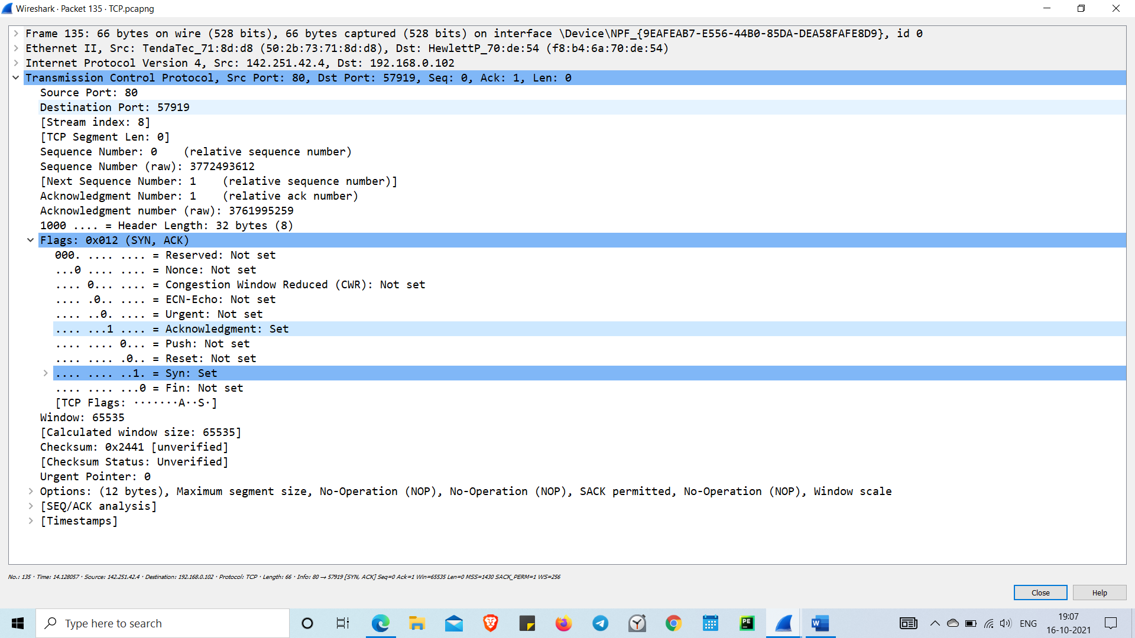

In the 2nd phase the receiver sends an ACK = 1 as well as SYN = 1 in the second step of connection establishment to saying to sender that it received its initial packet.

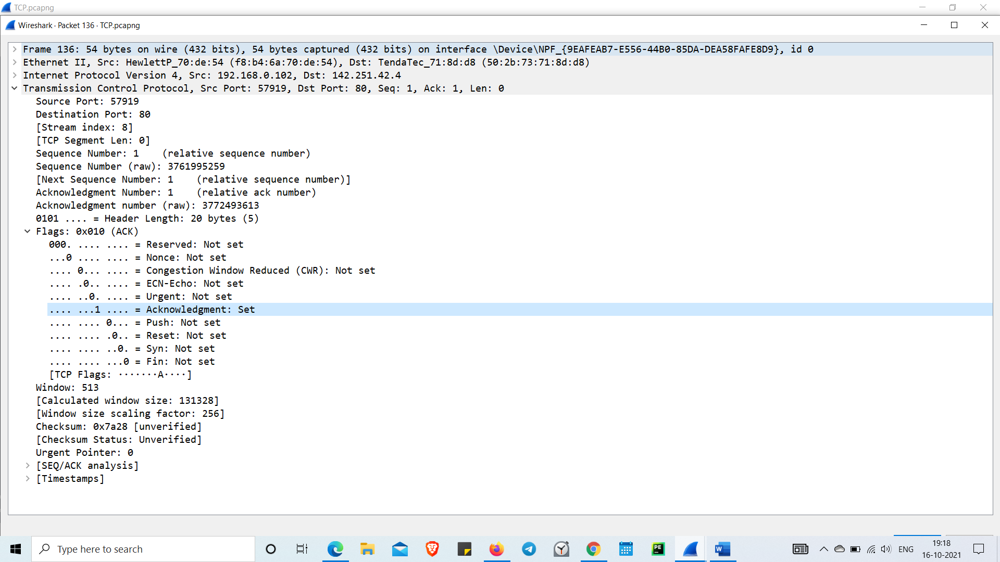

In this 3rd phase , the client acknowledges the response of the Server, and they both create a stable connection will begin the actual data transfer process.

2)

Whenever packet is lost. This causes the receiver to send the acknowledgement with same ACK number to the sender. As a result, sender retransmits the same segment to the receiver TCP retransmission.

Here there is no retransmit

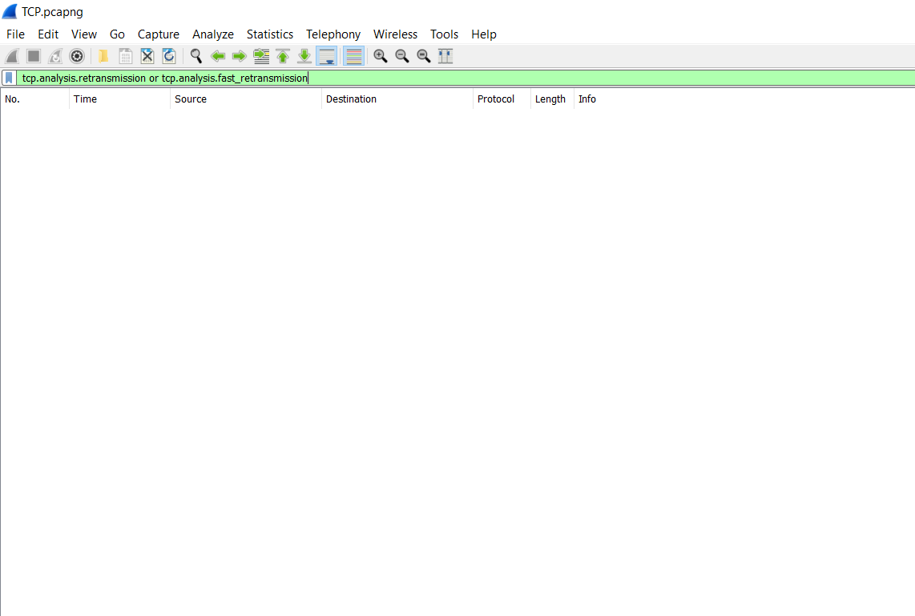

We can find retransmissions using the tcp.analysis.retransmission or tcp.analysis.fast_retransmission display filters