**Part A**

1) 1. Print the list of network interfaces, their MAC addresses and their assigned IP addresses, if any.

The different interfaces available in mininet VM are shown in the below picture including their IP and MAC address

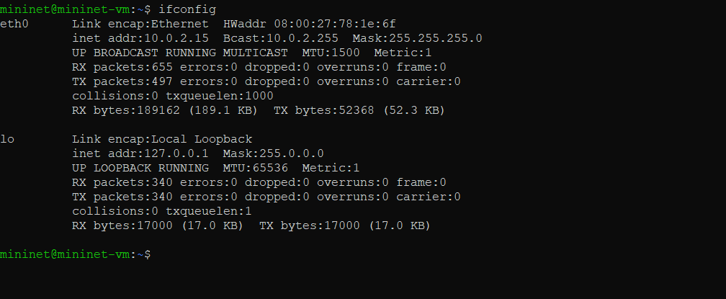

MAC address

IP address

2. Calculate the latency between mininet vm and www.rutgers.edu for 10 packets. Repeat the result for stanford.edu and www.google.co.in and compare the difference in latency.

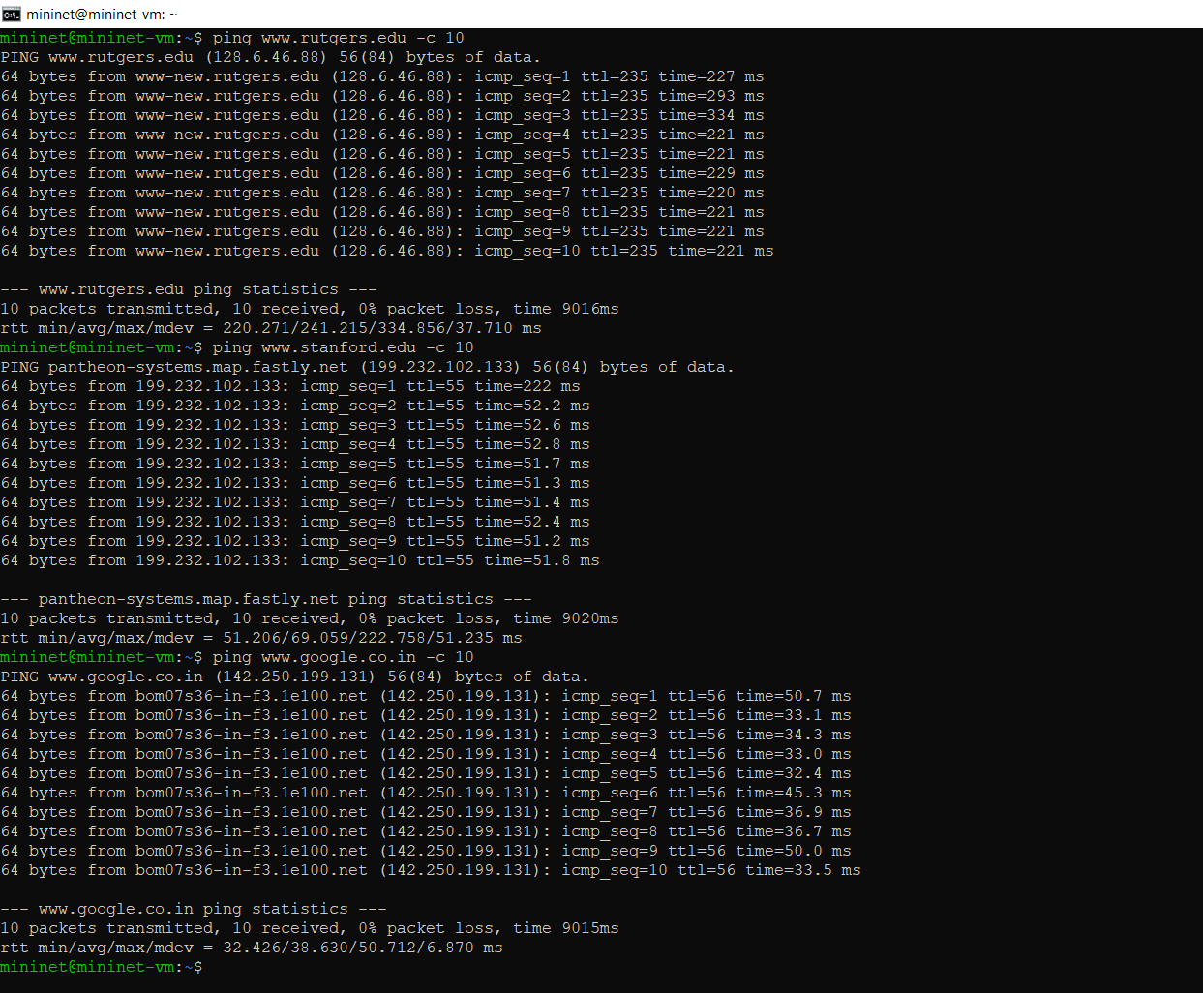

* The Avg latency of Rutgers.edu is 241.215 ms and The avg latency of Standford.edu is 69.059 ms and The Avg latency of google.co.in is 38.630 ms ..
* The difference between google.co.in and Rutgers.edu is 202.585 ms
* The difference between google.co.in and standford.edu is 30.429 ms

**Part 2:**

1)

Create a simple two node network using "sudo mn" and do the following

* Print the MAC address of host h1. Print the MAC addresses of switch s1.
* Explain the different interfaces that s1 has.

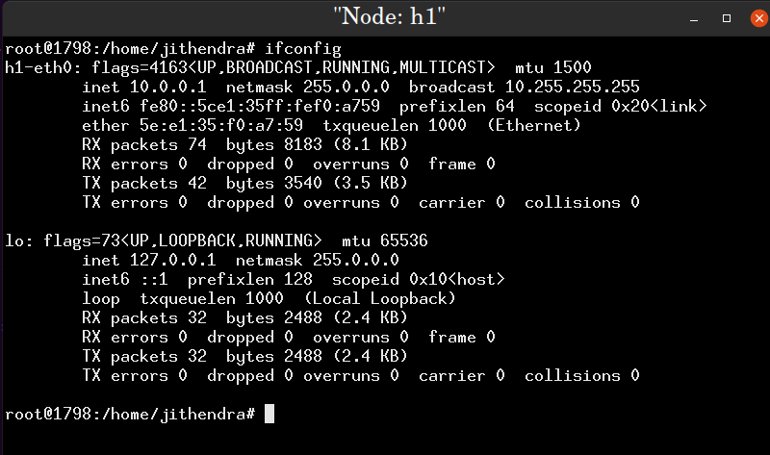

Ip address of host h1

MAC Address of host h1

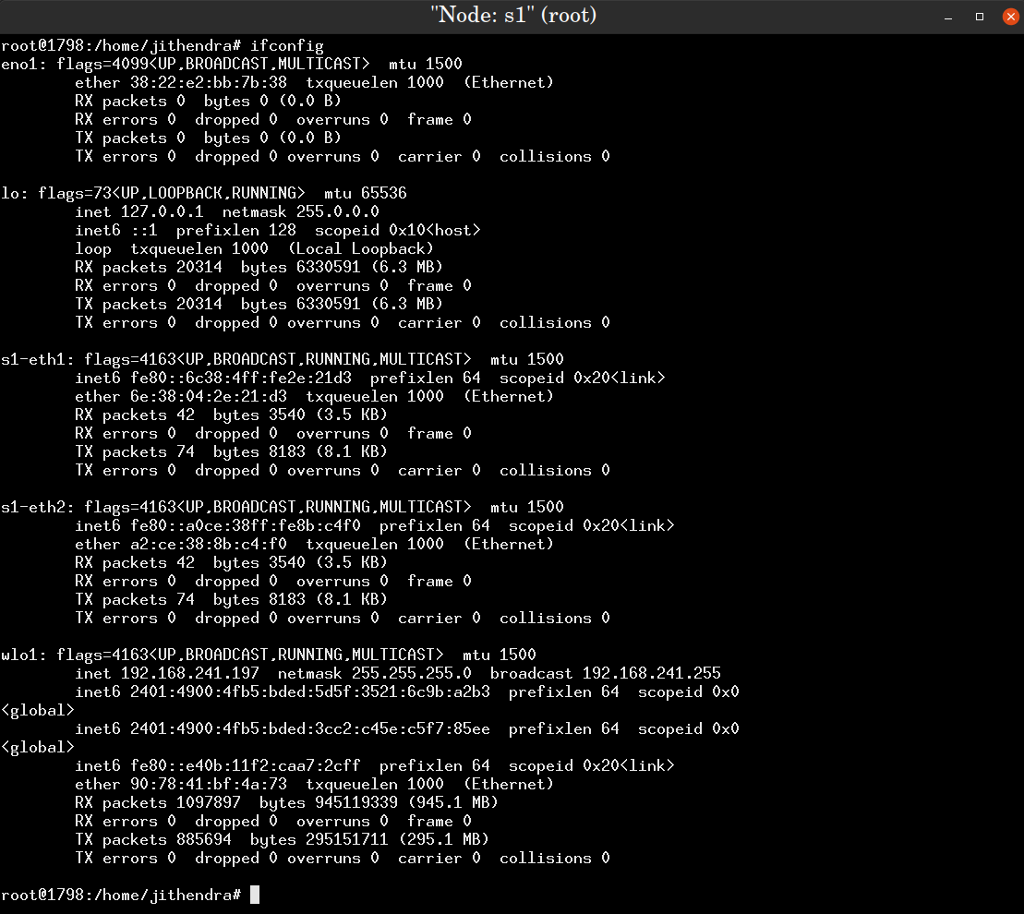

MAC address of switch

**The different network interfaces in the switch**

Details of connection switch and host 2

Details of connection switch and host 1

b) Ping h1 from h2 and view the ARP entries stored at hosts h1 and h2. 3. Measure the TCP throughput from h1 to h2 using iperf

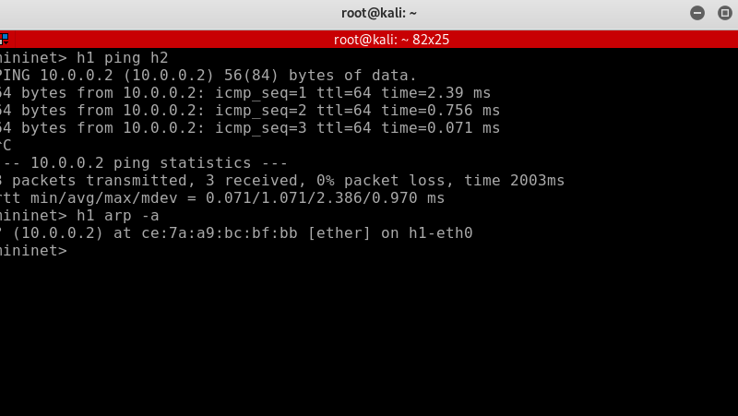

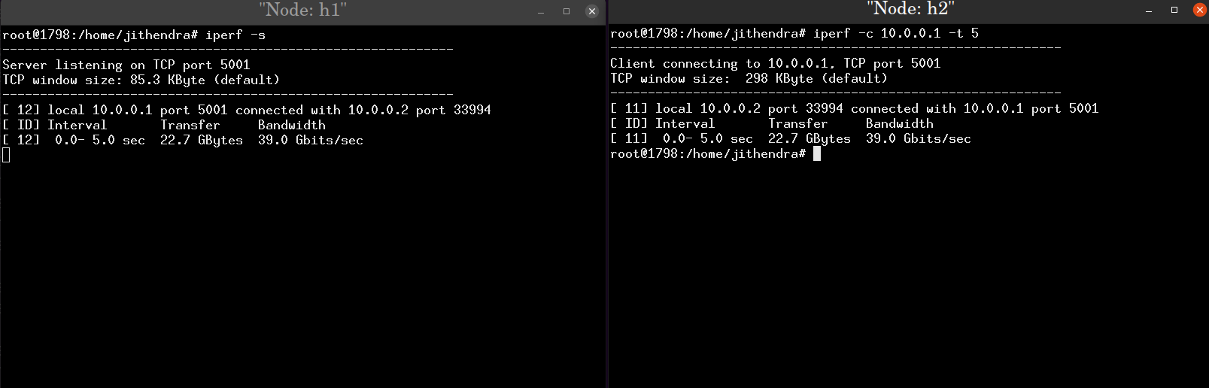

Measure the TCP throughput from h1 to h2 using iperf