**ML ASSIGNMENT-1**

***ANN VS CNN***

NAME :VAMSHIKRISHNA M

RollNo:191CS261

Instructor :Dr.Jenny Rajan

**Introduction:**

ANN:

An ANN is based on a collection of connected units or nodes called neurons, which represents the structure of the human brain. An artificial neuron receives a signal and then processes it further. These layers are divided into three categories—input layer, hidden layer and output layer. The input layer takes the input, the hidden layer processes the inputs, and the output layer produces the result. Essentially, each layer tries to learn certain weights.

CNN:

A Convolutional Neural Network (ConvNet) is a Deep Learning algorithm that can take in an input image, assign importance to various aspects/objects in the image and be able to differentiate one from the other. The pre-processing required in a ConvNet is much lower as compared to other classification algorithms.

**Comparison between ANN and CNN:**

There are some major differences between the ANN vs CNN

The main thing that leads to popularity of CNN is its feature engineering. That is extracting features. which are very difficult in ANN. hidden layers increase if we use ANN in feature extraction.in CNN it is comparatively easy to extract features.

Parameter sharing is main advantage of CNN which deals with sharing of weights by all neurons in a particular feature map. This helps to reduce the number of parameters in the whole system and makes the computation more efficient. Unlike a ANN where all the neurons are fully connected. There fore CNN is more powerful than ANN.

Spatial relationship is another difference between CNN and ANN where property defines that the data points in a data unit are related to each other in a way that they cannot be separated.

ANN is ideal for handling document issues. Image data, text data, and tabular data can all be processed with forward-facing algorithms. To reach its revolutionary high accuracy rate, CNN requires a lot more data inputs.

**Method:**

*In ANN* :

* CIFAR 10 data set is used,

model=tf.keras.Sequential([

    tf.keras.layers.Flatten(input_shape=(32,32,3)),

    tf.keras.layers.Dense(128,activation='relu'),

    tf.keras.layers.Dense(128,activation='relu'),

    tf.keras.layers.Dense(10,activation='softmax')

])

* Here model is made with 3 dense layers with relu in 1st and 2nd layers and at the end softmax as the activation function.

*In CNN*

* Here also CIFAR 10 data set is used,

model=tf.keras.models.Sequential([

  tf.keras.layers.Conv2D(64, (3,3), activation='relu', input_shape=(32, 32, 3)),

  tf.keras.layers.MaxPooling2D(2, 2),

  tf.keras.layers.Conv2D(64, (3,3), activation='relu'),

  tf.keras.layers.MaxPooling2D(2,2),

  tf.keras.layers.Flatten(),

  tf.keras.layers.Dense(128, activation='relu'),

  tf.keras.layers.Dense(10, activation='softmax')

])

* Here model is made with 2 convolutions layers ,2 dense layers and then 2 times pooling is done .At the end soft max is used activation function in dense layers

**Motivation**

The main aim is to see that how CIFAR10 data set perform with traditional neural Network because if we use the MNIST dataset we can achieve the accuracy more than or nearly 95%.and If we tried to use CIFAR10 in it . ANN performs doesn’t perform well it gave accuracy of nearly 50% and with with CNN it was around 70%.

**Results and discussion:**

***Quantitative comparison:***

Accuracy for ANN is 48% and for CNN it is 68%

***Metrics of comparison* (Accuracy, F1-score, Precision, Recall):**

ANN :

Precision: 0.62

Recall:0.48

F1-score:0.54

Accuracy:0.48

CNN:

Precision: 0.83

Recall:0.71

F1-score:0.77

Accuracy:0.69

***Statistical representation of results***

Confusion Matrix has been represented

ANN  
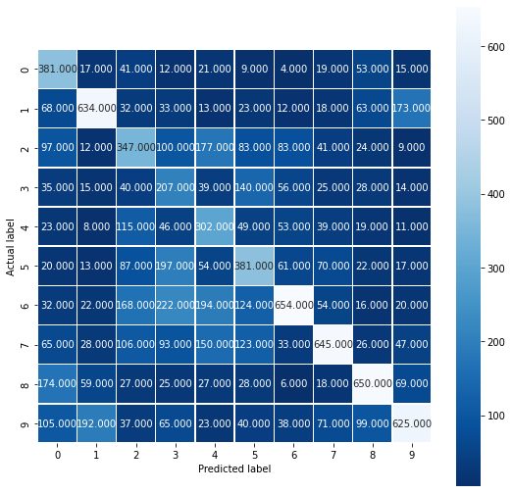

CNN

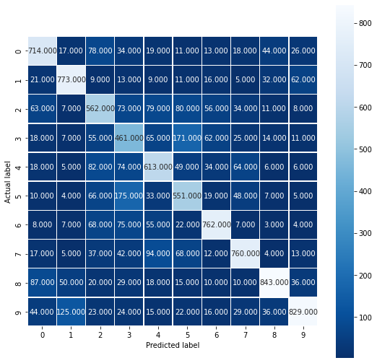

***Outcome of the study conducted:***

CNN model gave a better accuracy on CIFAR 10 dataset when compared to ANN. And CNN is also better for image processing. There for CNN, is the most popular solution for computer vision and image-dependent machine learning problems due to its ability to see images as data.

***Conclusion:***

When solving classification problems, CNN is a more robust and accurate method. ANN still dominates for problems with limited datasets and no need for image inputs.

There are some situations where ANN may be preferred to CNN and vice versa.They both work logically in a distinct way, making them superior at addressing specific problems.

References :

* <https://towardsdatascience.com/introduction-to-neural-networks-advantages-and-applications-96851bd1a207>
* <https://en.wikipedia.org/wiki/Artificial_neural_network>
* <https://www.geeksforgeeks.org/difference-between-ann-cnn-and-rnn/>
* <https://medium.com/towards-data-science/the-most-intuitive-and-easiest-guide-for-artificial-neural-network-6a3f2bc0eecb>