Configuration Manual
Hierarchical Multi-Granularity Sentiment Analysis
for E-Commerce Reviews
MSc Research Project
Cloud Computing
Vamshi Maidam
Student ID: X23289635
School of Computing
National College of Ireland
Supervisor: Nitish Bharoth
April 2026

1. Introduction
This configuration manual provides comprehensive instructions for setting up, configuring, deploying, and maintaining the Hierarchical Multi-Granularity Sentiment Analysis platform. The document covers all aspects required to reproduce the development environment, configure the system for local development or production deployment, and manage the cloud infrastructure components.
The system comprises three main components: a Python/FastAPI backend for model inference and training, a React/Vite frontend for the user interface, and cloud infrastructure using Docker and AWS services for deployment and model storage.
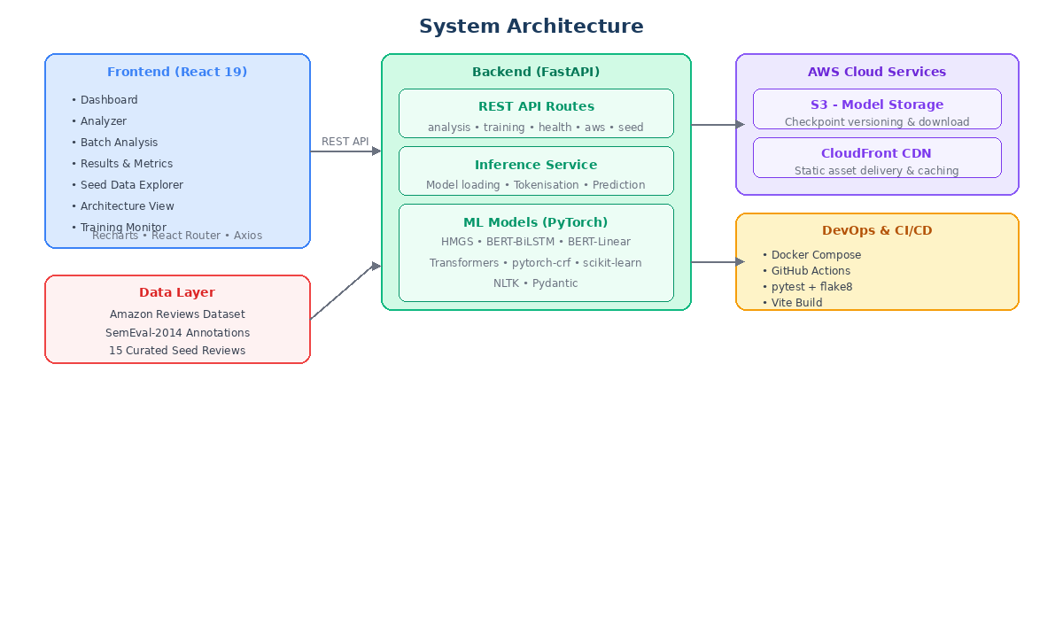
Figure 1: System Architecture Overview

2. System Requirements

2.1 Hardware Requirements
The following hardware specifications are recommended for development and deployment:
Component | Minimum | Recommended
RAM | 8 GB | 16 GB+
CPU | Quad-core | 8-core (Intel i7/AMD Ryzen 7)
GPU (Training) | Not required (CPU) | NVIDIA GPU (V100/T4) - AWS p3.2xlarge
Storage | 10 GB free | 50 GB+ SSD

2.2 Software Requirements
Software | Version | Purpose
Python | 3.11+ | Backend runtime
Node.js | 20+ | Frontend build
npm | 10+ | Package management
Docker | 24+ | Containerisation
Docker Compose | 2.0+ | Service orchestration
Git | 2.40+ | Version control
AWS CLI | 2.0+ (optional) | Cloud management

3. Project Setup

3.1 Cloning the Repository
Clone the project repository from GitHub:
git clone https://github.com/vamshimaidam4/Thesis-final.git
cd Thesis-final

3.2 Project Directory Structure
The project is organised as follows:
Thesis-final/
backend/
app/
main.py # FastAPI entry point
config.py # Configuration dataclasses
models/
sentiment_models.py # HMGS, BiLSTM, Baseline models
routes/
analysis.py # Analysis API endpoints
training.py # Training API endpoints
health.py # Health check endpoint
aws_routes.py # AWS S3 operations
seed_routes.py # Seed data endpoints
services/
inference_service.py # Model inference
aws_service.py # AWS S3 client
seed_service.py # Seed data management
tests/ # pytest test suite
train.py # Training script
requirements.txt # Python dependencies
frontend/
src/
pages/ # React page components
components/ # Reusable UI components
services/api.js # Axios API client
package.json # Node dependencies
vite.config.js # Vite build config
Dockerfile # Frontend container
aws/deploy.py # AWS deployment utility
seed_data/sample_reviews.json # 15 annotated reviews
.github/workflows/ci.yml # CI/CD pipeline
docker-compose.yml # Service orchestration
Dockerfile # Backend container
.env.example # Environment template

4. Backend Configuration

4.1 Python Virtual Environment
Create and activate a Python virtual environment:
cd backend
python -m venv venv
source venv/bin/activate # Linux/Mac
venv\Scripts\activate # Windows

4.2 Installing Dependencies
Install all Python packages:
pip install -r requirements.txt
Key dependencies include: FastAPI 0.115.6 (REST API framework), PyTorch 2.1+ (deep learning), Transformers 4.36+ (BERT models), pytorch-crf 0.7.2+ (CRF layer), scikit-learn 1.3+ (metrics and baselines), NLTK 3.8+ (sentence tokenisation), and Pydantic 2.0+ (request validation).

4.3 NLTK Data Download
Download required NLTK tokeniser data:
python -c "import nltk; nltk.download('punkt'); nltk.download('punkt_tab')"

4.4 Environment Variables
Copy the environment template and configure your settings:
cp .env.example .env
Edit the .env file with your configuration:
Variable | Description | Default
AWS_ACCESS_KEY_ID | AWS access key | (required for S3)
AWS_SECRET_ACCESS_KEY | AWS secret key | (required for S3)
AWS_DEFAULT_REGION | AWS region | us-east-1
S3_BUCKET_NAME | S3 bucket for models | deep-learning-sentiment-models
MODEL_PATH | Local model directory | ./models
DEVICE | Compute device | cpu

4.5 Running the Backend Server
Start the FastAPI development server:
uvicorn app.main:app --reload --port 8000
The API will be available at http://localhost:8000 and interactive documentation at http://localhost:8000/docs.

5. Frontend Configuration

5.1 Installing Node Dependencies
Navigate to the frontend directory and install packages:
cd frontend
npm install

5.2 Development Server
Start the Vite development server:
npm run dev
The frontend will be available at http://localhost:5173. It communicates with the backend API at http://localhost:8000.

5.3 Production Build
Create an optimised production build:
npm run build
The built files are output to the frontend/dist/ directory, which can be served by the FastAPI backend as static files.

5.4 Frontend Pages
Page | Route | Description
Dashboard | / | System overview, health status, model info
Training | /training | Configure and run model training
Analyzer | /analyze | Interactive single-review analysis
Batch Analysis | /batch | Multi-review batch processing
Results | /results | Model evaluation metrics
Seed Data | /seed-data | Browse annotated validation data
Architecture | /architecture | HMGS model architecture diagram

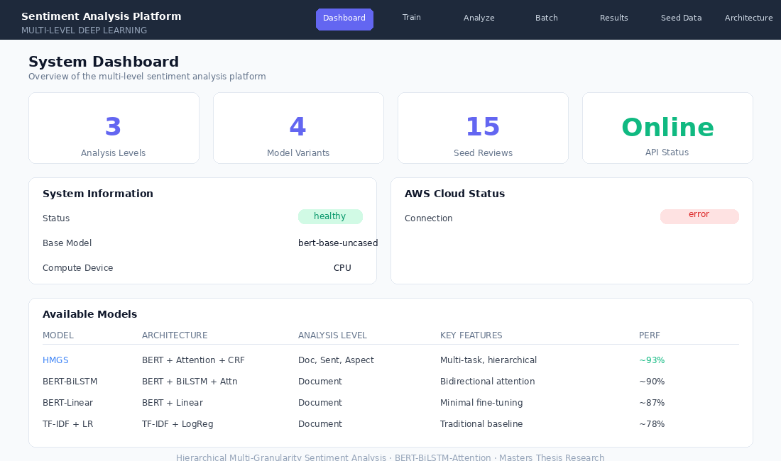
Figure 2: Web Application Dashboard Interface

6. Model Training Configuration

6.1 Training via CLI
Train models using the command-line training script:
# Train all models with default settings (quick demo)
python train.py --model all --epochs 3 --batch-size 8 --train-samples 600
# Train HMGS on larger dataset
python train.py --model hmgs --epochs 5 --batch-size 16 --train-samples 50000
# Train BiLSTM baseline only
python train.py --model bilstm --epochs 3 --batch-size 8 --train-samples 600

6.2 Training Parameters
Parameter | Options | Default
--model | hmgs, bilstm, all | all
--epochs | 1-100 | 3
--batch-size | 1-128 | 8
--train-samples | 100-50000 | 600

6.3 Training via Web UI
The Training page in the web application provides a browser-based interface for model training. Users can select the model type, configure epochs, batch size, and training samples through form controls, and monitor training progress in real-time through the status polling mechanism.

6.4 Model Configuration
The HMGS model configuration is defined in backend/app/config.py:
Parameter | Value | Description
model_name | bert-base-uncased | Pre-trained BERT model
hidden_size | 768 | BERT hidden dimension
max_seq_length | 128 | Max tokens per sentence
max_sentences | 10 | Max sentences per review
lambda_doc | 1.0 | Document loss weight
lambda_sent | 0.5 | Sentence loss weight
lambda_ate | 0.3 | Aspect extraction loss weight

7. Docker Deployment

7.1 Building and Running with Docker Compose
Build and start all services:
docker compose up --build
This starts two services: the backend (port 8000) with PyTorch and FastAPI serving the API and frontend static files, and the frontend (port 3000) as a separate development container. The backend Dockerfile uses a multi-stage build: Stage 1 builds the React frontend with Node 20 Alpine, and Stage 2 creates the Python 3.11 runtime with all dependencies.

7.2 Service Ports
Service | Port | URL
Backend API | 8000 | http://localhost:8000
Frontend (dev) | 3000 | http://localhost:3000
API Docs | 8000 | http://localhost:8000/docs

7.3 Health Check
The Docker container includes a health check that polls the API:
curl http://localhost:8000/api/health
Expected response: {"status":"healthy","model":"bert-base-uncased","device":"cpu"}

8. AWS Configuration

8.1 AWS Credentials Setup
Configure AWS credentials in the .env file or via AWS CLI:
AWS_ACCESS_KEY_ID=your_access_key
AWS_SECRET_ACCESS_KEY=your_secret_key
AWS_DEFAULT_REGION=us-east-1
S3_BUCKET_NAME=deep-learning-sentiment-models

8.2 S3 Model Storage
Use the deployment utility for S3 operations:
# Check AWS connectivity
python aws/deploy.py status
# Create S3 bucket and upload models
python aws/deploy.py setup
# Download models from S3
python aws/deploy.py download

8.3 CloudFront Deployment
The application is deployed via AWS CloudFront at https://d3qr3s0etchs7v.cloudfront.net. The CloudFront distribution serves the built frontend assets as static files and proxies API requests to the backend service. This provides global edge caching for the frontend and low-latency API access.

9. CI/CD Pipeline Configuration
The GitHub Actions CI/CD pipeline is configured in .github/workflows/ci.yml and runs on pushes to main and pull requests.

9.1 Pipeline Stages
Stage | Environment | Actions
Backend Tests | Python 3.11 | pytest, flake8 linting (max-line=120)
Frontend Build | Node 20 | npm ci, vite build, artifact upload
Docker Build | Ubuntu latest | Build images, validate compose config
Deploy | Main branch only | AWS credential check, S3 model sync

10. Testing

10.1 Running the Test Suite
Execute all tests from the backend directory:
cd backend
pytest tests/ -v

10.2 Test Coverage
Test File | Coverage
test_api.py | API endpoints, validation, health checks
test_models.py | Model forward passes, shapes, losses
test_config.py | Configuration loading and defaults
test_aws_service.py | AWS S3 client operations
test_seed_service.py | Seed data loading and statistics

11. Troubleshooting
BERT model download fails
Ensure internet connectivity. The bert-base-uncased model (approximately 440MB) is downloaded on first run. If behind a proxy, configure the HF_HOME environment variable to a writable directory.
CUDA out of memory during training
Reduce batch size (--batch-size 4) or reduce training samples. For CPU-only training, set DEVICE=cpu in .env.
AWS S3 connection error
Verify AWS credentials in .env file. Ensure the IAM user has s3:ListBucket, s3:PutObject, and s3:GetObject permissions. Check the AWS region matches your bucket location.
Frontend build fails
Ensure Node.js 20+ is installed. Delete node_modules/ and package-lock.json, then run npm install again.
Docker build fails
Ensure Docker daemon is running. Check available disk space (at least 5GB needed). For ARM-based Macs, ensure Docker Desktop has Rosetta emulation enabled.
NLTK punkt tokeniser error
Run the NLTK download command: python -c "import nltk; nltk.download('punkt'); nltk.download('punkt_tab')"
Port already in use
Check if another service is using port 8000 or 5173. Use lsof -i :8000 to identify the process and terminate it.

