How LLMs Actually Work
A detailed extracted and expanded study document
Core idea: An LLM is a next-token predictor. It turns text into numbers, runs those numbers through stacked attention layers that mix context, and outputs a probability distribution over the next token. Everything else is engineering on top of that single loop.

Audience | Developers who can read Python but have never trained or deeply inspected a language model.
Prerequisites | Basic linear algebra intuition, especially vectors and dot products; comfort reading code.
Read time | About 18 minutes for the original notes; longer if you read the expanded explanations carefully.
Source | Clean extraction and reconstruction from the screenshots supplied by the user. Diagrams are redrawn in a shareable format and the code snippets are transcribed.

Document roadmap
- TL;DR and mental model
- Architecture overview and autoregressive loop
- Step 1: text -> tokens -> vectors
- Step 2: position information
- Step 3: self-attention and Q/K/V
- Step 4: stacked transformer blocks and feed-forward layers
- Step 5: sampling, autoregression, and training
- Worked example: "The capital of France is" end to end
- Appendix: code snippets, check answers, and glossary

TL;DR
- At inference time, an LLM does one core operation: given a sequence of tokens, predict a probability distribution for the next token. Chat, code, essays, and reasoning are produced by repeating that loop.
- Text is split into tokens. Each token becomes a learned embedding vector, and position information is added or rotated into that vector so word order matters.
- The core machinery is self-attention. Every token compares itself against other tokens and decides how much each one should influence its updated representation.
- Training adjusts billions of weights by repeatedly making the actual next token more probable than alternatives, usually with gradient descent on a cross-entropy loss.
- The model has no separate database and no separate symbolic logic engine. Its facts, patterns, style, and reasoning behavior are compressed into learned weights.
Important: A 200-word answer usually contains roughly 250-350 tokens. In a simple mental model, the network is run roughly once per generated token, so that answer needs about 250-350 forward passes. Production systems use caching to avoid recomputing everything from scratch each time.

The mental model: aggressive autocomplete scaled up
Imagine the world's most aggressive autocomplete. You type half a sentence and it finishes the sentence. Now scale that idea up: feed it the entire prompt plus everything it has generated so far, and ask it again, one token at a time, until it decides to stop. That repeated loop, running on a neural network with billions or hundreds of billions of parameters trained on trillions of words, is what we call a Large Language Model.
The loop alone is not the magic. The intelligence comes from what happens inside the network at each step. The most important mechanism is self-attention: each word or token can rewrite its own representation by looking at the other tokens around it.
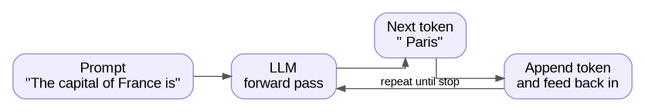
Figure 1. Autoregressive generation loop: predict one token, append it, and run the model again.

Architecture overview: what the Transformer stack is doing
The original Transformer architecture contains an encoder stack and a decoder stack. The encoder reads a source sequence and produces contextual representations. The decoder generates tokens while attending to earlier target tokens and, in the original encoder-decoder setup, also attending to the encoder output.
Modern GPT-style decoder-only LLMs use the decoder-side idea: embeddings, position information, repeated masked self-attention blocks, feed-forward networks, final normalization, and a linear projection to vocabulary logits. They usually do not use the encoder cross-attention component shown in the original architecture.
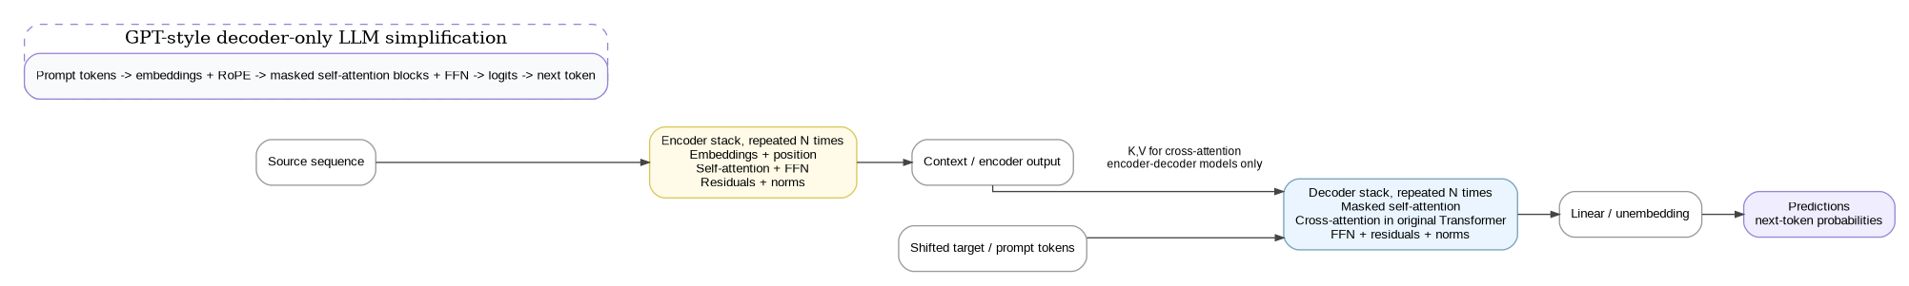
Figure 2. Reconstructed Transformer architecture. Decoder-only LLMs use the right-hand stack concept, especially masked self-attention, repeated many times.
Key distinction: Cross-attention is part of the original encoder-decoder Transformer. GPT-style decoder-only LLMs mainly use masked self-attention over the prompt and previously generated tokens. The causal mask prevents a token from seeing future tokens during training and generation.

Step 1: Text becomes tokens, tokens become vectors
A neural network cannot directly consume strings. It consumes numbers. So the first job is to turn text into a sequence of integer token IDs, then turn those IDs into vectors.
A token is a chunk of text the model treats as one atomic unit. In English, a token is often around 3-4 characters on average, but it can also be a whole common word, part of a word, punctuation, whitespace plus a word, or even a byte-like representation for rare characters.
The mapping from text to tokens is handled by a tokenizer. The tokenizer is trained once, often using algorithms such as Byte-Pair Encoding, and then frozen for a model family. During inference, the model does not invent token boundaries; it uses the tokenizer vocabulary it was built with.
Example: with GPT-style tokenization, the string "unbelievable" might split roughly into ["un", "bel", "iev", "able"]. The string "hello" is often a single token. Whitespace often attaches to the following word, so " Paris" with a leading space is a different token from "Paris" without the leading space.
After tokenization, each token ID is looked up in an embedding matrix: a large table with one row per vocabulary entry and many columns. Common vocabulary sizes are roughly 50,000 to 200,000 entries. The lookup returns a learned vector, such as 4096 numbers for a model with d_model = 4096. Training pushes related tokens to have related vector behavior, so embeddings become useful numeric representations rather than arbitrary IDs.
# Pseudocode for the front of the pipeline
token_ids = tokenizer.encode("The capital of France is")
# -> [791, 6864, 315, 9822, 374] (5 ints)
embeddings = embedding_matrix[token_ids]
# -> shape (5, d_model), e.g. (5, 4096)

Check question: Why not use one-hot vectors of size 200k instead of learned embeddings?

Answer: one-hot vectors are huge and sparse, waste memory, and treat every token as equally unrelated to every other token. Learned embeddings are dense, smaller, trainable, and can encode useful similarity and meaning-like structure. For example, related tokens can end up near each other or interact similarly because training made that useful.

Step 2: Position is added because raw vectors have no order
Self-attention by itself is permutation-invariant: if you shuffle the input token vectors, the mechanism has no built-in sense that token 1 came before token 2. That is fatal for language because order changes meaning. "dog bites man" and "man bites dog" contain similar words but mean very different things.
The fix is positional encoding. A position-dependent signal is added to, or rotated into, each token embedding. Older Transformers used fixed sinusoidal vectors or learned position embeddings. Modern LLMs commonly use RoPE, Rotary Position Embedding, which rotates pairs of dimensions by an angle related to the token position.
The point is the same across methods: after position is applied, the same word at position 3 has a different numeric representation than the same word at position 17. The vector now carries both what the token is and where it is.
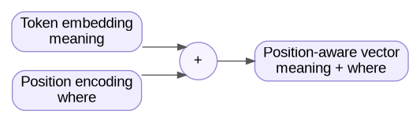
Figure 3. Token meaning plus position information becomes a position-aware vector.
After this step, the model has a matrix with shape (sequence_length, d_model). Each row is the position-aware vector for one token. This matrix becomes the input to the stack of Transformer layers.

Step 3: Self-attention, the core mechanism
Self-attention is the step that lets each token decide which other tokens are relevant for understanding itself. For example, in "The trophy did not fit in the brown suitcase because it was too big", the word "it" should connect strongly to "trophy", because the trophy is the thing that is too big. Humans resolve this by looking at surrounding words. Self-attention does a mechanical version of that.
For every token vector x, the model computes three learned projections by multiplying x with three different weight matrices:
- Query q = x * W_Q: "what am I looking for?"
- Key k = x * W_K: "what do I offer?"
- Value v = x * W_V: "what content do I contribute if attended to?"
Then, for each token's query, the model computes dot products with every other token's key. A high dot product means "this key matches what I am looking for." These raw scores are divided by sqrt(d_k), passed through softmax to turn them into weights that sum to 1, and then used to take a weighted sum of value vectors. That weighted sum becomes the token's new representation.
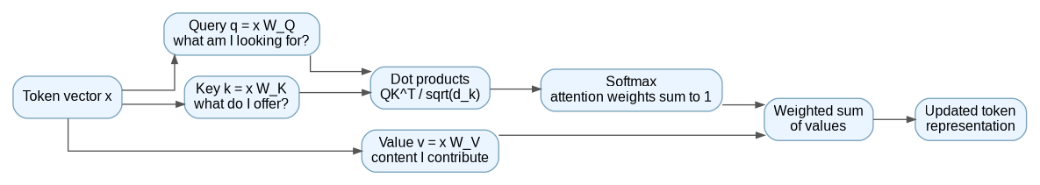
Figure 4. Self-attention data flow for Q, K, V, dot products, softmax weights, and weighted values.
Attention(Q, K, V) = softmax((Q K^T) / sqrt(d_k)) V

The sqrt(d_k) divisor keeps dot products from becoming too large as vector dimensionality grows. Without scaling, the softmax can saturate, meaning it becomes too close to a hard maximum too early and gradients become less useful during training.
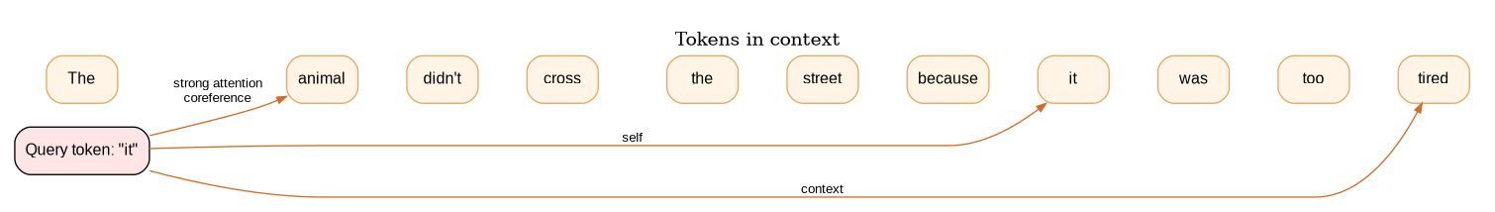
Figure 5. A simplified attention example: the query token "it" attends strongly to the noun it refers to.
Decoder-only LLMs add one crucial constraint: token position t can only attend to positions <= t. This is causal masking. Disallowed future positions are set to negative infinity before softmax, which makes their softmax probability effectively zero. Without this mask, training would leak the answer by letting each token peek at future tokens.
Real models use multi-head attention. Instead of one set of W_Q, W_K, and W_V matrices, they use many sets in parallel, such as 32 or 64 heads. Different heads can specialize in different patterns: one may track subject-verb agreement, another may track coreference, and another may track syntactic structure. The head outputs are concatenated and projected back to d_model.
# Pseudocode for one attention head, decoder-only, no batching
def attention_head(x, W_Q, W_K, W_V):
Q = x @ W_Q # (seq_len, d_k)
K = x @ W_K # (seq_len, d_k)
V = x @ W_V # (seq_len, d_v)
scores = Q @ K.T / sqrt(d_k) # (seq_len, seq_len)
scores = apply_causal_mask(scores) # upper triangle -> -inf
weights = softmax(scores, axis=-1)
return weights @ V # (seq_len, d_v)

Check question: In "The trophy did not fit in the brown suitcase because it was too big", which token should the query vector for "it" match most strongly with?

Answer: it should match most strongly with the key for "trophy", because the trophy is the object that is too big to fit. This matters because attention moves information about "trophy" into the representation for "it", helping the model predict sensible next tokens and maintain coherent meaning.

Step 4: Stack the layers and add the feed-forward network
A single attention layer is not enough. Real LLMs stack Transformer blocks dozens to hundreds of times. Each block lets the model do another round of contextual mixing and per-token transformation.
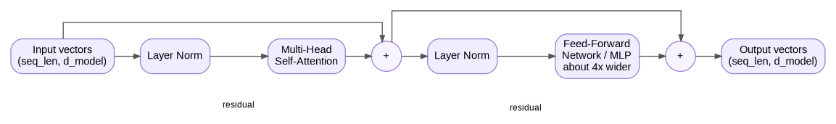
Figure 6. Reconstructed Transformer block: layer norm, multi-head attention, residual connection, layer norm, feed-forward network, residual connection.
Two new pieces are especially important:
1. Residual connections: the block output is input + transformation(input). This lets gradients flow cleanly through many layers and lets each layer learn an adjustment rather than rewriting everything from scratch. Without residual paths, very deep Transformers are difficult to train.
2. Feed-Forward Network (FFN), also called MLP: after attention mixes information across positions, the FFN processes each position independently. It is typically a two-layer network that expands the dimension by about 4x, applies a nonlinearity such as GeLU or SwiGLU, and projects back to d_model. This is where a large share of the model parameters live.
Stacking N such blocks gives the model two axes of computation: attention across positions, and feed-forward processing within each position, repeated N times. A 70B-parameter model can have on the order of 80 such blocks, while frontier models may have more than 100.
After the final block, the model applies one more normalization and then a linear projection from d_model to vocabulary size. This projection is sometimes tied to the embedding matrix transpose. The result is a vector of logits, one score per vocabulary token. A softmax converts those logits into a probability distribution over possible next tokens.

Step 5: Sampling, autoregression, and how training shaped all of this
The final layer gives a probability distribution over the entire vocabulary for every position. For text generation, we care about the last position: the prediction for the token that would extend the current prompt.
There are several ways to choose the next token from that distribution:
- Greedy decoding: take argmax. This is deterministic, but it can be boring or repetitive.
- Temperature sampling: divide logits by temperature T before softmax. T < 1 sharpens the distribution and makes output more deterministic. T > 1 flattens the distribution and makes output more random. T = 0 collapses to greedy behavior.
- Top-k sampling: keep only the k highest-probability tokens, renormalize, and sample from them.
- Top-p or nucleus sampling: keep the smallest set of tokens whose cumulative probability exceeds p, renormalize, and sample from that set.
Once a token is chosen, it is appended to the input and the whole forward pass runs again. This is what autoregressive means: each output token depends on all previous input and output tokens.
Production inference uses a KV cache to avoid recomputing keys and values for tokens that have not changed. The cache stores K and V matrices from each layer for every previous position. This is why generating the second token onward can be much faster than recomputing the full prompt every time.

How the weights ended up holding knowledge
The weights W_Q, W_K, W_V, FFN weights, embeddings, and output projections become useful through three broad training stages:
1. Pretraining. Take trillions of tokens of internet-scale text. For each training window, ask the model to predict the next token at every position in parallel, made possible by causal masking. Compute cross-entropy loss, commonly summarized as -log P(actual_next_token), average it over positions, backpropagate gradients, and update weights with an optimizer such as AdamW. Repeating this for months on many GPUs teaches grammar, facts, code patterns, and the statistical shape of human reasoning from one objective: be less surprised by the next token.
2. Supervised fine-tuning (SFT). Continue training on a much smaller set of high-quality instruction and ideal-response pairs written or curated by humans. The objective is still cross-entropy, but the data teaches the model the format and behavior of a helpful assistant.
3. Preference tuning, such as RLHF, DPO, or variants. Show the model candidate responses, learn a preference or reward signal for which answer is better, and optimize the policy to produce preferred responses. This stage shapes refusal behavior, instruction following, safety behavior, and consistent assistant tone.
Figure 7. Training pipeline from raw text to assistant model.
Answer to the earlier check: A 200-word reply is roughly 250-350 tokens, so the network runs roughly 250-350 times to produce that answer. Each forward pass uses the full prompt plus everything generated so far, although KV caching makes this much more efficient in production.

Worked example: tracing "The capital of France is" end to end
This example uses small illustrative dimensions so the shapes fit on a screen. The numbers are not from a real model; they are meant to make the pipeline concrete.
Configuration | vocab_size = 50,257; d_model = 12; n_heads = 2; n_layers = 4
Input string | "The capital of France is"

1. Tokenize. ["The", " capital", " of", " France", " is"] -> [464, 3139, 286, 4881, 318]. Five tokens.
2. Embed. Look up each ID in the 50,257 x 12 embedding matrix. Now we have a 5 x 12 matrix. Row 0, corresponding to "The", might look like [0.12, -0.04, 0.88, ..., 0.31].
3. Add position. Apply RoPE rotations to each row based on positions 0 through 4. The shape stays 5 x 12, but values change so the model knows order.
4. Block 1 attention. Project each row to Q, K, and V. With 2 heads and d_model = 12, each head uses dimensions of 6, so each projection is 5 x 6 per head. Compute Q @ K^T to get a 5 x 5 score matrix. Apply the causal mask so position 0 sees only itself, position 1 sees positions 0 and 1, and so on. Softmax row-wise, multiply by V, concatenate the two heads to 5 x 12, then add the residual connection.
5. Block 1 FFN. Each of the 5 rows independently goes through a 12 -> 48 -> 12 MLP with a nonlinearity. Add the residual connection.
6. Blocks 2, 3, and 4. Repeat the same process with each block's own weights. After block 4, we have a final 5 x 12 matrix. Each row's vector encodes what should come after that position, in context.
7. Project to vocabulary. Take the last row, position 4, corresponding to " is". Multiply it by the 12 x 50,257 unembedding matrix. Now we have a vector of 50,257 logits.
8. Softmax. Suppose the top entries after softmax are: " Paris" 0.78, " the" 0.09, " a" 0.04, " located" 0.03, and " one" 0.02.
9. Sample. With T = 0.7 and top-p = 0.9, the candidate set may collapse to [" Paris", " the"] with renormalized probabilities roughly [0.90, 0.10]. The model samples " Paris".
10. Append and repeat. The new input is "The capital of France is Paris" with six tokens. Run the forward pass again to get the next token, perhaps ".". Continue until an end-of-sequence token is sampled or a length limit is reached.
Output: " Paris."
That is the core loop. Every chat reply, code completion, and essay is produced by repeated next-token prediction. The intelligence lives in the values of the weight matrices, which were shaped by pretraining, supervised fine-tuning, and preference tuning.

Appendix A: Code snippets in one place
# Tokenization and embedding lookup
token_ids = tokenizer.encode("The capital of France is")
# -> [791, 6864, 315, 9822, 374] (5 ints)
embeddings = embedding_matrix[token_ids]
# -> shape (5, d_model), e.g. (5, 4096)

# One attention head, decoder-only, no batching
def attention_head(x, W_Q, W_K, W_V):
Q = x @ W_Q # (seq_len, d_k)
K = x @ W_K # (seq_len, d_k)
V = x @ W_V # (seq_len, d_v)
scores = Q @ K.T / sqrt(d_k) # (seq_len, seq_len)
scores = apply_causal_mask(scores) # upper triangle -> -inf
weights = softmax(scores, axis=-1)
return weights @ V # (seq_len, d_v)

# Key formulas
Attention(Q, K, V) = softmax((Q K^T) / sqrt(d_k)) V
cross_entropy_for_one_token = -log(P(actual_next_token))

Appendix B: Quick glossary
Token | A chunk of text treated as one unit by the model, such as a word, word piece, punctuation mark, or whitespace-attached word.
Tokenizer | The fixed algorithm and vocabulary that convert text into token IDs and back.
Embedding | A learned dense vector representing a token ID.
d_model | The main hidden vector width used by the model.
Position encoding / RoPE | A mechanism that gives each token vector information about where it appears in the sequence.
Query, Key, Value | The three projections used by attention. Queries look for relevant information, keys advertise what tokens contain, and values carry the content to mix.
Softmax | A function that converts raw scores into probabilities that sum to 1.
Causal mask | A mask that prevents a position from attending to future positions.
Multi-head attention | Several attention mechanisms run in parallel, allowing different heads to track different relationships.
Residual connection | A skip connection that adds the input back to a transformation output.
FFN / MLP | A feed-forward network applied independently to each position after attention.
Logits | Raw scores for each possible next token before softmax.
Temperature | A sampling control that sharpens or flattens the next-token probability distribution.
Top-k / Top-p | Sampling filters that restrict possible next tokens before sampling.
KV cache | A cache of key and value tensors for previous tokens, used to speed autoregressive generation.
Pretraining | Large-scale next-token prediction training over massive text data.
SFT | Supervised fine-tuning on instruction-response examples.
RLHF / DPO | Preference tuning methods that shape model behavior using comparisons or preference signals.

Appendix C: Fast recap as a single pipeline
1. Text is tokenized into integer IDs.
2. IDs are looked up in an embedding matrix to become vectors.
3. Position information is added or rotated into the vectors.
4. The vectors pass through repeated Transformer blocks.
5. Inside each block, attention mixes information across positions and the FFN processes each position independently.
6. The final vector at the last position is projected to vocabulary logits.
7. Softmax converts logits to next-token probabilities.
8. A decoding strategy chooses one token.
9. The chosen token is appended, and the loop repeats.

