Assignment – 2
Conceptual Requirements
- Linear Regression loss – This uses the Residual Sum of Squares as the loss function.
Loss = $\sum_{i=1}^{n}{(}y_{i}-{\hat{y}}_{i})^{2}$
This formula calculates the error by squaring the difference between the real ‘mpg’ and ‘predicted_mpg’ by the model. By squaring, when we use the optimization algorithm like Gradient descent, it will punish the large errors than the small ones.

- Ridge Regression loss – This use the Residual Sum of Squares as the loss function + adds a penalty term proportional to the square of the magnitude of the coefficients
Loss = $\sum_{i=1}^{n}{(}y_{i}-{\hat{y}}_{i})^{2}+λ\sum_{j=1}^{p}{β_{j}^{2}}$
By adding this, any feature has large weights will be punished heavily and it makes the importance of each feature. It reduces model variance (overfitting) by ‘shrinking’ the weights towards ‘zero’ but not zero.

- Lasso Regression loss - This use the Residual Sum of Squares as the loss function +
adds a penalty term proportional to the absolute value of the coefficients.
$$\text{Loss}=\sum_{i=1}^{n}{(}y_{i}-{\hat{y}}_{i})^{2}+λ\sum_{j=1}^{p}{|}β_{j}|$$
This model forces the least useful feature to become exactly zero. In our code example, as the model regularization increases, the strictness on coefficients increases and the coefficient is set to zero.
- Elastic Net loss – It combines both L1 and l2 regularization penalties. In model we control it with l1_ratio value.
$$\text{Loss}(β)=\sum_{i=1}^{n}{(}y_{i}-{\hat{y}}_{i})^{2}+λ_{1}\sum_{j=1}^{p}{|}β_{j}|+λ_{2}\sum_{j=1}^{p}{β_{j}^{2}}$$
This model provides a balanced approach to handle correlated features better than lasso, where lasso will select one feature and eliminates other feature.

Analysis & Hypothesis
- Why does regularization improve test performance?
A standard Linear Regression tries to perfectly fit every point in the training set, even if the data points are likely highly correlated or just noise, when the polynomial degree increases, it adds more features. By introducing regularization we can cut the extreme coefficients reducing the variance and preventing the model from overreacting to small fluctuations in the data.

- Why does Ridge keep all features but shrink them?
Mathematically, ridge formula (algorithm) puts pressure on feature and the coefficient gets smaller. But they never get to zero. It uses a rubber band analogy that gets weaker the closer you get to the center but never gets to zero.

- Why does Lasso remove features entirely?
Lasso uses (|w|) a constant push towards zero (the derivative is zero). This allows it to push a coefficient all the way to zero, effectively performing feature selection.

- Why does Elastic Net behave differently from both?
Elastic Net is the best of both worlds. It uses the ridge and lasso regularizations by setting l1_ratio value to the model. If we have two features that are highly correlated (like displacement and weight), Lasso might randomly pick one and kill the other. Elastic Net's Ridge component helps it keep a more stable group of features while still eliminating the true noise.

- Which model performed best on your dataset and why?
Model Performance:
With polynomial degree 2
Below is the plot how each model performs at different alpha levels. Ridge reduced the coefficient to almost zero when alpha (regularization is increased but not zero), whereas lasso, makes most of the coefficients to zero removing many useful features out of the context. ElasticNet model shows better results.
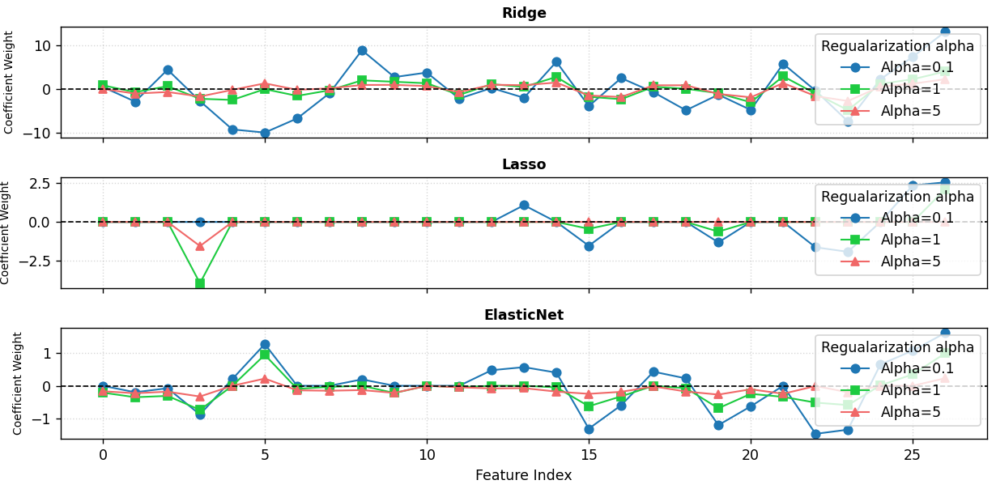
Below is the mse values for all the models.
Ridge: [5.93, 5.77, 5.97] (Error decreases as alpha increases)
Lasso: [7.21, 8.71, 36.37] (Error explodes as alpha increases)
ElasticNet: [6.89, 8.77, 20.42] (Error increases significantly)
As there is high multicollinearity between the features, ridge model performance is better than lasso and elasticnet.

Plot 2 (A training vs testing error plot for different regularization strengths)
As the regularization increases MSE also increases (polynomial degree = 2)
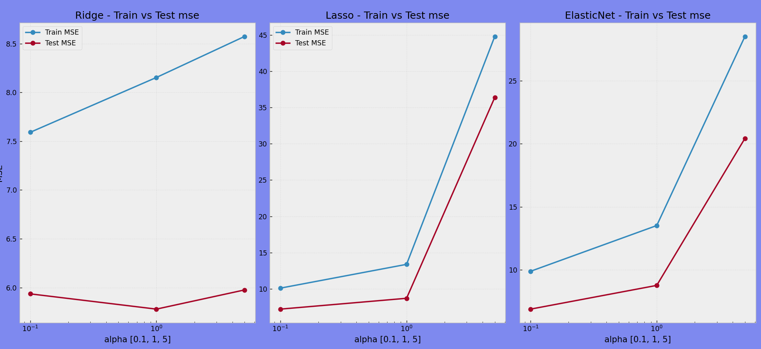
When the polynomial degree is high = 15
Linear model = MSE is worse 290.57
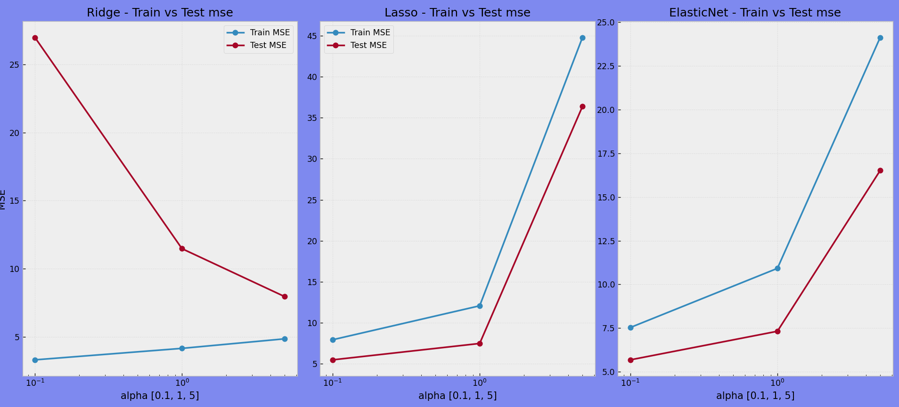

Assignment -1
Conceptual Requirements
- Why squared error is used
Squared error is used because it heavily penalizes large deviations between predicted and actual values and is differentiable, making it suitable for optimization. It ensures that predictions stay close to the true values
Loss = $1/n\sum_{i=1}^{n}{(}y_{i}-{\hat{y}}_{i})^{2}$

- What minimizing the loss actually means
Minimizing the loss means finding model parameters (weights and bias) that make the predictions as close as possible to the true values on the training data. For MSE, this involves adjusting parameters to reduce the average squared difference between predicted and actual values.

- How the model parameters influence the loss
Model parameters directly determine the predictions. Large coefficients or high-degree polynomials can reduce training loss but may cause overfitting, leading to higher test loss. Multicollinearity can make coefficients unstable and affect generalization.
Analysis & Explanation
- Why does training error always decrease with higher polynomial degree?
Higher-degree polynomials have more flexibility to fit the data. As the degree increases, the model can fit the training points more precisely, so the training error continuously decreases. However, this increased flexibility can cause overfitting and lead to poor performance on test data.

- Why does test error behave differently?
Lower-degree polynomials may underfit and have high bias, resulting in high test error. Moderate-degree polynomials (like 2, 3, or 5) can capture the underlying patterns, giving lower test error. However, very high-degree polynomials can overfit the training data, which increases the test error.

- At what point does the model start overfitting, and how can you tell?
Overfitting starts when increasing the polynomial degree reduces the training error but increases the test error. In plots, overfitting is often visible as a very wiggly curve that fits all the training points rather than following the overall trend.

- If you had to choose one polynomial degree, which would it be and why?
I would choose the degree that achieves the lowest test error while capturing the trend smoothly, typically in the range of 2–4 for this dataset. Higher-degree polynomials may fit the training data better, but they can also fit noise and perform poorly on unseen data.

Plot -1

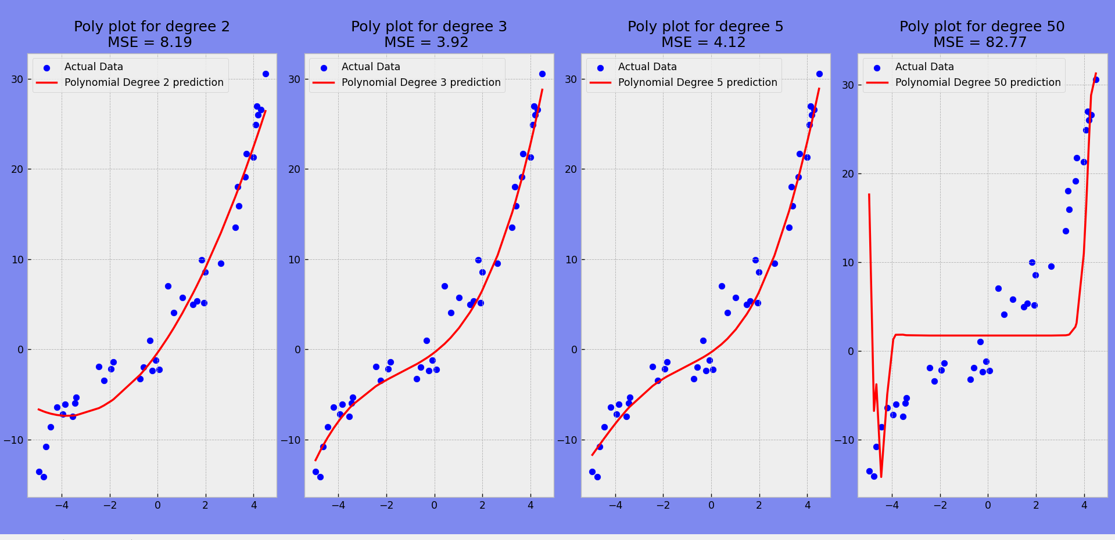

Plot -2
