
Brolly Software Solutions Private Limited
Mail Id: hr@digitalbrolly.com Phone: +918186844555

EXPERIENCE LETTER
Date: {{ date }}
{{ name }}
{{ email }}
Mobile: {{ phone_number }}

This is to certify that {{ title }} {{name}} was employed with Brolly Software Solutions as a {{ job_role }} in the domain of {{ domain }} from {{ from_date }} to {{ to_date }}.


During this period, {{ sub }} was responsible for {{ key_responsibilities }}. {{ poss_cap }} role involved working on {{ tools_technologies }}, ensuring timely execution of tasks, and contributing effectively to the team’s objectives.

{{ name }} consistently demonstrated professionalism, dedication, and strong problem-solving skills in handling responsibilities. {{ sub_cap }} proved to be a reliable team member, capable of working both independently and collaboratively.

We wish him success in all his future endeavors.

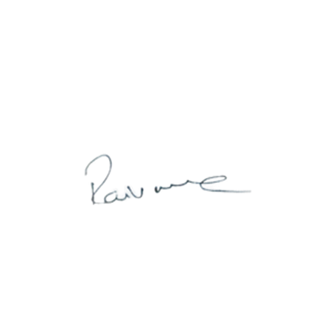

Brolly Software Solutions Pvt Ltd Manager

Ravi varma Dandu

