
Brolly Software Solutions Private Limited
Mail Id: hr@brollyacademy.com Phone: +91 8186844555

Date:{{ date }}

TO WHOMSOEVER IT MAY CONCERN

This is to certify that {{ name }} has completed {{ poss }} internship in {{ domain }} under the {{ course_name }} at Brolly Software Solutions from {{ from_date }} to {{ to_date }}.

{{ sub_cap }} has worked on {{ project_name }} projects in {{ domain }}, gaining practical knowledge and hands-on experience through the internship program. As part of the program, {{ sub }} actively contributed as an intern.
During the internship, {{ sub }} demonstrated strong learning ability, self-motivation, and commitment to completing tasks. {{ poss_cap }} performance met our expectations, and {{ sub }} successfully completed the assigned projects on time.

We wish all the best for his upcoming career

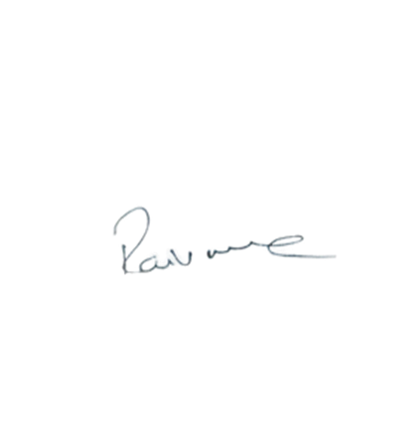

Brolly Software Solutions Pvt Ltd Manager

Ravi varma Dandu

