
Brolly Software Solutions Private Limited
Mail Id: hr@digitalbrolly.com Phone: +91 8186844555

RELIEVING LETTER
Date: {{ date }}
Acceptance of Resignation,

Dear {{ name }},
This is to formally confirm that {{ title }} {{ name }} was employed with Brolly Software Solutions as a {{ job_role }} from {{ from_date }} to {{ to_date }}.


{{ poss_cap }} resignation has been accepted, and {{ sub }} has been relieved from duties effective {{ relieving_date }}. We confirm that all clearance procedures have been completed and there are no dues pending from {{ poss }} side.

During {{ poss }} tenure with us, {{ name }} made valuable contributions to the organization. {{ poss_cap }} professionalism, dedication, and knowledge—particularly in areas such as {{ key_responsibilities }}—have been commendable and beneficial to our team.

We wish him success in all his future endeavors.

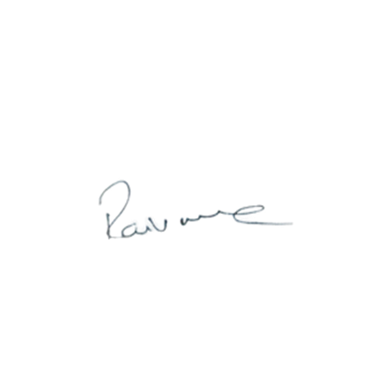

Brolly Software Solutions Pvt Ltd Manager

Ravi varma Dandu

