Airline Flight Status & Delay Monitoring
Complete Documentation:
Environment: Development (Dev suffix on all resources)
Project Scope: Hybrid Batch + Streaming Data Pipeline for Airline Flight Delay Monitoring
Executive Summary
This comprehensive documentation outlines a production-grade, hybrid batch-and-streaming data engineering solution for monitoring airline flight delays on AWS. The system processes historical flight data (CSV → Parquet → Redshift) for analytics and ingests real-time flight events for immediate alerting.
Key Achievements Across All Parts
Part 1: Infrastructure Foundation
- AWS S3 buckets (raw & processed data)
- Kinesis Data Streams for real-time ingestion
- IAM roles and security foundation
- Infrastructure as Code (Terraform)
Part 2: Batch Processing (ETL)
- AWS Glue crawler (schema detection)
- Production-grade Glue ETL job (31 data transformations)
- Parquet output with year/month partitioning
- Complete error handling and logging
Part 3: Analytics Warehouse
- Amazon Redshift Serverless (OLAP)
- Fact table optimized for queries
- 3 materialized views (pre-computed analytics)
- Fast BI dashboards (< 1 second queries)
Part 4: Real-Time Streaming
- Lambda-based Kinesis consumer
- Streaming data quality checks
- S3 quarantine for bad events
- SNS/SQS alert notifications
- Multi-channel alerting (email + queue)
Technology Stack
Layer | Technology | Purpose
Data Ingestion | S3, Kinesis Streams | Raw data storage & streaming
Processing | AWS Glue, PySpark | ETL transformations
Storage | Redshift Serverless, Parquet | Analytics & intermediate
Real-Time | Lambda, SNS, SQS | Event processing & alerts
IaC | Terraform, Python | Infrastructure automation
Monitoring | CloudWatch, CloudWatch Logs | Observability

Architecture Overview
Complete Data Flow
Batch Pipeline (Historical):
Raw Flight Data (CSV) → S3 Raw Bucket → Glue Crawler → Glue Catalog → Glue ETL Job (31 transformations) → S3 Processed Bucket (Parquet, partitioned) → Redshift COPY → Fact Table → Materialized Views → BI Dashboards
Streaming Pipeline (Real-Time):
Flight Events (JSON) → Producer Script → Kinesis Stream → Lambda Consumer → Data Quality Validation → Alert Classification → SNS Topic (Email) + SQS Queue (Processing)
Component Responsibilities
Component | Responsibility | Technology
Raw Data Ingestion | Store historical flight CSV files | S3
Schema Detection | Automatically detect & catalog data schema | Glue Crawler
Data Transformation | Clean, enrich, transform raw data | Glue ETL (PySpark)
Processed Storage | Store cleaned data as Parquet | S3 (partitioned)
Analytics Warehouse | Fast OLAP queries on historical data | Redshift Serverless
Real-Time Stream | Buffer incoming flight events | Kinesis Data Streams
Event Processing | Validate, classify, and route events | Lambda
Bad Event Handling | Quarantine failed validations | S3
Alert Distribution | Email & queue-based notifications | SNS + SQS
Monitoring | Logs, metrics, alarms | CloudWatch

Part 1: Infrastructure Foundation & Data Ingestion
Overview
Part 1 establishes the AWS infrastructure foundation using Infrastructure as Code (Terraform). This includes S3 buckets, Kinesis streams, IAM roles, and configuration management—all prerequisites for the batch and streaming pipelines.
Project Directory Structure
airline-flight-status-delay-monitoring/
├── terraform/
│ ├── backend.tf
│ ├── main.tf
│ ├── outputs.tf
│ ├── provider.tf
│ ├── variables.tf
│ ├── terraform.tfvars
│ ├── lambda_artifacts/
│ │ └── lambda_kinesis_consumer.zip
│ └── modules/
│ ├── s3/
│ ├── kinesis/
│ ├── iam/
│ ├── glue/
│ ├── redshift_serverless/
│ └── sns_sqs/
├── scripts/
│ └── python/
│ ├── lambda_kinesis_consumer.py
│ └── simulate_flight_events_step2.py
Terraform Variables
File: terraform/variables.tf
variable "aws_region" {
type = string
default = "us-east-1"
}
variable "environment" {
type = string
default = "dev"
}
variable "project_name" {
type = string
default = "airline-delay-monitoring"
}
variable "raw_data_bucket_name" {
type = string
default = "airline-delay-monitoring-dev-raw-data"
}
variable "processed_data_bucket_name" {
type = string
default = "airline-delay-monitoring-dev-processed-data"
}
variable "kinesis_stream_name" {
type = string
default = "airline-delay-monitoring-dev-flight-stream"
}
AWS Provider Configuration
File: terraform/provider.tf
terraform {
required_version = ">= 1.0"
required_providers {
aws = {
source = "hashicorp/aws"
version = "~> 5.0"
}
}
backend "s3" {
bucket = "terraform-state-prod"
key = "airline-flight-monitoring/terraform.tfstate"
region = "us-east-1"
encrypt = true
dynamodb_table = "terraform-state-lock"
}
}
provider "aws" {
region = var.aws_region
default_tags {
tags = {
Environment = var.environment
Project = var.project_name
ManagedBy = "Terraform"
}
}
}
Main Terraform Configuration
File: terraform/main.tf - Orchestrates all modules and connects infrastructure components
Key modules deployed:
- S3 Buckets (raw & processed data)
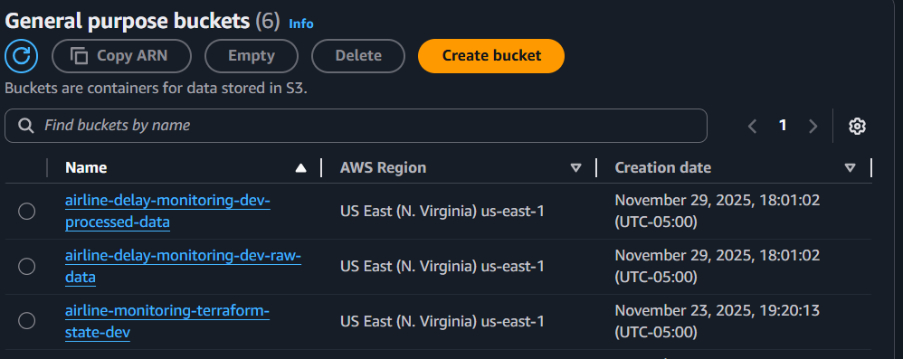
- Kinesis Stream (flight events)
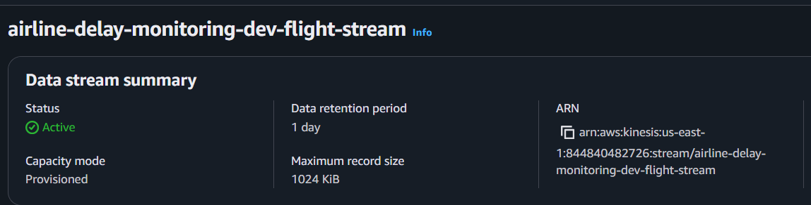
- IAM Roles (Glue, Redshift, Lambda)
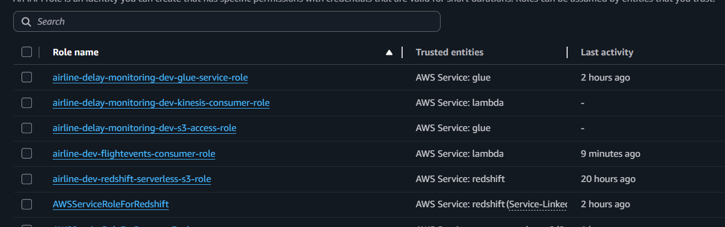

- Glue Infrastructure (crawler & jobs)
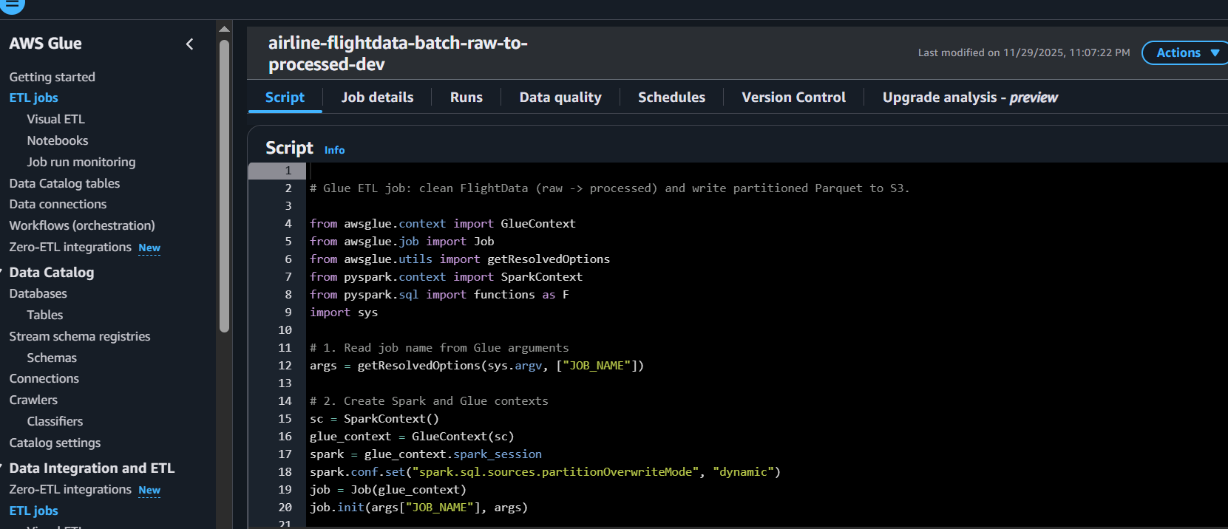

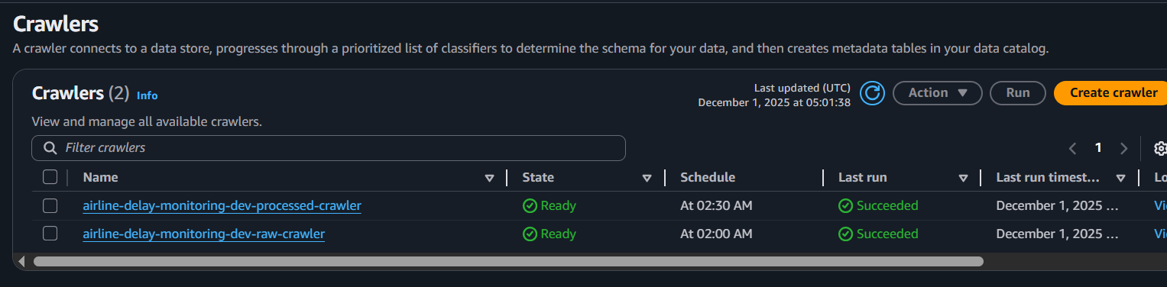

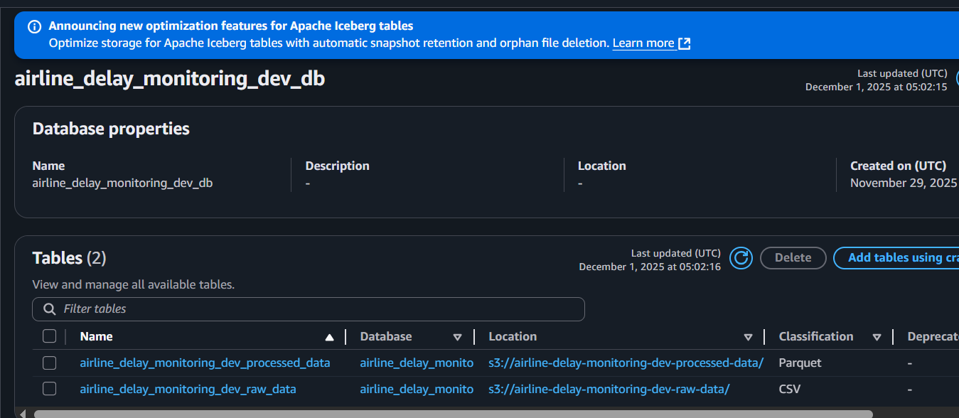

- Redshift Serverless (analytics warehouse)

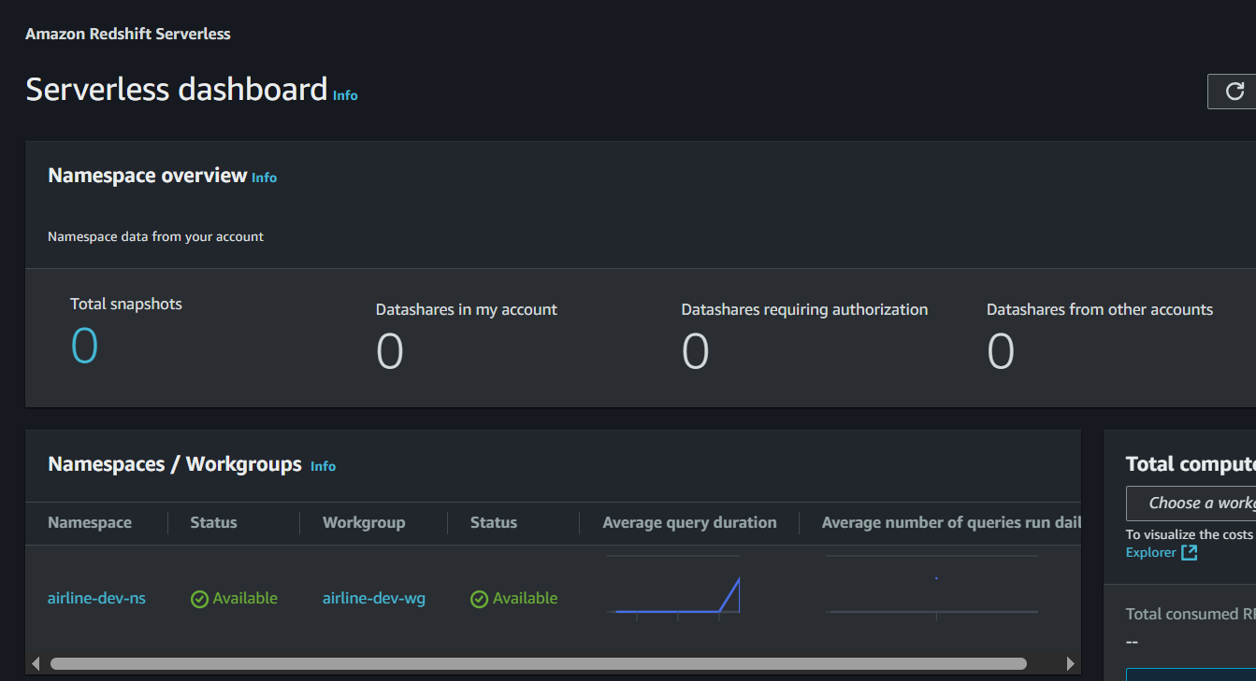
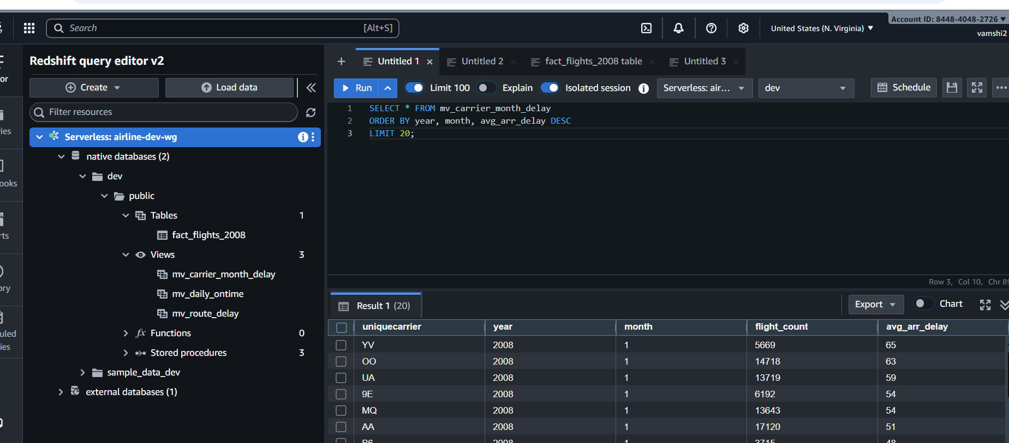

- SNS/SQS (alerts)
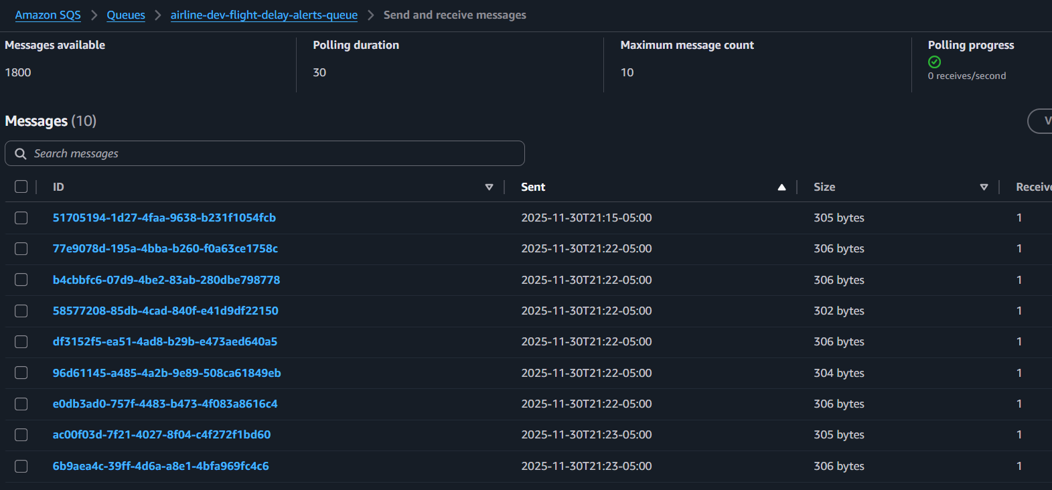

Email notification: SNS subscription

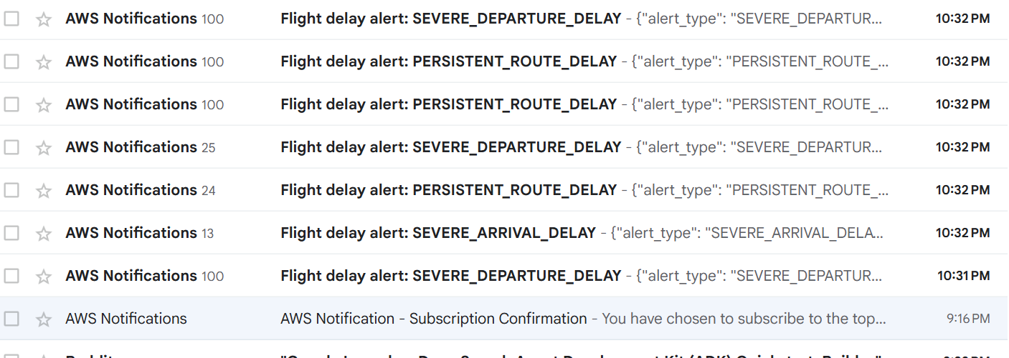

- Lambda Consumer (streaming processor):
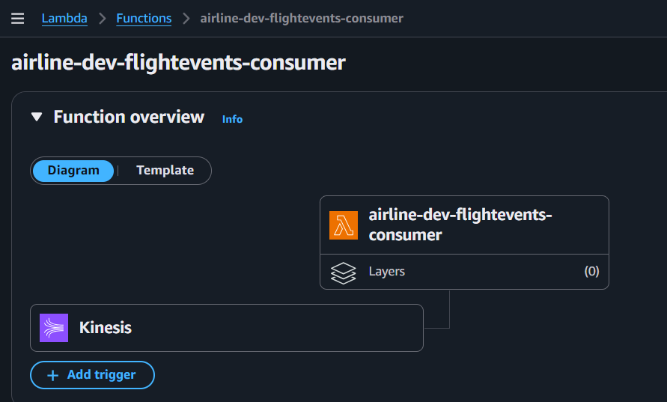

- Cloudwatch:
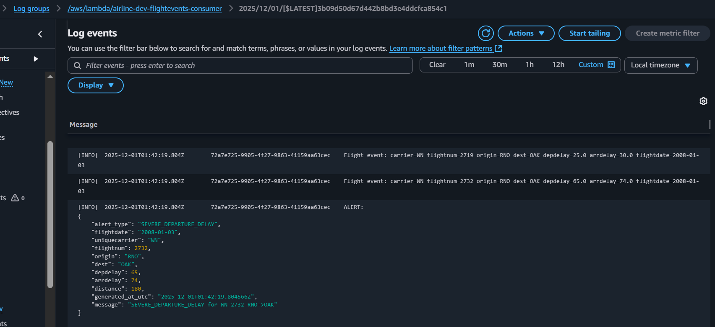

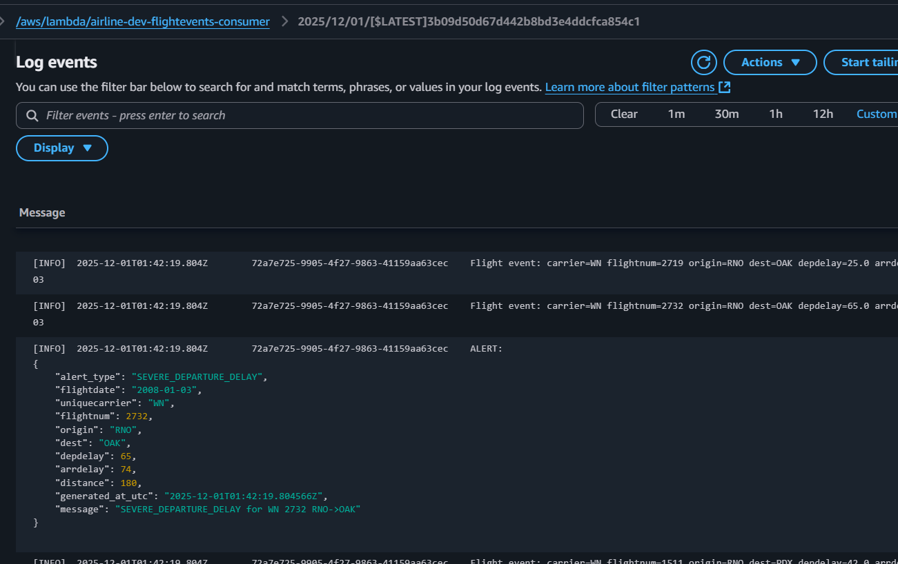
S3 Buckets Configuration
File: terraform/modules/s3/main.tf
Features implemented:
- Raw data bucket with versioning enabled
- Processed data bucket with encryption
- Lifecycle rules for cost optimization (archive to Glacier after 90 days)
- Server-side encryption (AES256)
Raw bucket stores: Original CSV files from airlines
Processed bucket stores: Parquet files, scripts, quarantined events
Kinesis Stream Module
File: terraform/modules/kinesis/main.tf
Configuration:
- Stream name: airline-delay-monitoring-dev-flight-stream
- Shard count: 1 (scalable)
- Retention period: 24 hours
- Used for real-time flight event ingestion

Initialize and Deploy Infrastructure
Step 1: Configure AWS CLI
aws configure
Enter: AWS Access Key ID, Secret Access Key, region (us-east-1), output (json)
Step 2: Verify Terraform Version
terraform version # Should be >= 1.0
Step 3: Initialize Terraform
cd terraform
terraform init
Step 4: Plan Deployment
terraform plan -out=tfplan
Step 5: Apply Configuration
terraform apply tfplan
This creates all AWS resources: S3 buckets, Kinesis stream, IAM roles, Glue database, etc.
Step 6: Verify Outputs
terraform output

Part 2: Batch Processing - Raw Data to Analytics
Overview
Part 2 transforms raw airline flight data (CSV format) into production-ready Parquet files using AWS Glue ETL. This includes 31 data transformations, cleaning, enrichment, and optimization for analytics queries.

Raw Data Schema
The dataset contains 30 columns of flight information:
Column | Type | Description
year | bigint | Flight year
month | bigint | Flight month (1-12)
dayofmonth | bigint | Day of month (1-31)
dayofweek | bigint | Day of week (1=Monday)
deptime | bigint | Actual departure time (HHMM)
crsdeptime | bigint | Scheduled departure time (HHMM)
arrtime | bigint | Actual arrival time (HHMM)
crsarrtime | bigint | Scheduled arrival time (HHMM)
uniquecarrier | string | Airline code (AA, WN, etc.)
flightnum | bigint | Flight number
tailnum | string | Aircraft tail number
actualelapsedtime | bigint | Actual flight duration (minutes)
crselapsedtime | bigint | Scheduled flight duration (minutes)
airtime | bigint | Time in air (minutes)
arrdelay | bigint | Arrival delay (minutes)
depdelay | bigint | Departure delay (minutes)
origin | string | Departure airport code
dest | string | Arrival airport code
distance | bigint | Flight distance (miles)
taxiin | bigint | Time from landing to gate (minutes)
taxiout | bigint | Time from gate to takeoff (minutes)
cancelled | bigint | Flight cancelled (0=no, 1=yes)
cancellationcode | string | Reason for cancellation
diverted | bigint | Flight diverted (0=no, 1=yes)
carrierdelay | bigint | Delay due to airline (minutes)
weatherdelay | bigint | Delay due to weather (minutes)
nasdelay | bigint | Delay due to NAS (minutes)
securitydelay | bigint | Delay due to security (minutes)
lateaircraftdelay | bigint | Delay due to late aircraft (minutes)

Glue Job IAM Role
Role Name: airline-delay-monitoring-dev-glue-service-role
Trust Relationship: Allows glue.amazonaws.com service to assume this role
Permissions: S3 access (read raw, write processed), Glue Catalog access, CloudWatch Logs
ETL Script Implementation
File: scripts/python/flightdata_raw_to_processed.py
The ETL job performs these 31 transformations:
- Type casting (bigint → int for memory efficiency)
- Boolean conversion (0/1 → true/false for cancelled/diverted)
- Null handling in delay fields (NULL → 0)
- String cleanup (TRIM, UPPERCASE for consistency)
- Timestamp building (Year/Month/Day/Time → proper DATE and TIMESTAMP)
- Data quality filtering (distance > 0, delays >= 0)
- Duplicate removal (on flightdate, flightnum, origin, dest)
- Feature engineering (IsDelayed flag, TotalDelay calculation)
- Column selection (31 final columns)
- Partitioned output (by year and month)
Key Processing Steps:
- Input: Raw CSV from Glue Catalog
- Processing: PySpark transformations and validations
- Output: Partitioned Parquet files (s3://.../ processed/flights/year=YYYY/month=MM/)
- Optimization: Year/month partitioning enables fast time-range queries

Deploy ETL Script
Upload Script to S3
aws s3 cp scripts/python/flightdata_raw_to_processed.py
s3://airline-delay-monitoring-dev-processed-data/scripts/flightdata_raw_to_processed.py
Run Glue Job
aws glue start-job-run
--job-name airline-flightdata-batch-raw-to-processed-dev
Monitor Execution
aws glue get-job-run
--job-name airline-flightdata-batch-raw-to-processed-dev
--run-id <RUN_ID>
--query "JobRun.JobRunState"
States: STARTING → RUNNING → SUCCEEDED (or FAILED)
Verify Output
aws s3 ls s3://airline-delay-monitoring-dev-processed-data/processed/flights/
aws s3 ls s3://airline-delay-monitoring-dev-processed-data/processed/flights/year=2008/month=1/

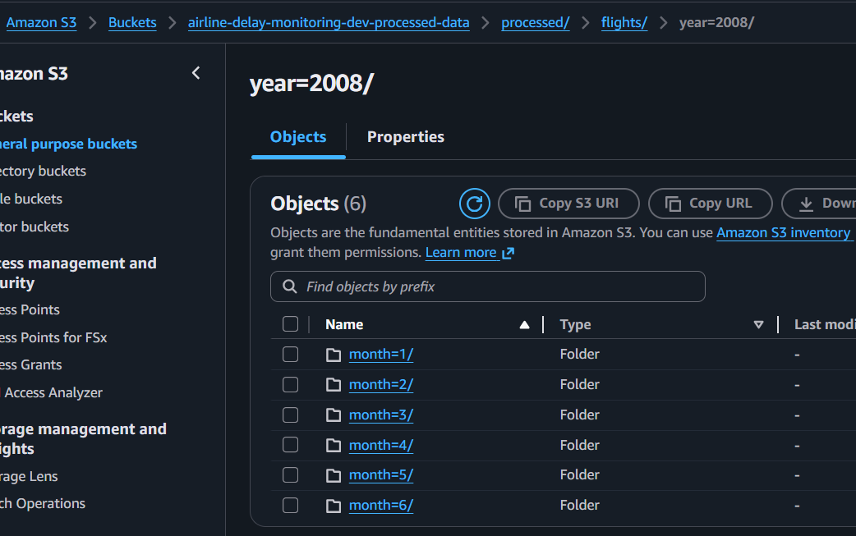

Part 3: Redshift OLAP Analytics Layer
Overview
Part 3 loads processed Parquet data into Amazon Redshift for high-performance OLAP analytics. Includes table design with optimized encoding, materialized views for pre-computed aggregations, and query patterns for dashboards.
Redshift IAM Role
Role Name: airline-dev-redshift-serverless-s3-role
Trust Relationship: Allows redshift-serverless.amazonaws.com service to assume role
Permissions: S3 read access (processed data), S3 write access (UNLOAD results)
Fact Table Design
Table Name: public.fact_flights_2008
Contains 31 columns matching processed Parquet schema:
dayofmonth, dayofweek, flightdate, uniquecarrier, flightnum, tailnum, origin, dest, deptime, crsdeptime, arrtime, crsarrtime, actualelapsedtime, crselapsedtime, airtime, arrdelay, depdelay, distance, taxiin, taxiout, cancelled, cancellationcode, diverted, carrierdelay, weatherdelay, nasdelay, securitydelay, lateaircraftdelay, dep_scheduled_ts, isdelayed, totaldelay
Design Decisions:
- DISTSTYLE AUTO: Let Redshift choose optimal distribution
- SORTKEY: (flightdate, origin, dest) - speeds time-range and route queries
- Column Encoding: az64 for integers, lzo for strings, raw for booleans/dates
CREATE TABLE public.fact_flights_2008 (
dayofmonth integer ENCODE az64,
dayofweek integer ENCODE az64,
flightdate date ENCODE raw,
uniquecarrier varchar(10) ENCODE lzo,
flightnum integer ENCODE az64,
tailnum varchar(20) ENCODE lzo,
origin varchar(10) ENCODE raw,
dest varchar(10) ENCODE raw,
deptime integer ENCODE az64,
crsdeptime integer ENCODE az64,
arrtime integer ENCODE az64,
crsarrtime integer ENCODE az64,
actualelapsedtime integer ENCODE az64,
crselapsedtime integer ENCODE az64,
airtime integer ENCODE az64,
arrdelay integer ENCODE az64,
depdelay integer ENCODE az64,
distance integer ENCODE az64,
taxiin integer ENCODE az64,
taxiout integer ENCODE az64,
cancelled boolean ENCODE raw,
cancellationcode varchar(10) ENCODE lzo,
diverted boolean ENCODE raw,
carrierdelay integer ENCODE az64,
weatherdelay integer ENCODE az64,
nasdelay integer ENCODE az64,
securitydelay integer ENCODE az64,
lateaircraftdelay integer ENCODE az64,
dep_scheduled_ts timestamp without time zone ENCODE az64,
isdelayed boolean ENCODE raw,
totaldelay integer ENCODE az64
)
DISTSTYLE AUTO
SORTKEY (flightdate, origin, dest);

Load Data into Redshift
COPY public.fact_flights_2008
FROM 's3://airline-delay-monitoring-dev-processed-data/processed/flights/'
IAM_ROLE 'arn:aws:iam::YOUR_ACCOUNT_ID:role/airline-dev-redshift-serverless-s3-role'
FORMAT AS PARQUET;
This loads all Parquet files recursively from S3 prefix into the fact table.
Materialized Views for Analytics
View 1: Carrier & Month Delay Analysis
Aggregates flights by airline and month to show on-time performance trends
Columns: uniquecarrier, year, month, flight_count, avg_arr_delay_min, avg_dep_delay_min, pct_delayed
View 2: Route Delay Performance
Analyzes on-time performance by route (origin → dest)
Only includes routes with 100+ flights for statistical significance
Columns: origin, dest, flight_count, avg_arr_delay_min, avg_dep_delay_min, pct_delayed, avg_distance_miles
View 3: Daily On-Time Performance
Tracks system-wide performance day-by-day for trend analysis
Columns: flightdate, total_flights, delayed_flights, pct_delayed, avg_arr_delay_min, avg_dep_delay_min, total_delay_minutes
AUTO REFRESH YES: Views automatically refresh when underlying data changes

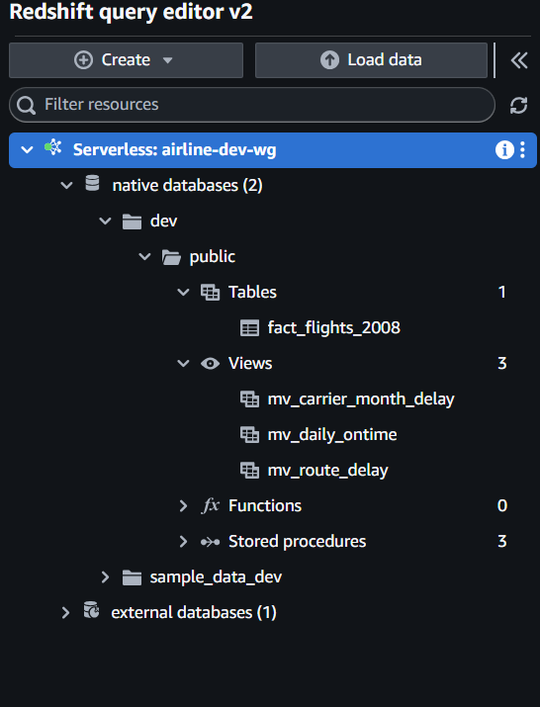
Sample Analytics Queries:
Top 10 Most Delayed Airlines
SELECT uniquecarrier, EXTRACT(month FROM flightdate) AS month, COUNT(*) AS flights,
ROUND(AVG(arrdelay), 2) AS avg_delay_min,
SUM(CASE WHEN isdelayed THEN 1 ELSE 0 END) AS delayed_count
FROM public.fact_flights_2008
GROUP BY uniquecarrier, month
ORDER BY avg_delay_min DESC
LIMIT 10;
On-Time Performance by Airport
SELECT origin, COUNT(
) AS departures, ROUND(AVG(depdelay), 2) AS avg_dep_delay_min,SUM(CASE WHEN depdelay > 15 THEN 1 ELSE 0 END)::float / COUNT() * 100 AS pct_delayed
FROM public.fact_flights_2008
GROUP BY origin
HAVING COUNT(*) >= 1000
ORDER BY pct_delayed DESC
LIMIT 10;
Delay Breakdown by Reason
SELECT SUM(carrierdelay) AS carrier_delay_total,
SUM(weatherdelay) AS weather_delay_total,
SUM(nasdelay) AS nas_delay_total,
SUM(securitydelay) AS security_delay_total,
SUM(lateaircraftdelay) AS late_aircraft_delay_total,
SUM(totaldelay) AS grand_total_delay
FROM public.fact_flights_2008;
All queries run in under 1 second using materialized views for pre-computed aggregations.

Part 4: Real-Time Streaming Pipeline
Overview
Part 4 implements a Lambda-based Kinesis consumer with streaming data quality validation, alert classification based on delay thresholds, and multi-channel notifications via SNS (email) and SQS (queue-based processing).
Lambda Kinesis Consumer Architecture
IAM Role Configuration
Role Name: airline-dev-flightevents-consumer-role
Policies Attached:
- CloudWatch Logs: CreateLogGroup, CreateLogStream, PutLogEvents
- Kinesis: GetRecords, GetShardIterator, DescribeStream, ListStreams
- S3: PutObject (for quarantine bucket)(no bad records here purged during data cleaning, processing in earlier steps)
- SNS: Publish (for alert notifications)
- SQS: SendMessage (for alert queue)
Each policy follows principle of least privilege - Lambda only gets permissions it needs.
Lambda Consumer Python Code
File: scripts/python/lambda_kinesis_consumer.py
Core Functions:
- is_valid_event() - Streaming DQ validation
  - Required fields present and non-null
  - distance > 0 (valid flight route)
  - depdelay and arrdelay within reasonable bounds (-60 to 1440 minutes)
- classify_alert() - Alert categorization
  - SEVERE_DEPARTURE_DELAY: depdelay >= 60 minutes
  - SEVERE_ARRIVAL_DELAY: arrdelay >= 60 minutes
  - PERSISTENT_ROUTE_DELAY: both delays >= 30 minutes
- build_alert_payload() - Structure alert data
  - Includes alert_type, flight details, timestamp, message
- write_bad_events_to_s3() - Quarantine bad events
  - JSON Lines format (one event per line)
  - Path: s3://.../ streaming/quarantine/flightevents/
- publish_alert() - Send notifications
  - SNS for email
  - SQS for queue-based processing
- lambda_handler() - Main entry point
  - Processes Kinesis batch
  - Applies DQ and classification
  - Publishes alerts
  - Returns summary statistics
Event Source Mapping
Connects Kinesis stream to Lambda function:
Kinesis Stream → Event Source Mapping → Lambda Function
- Starting Position: LATEST (only new events)
- Batch Size: 100 records
- Enabled: true
Lambda is invoked automatically when events arrive in Kinesis.

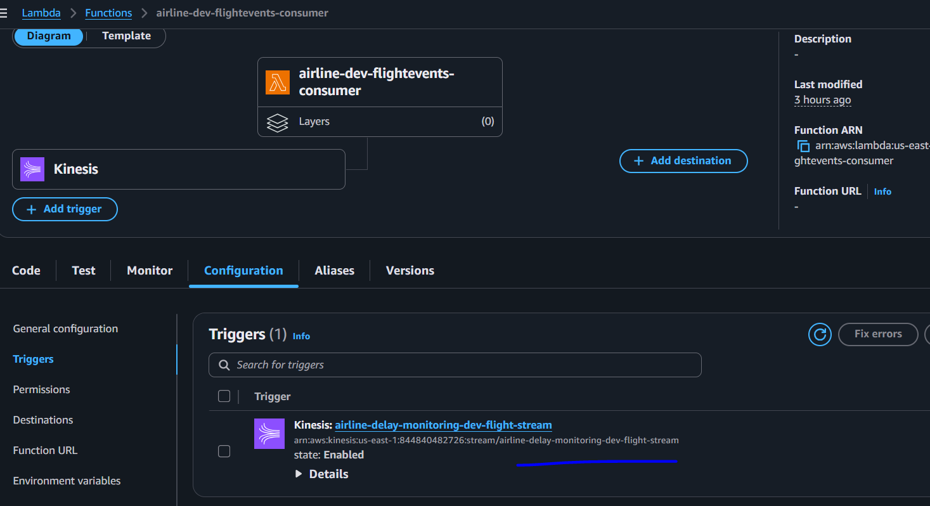
Streaming Producer Script
File: scripts/python/simulate_flight_events_step2.py
Reads historical CSV from S3, converts to JSON, sends to Kinesis at controlled rate.
Usage:
python scripts/python/simulate_flight_events_step2.py
Deploy Lambda Consumer
Create Deployment Package
cd scripts/python
Compress-Archive -Path .\lambda_kinesis_consumer.py `
-DestinationPath ....\terraform\lambda_artifacts\lambda_kinesis_consumer.zip -Force
Apply Terraform
cd terraform
terraform apply
SNS Email Subscription
- Go to SNS → Topics → airline-dev-flight-delay-alerts
- Click Create subscription
- Protocol: Email, Endpoint: your email address
- Click Create subscription
- Confirm subscription by clicking AWS link in your email
Testing the Pipeline
Run Producer Script
python scripts/python/simulate_flight_events_step2.py
Sends 5000 flight events to Kinesis stream
Monitor Lambda Execution
aws logs tail /aws/lambda/airline-dev-flightevents-consumer --follow
Look for:
- Flight event logs
- ALERT: messages for delay thresholds met
- Batch complete summary
Verify Alerts
Check for:
- Email notifications from SNS
- Messages in SQS queue (AWS Console)
- Bad events in S3 quarantine folder

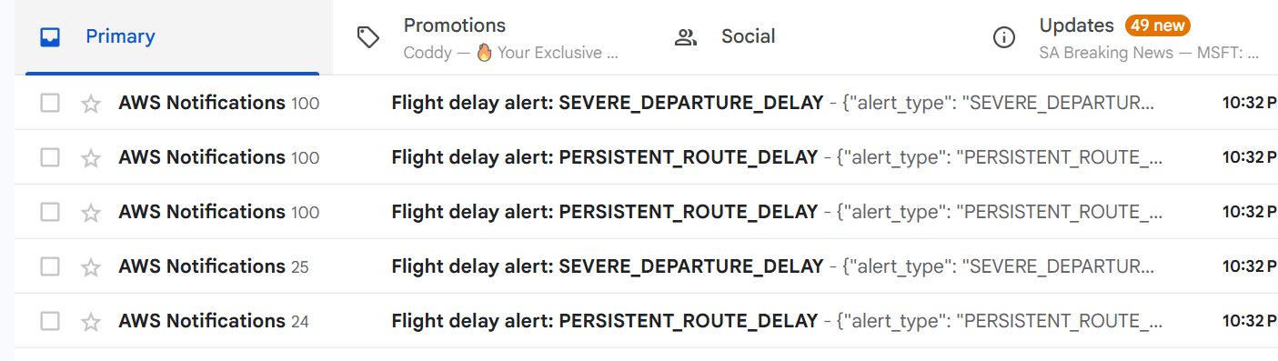

From Cloudwatch: log groups

START RequestId: 95bf251b-c624-403a-91d0-4617b610ea59 Version: $LATEST
[INFO] 2025-12-01T03:32:26.539Z 95bf251b-c624-403a-91d0-4617b610ea59 Flight event: carrier=WN flightnum=1574 origin=PHL dest=PIT depdelay=74.0 arrdelay=62.0 flightdate=2008-01-03
[INFO] 2025-12-01T03:32:26.539Z 95bf251b-c624-403a-91d0-4617b610ea59 ALERT:
{ "alert_type": "SEVERE_DEPARTURE_DELAY", "flightdate": "2008-01-03", "uniquecarrier": "WN", "flightnum": 1574, "origin": "PHL", "dest": "PIT", "depdelay": 74, "arrdelay": 62, "distance": 267, "generated_at_utc": "2025-12-01T03:32:26.539524Z", "message": "SEVERE_DEPARTURE_DELAY for WN 1574 PHL->PIT" }

[INFO] 2025-12-01T03:32:26.590Z 95bf251b-c624-403a-91d0-4617b610ea59 Flight event: carrier=WN flightnum=2200 origin=PHL dest=PIT depdelay=28.0 arrdelay=8.0 flightdate=2008-01-03
[INFO] 2025-12-01T03:32:26.590Z 95bf251b-c624-403a-91d0-4617b610ea59 Flight event: carrier=WN flightnum=2560 origin=PHL dest=PIT depdelay=10.0 arrdelay=5.0 flightdate=2008-01-03
[INFO] 2025-12-01T03:32:26.590Z 95bf251b-c624-403a-91d0-4617b610ea59 Flight event: carrier=WN flightnum=2877 origin=PHL dest=PIT depdelay=23.0 arrdelay=8.0 flightdate=2008-01-03
[INFO] 2025-12-01T03:32:26.590Z 95bf251b-c624-403a-91d0-4617b610ea59 Batch complete. Processed=4, BadDQ=0, Failed=0
END RequestId: 95bf251b-c624-403a-91d0-4617b610ea59
REPORT RequestId: 95bf251b-c624-403a-91d0-4617b610ea59 Duration: 71.49 ms Billed Duration: 72 ms Memory Size: 128 MB Max Memory Used: 88 MB

SQS console:

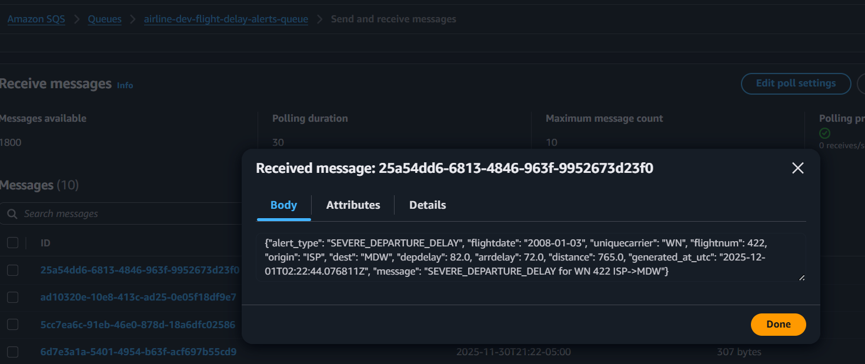

Conclusion:
A complete batch analytics stack is built: raw CSV flight data is ingested into S3, cataloged by AWS Glue, transformed via a 31-step Glue ETL job into partitioned Parquet, and loaded into an optimized Amazon Redshift fact table with materialized views for carrier, route, and daily performance analysis.
A fully integrated streaming stack delivered: simulated live flight events are published to Amazon Kinesis Data Streams, processed by an AWS Lambda consumer that enforces streaming data-quality rules, quarantines bad records to S3, and emits severity-based alerts to Amazon SNS (email) and Amazon SQS (downstream consumers)

