Option 2

The second integration has to do with the actual product.The PTWC Widgets will be deployed into the field, and communicate their GPS position.In order to prepare field operations, we will need to establish a database which can determine the proximity of Widgets to county and township locations where field operators may be stationed, or sent.In order to do this, we must deploy a GIS database, called PostGIS and ingest the city lat / long positions.In addition, we must notify and record the ingest of these positions in preparation for the location of the field operators and Widget positions. We must do so using the AWS SQS, and SNS/ SES interfaces in order to send the notifications and emails, and finally deposit log entries on s3. The plan for this must be expressed using AWS symbols and draw.io.

Github link:<https://github.com/vamshivuppula/vv1020_si_project>

**Design:**

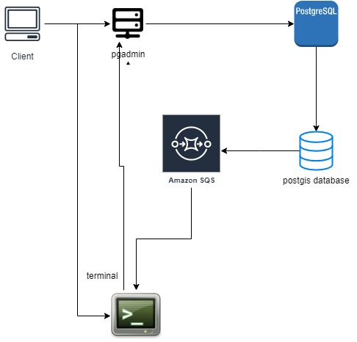

**Working**

* First install postgres
* Create a post gis database
* Create the table from the project resource provided in the pg admin
* The database should ingest latitude and longitude
* Connect the database from the terminal

**step 1:** Create Post GIS Extension

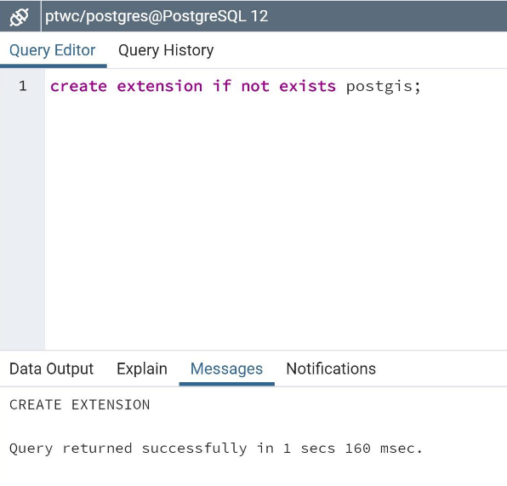

**step 2:** Creation of table and index

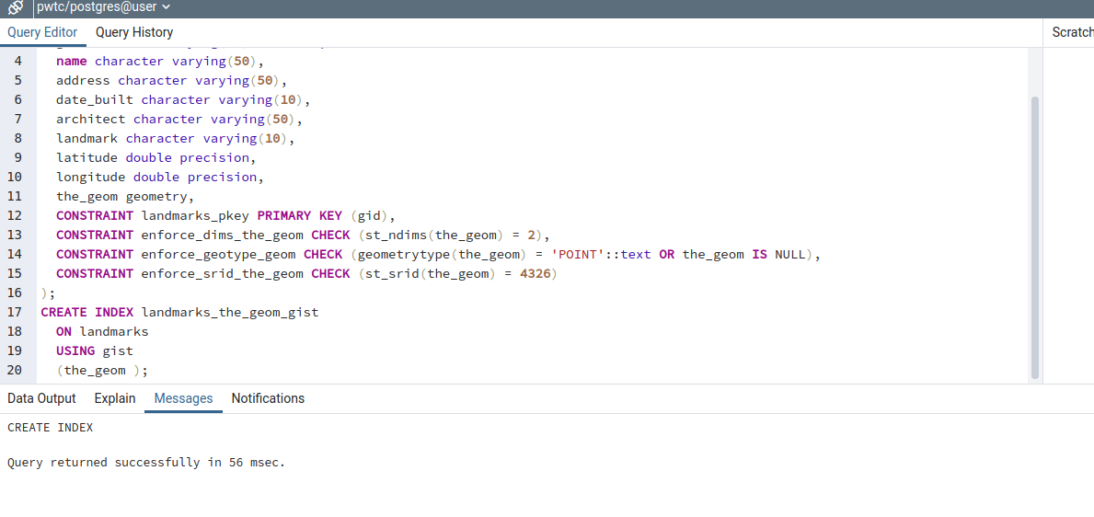

**step 3:** Import data from the CSV file

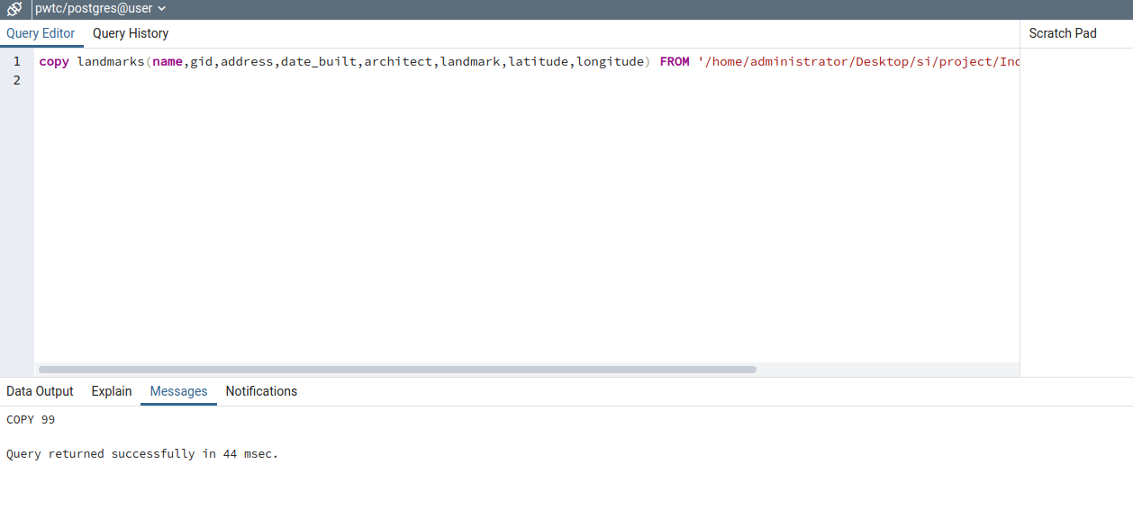

**step 4:** Import data from the CSV fileStep5:Convert Latitude and longitude coordinates to points that are readable by Post GIS

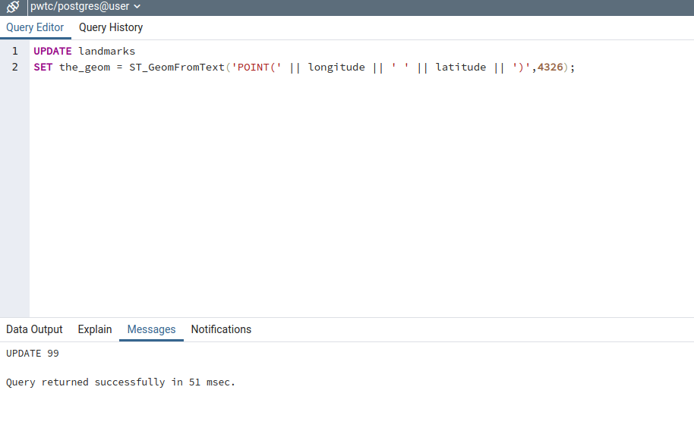

**step 5:** Write a Post GIS query to display the nearest 5 locations for the given latitude and longitude

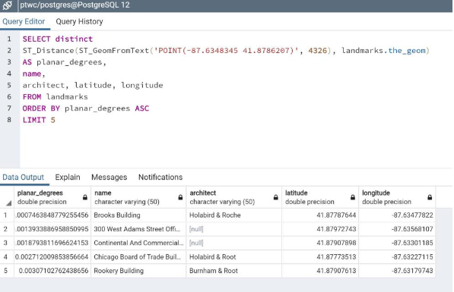

Displaying the imported data:

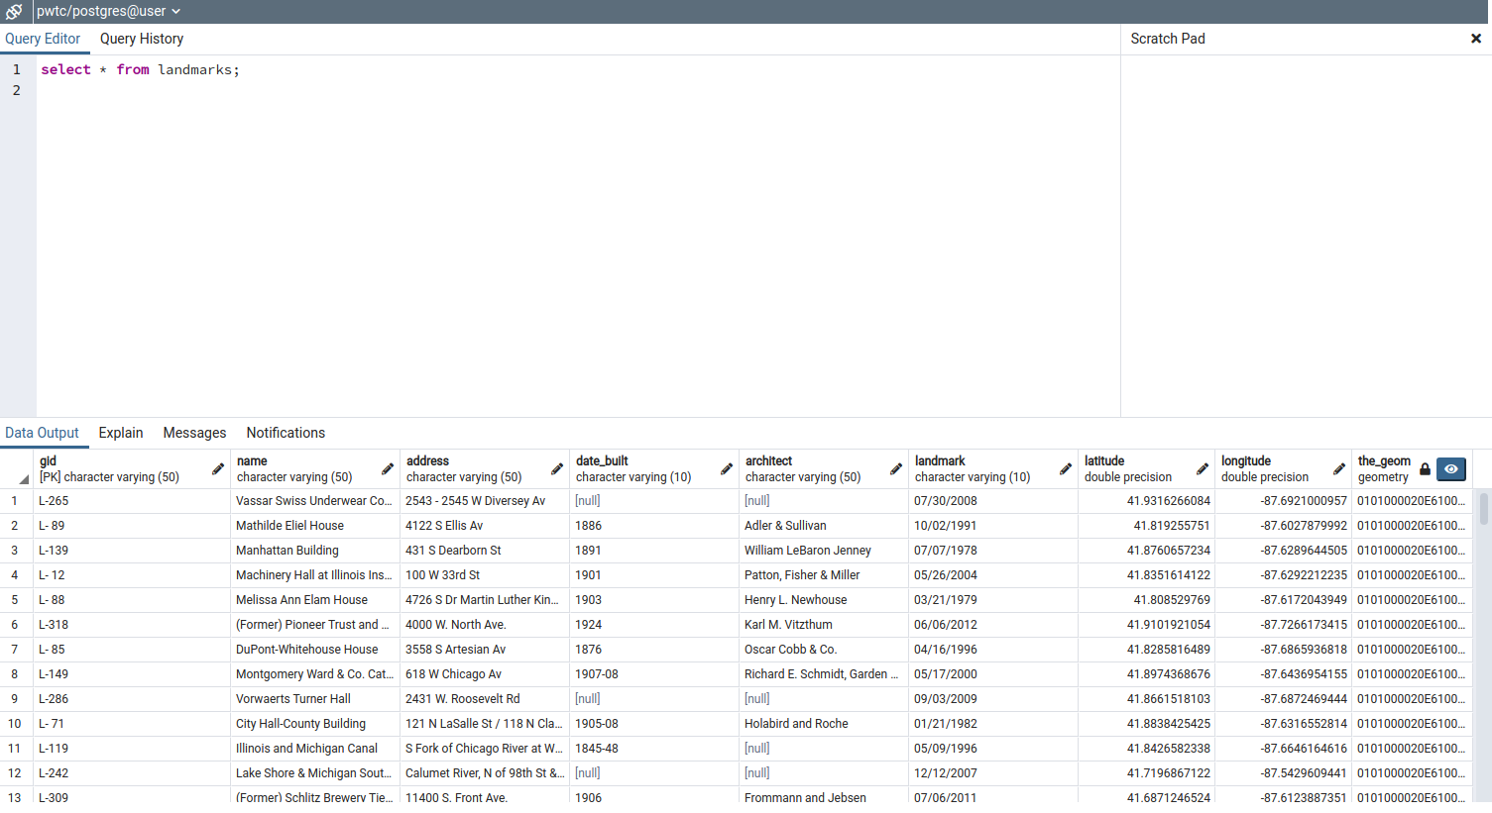

**Import code:**

import psycopg2

import boto3

from psycopg2.extensions import ISOLATION_LEVEL_AUTOCOMMIT

try:

#boto3

sqs = boto3.resource('sqs',aws_access_key_id = '',

aws_secret_access_key = '')

queue = sqs.create_queue(QueueName='pwtc-project', Attributes={'DelaySeconds': '5'})

#connecting to postgis

connection = psycopg2.connect(user="postgres", database = "pwtc",

password="root",

host="127.0.0.1")

connection.set_isolation_level(ISOLATION_LEVEL_AUTOCOMMIT);

cursor = connection.cursor()

#create extension postgis

create_extension_query = """create extension if not exists postgis;"""

cursor.execute(create_extension_query)

connection.commit()

#create tables and indexes

create_tables_landmarks = """ CREATE TABLE if not exists landmarks

(

gid character varying(50) NOT NULL,

name character varying(50),

address character varying(50),

date_built character varying(10),

architect character varying(50),

landmark character varying(10),

latitude double precision,

longitude double precision,

the_geom geometry,

CONSTRAINT landmarks_pkey PRIMARY KEY (gid),

CONSTRAINT enforce_dims_the_geom CHECK (st_ndims(the_geom) = 2),

CONSTRAINT enforce_geotype_geom CHECK (geometrytype(the_geom) = 'POINT'::text OR the_geom IS NULL),

CONSTRAINT enforce_srid_the_geom CHECK (st_srid(the_geom) = 4326)

)"""

cursor.execute(create_tables_landmarks)

connection.commit()

create_index_landmarks = """ CREATE INDEX if not exists landmarks_the_geom_gist ON landmarks USING gist (the_geom )"""

cursor.execute(create_index_landmarks)

connection.commit()

#insertion of data

insert_data = """ copy landmarks(name,gid,address,date_built,architect,landmark,latitude,longitude) FROM '/home/administrator/Desktop/si/project/Individual_Landmarks.csv' DELIMITERS ',' CSV HEADER """

cursor.execute(insert_data)

connection.commit()

#sending insertion info to queue

response = queue.send_message(MessageBody='Landmarks',MessageAttributes={

'Insertion':{

'StringValue':'Data Uploaded Successfully!!!',

'DataType':'String'

}})

queue = sqs.get_queue_by_name(QueueName='pwtc-project')

#updation of table for POINT

update_table = """UPDATE landmarks SET the_geom = ST_GeomFromText('POINT(' || longitude || ' ' || latitude || ')',4326) """

cursor.execute(update_table)

connection.commit()

#Display near locations

select_statement = """SELECT distinct

ST_Distance(ST_GeomFromText('POINT(-87.6348345 41.8786207)', 4326), landmarks.the_geom) AS planar_degrees,

name,

architect, latitude, longitude

FROM landmarks

ORDER BY planar_degrees ASC

LIMIT 5 """

count = 1

cursor.execute(select_statement)

connection.commit()

location_details=[]

records = cursor.fetchall()

print("5 closest landmarks to -87.6348345 41.8786207")

print("*******************")

for row in records:

print("Location-" + str(count))

print("----------")

print("Planar_Degrees - " + str(row[0]))

print("Name - " + str(row[1]))

print("Architect - " + str(row[2]))

print("Latitude - "+ str(row[3]))

print("Longitude - "+ str(row[4]))

print("*******************")

count +=1

location_details.append(str(row[0]))

location_details.append(str(row[1]))

location_details.append(str(row[2]))

location_details.append(str(row[3]))

location_details.append(str(row[4]))

#sending location data to the queue

response = queue.send_message(MessageBody='Landmarks',MessageAttributes={

'Locations':{

'StringValue':",".join(location_details),

'DataType':'String'

}})

connection.commit()

except (Exception, psycopg2.Error) as error :

if(connection):

print(error)

finally:

#closing database connection.

if(connection):

cursor.close()

connection.close()

print("PostgreSQL connection is closed")

**Output:**

