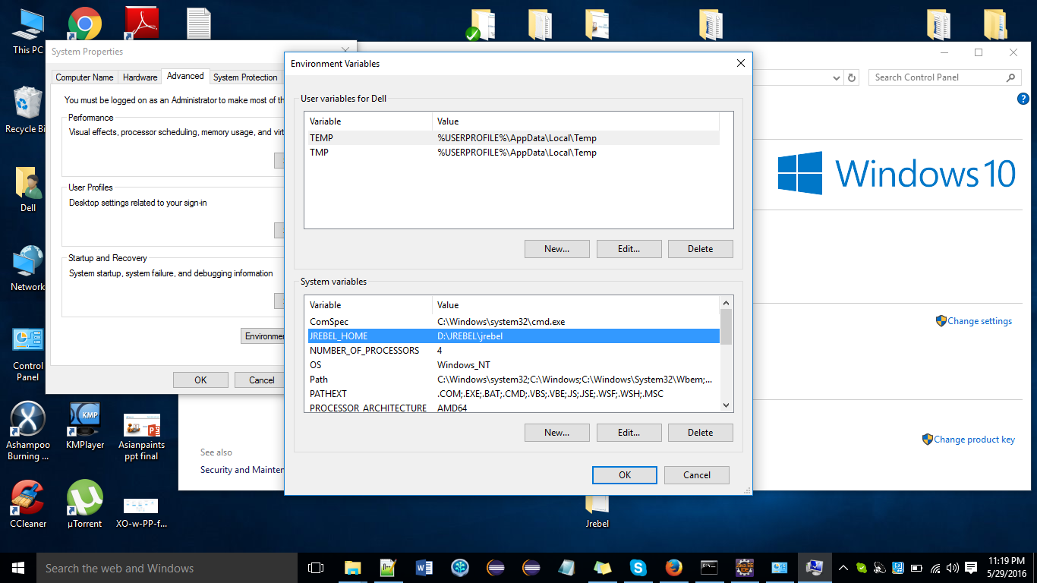

Install from (<https://wiki.hybris.com/display/release5/How+to+Use+JRebel>)

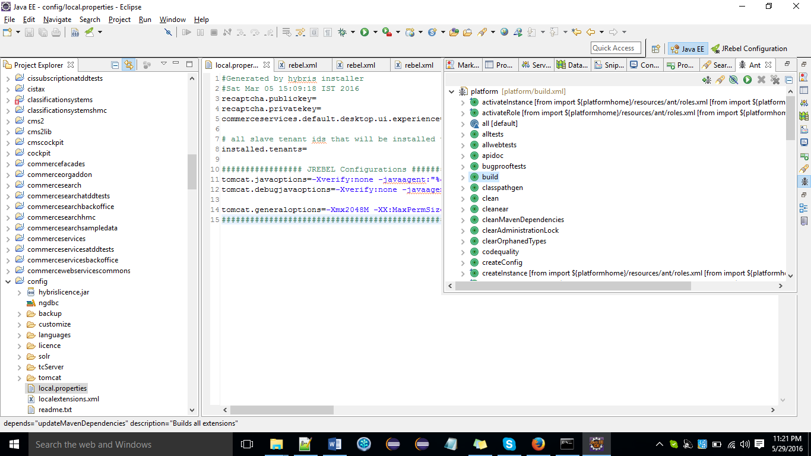

Change in all rebel.xml files (classes )