

Customer Extraction Half Interface

Functional Design Document

Document History

|  |  |  |  |
| --- | --- | --- | --- |
| **Version** | **Updated by** | **Date** | **Comments** |
| 1.0 | Jayachandra Gudiwada | 03/09/2015 | DRAFT |
|  |  |  |  |
|  |  |  |  |
|  |  |  |  |
|  |  |  |  |
|  |  |  |  |
|  |  |  |  |

Document Sign-off

|  |  |  |  |
| --- | --- | --- | --- |
| **Name** | **Role** | **Date** | **Signature** |
| **Pascal ESPINOUSE** |  |  |  |
| **Aliasgar Muchhala** |  |  |  |
| **Gyaneshwar Dubey** |  |  |  |
|  |  |  |  |
|  |  |  |  |
|  |  |  |  |
|  |  |  |  |

Document references

|  |  |  |  |
| --- | --- | --- | --- |
| **Reference and Document Title** | | **Version Number** | **Date** |
|  |  |  |  |

# Table of Contents

Table of Contents 2

1. Introduction 3

1.1 Document Purpose 3

1.2 Intended Audience 3

1.3 Document Scope 3

1.4 Document Structure 3

1.5 Additional Resources 4

1.6 Interface List 4

2. Brief description of the customer extraction half interface 5

2.1 Extraction half interface description 5

2.2 Extraction Half interface connectivity overview 5

2.3 Extraction Half Interface behavior 5

2.4 Message format and specification 5

2.5 Data 5

2.6 File / Message processing 6

2.7 Transformations 6

2.8 Exception Management and Logging 7

2.8.1 Exception Management 7

2.8.2 Logging / Audit 7

2.9 Security requirements 7

1. Introduction
   1. Document Purpose

This document is the Functional Design Document which provides information of hotfolder addon. It covers:

1. Brief description of the half interface for customers
2. Message format and specification
   1. Intended Audience

This document is aimed at the client who wants to discover the principle of the hot folder addon in Hybris.

* 1. Document Scope

This document covers the details about the functionality hot folder addon.

* 1. Document Structure

|  |  |  |
| --- | --- | --- |
| Section | | Description |
| 1 | Introduction | Describes the purpose and intended audience of the document and explains its structure. |
| 2 | Brief Description | Overview of the module. |
| 3 | Appendices | Supporting information |

* 1. Additional Resources

|  |  |  |  |
| --- | --- | --- | --- |
| # | Description | URL | Purpose |
| 1 | Wiki Portal | <https://wiki.hybris.com> | To gather more information |
| 2 | Coconet | <https://coconet2.capgemini.com/sf/go/doc3339636?nav=1> | To refer technical specifications |
| 3 | Data importation | <https://wiki.hybris.com/display/accdoc/Data+Importing+Capability+in+the+Commerce+Accelerator> | Documentation of import process |

* 1. Interface List

|  |  |  |  |
| --- | --- | --- | --- |
| 1 | B2BUnit Data |  | Sample file for B2BUnit Data |
| 2 | Customer Address Data |  | Sample file for Customer address data |
| 3 | B2BCustomr data |  | Sample file for B2B customer data. |

1. Brief description of the customer extraction half interface
   1. Extraction half interface description

The hot folder module has been created to permit the importation of CSV files easily. The files have just to be copy in the customer folder to be consumed by the interface. The process converts the file in IMPEX format specific to Hybris and then imports the data in the database. If the file is successfully imported, it is moved in archive folder. Otherwise it is moved in error folder and you have to analyze the file in log folder of interfaceerror folder to understand the error.

* 1. Extraction Half interface connectivity overview

N.A

* 1. Extraction Half Interface behavior

The poller refreshes the directory at a given frequencies (default: 1000 ms).

If a match file is present in the directory import process with parameters starts automatically (conversion into IMPEX format, importation, clean).

The interfaceerror module formalizes the errors messages to make them understandable by the user.

* 1. Message format and specification

The data about customer inter face have to be saved in CSV files. The name of the file MUST follow this mask:

CustomerB2BUnitData-xxx.csv, CustomerAddressData- xxx.csv, customerB2BCustomerData-xxx.csv where “xxx” is the version of the file.

Example: CustomerB2BUnitData -001.csv

The file must be placed in the folder: hybris/data/acceleratorservices/import/master/customers

* 1. Data

Below is the sample data



* 1. File / Message processing

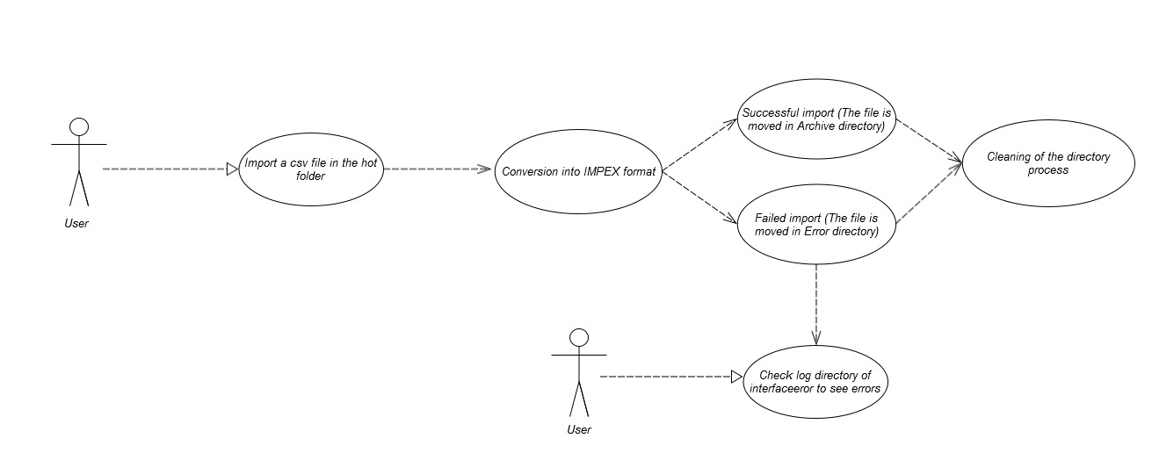

Description: User import a CSV file then check log directory if the process failed

* 1. Transformations

The csv file is converted in an impex file. The impex is then used to import data.

* 1. Exception Management and Logging
     1. Exception Management

|  |  |
| --- | --- |
| **Exception** | **Message** |
| UnresolvedValueException | Exception caught when :   * error finding existing item * no existing item found for update * cannot create due to unresolved mandatory/initial columns |
| InsufficientDataException | Exception caught when :   * target type is not permitted by current header – {header} * cannot import localized column without default session language |
| ImpexException | Exception caught when :   * unknow mode (INSERT | UPDATE | INSERT_UPDATE | REMOVE) * batch inserts are not supported – found more than one item for value line {valueLine} * Configured type {type} is abstract and you want to insert {valueLine}. Please specify the subtype of the item you want to create at the first column of the value line or change the configured type * Composed type {code} of found item with PK {PK} is not an instance of specified type {typecode} * Composed type {code} of found item with PK {PK} is not permitted in Insert_Update mode, because of {typeErrorMsg} |
| HeaderValidationException | Exception caught when :   * cacheUnique modifier is not allowed for Singleton types, please remove cacheUnique modifier |

* + 1. Logging / Audit

N.A

* 1. Security requirements

User must have a sftp access to the server in order to drag and drop the CSV file into the hot folder.