

Multi-cart module

Functional Design Document

Document History

|  |  |  |  |
| --- | --- | --- | --- |
| **Version** | **Updated by** | **Date** | **Comments** |
| V1.0 | Hamzi BOUDIAF | 05/05/2015 | Creation |
| V2.0 | Sisi WANG | 07/05/2015 | Modificaiton |
|  |  |  |  |
|  |  |  |  |
|  |  |  |  |
|  |  |  |  |
|  |  |  |  |

Document Sign-off

|  |  |  |  |
| --- | --- | --- | --- |
| **Name** | **Role** | **Date** | **Signature** |
| **Pascal ESPINOUSE** |  |  |  |
| **Florent ESTUPINA** | **Hybris developer** | **19/05/2015** | **Validation** |
|  |  |  |  |
|  |  |  |  |
|  |  |  |  |
|  |  |  |  |
|  |  |  |  |

Document references

|  |  |  |  |
| --- | --- | --- | --- |
| **Reference and Document Title** | | **Version Number** | **Date** |
|  | CGHA\_Multicart\_FDD\_V1.0.docx | V1.0 | 05/05/2015 |
|  | CGHA\_Multicart\_FDD\_V2.0.docx | V2.0 | 07/05/2015 |

# Table of Contents

[Table of Contents 2](#_Toc418677362)

[1 Introduction 3](#_Toc418677363)

[1.1 Aim of this document 3](#_Toc418677364)

[1.2 Reading the specifications 3](#_Toc418677365)

[2 Multi-cart module description 4](#_Toc418677366)

[2.1 Benefits 4](#_Toc418677367)

[2.2 Description 4](#_Toc418677368)

[2.3 Use case 4](#_Toc418677369)

[2.3.1 Create a new cart 4](#_Toc418677370)

[2.3.2 Manage my carts 4](#_Toc418677371)

[2.3.3 Share my cart 4](#_Toc418677372)

[2.3.4 Update the cart 4](#_Toc418677373)

[2.4 Functional details 4](#_Toc418677374)

[2.4.1 Create a new cart 4](#_Toc418677375)

[2.4.2 Manage my carts 5](#_Toc418677376)

[2.4.3 Share my cart 6](#_Toc418677377)

[2.4.4 Update the cart 7](#_Toc418677378)

# Introduction

## Aim of this document

The aim of this document is to provide the Functional Requirement Specifications (FRS) corresponding to the functional description of requirements of the module Multi-cart.

## Reading the specifications

Each functionality is described as follows:

**Alert messages**

* Alert messages post fixed with (\*) are given as information. They will be updated globally during the project.

**As a customer, I want to etc.**

* Story description for each functionality.

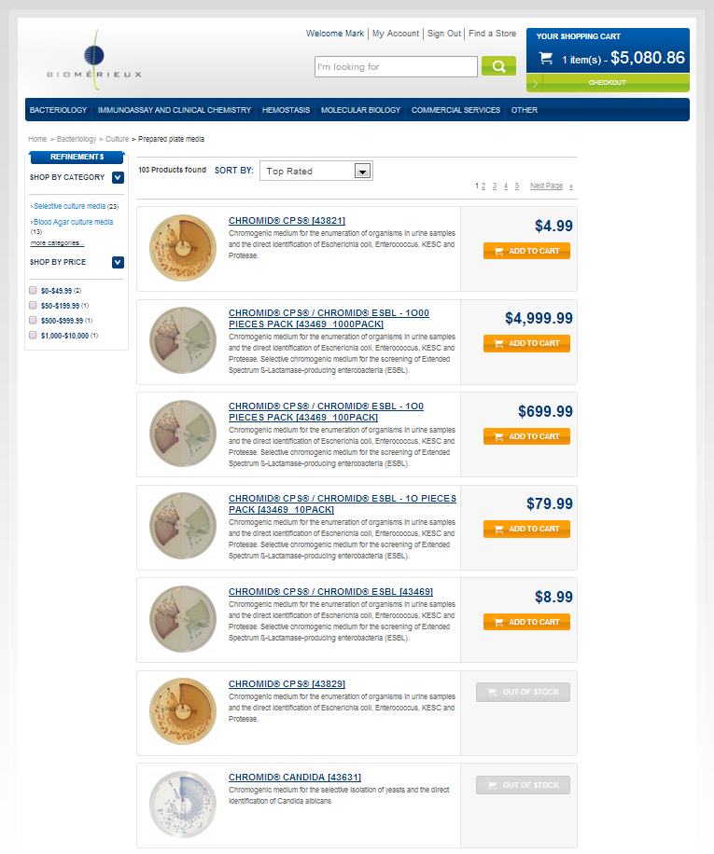

➊

➋

* The screen shot is used to illustrate the functionality.

###### Description - specific

|  |  |
| --- | --- |
| **Name** | **Description** |
|  |  |

* Detailed description for the specific development

# Multi-cart module description

## Benefits

The multi-cart module offers flexibility in managing and sharing commercial activities.

It enables parallel work by offering multiple carts management.

## Description

The multi-cart module enables the multiples carts management.

This module allows the creation and management of multiple carts. The user can also share his cart with the members of his B2B unit.

The current cart can be changed at any time through the order history page.

The user can search for a cart of his B2B unit in the advanced cart(s)/order(s) page. Please check the details in the documentation CGHA\_AdvancedSearchOrders\_FDD.docx

## Use cases

### Create a new cart

As a customer, I want to create a new cart.

### Manage my carts

As a customer, I want to manage my cart:

* The cart name
* The notification
* The modification
* The history
* The deletion

### Share my cart

As a customer, I want to share my cart with my B2B unit colleagues.

### Update the cart

As a customer, I want to update my cart. I want my B2B unit colleagues have the same accessibility to the cart as I do but I want to be notified.

## Functional details

### Create a new cart

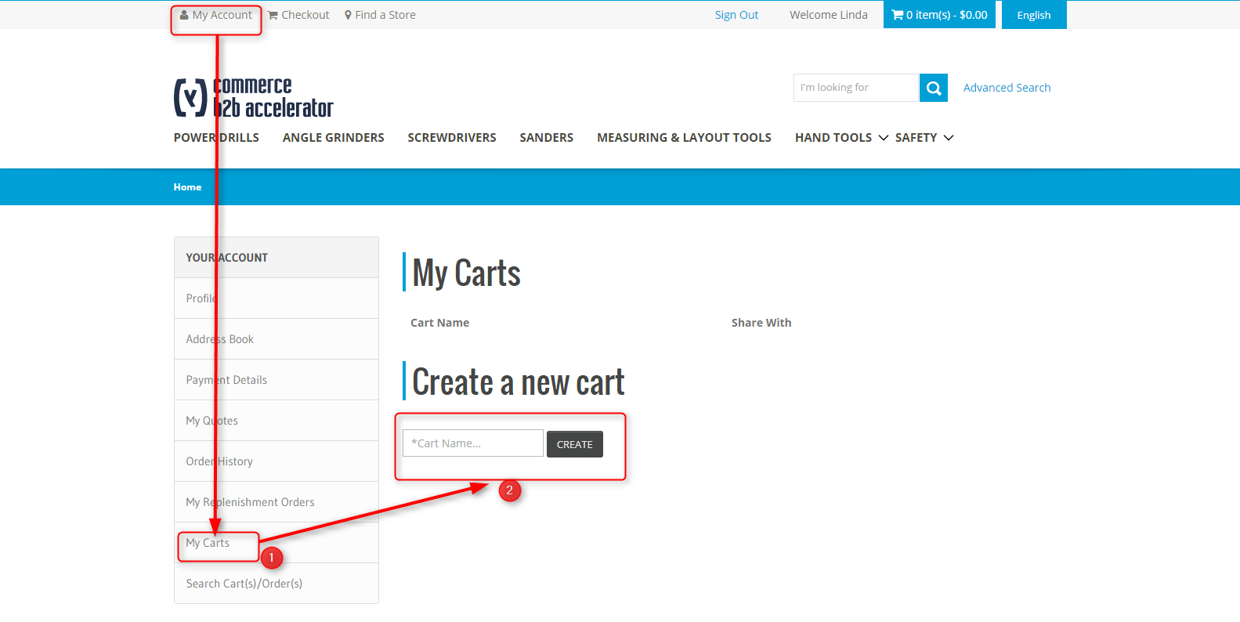

Illustration: MyCarts is accessible from customer personal space

###### Description - specific

|  |  |
| --- | --- |
| **Name** | **Description** |
| **1 – “My carts”** | Placed in the account information toolbar, it enables the access to the cart list and the new cart creation functionality. |
| **2 – “New cart”** | The text field is used to enter the new cart’s name.  The create button enables the user to create the new cart, and the connected user is the owner of the cart. |

### Manage my carts

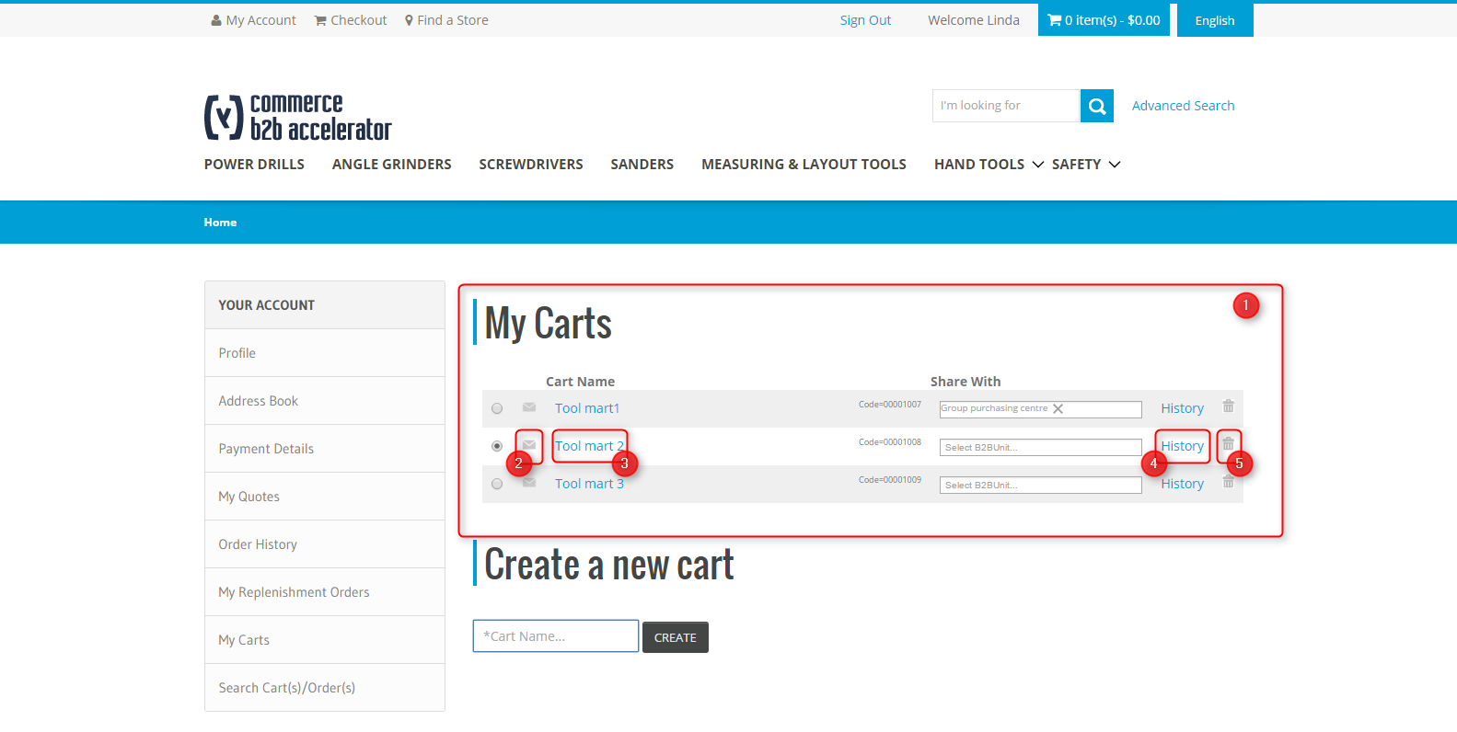

Illustration: My Carts is accessible from customer personal space

###### Description - Specific

|  |  |
| --- | --- |
| Name | Description |
| 1 – mycarts view | This section contains a list of the carts that are accessible by the connected user. |
| 2 – notification icon | When the user clicks on the icon, he can subscribe or unsubscribe to the cart notifications.  A notification is sent when the cart is modified.  The user can only subscribe to shared carts. |
| 3 – cart name | Carts’ names are displayed in this section.  When the user clicks on the cart name, he can edit the name in a dialog box, then click on “Edit Cart” to save the name. |
| 4 – history | It allows the user trace the cart history.  The cart history contains all cart modifications :   * Create cart * Add product * Remove product * Change quantity   D:\Users\hboudiaf\Documents\Hybris\B2B Asset\Specifications\Screenshot\multicart_history.png |
| 5 – delete button | Only the creator of a cart is allowed to delete it. |

### Share my cart

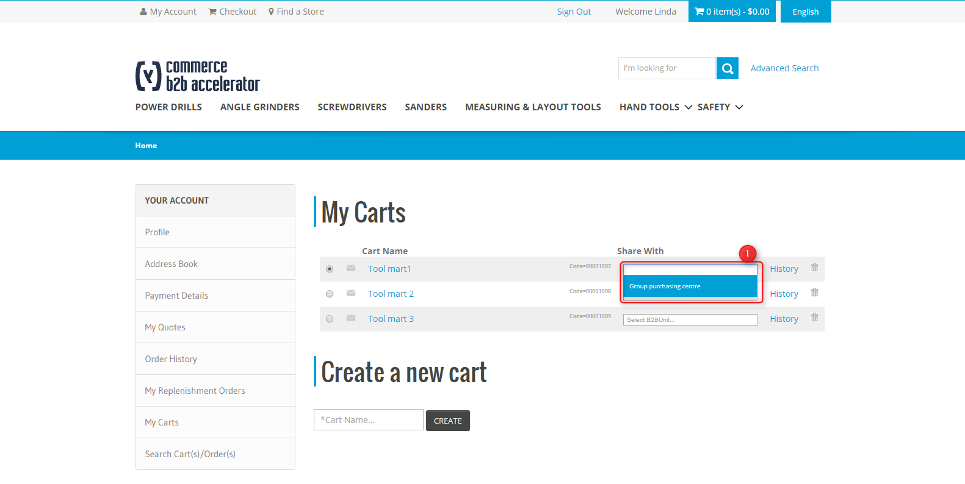

Illustration: My Carts is accessible from customer personal space

###### Description - Specific

|  |  |
| --- | --- |
| Name | Description |
| 1 – Share with | The “share with” dropdown list contains the B2B units in which the user presents.  Only the creator of the cart can change the share options. |

### Update the cart

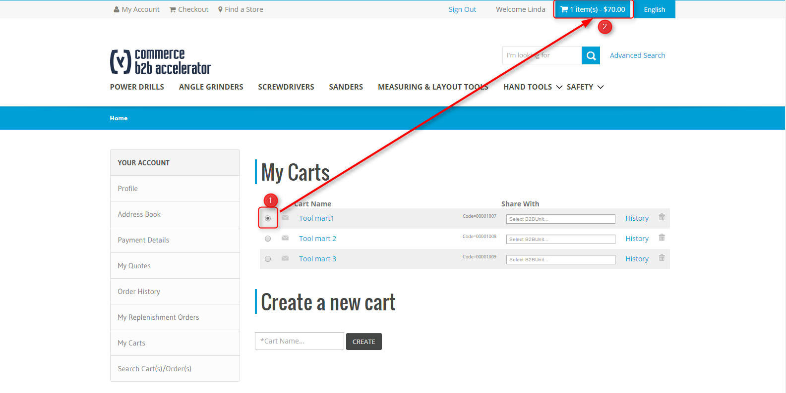

Illustration: MyCarts is accessible from customer personal space

###### Description - Specific

|  |  |
| --- | --- |
| Name | Description |
| 1 – cart selection | The user can activate the cart he wants to update by clicking on the radio button. |
| 2 –cart activation | The active cart is the current cart  The user can continue his shopping by going back to the product list page for example |