

Product Extraction Half Interface

Functional Design Document

Document History

|  |  |  |  |
| --- | --- | --- | --- |
| **Version** | **Updated by** | **Date** | **Comments** |
| 1.0 | FLAVIEN RECOUVREUR | 20/02/2015 | DRAFT |
|  |  |  |  |
|  |  |  |  |
|  |  |  |  |
|  |  |  |  |
|  |  |  |  |
|  |  |  |  |

Document Sign-off

|  |  |  |  |
| --- | --- | --- | --- |
| **Name** | **Role** | **Date** | **Signature** |
| **Pascal ESPINOUSE** |  |  |  |
| **Aliasgar Muchhala** |  |  |  |
| **Gyaneshwar Dubey** |  |  |  |
|  |  |  |  |
|  |  |  |  |
|  |  |  |  |
|  |  |  |  |

Document references

|  |  |  |  |
| --- | --- | --- | --- |
| **Reference and Document Title** | | **Version Number** | **Date** |
|  |  |  |  |

# Table of Contents

Table of Contents 2

1. Introduction 4

1.1 Document Purpose 4

1.2 Intended Audience 4

1.3 Document Scope 4

1.4 Document Structure 4

1.5 Additional Resources 4

1.6 Interface List 5

Brief description of the extraction half interface 6

2.1 Extraction half interface description 6

2.2 Extraction half interface connectivity overview 6

2.3 Extraction half Interface behavior 6

2.4 Message format and specification 6

2.5 Data 7

2.6 ER Diagram 7

2.7 File / Message processing 11

2.8 Transformations 11

2.9 Exception Management and Logging 11

2.9.1 Exception Management 11

2.9.2 Logging / Audit 12

2.10 Security requirements 12

1. Introduction
   1. Document Purpose

This document is the Functional Design Document which provides information of hotfolder addon. It covers:  
a) Brief description of the half interface  
b) Message format and specification  
c) Security Requirement

* 1. Intended Audience

This document is aimed at the client who wants to discover the principle of the hotfolder addon in Hybris.

* 1. Document Scope

This document covers the details about the functionality hot folder addon.

* 1. Document Structure

|  |  |  |
| --- | --- | --- |
| Section | | Description |
| 1 | Introduction | Describes the purpose and intended audience of the document and explains its structure. |
| 2 | Brief Description | Overview of the module. |
| 3 | Appendices | Supporting information |

* 1. Additional Resources

|  |  |  |  |
| --- | --- | --- | --- |
| # | Description | URL | Purpose |
| 1 | Wiki Portal | <https://wiki.hybris.com> | To gather more information |
| 2 | Coconet | <https://coconet2.capgemini.com/sf/go/doc3313610?nav=1> | To refer technical specifications |
| 3 | Data importation | <https://wiki.hybris.com/display/accdoc/Data+Importing+Capability+in+the+Commerce+Accelerator> | Documentation of import process |

* 1. Interface List

|  |  |  |  |
| --- | --- | --- | --- |
| 1 | File productData with header |  | Template of header productData |
| 2 | File productData with data |  | Template of productData with data |
| 3 | File productInternationalData with header |  | Template of header productInternationalData |
| 4 | File productInternationalData with data |  | Template of productInternationalData with data |

1. Brief description of the extraction half interface
   1. Extraction half interface description

The hotfolder module has been created to permit the importation of CSV files easily. The files have just to be copy in the products folder to be digested by the interface. The process converts the file in IMPEX format specific to Hybris and then imports these data in the database. If the file is successfully imported, he is next moved in archive folder. Otherwise he is moved in error folder and you have to analyze the file in log folder of interfaceerror folder to understand the error.

* 1. Extraction half interface connectivity overview

N.A

* 1. Extraction half Interface behavior

The poller refreshes the directory at a given frequencies (default: 1000 ms).   
If a match file is present in the directory import process with parameters starts automatically (conversion into IMPEX format,importation,clean).  
The interfaceerror module formalizes the errors messages to make them understandable by the user.

* 1. Message format and specification

The data about products have to be saved in CSV files. The name of the file MUST follow this mask:

* ProductData-xxx.csv where “xxx” is the version of the file. E.G ProductData-001.csv
* ProductInternationalData-{lang}-xxx.csv where “xxx” is the version of the file. E.G ProductInternationalData-en-001.csv

ProductData is the file that correspond to the details informations about products. The file must follow this structure:



ProductInternationalData is the file that correspond to another language of the details informations about products. The file must follow this structure:



The files must be placed in the folder: hybris/data/acceleratorservices/import/master/products

* 1. Data

Here is an example of data for ProductData file: 

Here is an example of data for ProductInternationalData file: 

* 1. ER Diagram

**When you find example with (code), you have to import the object relation before the product data.**

**Product hot folder ER Diagram:**

|  |  |  |  |  |  |
| --- | --- | --- | --- | --- | --- |
| **Name** | **Description** | **Type** | **Default Value** | **Mandatory** | **Example** |
| code | Product ID | String | / | TRUE | 107701 |
| ean | Article number | String | / | FALSE | 0027242612242 |
| supercategories | Product Category | CategoryProductRelationsupercategoriesColl | / | FALSE | 827 – brand_5 |
| manufacturerName | Manufacturer name | String | / | FALSE | Sony |
| manufacturerAID | Manufacturer ID | String | / | FALSE | DCC-L50B |
| unit | Type of unit | Unit | pieces | FALSE | pieces |
| deliveryModes | Modes of delivery | ProductDeliveryModeRelationdeliveryModesColl | / | FALSE | Free-standard-shipping |
| deliveryTime | Delivery time | Double | / | FALSE | 55 |
| contentUnit | Unit of content | Unit | pieces | FALSE | 1A |
| numberContentUnits | Number of content uints | Double | / | FALSE | 20 |
| Europe1PriceFactory_PTG | Product tax group | ProductTaxGroup - Product Tax Class | / | FALSE | **JP Consumption Tax (code)** |
| Europe1PriceFactory_PDG | Product discount group | ProductDiscountGroup - Product Discount Class | / | FALSE | **Discount (code)** |
| Europe1PriceFactory_PPG | Product price group | ProductPriceGroup - Product Price Class | / | FALSE | **standard (code)** |
| offlineDate | Product offline date | Date | / | FALSE | 15/05/2015 08:30 |
| onlineDate | Product online date | Date | / | FALSE | 15/05/2015 08:30 |
| maxOrderQuantity | Maximum quantity of order | Integer | / | FALSE | 300 |
| minOrderQuantity | Minimum quantity of order | Integer | / | FALSE | 2 |
| erpGroupBuyer | Name of the group buyer ERP | String | / | FALSE | buyerGroup |
| erpGroupSupplier | Name of the group Supplier ERP | String | / | FALSE | supplierGroup |
| productOrderLimit | Not documented in wiki | ProductOrderLimit - Product Order Limit | / | FALSE | order-limit-2 (code) |
| supplierAlternativeAID | Supplier alternative ID | String | / | FALSE | supplierAlternative |
| vendors | Vendors code | ProductVendorRelationvendorsColl | / | FALSE | **Powertools( code)** |
| approvalStatus | Status of approval | ArticleApprovalStatus - Article approval status | Check | FALSE | approved |
| catalogVersion | Catalog version | CatalogVersion - Catalog version | defaultCatalog + defaultCatalogVersion | TRUE | electronicsProductCatalog |
| sequenceId | Avoid importing twice a file | Long | / | FALSE | 1424351634 => timestamp |

**When you import your Product-localized CSV file, you just have to append to the name of the file a “_{lang}” e.g : ProductInternationalData_en.csv to correspond the data with a specific language.**

**Product-localized hot folder ER Diagram:**

|  |  |  |  |  |  |
| --- | --- | --- | --- | --- | --- |
| **Name** | **Description** | **Type** | **Default Value** | **Mandatory** | **Example** |
| description | Description | localized:String | / | FALSE | It's time to take a road trip and you want to capture... |
| keywords | Keywords | Product2KeywordRelationkeywordsLocMap | / | FALSE | Camera, capture |
| manufacturerTypeDescription | Description of type Manufacturer | localized:String | / | FALSE | Battery adapter for car |
| name | Name | localized:String | / | FALSE | DC Car Battery Adapter |
| remarks | Remarks | localized:String | / | FALSE | This product is famous… |
| segment | Segment | localized:String | / | FALSE | buyerPremium |
| summary | Summary | localized:String | / | FALSE | DC Car Battery Adapter |

**Product-media hot folder ER Diagram:**

|  |  |  |  |  |  |
| --- | --- | --- | --- | --- | --- |
| **Name** | **Description** | **Type** | **Default Value** | **Mandatory** | **Example** |
| data-sheet | Not documented in Hybris | MediaCollection | / | FALSE |  |
| detail | Detail picture (the biggest one) | MediaCollection | / | FALSE | /1200Wx1200H/637227-6683.jpg |
| galleryImages | Gallery of images | MediaContainerList | / | FALSE | 637227-6683 |
| logo | Logo | MediaCollection | / | FALSE |  |
| normal | Standard picture | MediaCollection | / | FALSE | /300Wx300H/637227-6683.jpg |
| others | Others views of the product (not displayed in store front) | MediaCollection | / | FALSE | /515Wx515H/637227-6683.jpg**,**/65Wx65H/637227-6683.jpg**,**/30Wx30H/637227-6683.jpg |
| picture | Product page main picture | Media | / | FALSE | /300Wx300H/637227-6683.jpg |
| thumbnail | Product list page picture | Media | / | FALSE | /96Wx96H/637227-6683.jpg |
| thumbnails | Product page picture list | MediaCollection | / | FALSE | /96Wx96H/637227-6683.jpg |

* 1. File / Message processing

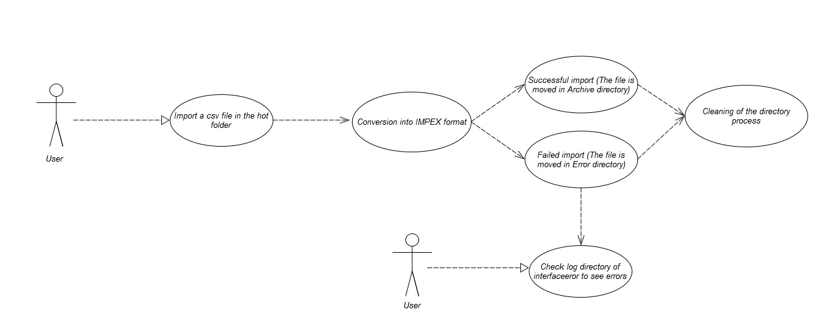

Description: User import a csv file then check log directory if the process failed

Location of the folder to drag and drop the files: hybris/data/acceleratorservices/import/master/product

The hybris serveur must be launch before the importation

* 1. Transformations

The csv file is converted in an impex file. The impex is then used to import data.  
The name and the order of the CSV column and the impex column are the same.

* 1. Exception Management and Logging
     1. Exception Management

|  |  |
| --- | --- |
| **Exception** | **Message** |
| UnresolvedValueException | Exception caught when :   * error finding existing item * no existing item found for update * cannot create due to unresolved mandatory/initial columns |
| InsufficientDataException | Exception caught when :   * target type is not permitted by current header – {header} * cannot import localized column without default session language |
| ImpexException | Exception caught when :   * unknow mode (INSERT | UPDATE | INSERT_UPDATE | REMOVE) * batch inserts are not supported – found more than one item for value line {valueLine} * Configured type {type} is abstract and you want to insert {valueLine}. Please specify the subtype of the item you want to create at the first column of the value line or change the configured type * Composed type {code} of found item with PK {PK} is not an instance of specified type {typecode} * Composed type {code} of found item with PK {PK} is not permitted in Insert_Update mode, because of {typeErrorMsg} |
| HeaderValidationException | Exception caught when :   * cacheUnique modifier is not allowed for Singleton types, please remove cacheUnique modifier |

* + 1. Logging / Audit

N.A

* 1. Security requirements

The general Sample data must be imported before the international data

User must have a sftp access to the server in order to drag and drop the csv file into the hotfolder.