

Single View of All Orders module

Functional Design Document

Document History

|  |  |  |  |
| --- | --- | --- | --- |
| **Version** | **Updated by** | **Date** | **Comments** |
| V1.0 | Sisi Wang | 13/04/2015 |  |
| V2.0 | Sisi Wang | 15/04/2015 |  |
|  |  |  |  |
|  |  |  |  |
|  |  |  |  |
|  |  |  |  |
|  |  |  |  |

Document Sign-off

|  |  |  |  |
| --- | --- | --- | --- |
| **Name** | **Role** | **Date** | **Signature** |
| **Pascal ESPINOUSE** |  |  |  |
| **Florent ESTUPINA** | Hybris developer | 19/05/15 | Validation |
|  |  |  |  |
|  |  |  |  |
|  |  |  |  |
|  |  |  |  |
|  |  |  |  |

Document references

|  |  |  |  |
| --- | --- | --- | --- |
| **Reference and Document Title** | | **Version Number** | **Date** |
|  | CGHA_SinglesViewOfAllOrders_FRD_V1.0 | V1.0 | 13/04/2015 |
|  | CGHA_SinglesViewOfAllOrders_FRD_V2.0 | V2.0 | 15/04/2015 |
|  |  |  |  |

# Table of Contents

Table of Contents 2

1 Introduction 3

1.1 Aim of this document 3

1.2 Reading the specifications 3

2 Single view of all orders module description 4

2.1 Benefits 4

2.2 Description 4

2.3 Use case 4

2.3.1 Order history list page 4

2.3.2 Order history detail page 4

2.4 Functional details 4

2.4.1 User Account Page 4

2.4.2 Order history list page 5

2.4.3 Order history detail page 7

# Introduction

## Aim of this document

The aim of this document is to provide the Functional Requirement Specifications (FRS) corresponding to the Functional description of requirements of the module Single View of all orders.

## Reading the specifications

Each functionality is described as follows:

**Alert messages**

* Alert messages postfixed with (*) are given as information. They will be updated globally during the project.

**As a customer, I want to etc.**

* Story description for each functionality.

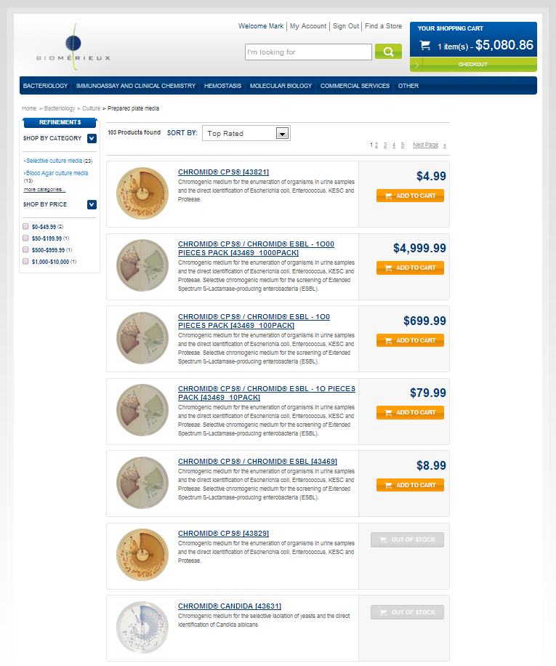

➊

➋

* The screen shot is used to illustrate the functionality.

###### Description - specific

|  |  |
| --- | --- |
| **Name** | **Description** |
|  |  |

* Detailed description for the specific development

# Single view of all orders module description

## Benefits

In a B2B site, the users are usually professional buyers. The more the site makes their job easier the more they will come back and purchase more products.

The quick order helps to fulfill this point by providing a single view in hybris of the multichannel orders (placed by email, online, fax…).

## Description

The single view of all orders module is used to display the order history containing the orders from all the purchase channels, and all the information related to an order history, for example: delivery information, order tracking information, etc.

## Use case

### Order history list page

As a customer I want to see all the order history including all the orders that have been placed by my colleges (The users that are in the same B2BUnit as I do)

### Order history detail page

As a customer I want to see the details of each order.

## Functional details

### User Account Page

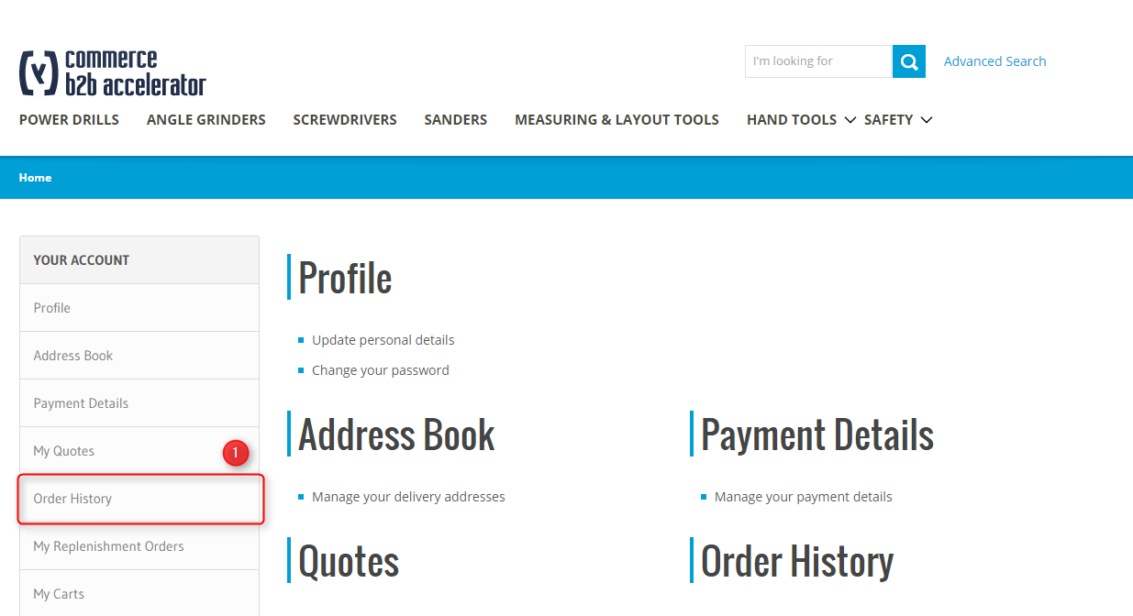 Illustration: Order history access from customer personal space

###### Description - specific

|  |  |
| --- | --- |
| **Name** | **Description** |
| **Description** | Hybris Accelerator provides order history feature from user account personal space providing the display and the reuse of former orders recorded into the system. The solution offers a first page with summary order history and permits the user to display order detail by selection |
| **1 – “Order History” Section** | Click on the “View order history” link to get access to order history list. |

### Order history list page

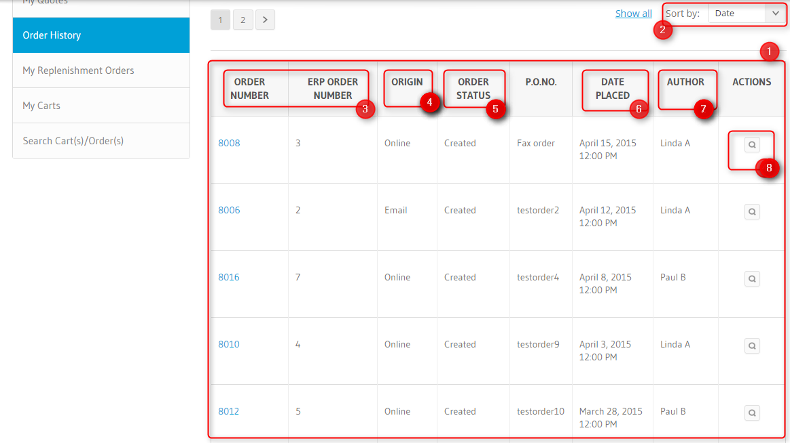

###### Description - Specific

|  |  |
| --- | --- |
| Name | Description |
| 1 - Order list | The list allows the customer to show all orders and access to detailed informations regarding them.  The user can see :   * All the orders he has placed in Hybris * All orders placed for his enterprise(B2BUnit) in Hybris * All orders placed for his enterprise(B2BUnit) in ERP   Hybris orders:   * Order with no change. The order is corresponding with the initial placement. * Order with one or several changes. The order has been updated partially or completely in ERP (through Hybris Order history, it is not possible to update a placed order). The new order content has to be corresponding with Hybris product catalog. If an ordered product doesn’t match with Hybris product catalog, the ERP update is rejected and the old order is maintained.   ERP orders:   * ERP orders data are mapped with Hybris data with the order interface structure. * ERP order doesn’t include the Hybris order number. * ERP order is sent to Hybris. No flow is send back to ERP. * ERP order content has to be corresponding with Hybris product catalog. If an ordered product doesn’t match with Hybris product catalog, the ERP order is rejected. |
| 2 – Sortby (Optional) | Allows to “sort by” the following columns:   * Order n° (oob) * Date Placed (oob) * ERP Order n° (order number provided by ERP) * Order status * PO number |
| 3 – Order n° | “Order n°” is the OOB order number provided by the Global eCommerce platform, Hybris.  “ERP Order n°” is the order number provided by ERP.  When an order has the two order number (Hybris & ERP), it means that this order has been created in the Global eCommerce platform. |
| 4 - Origin | Allow to specify the origin of the order. The value is provided by ERP.  PO Type values list:  1 Fax  2 Mail  3 Phone  4 From other SAP  5 Hybris Order |
| 5 – order status | Example: Acknowledge, Confirmed, Cancelled, In Progress, Shipped, Completed, Deleted. |
| 6 – date placed | Is the creation date of the order in Hybris. |
| 7 - Author | Is the first and last name that corresponding with the contact email recorded in the Hybris order.  As no author is existing in SAP, the value “SAP” is displayed. |
| 7 – Action “View” | Click on the “View” link to get access to the order history detail page. |

### Order history detail page

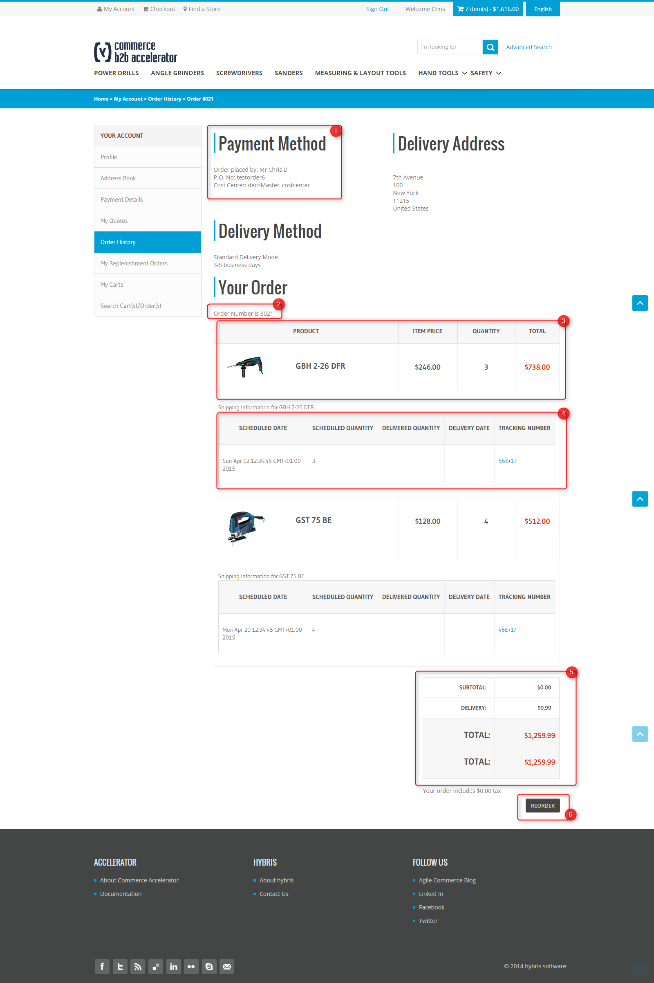

###### Description - Specific

|  |  |
| --- | --- |
| Name | Description |
| 1 – payment method | The payment information used in the checkout page.   * **Order placed by**: the contact name that placed the order. * **PO order number**: the PO number completed by the purchaser. * **Cost centre** * **Payment type**: the payment type used during the checkout. |
| 2 – global order status | The global order information generated after placing the order:   * **Order number**: generated when the order is placed through the global ecommerce platform, Hybris. * **ERP order number** provided by ERP which is mapped with the Hybris order number.   + An order is placed on the global ecommerce and send to ERP   + An order is created directly in ERP * **Placed on date**:   + For a Hybris order, it is the order creation date.   + For an ERP order, it is the ERP order creation date. * **Order status**: the global order status: Acknowledge, Confirmed, Cancelled, In Progress, Shipped, Completed, Deleted. * **Contact email**: is the email of the user that placed the order. The eMail is available in MyAccount. |
| 3 – Delivery followup | Is the tab dedicated to the global product delivery followup:   * **Order quantity**: the quantity ordered in the checkout page. * **Shipped quantity**: the quantity that has been already delivered to the customer. Is provided by ERP. * **Open quantity**: the quantity that need to be delivered to the customer. Is the result of Order quantity – Shipped quantity. * **Expected release date**: is the LAST KNOWN scheduled date for the next delivery. Is provided by ERP (scheduled date). * **Delivery status**: all delivery status are provided by ERP. * **Delivery method:** the delivery method selected in the checkout page on Hybris. Is provided by ERP. * **Total product price:** When the order is updated in ERP side, the total product price is provided by ERP and includes all Rebates, Freights, fees.   For the orders that contain products not available in the local catalogs, a message should be displayed per order entry in the Order History Detail Page: Product is currently not available online. |
| 4 – Shipped | Is corresponding with the shipments tracking.   * **Scheduled date**: is the scheduled shipment date. Is provided by ERP * **Scheduled quantity**: is the quantity to be delivered in the shipment. Is provided by ERP * **Delivered date**: is the actual shipment date. Is provided by ERP * **Delivered quantity**: is the quantity delivered in the shipment. Is provided by ERP * **Tracking number**: is corresponding with one or several tracking number to deliver the quantity. To organize the delivery (stock localization, planning, truck size etc.), it is possible to use several shipment. Is provided by ERP (Tracking number) |
| 5 – Total amount | When the order is updated in ERP side, the Total amount includes all Rebates, Freights, fees. |
| 6 – Reorder | When clicking the reorder button, a new cart will be generated with the current order entries.  In the case that not all the products are available in the local catalog, a message should be displayed in the cart page: Some products of the historical order are not available online. |