

Catalog Restriction Import Half Interface

Technical Design Documentation

Document History

|  |  |  |  |
| --- | --- | --- | --- |
| Version | Updated By | Date | Comments |
| 0.1 | Jayachandra Gudiwada | 26/03/2015 | Initial Draft |
| 1.0 | Jayachandra Gudiwada | 27/03/2015 | Initial Draft |

Document Sign-Off

|  |  |  |
| --- | --- | --- |
| Name | Role | Signature/Date |
| Pascal ESPINOUSE |  |  |
| RECOUVREUR FLAVIEN |  |  |
| DURANT DE LA PASTELLIERE BENOIT |  |  |

Table of Contents

1. Introduction 3

1.1 Purpose 3

1.2 Intended Audience 3

1.3 Document Scope 3

1.4 Functional Rules 3

1.5 Assumptions/Restrictions 3

1.6 Documents Structure 4

1.7 Additional Resources 4

2. High Level Design Diagram 5

2.1 Overview 5

2.2 Sequence Diagram 6

2.3 Use Case Diagram 7

3. Detailed Application Design 8

3.1 Class Diagram 8

3.2 Beans 8

3.3 Facade 8

3.4 Strategy 8

3.5 Controller 8

3.6 View/JSP 8

4. Database architecture 9

4.1 ER Diagram 9

5. Exception Handling and Logging 10

5.1 Exception Scenarios 10

5.2 Exception Handling 10

5.3 Logging 11

6. Installation and Configuration 12

6.1 Installation steps for the addon 12

6.2 Configuration steps for the addon 12

7. Appendix A *– Glossary of terms* 13

1. Introduction

Purpose

This document is the Technical Design Document which provides information of product restriction hotfolder addon and steps to configure the module. It covers:

1. High Level Design
2. Application Architecture
3. Database Architecture
4. Installation Steps

Intended Audience

This document is aimed at Hybris developers and Technical members who want to implement the hotfolder addon in Hybris.

Document Scope

This document covers the details about the product restriction hot folder addon.

Functional Rules

* The hot folder permits to import the B2BUnit specific products with file format of CSV.
* B2BUnits and Products link be created using product id and B2BUnit.
* Link between product and B2BUnit is B2BUnit specific. If the link is enabled for the specific B2BUnit then product will be displayed in storefront for the specific B2BUnit customers.

Assumptions/Restrictions

* This module has been created for version 5.4.0.0.
* Business Unit & SKU ID should be predefined in the Hybris database before pass this SKU using CSV file.
* The entire three columns (Product id, B2BUnit and is Displayable) that need to be passing in the CSV file are mandatory.

Export: No export is available

Documents Structure

|  |  |  |
| --- | --- | --- |
| Section | | Description |
| 1 | Introduction | Describes the purpose and intended audience of the document and explains its structure. |
| 2 | High Level Design | Overview of the module. |
| 3 | Detailed Application Design | Application architecture applicable to this module. |
| 4 | Detailed Database Design | Conceptual and logical architecture applicable to this module. |
| 5 | Exception Management & Logging | Information about the Exception handling and logging. |
| 6 | Installation & Configuration | Steps to install and configure the module. |
| 7 | Appendices | Supporting information. |

Additional Resources

|  |  |  |  |
| --- | --- | --- | --- |
| # | Description | URL | Purpose |
| 1 | Wiki Portal | <https://wiki.hybris.com> | To gather more information |
| 2 | Coconet | <https://coconet2.capgemini.com/sf/go/doc3347531?nav=1> | To refer functional specifications |
| 3 | Data importation | <https://wiki.hybris.com/display/accdoc/Data+Importing+Capability+in+the+Commerce+Accelerator> | Documentation of import process |
| 4 | Product restriction sample data file |  | Template of Product Restriction customer data with sample data |

1. High Level Design Diagram

Overview

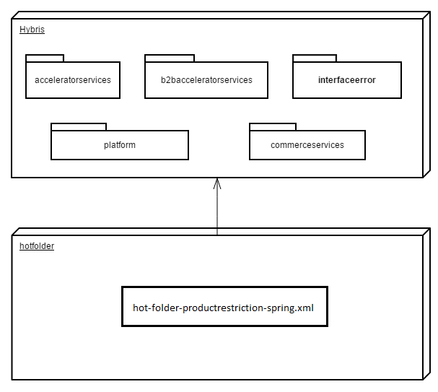

Sequence Diagram

Sequence of events during the hot folder process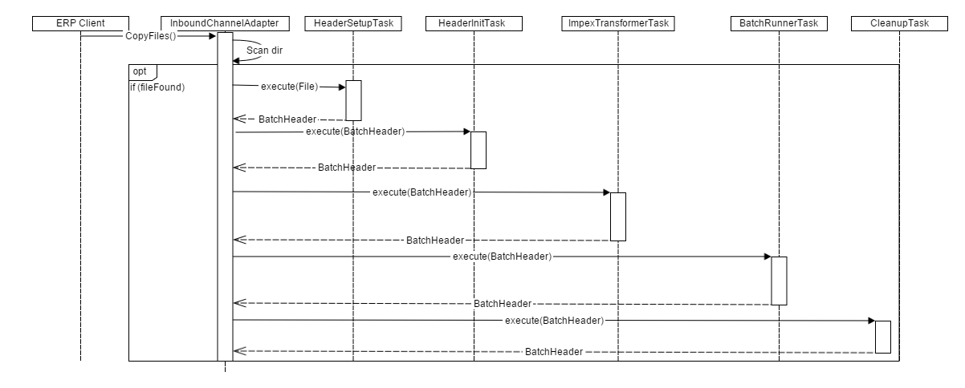

|  |  |  |
| --- | --- | --- |
| **#** | **Component** | **Description** |
| 1 | **ERP client** | The system of the client which provide the CSV files |
| 2 | **InboundChannelAdapter** | Spring integration scans folder and looks for new files that matches filename prefix |
| 3 | **HeaderSetupTask** | The task which create BatchHeader initialize import process with parameters Catalog and Net |
| 4 | **HeaderInitTask** | The task which initialize import process with parameters Lang and SequenceID |
| 5 | **ImpexTransformerTask** | The task that is responsible of the conversion into IMPEX format |
| 6 | **BatchRunnerTask** | The task which does the import process |
| 7 | **CleanupTask** | The task which clean the directory “process” and move files in directory “error” or “archive” |

Use Case Diagram

Use case diagram for the hot folder product restriction addon

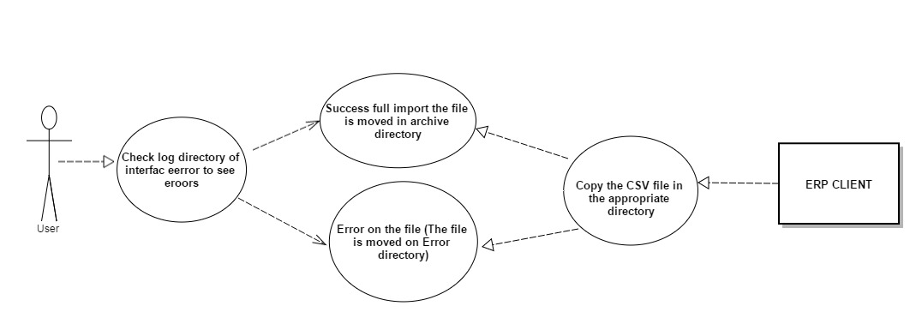

**Description:** User checks the result of the import process starts from ERP CLIENT. If the file reaches to the appropriated directory (**hybris\data\acceleratorservices\import\master\customers**). Immediately the file will be validated. If there is any error like missing mandatory fields then file will be moved to the error folder then the error logs will be available in **hybris\log\interfaceerror** directory. If there are no errors then it will be processed successfully to the archive directory.

1. Detailed Application Design

Class Diagram

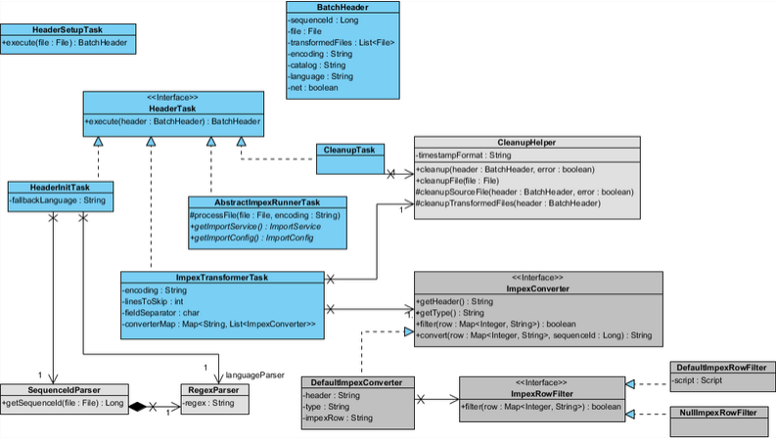

Beans

**HeaderSetupTask:** The task which initialize import process with parameters.

**HeaderInitTask:** Define the language of the import file and verify that the file isn’t a duplicate

**ImpexTransformerTask:** Define some variables for the conversion and do this.

**Cleanup Task:** Clean the import files and move them into error folder or archive error.

Facade

N.A

Strategy

N.A

Controller

N.A

View/JSP

N.A

1. Database architecture

ER Diagram

**Product Restriction ER Diagram:**

|  |  |  |  |  |  |
| --- | --- | --- | --- | --- | --- |
| **Name** | **Description** | **Type** | **Default Value** | **Mandatory** | **Example** |
| Product Code | This is dynamic value but it should be defined in Hybris database | String | / | TRUE | 1101690 |
| B2BUnit UID | This is dynamic value but it should be defined in Hybris database | B2BUnit | / | TRUE | Pronto |
| isDisplayable | It is an attribute. | Boolean | FALSE | TRUE | true |

1. Exception Handling and Logging

Exception Scenarios

The module interfaceerror log all actions that can handle errors. It is log using Log.error() method in the log file.

Exception Handling

Generated by de.hybris.platform.impex.jalo.imp.DefaultImportProcessor

|  |  |
| --- | --- |
| **Exception** | **Message** |
| UnresolvedValueException | Exception caught when :   * error finding existing item * no existing item found for update * cannot create due to unresolved mandatory/initial columns |
| InsufficientDataException | Exception caught when :   * target type is not permitted by current header – {header} * cannot import localized column without default session language |
| ImpexException | Exception caught when :   * unknown mode (INSERT | UPDATE | INSERT_UPDATE | REMOVE) * batch inserts are not supported – found more than one item for value line {valueLine} * Configured type {type} is abstract and you want to insert {valueLine}. Please specify the subtype of the item you want to create at the first column of the value line or change the configured type * Composed type {code} of found item with PK {PK} is not an instance of specified type {typecode} * Composed type {code} of found item with PK {PK} is not permitted in Insert_Update mode, because of {typeErrorMsg} |
| HeaderValidationException | Exception caught when :   * cacheUnique modifier is not allowed for Singleton types, please remove cacheUnique modifier |

Logging

* For logging in the hotfolder module Log4j will be used.
* The logging level will be set at INFO level.
* The exceptions are logged using Log.error() method.
* Product restriction file process fails then check the logs in the **hybris\log\interfaceerror** folder.If the file gets rejected then it will be tracked in **hybris\log\interfaceerror\reject**
* List of error messages:

1. Missing a mandatory field for SKU(product id).

Original file: ProductRestrictionCustomerData-0012.csv;line: 14;message: Missing value for 0;original line: ;Pronto Goods;true

1. Missing a mandatory filed for B2BUnit

Original file: ProductRestrictionCustomerData-0012.csv;line: 14;message: Missing value for 1;original line: 23456;;true

1. Missing a mandatory filed isDisplayable(true/false)

Original file: ProductRestrictionCustomerData-0011.csv;line: 2;message: Missing value for 2;original line: 3778926;Pronto Goods;

Note: Line numbers and product id, B2Bunit id might changes as these values are dynamic.

1. Installation and Configuration

Installation steps for the addon

The steps in section 6.1 need not be followed if the hotfolder is already configured and only a new interface is being added.

Add the hotfolder module dependency in hybris/Assets/hybris/config/localextension.xml file as follows.

<extension name="hotfolder"/>

Next, Copy **both hotfolder and interfaceerror** module directory into hybris/bin/custom.

To finish, execute the following commands marked in green using command prompt.

Cd <hybris.directory>/bin/platform

# **Note:** <hybris.directory> is the installation location of the hybris

setantenv.bat

ant all

Configuration steps for the addon

1. Add the following properties in project.properies it is available in hybris\bin\custom\hotfolder directory.

# Frequency in ms of the directory scan

hotfolder.productrestriction.poller.rate=1000

# The name of the default catalog

hotfolder.productrestriction.default.catalog=powertoolsProductCatalog

# The version of the product default catalog version

hotfolder.productrestriction.default.catalogVersion=Staged

Note: You can change the Frequency scan of the poller directory, the default name of the catalog and the default version of the catalog if neede.

1. hybris\bin\custom\hotfolder\resources\hotfolder\integration directry add the below given fonfiguration file.



1. After adding the configuration file performs the ant all and start the hybris server.
2. Check the productrestriction folder is created or not in hybris\data\acceleratorservices\import\master.
3. If the folder is available then configuration is done successfully. It can test using the test data (ProductRestrictionCustomerData-001) it is available in hybris\bin\custom\hotfolder\resources\test\Productrestriction.

7. Appendix A *– Glossary of terms*

|  |  |
| --- | --- |
| **Term/Abbreviation/Acronym** | **Meaning** |
| B2B | Business to Business |