

Customer Import Half Interface

Technical Design Documentation

Document History

|  |  |  |  |
| --- | --- | --- | --- |
| Version | Updated By | Date | Comments |
| 0.1 | Jayachandra Gudiwada & Venkatesh Dasari | 03/03/2015 | Initial Draft |
|  |  |  |  |
|  |  |  |  |

Document Sign-Off

|  |  |  |
| --- | --- | --- |
| Name | Role | Signature/Date |
| Pascal ESPINOUSE |  |  |
| RECOUVREUR FLAVIEN |  |  |
| DURANT DE LA PASTELLIERE BENOIT |  |  |

Table of Contents

1. Introduction 4

1.1 Purpose 4

1.2 Intended Audience 4

1.3 Document Scope 4

1.4 Functional Rules 4

1.5 Assumptions/Restrictions 4

1.6 Documents Structure 5

1.7 Additional Resources 5

1.7.1 Useful Site 5

1.7.2 B2BUnit Data 6

1.7.3 Address Data 6

1.7.4 B2BCustomer Data 6

2. High Level Design Diagram 7

2.1 Overview 7

2.2 Sequence Diagram 8

2.3 Use Case Diagram 9

3. Detailed Application Design 10

3.1 Class Diagram 10

3.2 Beans 10

3.3 Facade 10

3.4 Strategy 10

3.5 Controller 10

3.6 View/JSP 11

4. Database architecture 12

4.1 ER Diagram 12

5. Exception Handling and Logging 15

5.1 Exception Scenarios 15

The module interfaceerror log all actions that can handle errors. It is log using Log.error() method in the log file. 15

5.2 Exception Handling 15

Generated by de.hybris.platform.impex.jalo.imp.DefaultImportProcessor 15

5.3 Logging 15

6. Installation and Configuration 16

6.1 Installation steps for the addon 16

6.2 Configuration steps for the addon 16

7. Appendix A *– Glossary of terms* 17

1. Introduction

Purpose

This document is the Technical Design Document which provides information of hotfolder addon and steps to configure the module. It covers:

1. High Level Design
2. Application Architecture
3. Database Architecture
4. Installation Steps

Intended Audience

This document is aimed at Hybris developers and Technical members who want to implement the hotfolder addon in Hybris.

Document Scope

This document covers the details about the sprint 1 hot folder implementation for Customer interface.

Functional Rules

* The hot folder permits to import B2B units, B2BCustomers and Address with file format of CSV.
* All fields of different types can be considered.

Assumptions/Restrictions

This module has been created for version 5.4.0.0.

The interface developed based on assumption that the user is assigned to any of b2b unit then address is assigned to that user.

Display: The hot folder module provide the directory where the CSV files have to be put to automatically import data in the system

Import: The different template we provide in CSV files filled with data.

Export: No export is available

Documents Structure

|  |  |  |
| --- | --- | --- |
| Section | | Description |
| 1 | Introduction | Describes the purpose and intended audience of the document and explains its structure. |
| 2 | High Level Design | Overview of the module. |
| 3 | Detailed Application Design | Application architecture applicable to this module. |
| 4 | Detailed Database Design | Conceptual and logical architecture applicable to this module. |
| 5 | Exception Management & Logging | Information about the Exception handling and logging. |
| 6 | Installation & Configuration | Steps to install and configure the module. |
| 7 | Appendices | Supporting information. |

Additional Resources

1.7.1 Useful Site

|  |  |  |  |
| --- | --- | --- | --- |
| # | Description | URL | Purpose |
| 1 | Wiki Portal | <https://wiki.hybris.com> | To gather more information |
| 2 | Coconet | Need to create | To refer functional specifications |
| 3 | Data importation | <https://wiki.hybris.com/display/accdoc/Data+Importing+Capability+in+the+Commerce+Accelerator> | Documentation of import process |

1.7.2 B2BUnit Data

|  |  |  |
| --- | --- | --- |
| B2BUnit with Data |  | CSV files to import B2BUnit. |

1.7.3 Address Data

|  |  |  |
| --- | --- | --- |
| Address with Data |  | CSV files to import Address. |

1.7.4 B2BCustomer Data

|  |  |  |
| --- | --- | --- |
| B2BCustomer with Data |  | CSV files to import B2BCustomer. |

1. High Level Design Diagram

Overview

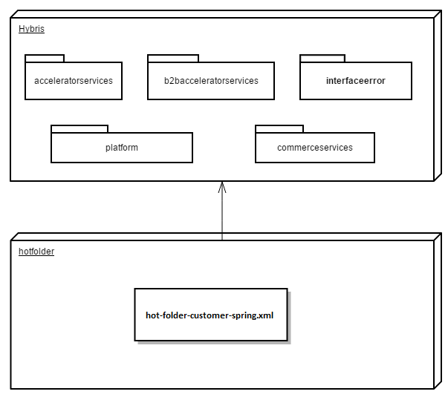

Sequence Diagram

Sequence of events during the hot folder process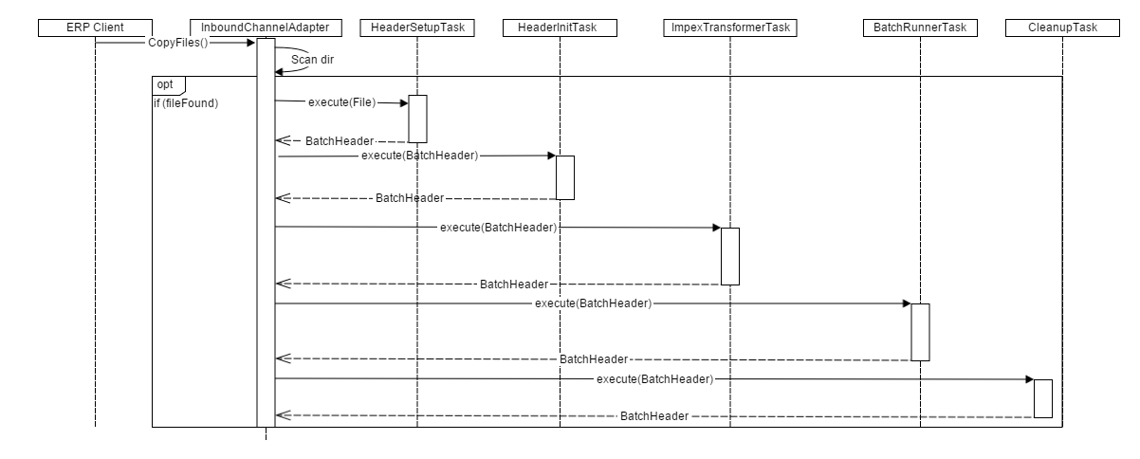

|  |  |  |
| --- | --- | --- |
| **#** | **Component** | **Description** |
| 1 | **ERP client** | The system of the client which provide the CSV files |
| 2 | **InboundChannelAdapter** | Spring integration scans folder and looks for new files that matches filename prefix |
| 3 | **HeaderSetupTask** | The task which create BatchHeader initialize import process with parameters Catalog and Net |
| 4 | **HeaderInitTask** | The task which initialize import process with parameters Lang and SequenceID |
| 5 | **ImpexTransformerTask** | The task that is responsible of the conversion into IMPEX format |
| 6 | **BatchRunnerTask** | The task which does the import process |
| 7 | **CleanupTask** | The task which clean the directory “process” and move files in directory “error” or “archive” |

Use Case Diagram

Use case diagram for the hot folder customer addon

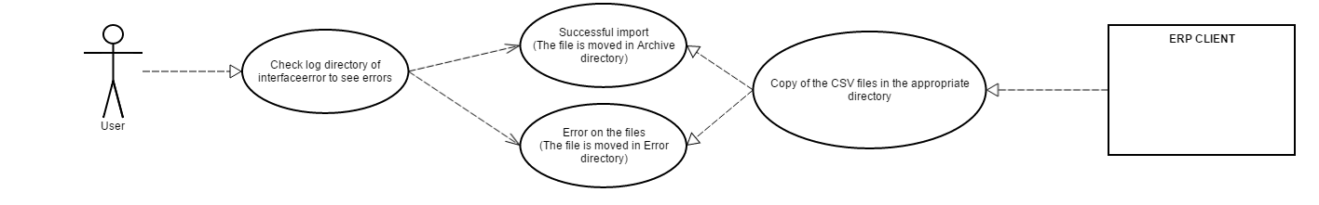

**Description:** User checks the result of the import process starts from ERP CLIENT.

1. Detailed Application Design

Class Diagram

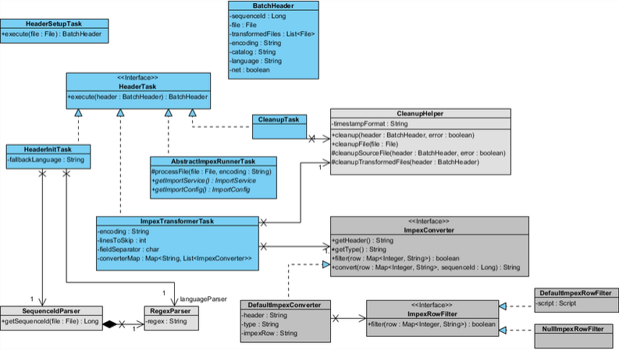

Beans

**HeaderSetupTask:** The task which initialize import process with parameters.

**HeaderInitTask:** Define the langage of the import file and verify that the file isn’t a duplicate

**ImpexTransformerTask:** Define some variables for the conversion and do this.

**CleanupTask:** Clean the import files and move them into error folder or archive error.

Facade

N.A

Strategy

N.A

Controller

N.A

View/JSP

N.A

1. Database architecture

ER Diagram

**Customer hot folder ER Diagram:**

**OrganizationData:**

|  |  |  |  |  |  |
| --- | --- | --- | --- | --- | --- |
| **Name** | **Description** | **Type** | **Default Value** | **Mandatory** | **Example** |
| uniqueid | Unique ID of the Organization | java.lang.String | / | TRUE | Custom Retail |
| Is_active | A user of the organization can/can not log to the site | java.lang.Boolean | true | TRUE | true |
| name | name | java.lang.String | / | FALSE | Custom Retail |
| locName | Localized name | localized:String | / | FALSE | Custom Retail |
| userPriceGroup | Price Group for the organization | String | / | FALSE | A DEFAULT B2B USERPRICEGROUP |

**AddressesData:**

| **Name** | **Description** | **Type** | **Default Value** | **Mandatory** | **Example** |
| --- | --- | --- | --- | --- | --- |
| code | Customer ID | String | / | TRUE | 107701 |
| owner | owner | Custom Retail | / | TRUE | Custom Retail |
| company | company | Company | / | TRUE | Spontis |
| StreetNumber | Street number | String | / | FALSE |  |
| streetName | Street name | String | / | FALSE |  |
| postalCode | Postal code | java.lang.String | / | FALSE | 91700 |
| town | town | java.lang.String | / | FALSE | Paris |
| country | country | java.lang.String | / | FALSE | Canada |
| appartment | appartment | java.lang.String | / | FALSE |  |
| building | building | java.lang.String | / | FALSE |  |
| department | department | java.lang.String | / | FALSE |  |
| district | district | java.lang.String | / | FALSE |  |
| fax | fax | java.lang.String | / | FALSE |  |
| cellphone | cellphone | java.lang.String | / | FALSE |  |
| Phone1 | Phone1 | java.lang.String | / | FALSE | 0100000000 |
| Phone2 | Phone2 | java.lang.String | / | FALSE | 0100000000 |
| soldtoAddress | Address used as selling address | java.lang.Boolean | FALSE | FALSE | false |
| shiptoAddress | Address used as shippingAddress | java.lang.Boolean | FALSE | FALSE | false |
| billtoAddress | Address used as billing Address | java.lang.Boolean | FALSE | FALSE | true |
| payerAddress | Address of the payer | java.lang.Boolean | FALSE | FALSE | true |
| firstname | firstname | java.lang.String | / | FALSE | John |
| lastname | lastname | java.lang.String | / | FALSE | Doe |
| email | email | java.lang.String | / | FALSE | hanna.schmidt@rustic-hw.com |
| title | title | Title | / | FALSE | mr |
| remarks | remarks | java.lang.String | / | FALSE | Friendly customer |
| url | url | java.lang.String | / | FALSE |  |
| visibleInAddressBook | visibleInAddressBook | java.lang.Boolean | / | FALSE | true |

**B2BCustomer:**

| **Name** | **Description** | **Type** | **Default Value** | **Mandatory** | **Example** |
| --- | --- | --- | --- | --- | --- |
| uid | Unique id of the users | java.lang.String | / | TRUE | admin |
| Description | Description | java.lang.String | / | FALSE | administrator description |
| email | email | java.lang.String | / | TRUE | hanna.schmidt@rustic-hw.com |
| name | name | java.lang.String | / | FALSE | Administrator |
| title | Title | Title | / | FALSE | mr |
| defaultB2BUnit | membership group | String | / | TRUE | Pronto,b2bapprovergroup |
| sessioncurrency | Currency of the session | Currency | / | FALSE | USD |
| password | password | java.lang.String | / | TRUE | nimda |

1. Exception Handling and Logging

Exception Scenarios

The module interfaceerror log all actions that can handle errors. It is log using Log.error() method in the log file.

Exception Handling

Generated by de.hybris.platform.impex.jalo.imp.DefaultImportProcessor

|  |  |
| --- | --- |
| **Exception** | **Message** |
| UnresolvedValueException | Exception caught when :   * error finding existing item * no existing item found for update * cannot create due to unresolved mandatory/initial columns |
| InsufficientDataException | Exception caught when :   * target type is not permitted by current header – {header} * cannot import localized column without default session language |
| ImpexException | Exception caught when :   * unknow mode (INSERT | UPDATE | INSERT_UPDATE | REMOVE) * batch inserts are not supported – found more than one item for value line {valueLine} * Configured type {type} is abstract and you want to insert {valueLine}. Please specify the subtype of the item you want to create at the first column of the value line or change the configured type * Composed type {code} of found item with PK {PK} is not an instance of specified type {typecode} * Composed type {code} of found item with PK {PK} is not permitted in Insert_Update mode, because of {typeErrorMsg} |
| HeaderValidationException | Exception caught when :   * cacheUnique modifier is not allowed for Singleton types, please remove cacheUnique modifier |

Logging

* For logging in the hotfolder module Log4j will be used.
* The logging level will be set at INFO level.
* The exceptions are logged using Log.error() method.

1. Installation and Configuration

Installation steps for the addon

The steps in section 6.1 need not be followed if the hotfolder is already configured and only a new interface is being added.

Add the hotfolder module dependency in hybris/Assets/hybris/config/localextension.xml file as follows.

<extension name="hotfolder"/>

Next, Copy **both hotfolder and interfaceerror** module directory into hybris/bin/custom.

To finish, execute the following commands marked in green using command prompt.

Cd hybris.directory/bin/platform

# **Note:** hybris.directory is the installation location of the hybris

setantenv.bat

ant all

Configuration steps for the addon

If you want to modify the parameters of the hotfolder module, you can find these in the **project.properties** file of the module.

You can change the Frequency scan of the poller directory, the default name of the catalog and the default version of the catalog.

# Frequency in ms of the directory scan

hotfolder.customers.poller.rate=1000

# The name of the default catalog

hotfolder.customers.default.catalog=powertoolsProductCatalog

# The version of the product default catalog

hotfolder.customers.default.catalogVersion=Staged

# The default password  
hotfolder.customers.default.password=1234

7. Appendix A *– Glossary of terms*

|  |  |
| --- | --- |
| **Term/Abbreviation/Acronym** | **Meaning** |
| B2B | Business to Business |
| CSV | Comma Separated Value |