pou

OrderTracking Import Half Interface

Technical Design Documentation

Document History

|  |  |  |  |
| --- | --- | --- | --- |
| Version | Updated By | Date | Comments |
| 0.1 | LEVY Quentin | 02/04/2015 | Initial Draft |
|  |  |  |  |
|  |  |  |  |

Document Sign-Off

|  |  |  |
| --- | --- | --- |
| Name | Role | Signature/Date |
| Pascal ESPINOUSE |  |  |
| RECOUVREUR FLAVIEN |  |  |
| DURANT DE LA PASTELLIERE BENOIT |  |  |

Table of Contents

1. Introduction 4

1.1 Purpose 4

1.2 Intended Audience 4

1.3 Document Scope 4

1.4 Functional Rules 4

1.5 Assumptions/Restrictions 4

1.6 Documents Structure 5

1.7 Additional Resources 5

1.7.1 Useful Sites 5

1.7.2 OrderData 6

1.7.3 OrderEntry Data 6

1.7.4 OrderTracking Data 6

2. High Level Design Diagram 7

2.1 Overview 7

2.2 Sequence Diagram 8

2.3 Use Case Diagram 9

3. Detailed Application Design 10

3.1 Class Diagram 10

3.2 Beans 10

3.3 Facade 10

3.4 Strategy 10

3.5 Controller 10

3.6 View/JSP 11

4. Database architecture 12

4.1 ER Diagram 12

5. Exception Handling and Logging 15

5.1 Exception Scenarios 15

5.2 Exception Handling 15

5.3 Logging 16

6. Installation and Configuration 17

6.1 Installation steps for the addon 17

6.2 Configuration steps for the addon 17

7. Appendix A *– Glossary of terms* 18

1. Introduction
   1. Purpose

This document is the Technical Design Document which provides information of hotfolder addon and steps to configure the module. It covers:

1. High Level Design
2. Application Architecture
3. Database Architecture
4. Installation Steps
   1. Intended Audience

This document is aimed at Hybris developers and Technical members who want to implement the hotfolder addon in Hybris.

* 1. Document Scope

This document covers the details about the sprint 1 hot folder addon.

* 1. Functional Rules
* The hot folder permits to import some data about order, orderEntry and OrderTracking with file format CSV
* All fields of different types can be considered
  1. Assumptions/Restrictions

This module has been created for version 5.4.0.0.

**Display:** The hot folder module provide the directory where the CSV files have to be put to automatically import data in the system

**Import**: The different template we provide in CSV files filled

**Export**: No export is available

* 1. Documents Structure

|  |  |  |
| --- | --- | --- |
| Section | | Description |
| 1 | Introduction | Describes the purpose and intended audience of the document and explains its structure. |
| 2 | High Level Design | Overview of the module. |
| 3 | Detailed Application Design | Application architecture applicable to this module. |
| 4 | Detailed Database Design | Conceptual and logical architecture applicable to this module. |
| 5 | Exception Management & Logging | Information about the Exception handling and logging. |
| 6 | Installation & Configuration | Steps to install and configure the module. |
| 7 | Appendices | Supporting information. |

* 1. Additional Resources

1.7.1 Useful Sites

|  |  |  |  |
| --- | --- | --- | --- |
| # | Description | URL | Purpose |
| 1 | Wiki Portal | <https://wiki.hybris.com> | To gather more information |
| 2 | Coconet | <https://coconet2.capgemini.com/sf/go/doc3313610?nav=1> | To refer functional specifications |
| 3 | Data importation | <https://wiki.hybris.com/display/accdoc/Data+Importing+Capability+in+the+Commerce+Accelerator> | Documentation of import process |

1.7.2 OrderData

|  |  |  |
| --- | --- | --- |
| File orderData with header |  | Template of header orderData |
| File orderData with data |  | Sample of orderData with data |

Be careful, the header must not be present in the Sample file, or with a # before to comment it

1.7.3 OrderEntry Data

|  |  |  |
| --- | --- | --- |
| File orderEntryData with header |  | Template of header OrderEntryData |
| File orderEntryData with data |  | Sample of orderEntryData with data |

Be careful, the header must not be present in the Sample file, or with a # before to comment it

1.7.4 OrderTracking Data

|  |  |  |
| --- | --- | --- |
| File orderTrackingData with header |  | Template of header orderTrackingData |
| File orderTrackingData with data |  | Sample of orderTrackingData with data |

Be careful, the header must not be present in the Sample file, or with a # before to comment it

1. High Level Design Diagram
   1. Overview

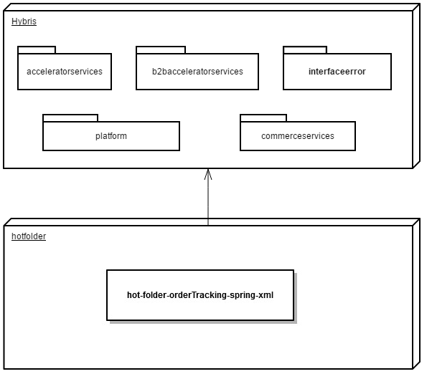

* 1. Sequence Diagram

Sequence of events during the hot folder process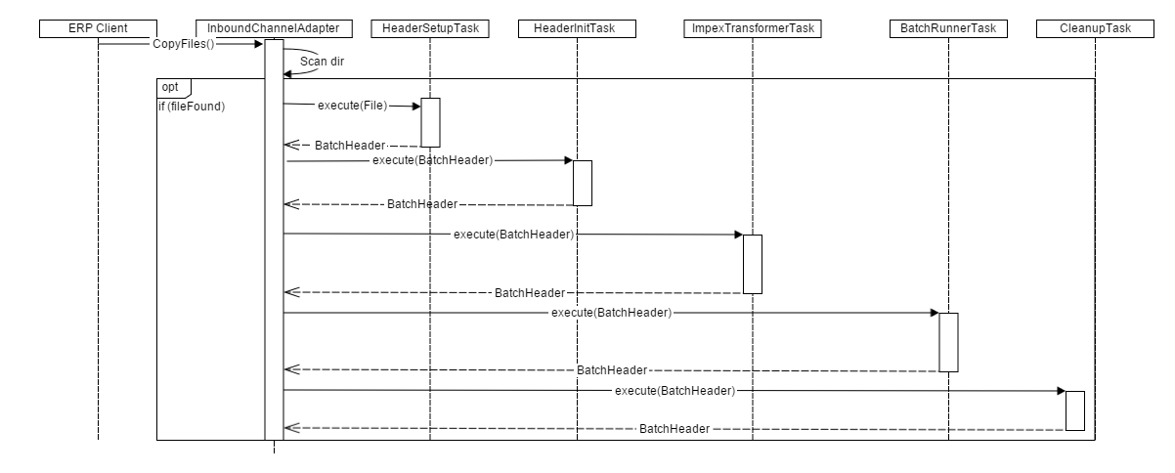

|  |  |  |
| --- | --- | --- |
| **#** | **Component** | **Description** |
| 1 | **ERP client** | The system of the client which provide the CSV files |
| 2 | **InboundChannelAdapter** | Spring integration scans folder and looks for new files that matches filename prefix |
| 3 | **HeaderSetupTask** | The task which create BatchHeader initialize import process with parameters Catalog and Net |
| 4 | **HeaderInitTask** | The task which initialize import process with parameters Lang and SequenceID |
| 5 | **ImpexTransformerTask** | The task that is responsible of the conversion into IMPEX format |
| 6 | **BatchRunnerTask** | The task which does the import process |
| 7 | **CleanupTask** | The task which clean the directory “process” and move files in directory “error” or “archive” |

* 1. Use Case Diagram

Use case diagram for the hot folder product addon

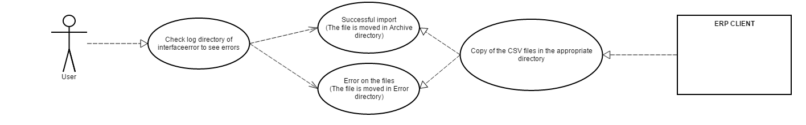

**Description:** User checks the result of the import process starts from ERP CLIENT.

1. Detailed Application Design
   1. Class Diagram

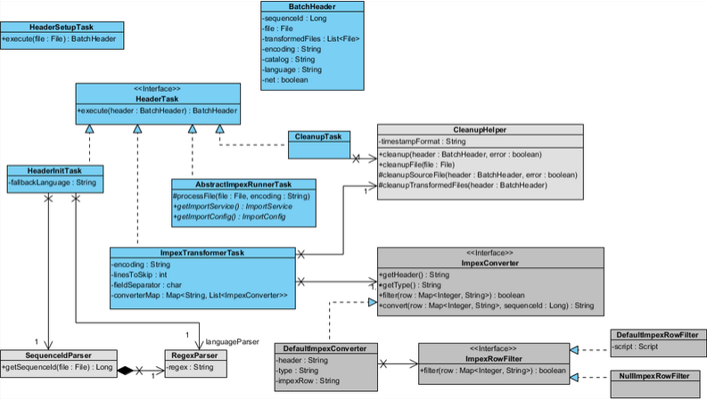

* 1. Beans

**HeaderSetupTask:** The task which initialize import process with parameters.

**HeaderInitTask:** Define the langage of the import file and verify that the file isn’t a duplicate

**ImpexTransformerTask:** Define some variables for the conversion and do this.

**CleanupTask:** Clean the import files and move them into error folder or archive error.

* 1. Facade

N.A

* 1. Strategy

N.A

* 1. Controller

N.A

* 1. View/JSP

N.A

1. Database architecture
   1. ER Diagram

**Order hot folder ER Diagram:**

| **Name** | **Description** | **Type** | **Default Value** | **Mandatory** | **Example** |
| --- | --- | --- | --- | --- | --- |
| code | Code of the order | String | / | TRUE | 107701 |
| status | Status of the order | String | / | FALSE | COMPLETED |
| purchaseNumber | Number added by the client to follow his command easily | String | / | FALSE | 12341234 |
| calculated | Boolean indicating if hybris must recalculate the price of the order | Boolean | ? | FALSE | FALSE |
| currency | Currency of the order | Currency | / | TRUE | USD |
| paymentStatus | Status of the payment | Payment Status | / | FALSE | PARTPAID |
| paymentMode | Mode of payment | Payment Mode | / | FALSE | pieces |
| TotalTax | Total Taxes | Double | / | FALSE | 0 |
| TotalDiscount | Total Discount | Double | / | FALSE | 0 |
| TotalPrice | Total Price | Double | / | TRUE | 128 |
| deliveryAddress | Adress of delivery | Address | / | FALSE | b2bassets |
| deliveryMode | Mode of delivery | Delivery Mode | / | FALSE | Standard-net |
| DeliveryCost | Cost of the delivery | Double | / | FALSE | 9 |
| statusInfo | Info about the status | String | / | FALSE | Information about the order |
| deliveryStatus | Status of the delivery | Delivery Status | / | FALSE | PARTSHIPPED |
| ExportStatus | Status of the exportation | Export Status | / | FALSE | EXPORTED |
| date | date | Date | / | FALSE | 2015-03-25 15:01:12.000000 |
| user | UniqueID of the owner | String | / | FALSE | anthony.lombardi@rustic-hw.com |
| soldtoAddress | Address used as selling address | java.lang.Boolean | FALSE | FALSE | false |
| shiptoAddress | Address used as shippingAddress | java.lang.Boolean | FALSE | FALSE | false |
| billtoAddress | Address used as billing Address | java.lang.Boolean | FALSE | FALSE | true |
| payerAddress | Address of the payer | java.lang.Boolean | FALSE | FALSE | true |
| ERPOrderNumber | Order identifier within the ERP | String | / | FALSE | 0123 |
| Origin | Origin of the order | String | / | FALSE | fax |

**OrderEntries hot folder ER Diagram:**

| **Name** | **Description** | **Type** | **Default Value** | **Mandatory** | **Example** |
| --- | --- | --- | --- | --- | --- |
| order | Number of the order | String | / | TRUE | 16 |
| costCenter | Cost center | B2B Cost Center | / | FALSE | Pronto Goods |
| entryNumber | Number of the entry | Integer | / | TRUE | 10 |
| info | info | String | / | FALSE | product “1128762” with name “Professional Network Installer Tool Kit” |
| namedDeliveryDate | namedDeliveryDate | Date | / | FALSE | 2015-03-25 15:01:12.000000 |
| product | Code of the product | String | / | TRUE | 1128762 |
| quantityStatus | Status based on quantity | String | / | FALSE | LIVING |
| quantity | quantity | Long | / | TRUE | 1.00000000 |
| rejected | rejected | Boolean | / | FALSE | 0 |
| calculated | Boolean indicating if hybris must recalculate the price of the order | Boolean | TRUE | FALSE | 0 |
| basePrice | Base price | Double | / | TRUE | 45 |
| TotalPrice | Total price | Double | / | TRUE | 90 |
| unit | unit | Unit | / | TRUE | pieces |

**OrderTracking hot folder ER Diagram:**

| **Name** | **Description** | **Type** | **Default Value** | **Mandatory** | **Example** |
| --- | --- | --- | --- | --- | --- |
| orderCode | Code of the order | String | / | TRUE | 10 |
| entryNumber | Number of the entry | Integer | / | TRUE | 0 |
| DeliveryDate | Date of delivery | Date | / | FALSE | 2015-03-27 00 :00 :00.000000 |
| deliveryQty | Quantity of the delivery | Integer | / | FALSE | 4 |
| scheduledDate | Scheduled Date | Date | / | FALSE | 2015-03-27 00:00:00.000000 |
| scheduledQty | Scheduled Quantity | Integer | / | FALSE | 5 |
| trackingNumber | trackingNumber | Integer | / | FALSE | 345675345678845000 |

**OrderTracking hot folder ER Diagram:**

| **Name** | **Description** | **Type** | **Default Value** | **Mandatory** | **Example** |
| --- | --- | --- | --- | --- | --- |
| Code | Code of the order | String | / | TRUE | 10 |
| orderEntry | Number of the entry | Integer | / | TRUE | 13 |
| DeliveryDate | Date of delivery | Date | / | FALSE | 2015-03-27 00 :00 :00.000000 |
| deliveryQty | Quantity of the delivery | Integer | / | FALSE | 4 |
| scheduledDate | Scheduled Date | Date | / | FALSE | 2015-03-27 00:00:00.000000 |
| scheduledQty | Scheduled Quantity | Integer | / | FALSE | 5 |
| trackingNumber | trackingNumber | Integer | / | FALSE | 345675345678845000 |

1. Exception Handling and Logging
   1. Exception Scenarios

The module interfaceerror log all actions that can handle errors. It is log using Log.error() method in the log file.

Internal errors are not displayed but translated in comprehensible error in the log folder

* 1. Exception Handling

Generated by de.hybris.platform.impex.jalo.imp.DefaultImportProcessor

|  |  |
| --- | --- |
| **Exception** | **Message** |
| UnresolvedValueException | Exception caught when :   * error finding existing item * no existing item found for update * cannot create due to unresolved mandatory/initial columns |
| InsufficientDataException | Exception caught when :   * target type is not permitted by current header – {header} * cannot import localized column without default session language |
| ImpexException | Exception caught when :   * unknow mode (INSERT | UPDATE | INSERT_UPDATE | REMOVE) * batch inserts are not supported – found more than one item for value line {valueLine} * Configured type {type} is abstract and you want to insert {valueLine}. Please specify the subtype of the item you want to create at the first column of the value line or change the configured type * Composed type {code} of found item with PK {PK} is not an instance of specified type {typecode} * Composed type {code} of found item with PK {PK} is not permitted in Insert_Update mode, because of {typeErrorMsg} |
| HeaderValidationException | Exception caught when :   * cacheUnique modifier is not allowed for Singleton types, please remove cacheUnique modifier |

* 1. Logging
* For logging in the advanced orderTracking search module Log4j will be used.
* The logging level will be set at INFO level.
* The exceptions are logged using Log.error() method.

1. Installation and Configuration
   1. Installation steps for the addon

Add the hotfolder module dependency in hybris/Assets/hybris/config/localextension.xml file as follows.

<extension name="hotfolder"/>

Next, Copy **both hotfolder and interfaceerror** module directory into hybris/bin/custom.

To finish, execute the following commands marked in green using command prompt.

Cd hybris.directory/bin/platform

# **Note:** hybris.directory is the installation location of the hybris

setantenv.bat

ant all

* 1. Configuration steps for the addon

If you want to modify the parameters of the hotfolder module, you can find these in the **project.properties** file of the module.

You can change the Frequency scan of the poller directory, the default name of the catalog and the default version of the catalog.

# Frequency in ms of the directory scan

hotfolder.product.poller.rate=1000

# The name of the default catalog

hotfolder.product.default.catalog=powertoolsProductCatalog

# The version of the product default catalog

hotfolder.product.default.catalogVersion=Staged

**When the order are imported, product associates to the order must be synchronized with the online catalog else the importation will failed even if the products are in the hmc**

7. Appendix A *– Glossary of terms*

|  |  |
| --- | --- |
| **Term/Abbreviation/Acronym** | **Meaning** |
| B2B | Business to Business |