

Order Export Interface

Technical Design Documentation

Document History

|  |  |  |  |
| --- | --- | --- | --- |
| Version | Updated By | Date | Comments |
| 1.0 | Shashank Bezalwar | 13/03/2015 | Initial Draft |
| 2.0 | Shashank Bezalwar | 30/03/2015 | Added steps to create CronJob |
|  |  |  |  |

Document Sign-Off

|  |  |  |
| --- | --- | --- |
| Name | Role | Signature/Date |
| Pascal ESPINOUSE |  |  |
| RECOUVREUR FLAVIEN |  |  |
| DURANT DE LA PASTELLIERE BENOIT |  |  |

Table of Contents

1. Introduction 4

1.1 Purpose 4

1.2 Intended Audience 5

1.3 Document Scope 5

1.4 Functional Rules 5

1.5 Assumptions/Restrictions 5

1.6 Documents Structure 5

1.7 Additional Resources 6

2. High Level Design Diagram 7

2.1 Overview 7

2.2 Sequence Diagram 8

2.3 Use Case Diagram 9

3. Detailed Application Design 10

3.1 Class Diagram 10

3.2 Beans 10

3.3 Facade 10

3.4 Strategy 10

3.5 Controller 10

3.6 View/JSP 11

4. Database architecture 12

4.1 ER Diagram 12

5. Exception Handling and Logging 13

5.1 Exception Scenarios 13

5.2 Exception Handling 13

5.3 Logging 13

6. Installation and Configuration 15

6.1 Installation steps for the addon 15

6.2 Configuration steps for the addon 15

7. Appendix A *– Glossary of terms* 16

1. Introduction

Purpose

This document is the Technical Design Document which provides information of Order Export Interface and steps to configure the module. It covers:

1. High Level Design
2. Application Architecture
3. Database Architecture
4. Installation Steps

Intended Audience

This document is aimed at Hybris developers and Technical members who want to implement the Export Order Interface in Hybris.

Document Scope

This document covers the details about the sprint 2 Export Order Interface.

Functional Rules

* The Export Order Interface exports orders placed in Hybris in CSV file format.

Assumptions/Restrictions

This module has been created for version 5.4.0.0.

The interface is developed based on assumption that the external system will would accept the order details in CSV file format. In the initial release below is the list of attributes that are exported:

* + Order Code
  + Order Status
  + Purchase Order Number
  + User Name who created the order
  + Calculated
  + Currency
  + Payment Status
  + Payment Mode
  + Total Tax
  + Total Discounts
  + Total Order Price
  + Delivery Address
  + Delivery Mode
  + Delivery Cost
  + Product Code
  + Quantity
  + Total Price for Product (i.e. Quantity * Product price)

Documents Structure

|  |  |  |
| --- | --- | --- |
| Section | | Description |
| 1 | Introduction | Describes the purpose and intended audience of the document and explains its structure. |
| 2 | High Level Design | Overview of the module. |
| 3 | Detailed Application Design | Application architecture applicable to this module. |
| 4 | Detailed Database Design | Conceptual and logical architecture applicable to this module. |
| 5 | Exception Management & Logging | Information about the Exception handling and logging. |
| 6 | Installation & Configuration | Steps to install and configure the module. |
| 7 | Appendices | Supporting information. |

Additional Resources

|  |  |  |  |
| --- | --- | --- | --- |
| # | Description | URL | Purpose |
| 1 | Wiki Portal | <https://wiki.hybris.com> | To gather more information |
| 2 | File OrderData with data |  | Template of OrderData with data |

1. High Level Design Diagram

Overview

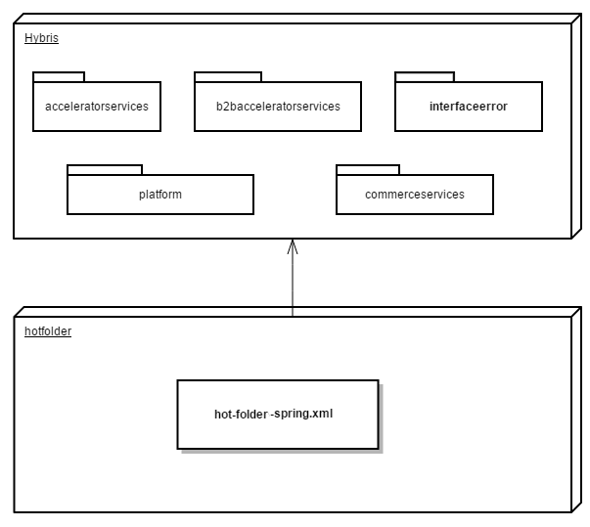

Sequence Diagram

Sequence of events during the export process

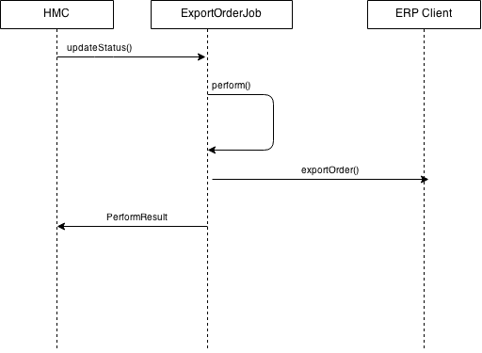

|  |  |  |
| --- | --- | --- |
| **#** | **Component** | **Description** |
| 1 | **HMC** | The user updates the Order status and Export status in HMC. |
| 2 | **ExportOrderJob** | ExportOrderJob extends AbstractJobPerformable and has the business logic to extract orders which has order status as completed and extract status as not exported and write the csv file. |
| 3 | **ERP client** | The system of the client which consumes the CSV files |

Use Case Diagram

Use case diagram for the Export Order Interface

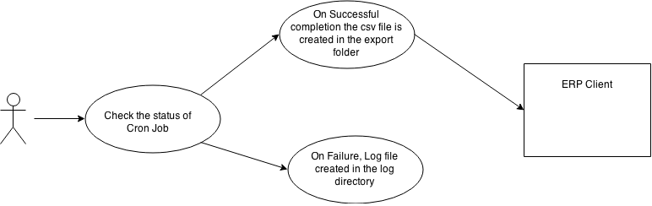

**Description:** Use Case diagram for the Export Order Interface.

1. Detailed Application Design

Class Diagram

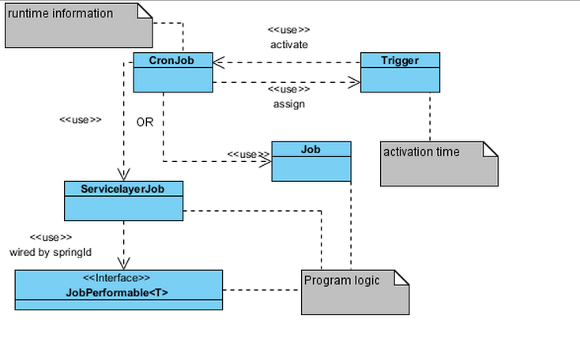

Beans

N.A.

Facade

N.A

Strategy

N.A

Controller

N.A

View/JSP

N.A

1. Database architecture

ER Diagram

N.A.

1. Exception Handling and Logging

Exception Scenarios

The Export Order Interface logs all actions that can handle errors. It is log using Log.error() method in the log file.

Exception Handling

Generated by com.generic.export.ExportOrderJob

|  |  |
| --- | --- |
| **Exception** | **Message** |
| FileNotFoundException | Exception caught when :   * Could not write CSV file to disk. |
| UnsupportedEncodingException | Exception caught when :   * The specified encoding is not supported. |
| IOException | Exception caught when :   * Error while writing the file to disk * Permission Issues * Corrupted Stream etc.s |

Logging

* For logging in the hotfolder module Log4j will be used.
* The logging level will be set at INFO level.
* The exceptions are logged using Log.error() method.

1. Installation and Configuration

Installation steps for the addon

**Note: The installation is not required if the hotfolder extension is already configured. The Export Order Interface in this release is part of the hotfolder addon. Below steps should be followed only of the hotfolder addon is not installed.**

Add the hotfolder module dependency in hybris/Assets/hybris/config/localextension.xml file as follows.

<extension name="hotfolder"/>

Next, Copy **both hotfolder and interfaceerror** module directory into hybris/bin/custom.

To finish, execute the following commands marked in green using command prompt.

Cd hybris.directory/bin/platform

# **Note:** hybris.directory is the installation location of the hybris

setantenv.bat

ant all

Configuration steps for the addon

1. Ensure the following line is present in the configuration file hotfolder-spring.xml present at location hybris/bin/custom/hotfolder/resources/.

<bean id="exportOrderJob"

class="com.generic.export.ExportOrderJob"

parent="abstractJobPerformable">

</bean>

1. Create Cron Job in HMC
   1. Navigate to <http://localhost:9001/hmc/hybris>
   2. Login using admin account
   3. In the left pane, Expand System and select CronJobs
   4. Right click on CronJobs in the left pane and select option Create>CronJob
   5. Provide Jobname as Export Order(This is configurable and any name can be used).
   6. Select Job as exportOrderJob
   7. Select check box to Enable the CronJob
   8. Click on Create to create the CronJob

7. Appendix A *– Glossary of terms*

|  |  |
| --- | --- |
| **Term/Abbreviation/Acronym** | **Meaning** |
| B2B | Business to Business |
| HMC | Hybris Management Console |
| Cron Job | A cron job is the scheduled task itself and used to automate repetitive tasks. |