

Product Import Half Interface

Technical Design Documentation

Document History

|  |  |  |  |
| --- | --- | --- | --- |
| Version | Updated By | Date | Comments |
| 0.1 | RECOUVREUR Flavien | 13/02/2015 | Initial Draft |
|  |  |  |  |
|  |  |  |  |

Document Sign-Off

|  |  |  |
| --- | --- | --- |
| Name | Role | Signature/Date |
| Pascal ESPINOUSE |  |  |
| RECOUVREUR FLAVIEN |  |  |
| DURANT DE LA PASTELLIERE BENOIT |  |  |

Table of Contents

1. Introduction 4

1.1 Purpose 4

1.2 Intended Audience 4

1.3 Document Scope 4

1.4 Functional Rules 4

1.5 Assumptions/Restrictions 4

1.6 Documents Structure 5

1.7 Additional Resources 5

1.7.1 Useful Sites 5

1.7.2 Product General Data 6

1.7.3 Product International Data 6

1.7.4 Product Media Data 6

2. High Level Design Diagram 7

2.1 Overview 7

2.2 Sequence Diagram 8

2.3 Use Case Diagram 9

3. Detailed Application Design 10

3.1 Class Diagram 10

3.2 Beans 10

3.3 Facade 10

3.4 Strategy 10

3.5 Controller 10

3.6 View/JSP 11

4. Database architecture 12

4.1 ER Diagram 12

5. Exception Handling and Logging 16

5.1 Exception Scenarios 16

5.2 Exception Handling 16

5.3 Logging 17

6. Installation and Configuration 18

6.1 Installation steps for the addon 18

6.2 Configuration steps for the addon 18

7. Appendix A *– Glossary of terms* 19

1. Introduction

Purpose

This document is the Technical Design Document which provides information of hotfolder addon and steps to configure the module. It covers:

1. High Level Design
2. Application Architecture
3. Database Architecture
4. Installation Steps

Intended Audience

This document is aimed at Hybris developers and Technical members who want to implement the hotfolder addon in Hybris.

Document Scope

This document covers the details about the sprint 1 hot folder addon.

Functional Rules

* The hot folder permits to import some data about products with file format CSV
* All fields of different types can be considered

Assumptions/Restrictions

This module has been created for version 5.4.0.0.

**Display:** The hot folder module provide the directory where the CSV files have to be put to automatically import data in the system

**Import**: The different template we provide in CSV files filled

**Export**: No export is available

Documents Structure

|  |  |  |
| --- | --- | --- |
| Section | | Description |
| 1 | Introduction | Describes the purpose and intended audience of the document and explains its structure. |
| 2 | High Level Design | Overview of the module. |
| 3 | Detailed Application Design | Application architecture applicable to this module. |
| 4 | Detailed Database Design | Conceptual and logical architecture applicable to this module. |
| 5 | Exception Management & Logging | Information about the Exception handling and logging. |
| 6 | Installation & Configuration | Steps to install and configure the module. |
| 7 | Appendices | Supporting information. |

Additional Resources

1.7.1 Useful Sites

|  |  |  |  |
| --- | --- | --- | --- |
| # | Description | URL | Purpose |
| 1 | Wiki Portal | <https://wiki.hybris.com> | To gather more information |
| 2 | Coconet | <https://coconet2.capgemini.com/sf/go/doc3313610?nav=1> | To refer functional specifications |
| 3 | Data importation | <https://wiki.hybris.com/display/accdoc/Data+Importing+Capability+in+the+Commerce+Accelerator> | Documentation of import process |

1.7.2 Product General Data

|  |  |  |
| --- | --- | --- |
| File productData with header |  | Template of header productData |
| File productData with data |  | Sample of productData with data |

Be careful, the header must not be present in the Sample file, or with a # before to comment it

1.7.3 Product International Data

|  |  |  |
| --- | --- | --- |
| File productInternationalData with header |  | Template of header productInternationalData |
| File productInternationalData with data |  | Sample of productInternationalData with data |

Be careful, the header must not be present in the Sample file, or with a # before to comment it

1.7.4 Product Media Data

|  |  |  |
| --- | --- | --- |
| File productMediaData with header |  | Template of header productMediaData |
| File productMediaData with data |  | Sample of productMediaData with data |

Be careful, the header must not be present in the Sample file, or with a # before to comment it

1. High Level Design Diagram

Overview

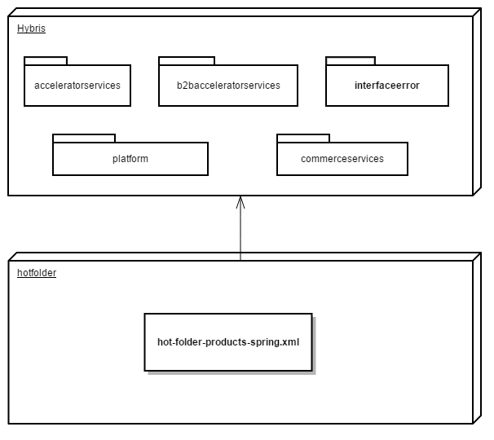

Sequence Diagram

Sequence of events during the hot folder process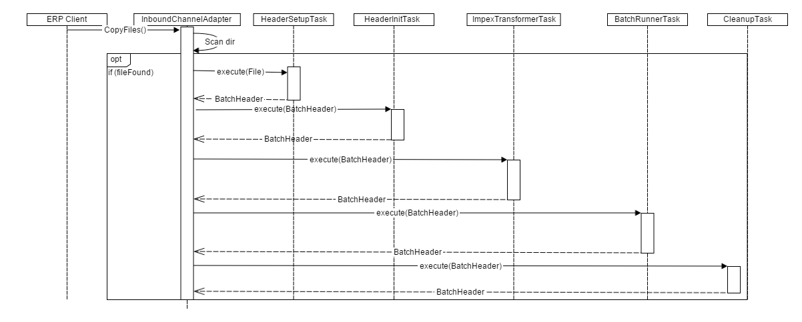

|  |  |  |
| --- | --- | --- |
| **#** | **Component** | **Description** |
| 1 | **ERP client** | The system of the client which provide the CSV files |
| 2 | **InboundChannelAdapter** | Spring integration scans folder and looks for new files that matches filename prefix |
| 3 | **HeaderSetupTask** | The task which create BatchHeader initialize import process with parameters Catalog and Net |
| 4 | **HeaderInitTask** | The task which initialize import process with parameters Lang and SequenceID |
| 5 | **ImpexTransformerTask** | The task that is responsible of the conversion into IMPEX format |
| 6 | **BatchRunnerTask** | The task which does the import process |
| 7 | **CleanupTask** | The task which clean the directory “process” and move files in directory “error” or “archive” |

Use Case Diagram

Use case diagram for the hot folder product addon

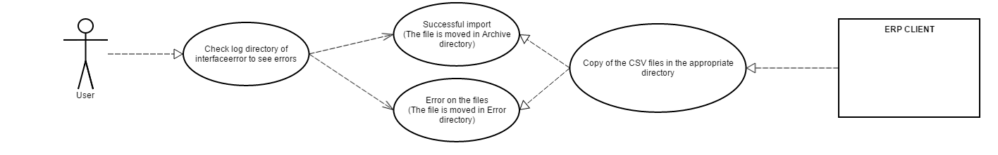

**Description:** User checks the result of the import process starts from ERP CLIENT.

1. Detailed Application Design

Class Diagram

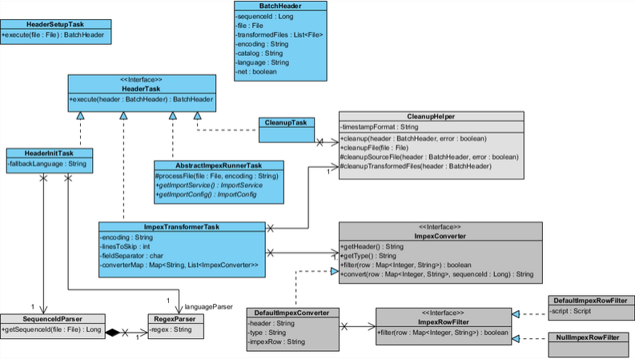

Beans

**HeaderSetupTask:** The task which initialize import process with parameters.

**HeaderInitTask:** Define the langage of the import file and verify that the file isn’t a duplicate

**ImpexTransformerTask:** Define some variables for the conversion and do this.

**CleanupTask:** Clean the import files and move them into error folder or archive error.

Facade

N.A

Strategy

N.A

Controller

N.A

View/JSP

N.A

1. Database architecture

ER Diagram

**When you find example with (code), you have to import the object relation before the product data.**

**Product hot folder ER Diagram:**

| **Name** | **Description** | **Type** | **Default Value** | **Mandatory** | **Example** |
| --- | --- | --- | --- | --- | --- |
| code | Product code | String | / | TRUE | 107701 |
| ean | Article number | String | / | FALSE | 0027242612242 |
| supercategories | Product Category | String | / | FALSE | brand_5 |
| approvalStatus | Status of approval | ArticleApprovalStatus | Check | TRUE | approved |
| manufacturerName | Manufacturer name | String | / | FALSE | Sony |
| manufacturerAID | Manufacturer ID | String | / | FALSE | DCC-L50B |
| unit | Type of unit | Unit | pieces | TRUE | pieces |
| deliveryModes | Modes of delivery | DeliveryMode | / | FALSE | Free-standard-shipping |
| deliveryTime | Delivery time | Double | / | FALSE | 55 |
| contentUnit | Unit of content | Unit | piece | FALSE | 1A |
| numberContentUnits | Number of content units | Double | / | FALSE | 20 |
| onlineDate | Product online date | Date | / | FALSE | 15/05/2015 08:30 |
| offlineDate | Product offline date | Date | / | FALSE | 15/05/2015 08:30 |
| minOrderQuantity | Minimum quantity of order | Integer | / | FALSE | 2 |
| maxOrderQuantity | Maximum quantity of order | Integer | / | FALSE | 300 |
| supplierAlternativeAID | Supplier alternative ID | String | / | FALSE | supplierAlternative |
| vendors | Vendors code | String | / | FALSE | Powertools |
| sequenceId | Avoid importing twice a file | Long | SequenceId is automatically calculed | FALSE | 1424351634 => timestamp |
| isSellableOnline | Is the product sellable on line | Boolean | 1=true means that the product is sellable online | FALSE | TRUE |

**When you import your Product-localized CSV file, you just have to append to the name of the file a “_{lang}” e.g : ProductInternationalData_en.csv to correspond the data with a specific language.**

**Product-international hot folder ER Diagram:**

|  |  |  |  |  |  |
| --- | --- | --- | --- | --- | --- |
| **Name** | **Description** | **Type** | **Default Value** | **Mandatory** | **Example** |
| code | Product ID | String | / | TRUE | 107701 |
| name | Name of the product | Localized:String | / | TRUE | 6 Inch Nylon Cable Ties 100-Pack |
| summary | Summary | localized:String | / | TRUE | DC Car Battery Adapter |
| description | Description | localized:String | / | TRUE | It's time to take a road trip and you want to capture... |
| remarks | Remarks | localized:String | / | FALSE | This product is famous… |
| segment | Segment | localized:String | / | FALSE | buyerPremium |

**Product-media hot folder ER Diagram:**

| **Name** | **Description** | **Type** | **Default Values** | **Mandatory** | **Example** |
| --- | --- | --- | --- | --- | --- |
| code | Product ID | String | / | TRUE | 107701 |
| mime | Mime type | String | / | FALSE | image/jpeg |
| folder | Folder of the media | MediaFolder - Media Folder | / | FALSE | images |
| realfilename | Real name of the file | String | / | FALSE | 49042000_BLACK-1200Wx1200H.jpg |
| mediaFormat | Format of the Media | MediaFormat - Media Format | / | FALSE | 300Wx300H |
| location_picture | Location of the exported picture | String | / | FALSE | c:\images\1128763\SUP123.jpg |

1. Exception Handling and Logging

Exception Scenarios

The module interfaceerror log all actions that can handle errors. It is log using Log.error() method in the log file.

Internal errors are not displayed but translated in comprehensible error in the log folder

Exception Handling

Generated by de.hybris.platform.impex.jalo.imp.DefaultImportProcessor

|  |  |
| --- | --- |
| **Exception** | **Message** |
| UnresolvedValueException | Exception caught when :   * error finding existing item * no existing item found for update * cannot create due to unresolved mandatory/initial columns |
| InsufficientDataException | Exception caught when :   * target type is not permitted by current header – {header} * cannot import localized column without default session language |
| ImpexException | Exception caught when :   * unknow mode (INSERT | UPDATE | INSERT_UPDATE | REMOVE) * batch inserts are not supported – found more than one item for value line {valueLine} * Configured type {type} is abstract and you want to insert {valueLine}. Please specify the subtype of the item you want to create at the first column of the value line or change the configured type * Composed type {code} of found item with PK {PK} is not an instance of specified type {typecode} * Composed type {code} of found item with PK {PK} is not permitted in Insert_Update mode, because of {typeErrorMsg} |
| HeaderValidationException | Exception caught when :   * cacheUnique modifier is not allowed for Singleton types, please remove cacheUnique modifier |

Logging

* For logging in the advanced product search module Log4j will be used.
* The logging level will be set at INFO level.
* The exceptions are logged using Log.error() method.

1. Installation and Configuration

Installation steps for the addon

Add the hotfolder module dependency in hybris/Assets/hybris/config/localextension.xml file as follows.

<extension name="hotfolder"/>

Next, Copy **both hotfolder and interfaceerror** module directory into hybris/bin/custom.

To finish, execute the following commands marked in green using command prompt.

Cd hybris.directory/bin/platform

# **Note:** hybris.directory is the installation location of the hybris

setantenv.bat

ant all

Configuration steps for the addon

If you want to modify the parameters of the hotfolder module, you can find these in the **project.properties** file of the module.

You can change the Frequency scan of the poller directory, the default name of the catalog and the default version of the catalog.

# Frequency in ms of the directory scan

hotfolder.product.poller.rate=1000

# The name of the default catalog

hotfolder.product.default.catalog=powertoolsProductCatalog

# The version of the product default catalog

hotfolder.product.default.catalogVersion=Staged

7. Appendix A *– Glossary of terms*

|  |  |
| --- | --- |
| **Term/Abbreviation/Acronym** | **Meaning** |
| B2B | Business to Business |