

Responsive theme

Technical documentation

Document History

|  |  |  |  |
| --- | --- | --- | --- |
| Version | Updated By | Date | Comments |
|  |  |  |  |
|  |  |  |  |
|  |  |  |  |

Document Sign-Off

|  |  |  |
| --- | --- | --- |
| Name | Role | Signature/Date |
|  |  |  |

Table of Contents

[1. Introduction 3](#_Toc411432245)

[1.1 Purpose 3](#_Toc411432246)

[1.2 Intended Audience 4](#_Toc411432247)

[1.3 Document Scope 4](#_Toc411432249)

[1.4 Functional Rules 4](#_Toc411432251)

[1.5 Assumptions/Restrictions 5](#_Toc411432252)

[1.6 Documents Structure 5](#_Toc411432254)

[1.7 Additional Resources 5](#_Toc411432255)

[2. High Level Design Diagram 6](#_Toc411432256)

[2.1 Overview 6](#_Toc411432257)

[2.2 Sequence Diagram 6](#_Toc411432258)

[2.3 Use Case Diagram 6](#_Toc411432259)

[3. Detailed Application 7](#_Toc411432260)

[3.1 Legend 7](#_Toc411432261)

[3.2 JSP files 7](#_Toc411432262)

[3.3 Tag files 10](#_Toc411432263)

[3.4 Component files 14](#_Toc411432264)

[3.5 Fragment files 14](#_Toc411432265)

[4. Database architecture 16](#_Toc411432266)

[4.1 ER Diagram 16](#_Toc411432267)

[5. Exception Handling and Logging 17](#_Toc411432268)

[5.1 Exception Handling Best Practices: 17](#_Toc411432269)

[5.2 Logging 17](#_Toc411432270)

[6. Installation and Configuration 18](#_Toc411432271)

[6.1 Installation steps for the addon 18](#_Toc411432272)

[6.2 Configuration steps for the addon 18](#_Toc411432273)

[7. Appendix A *– Glossary of terms* 19](#_Toc411432274)

1. Introduction

Purpose

This document is the Technical Design Document which provides information of responsive theme and steps to configure the theme. It covers:

1. JSP modifications
2. Store customization

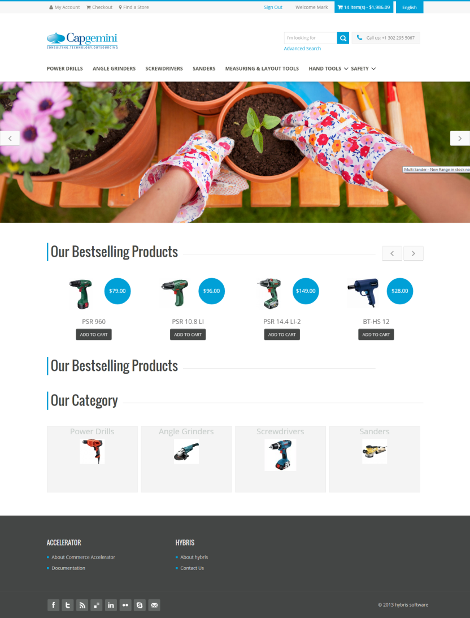 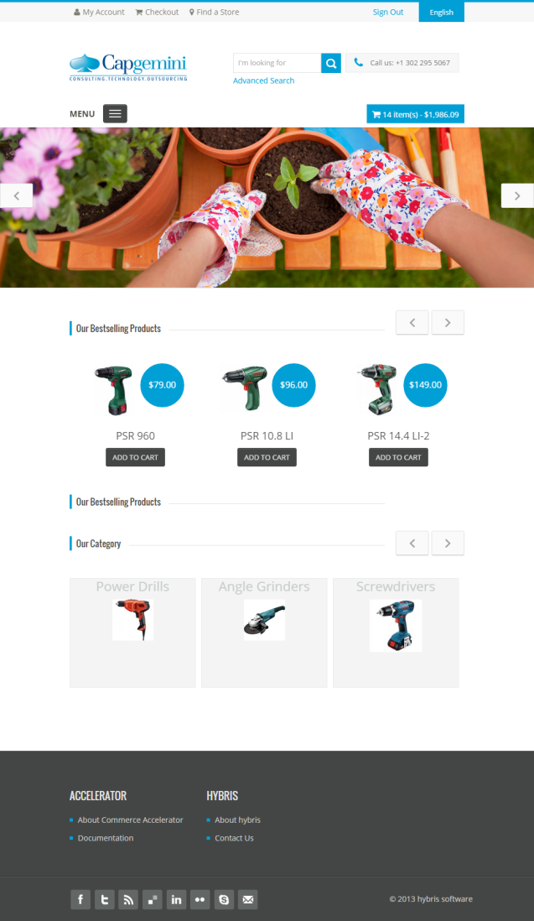

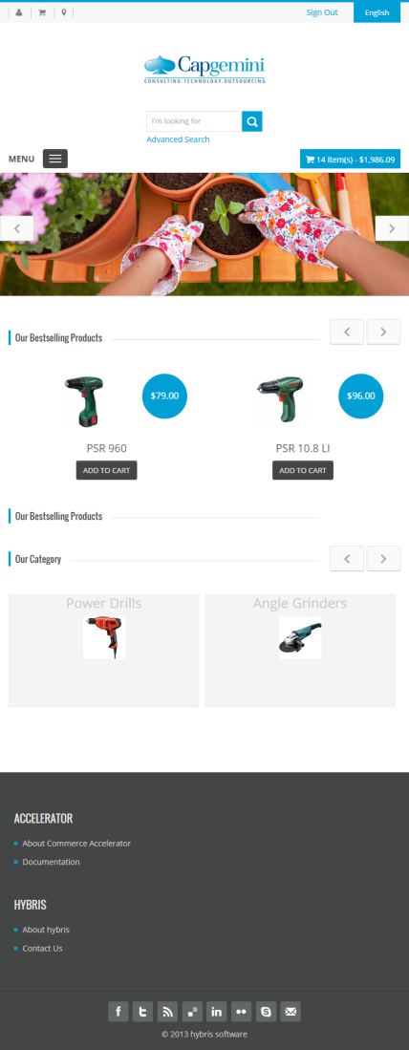

Intended Audience

This document is aimed at Hybris developers and Technical members who want to add a responsive theme in Hybris.

Document Scope

This document covers the details about the sprint 1.

Functional Rules

* **Display:** The responsive design theme and all its components fit the chosen screen
* **Front Office**: A full responsive theme for the store
* **Back Office**: No responsive theme for the BO

Assumptions/Restrictions

The responsive theme has been created for version 5.4.0.0.

Documents Structure

|  |  |  |
| --- | --- | --- |
| Section | | Description |
| 1 | Introduction | Describes the purpose and intended audience of the document and explains its structure. |
| 2 | High Level Design | Overview of the module. |
| 3 | Detailed Application Design | Application architecture applicable to this module. |
| 4 | Detailed Database Design | Conceptual and logical architecture applicable to this module. |
| 5 | Exception Management & Logging | Information about the Exception handling and logging. |
| 6 | Installation & Configuration | Steps to install and configure the module. |
| 7 | Appendices | Supporting information. |

Additional Resources

Wiki Portal: <https://wiki.hybris.com>

Coconet: <https://coconet2.capgemini.com/sf/go/doc3313610?nav=1>

1. High Level Design Diagram

Overview

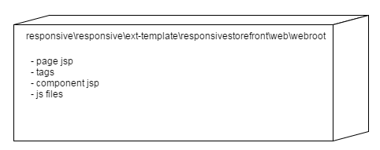

The theme includes all jsp for pages and components, tags, bootstrap and js files.

Sequence Diagram

N.A

Use Case Diagram

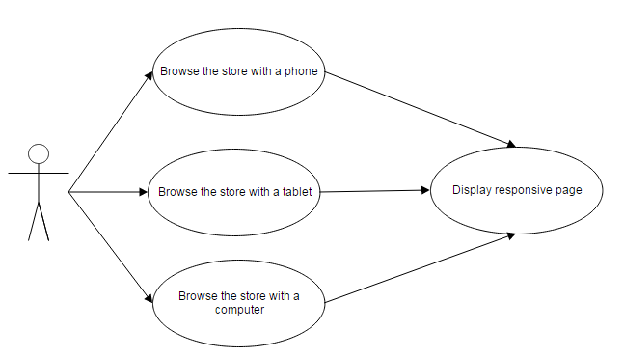

The user can display the store with several devices. The store must be responsive.

1. Detailed Application

Legend

Existing files – Responsive

Missing files – Not responsive yet

JSP files

account/accountAddressBookPage.jsp

account/accountCancelActionConfirmationPage.jsp

account/accountChangePasswordPage.jsp

account/accountEditAddressPage.jsp

account/accountHomePage.jsp

account/accountLayoutPage.jsp

account/accountLoginPage.jsp

account/accountMyQuotesPage.jsp

account/accountOrderApprovalDashboardPage.jsp

account/accountOrderApprovalDetailsPage.jsp

account/accountOrderHistoryPage.jsp

account/accountOrderPage.jsp

account/accountPaymentInfoPage.jsp

account/accountProfileEditPage.jsp

account/accountProfileEmailEditPage.jsp

account/accountProfilePage.jsp

account/accountQuoteDetailPage.jsp

account/accountReplenishmentSchedule.jsp

account/accountReplenishmentScheduleDetails.jsp

cart/cartPage.jsp

category/categoryPage.jsp

category/productGridPage.jsp

category/productListPage.jsp

checkout/checkoutConfirmationPage.jsp

checkout/checkoutLoginPage.jsp

checkout/checkoutReplenishmentConfirmationPage.jsp

checkout/multi/checkoutSampleLandingPage.jsp

checkout/quoteCheckoutConfirmationPage.jsp

checkout/single/checkoutSummaryPage.jsp

company/myCompanyAddCostCenterPage.jsp

company/myCompanyCostCenterEditPage.jsp

company/myCompanyCostCenterViewPage.jsp

company/myCompanyDisableBudgetConfirmPage.jsp

company/myCompanyDisableCostCenterConfirmPage.jsp

company/myCompanyHomePage.jsp

company/myCompanyLoginPage.jsp

company/myCompanyManageBudgetsAddPage.jsp

company/myCompanyManageBudgetsEditPage.jsp

company/myCompanyManageBudgetsPage.jsp

company/myCompanyManageBudgetsViewPage.jsp

company/myCompanyManageCostCentersPage.jsp

company/myCompanyManagePermissionAddPage.jsp

company/myCompanyManagePermissionDisablePage.jsp

company/myCompanyManagePermissionsEditPage.jsp

company/myCompanyManagePermissionsPage.jsp

company/myCompanyManagePermissionsViewPage.jsp

company/myCompanyManagePermissionTypeSelectPage.jsp

company/myCompanyManageUnitAddAddressPage.jsp

company/myCompanyManageUnitApproversListPage.jsp

company/myCompanyManageUnitCreatePage.jsp

company/myCompanyManageUnitDetailsPage.jsp

company/myCompanyManageUnitDisablePage.jsp

company/myCompanyManageUnitEditPage.jsp

company/myCompanyManageUnitsPage.jsp

company/myCompanyManageUnitUserListPage.jsp

company/myCompanyManageUserAddEditFormPage.jsp

company/myCompanyManageUserB2BUserGroupsPage.jsp

company/myCompanyManageUserCustomersPage.jsp

company/myCompanyManageUserDetailPage.jsp

company/myCompanyManageUserDisableConfirmPage.jsp

company/myCompanyManageUsergroupCreatePage.jsp

company/myCompanyManageUsergroupDisableConfirmationPage.jsp

company/myCompanyManageUsergroupEditPage.jsp

company/myCompanyManageUserGroupMembersPage.jsp

company/myCompanyManageUserGroupPermissionsPage.jsp

company/myCompanyManageUsergroupRemoveConfirmationPage.jsp

company/myCompanyManageUserGroupsPage.jsp

company/myCompanyManageUsergroupViewPage.jsp

company/myCompanyManageUserPassword.jsp

company/myCompanyManageUserPermissionsPage.jsp

company/myCompanyManageUsersPage.jsp

company/myCompanyRemoveDisableConfirmationPage.jsp

company/myCompanySelectBudgetsPage.jsp

error/errorNotFoundPage.jsp

error/serverError.jsp

layout/contentLayout1Page.jsp

layout/landingLayout1Page.jsp

layout/landingLayout2Page.jsp

layout/landingLayout3Page.jsp

layout/landingLayout4Page.jsp

layout/landingLayout5Page.jsp

layout/landingLayout6Page.jsp

list.txt

misc/miscRobotsPage.jsp

password/passwordResetChangePage.jsp

product/productLayout1Page.jsp

product/productLayout2Page.jsp

product/productOrderFormPage.jsp

search/searchAdvancedEmptyPage.jsp

search/searchEmptyPage.jsp

search/searchGridPage.jsp

search/searchListPage.jsp

storeFinder/storeFinderDetailsPage.jsp

storeFinder/storeFinderSearchPage.jsp

Tag files

desktop/address/addressFormElements.tag

desktop/address/addressFormSelector.tag

desktop/address/billAddressFormSelector.tag

desktop/address/billingAddressFormElements.tag

desktop/address/suggestedAddresses.tag

desktop/cart/addToCart.tag

desktop/cart/ajaxCartTotals.tag

desktop/cart/cartItems.tag

desktop/cart/cartPotentialPromotions.tag

desktop/cart/cartPromotions.tag

desktop/cart/cartRestoration.tag

desktop/cart/cartTotalPrice.tag

desktop/cart/cartTotals.tag

desktop/cart/cartValidation.tag

desktop/cart/checkoutButton.tag

desktop/cart/continueShopping.tag

desktop/cart/negotiateQuote.tag

desktop/cart/replenishmentScheduleForm.tag

desktop/cart/rolloverCartPopup.tag

desktop/checkout/single/deliveryAddressForm.tag

desktop/checkout/single/deliveryAddressPopup.tag

desktop/checkout/single/paymentDetailsForm.tag

desktop/checkout/single/summaryFlow.tag

desktop/checkout/single/summaryFlowCostCenter.tag

desktop/checkout/single/summaryFlowDeliveryAddress.tag

desktop/checkout/single/summaryFlowDeliveryMode.tag

desktop/checkout/single/summaryFlowPayment.tag

desktop/checkout/single/summaryFlowPaymentType.tag

desktop/checkout/summaryCartItems.tag

desktop/checkout/termsAndConditions.tag

desktop/common/back.tag

desktop/common/footer/footer.tag

desktop/common/globalMessages.tag

desktop/common/header/bottomHeader.tag

desktop/common/header/currencySelector.tag

desktop/common/header/header.tag

desktop/common/header/languageSelector.tag

desktop/common/header/searchBox.tag

desktop/common/infiniteScroll.tag

desktop/common/spinner.tag

desktop/company/approverList.tag

desktop/company/b2bBudgetForm.tag

desktop/company/b2bCostCenterForm.tag

desktop/company/b2bEditUserGroupPopup.tag

desktop/company/b2bPermissionForm.tag

desktop/company/b2bUnitForm.tag

desktop/company/b2bUserGroupForm.tag

desktop/company/deselectBudgetPopup.tag

desktop/company/unitTree.tag

desktop/company/userList.tag

desktop/form/formCheckbox.tag

desktop/form/formCheckboxes.tag

desktop/form/formInputBox.tag

desktop/form/formInputGroupArea.tag

desktop/form/formPasswordBox.tag

desktop/form/formRadioBox.tag

desktop/form/formSelectBox.tag

desktop/form/formTextArea.tag

desktop/formElement/formCheckbox.tag

desktop/formElement/formCheckboxes.tag

desktop/formElement/formInputBox.tag

desktop/formElement/formInputGroupArea.tag

desktop/formElement/formPasswordBox.tag

desktop/formElement/formRadioBox.tag

desktop/formElement/formRadioBoxLeft.tag

desktop/formElement/formSelectBox.tag

desktop/formElement/formTextArea.tag

desktop/grid/coreTable.tag

desktop/grid/coreTableHeader.tag

desktop/grid/coreTableStockRow.tag

desktop/grid/grid1dimension.tag

desktop/grid/grid2dimensions.tag

desktop/grid/grid3dimensions.tag

desktop/grid/gridLegend.tag

desktop/nav/accountNav.tag

desktop/nav/breadcrumb/breadcrumb.tag

desktop/nav/categoryNav.tag

desktop/nav/categoryNavLinks.tag

desktop/nav/facetNavAppliedFilters.tag

desktop/nav/facetNavRefinementFacet.tag

desktop/nav/facetNavRefinements.tag

desktop/nav/facetNavRefinementStoresFacet.tag

desktop/nav/myCompanyNav.tag

desktop/nav/pagination/defaultPagination.tag

desktop/nav/pagination/pageSelectionPagination.tag

desktop/nav/pagination.tag

desktop/nav/searchSpellingSuggestion.tag

desktop/nav/topNavigation.tag

desktop/order/accountOrderDetailsItem.tag

desktop/order/billingAddressItem.tag

desktop/order/deliveryAddressItem.tag

desktop/order/deliveryMethodItem.tag

desktop/order/orderApprovalDetailsItem.tag

desktop/order/orderApprovalStatusDetailsItem.tag

desktop/order/orderDetailsItem.tag

desktop/order/orderEntryDetail.tag

desktop/order/orderHistoryEntriesDetailsItem.tag

desktop/order/orderTotalsItem.tag

desktop/order/orderUnconsignedEntries.tag

desktop/order/paymentDetailsItem.tag

desktop/order/paymentMethodItem.tag

desktop/order/paymentMethodItemOnAccount.tag

desktop/order/paymentMethodItemOnCreditCard.tag

desktop/order/quoteOrderStatusDecisionItem.tag

desktop/order/receivedPromotions.tag

desktop/order/reorderButton.tag

desktop/order/replenishmentOrderDetailsItem.tag

desktop/order/replenishmentOrderTotalsItem.tag

desktop/order/replenishmentScheduleInformation.tag

desktop/password/forgotPasswordValidation.tag

desktop/product/productAddToCartPanel.tag

desktop/product/productDetailsClassifications.tag

desktop/product/productDetailsFutureStock.tag

desktop/product/productDetailsJavascript.tag

desktop/product/productDetailsPanel.tag

desktop/product/productDetailsTab.tag

desktop/product/productFilterOrderForm.tag

desktop/product/productFormAddToCartPanel.tag

desktop/product/productFutureAvailability.tag

desktop/product/productImage.tag

desktop/product/productImageCarousel.tag

desktop/product/productImagePanel.tag

desktop/product/productLister.tag

desktop/product/productListerClassifications.tag

desktop/product/productListerGridItem.tag

desktop/product/productListerItem.tag

desktop/product/productListerItemDetails.tag

desktop/product/productListerItemPrice.tag

desktop/product/productListerOrderForm.tag

desktop/product/productOrderFormGrid.tag

desktop/product/productOrderFormJQueryTemplates.tag

desktop/product/productPageReviewsTab.tag

desktop/product/productPageTabs.tag

desktop/product/productPricePanel.tag

desktop/product/productPrimaryImage.tag

desktop/product/productPromotionSection.tag

desktop/product/productReviewSummary.tag

desktop/product/productShareTag.tag

desktop/product/productStars.tag

desktop/product/productVariantSelector.tag

desktop/store/openingSchedule.tag

desktop/store/openingSpecialDays.tag

desktop/store/storeDetails.tag

desktop/store/storeImage.tag

desktop/store/storeListForm.tag

desktop/store/storeMap.tag

desktop/store/storeSearch.tag

desktop/store/storesMap.tag

desktop/template/cms/previewCSS.tag

desktop/template/cms/previewJS.tag

desktop/template/compressible/css.tag

desktop/template/compressible/js.tag

desktop/template/debugFooter.tag

desktop/template/errorSpanField.tag

desktop/template/javaScript.tag

desktop/template/javaScriptVariables.tag

desktop/template/master.tag

desktop/template/page.tag

desktop/template/styleSheets.tag

desktop/user/forgottenPwd.tag

desktop/user/login.tag

desktop/user/updatePwd.tag

shared/analytics/analytics.tag

shared/analytics/googleAnalytics.tag

shared/analytics/jirafe.tag

shared/component/emptyComponent.tag

shared/format/fromPrice.tag

shared/format/price.tag

shared/theme/image.tag

Component files

accountnavigationcollectioncomponent.jsp

accountnavigationcomponent.jsp

bannercomponent.jsp

categoryfeaturecomponent.jsp

cmsimagecomponent.jsp

cmstabparagraphcomponent.jsp

component.txt

footercomponent.jsp

headernavigationcomponent.jsp

imagemapcomponent.jsp

languagecurrencycomponent.jsp

minicartcomponent.jsp

navigationbarcomponent.jsp

productaddtocartcomponent.jsp

productcarouselcomponent.jsp

productfeaturecomponent.jsp

productreferencescomponent.jsp

productvariantselectorcomponent.jsp

rotatingimagescomponent.jsp

searchboxcomponent.jsp

simplebannercomponent.jsp

simplesuggestioncomponent.jsp

Fragment files

cart/addToCartPopup.jsp

cart/cartPopup.jsp

cart/expandGridInCart.jsp

cart/miniCartPanel.jsp

checkout/single/deliveryAddressFormPopup.jsp

checkout/single/paymentDetailsFormPopup.jsp

checkout/termsAndConditionsPopup.jsp

password/forgotPasswordValidationMessage.jsp

password/passwordResetRequestPopup.jsp

product/futureStockPopup.jsp

product/productLister.jsp

product/quickViewPopup.jsp

product/reviewsTab.jsp

product/zoomImagesPopup.jsp

1. Database architecture

ER Diagram

N.A

1. Exception Handling and Logging

Exception Handling Best Practices:

* Never swallow the exception in catch block
* Declare the specific checked exceptions that your method can throw
* Do not catch the Exception class rather catch specific sub classes
* Never catch Throwable class
* Always correctly wrap the exceptions in custom exceptions so that stack trace is not lost
* Either log the exception or throw it but never do the both
* Never throw any exception from finally block
* Always catch only those exceptions that you can actually handle
* Don't use printStackTrace() statement or similar methods
* Use finally blocks instead of catch blocks if you are not going to handle exception
* Remember "Throw early catch late" principle
* Always clean up after handling the exception
* Throw only relevant exception from a method
* Never use exceptions for flow control in your program
* Validate user input to catch adverse conditions very early in request processing
* Always include all information about an exception in single log message
* Pass all relevant information to exceptions to make them informative as much as possible
* Always terminate the thread which it is interrupted
* Use template methods for repeated try-catch
* Document all exceptions in your application in javadoc

Logging

N.A

1. Installation and Configuration

Installation steps for the addon

So, copy all jsp from

responsive.zip\responsive\ext-template\responsivestorefront\web\webroot\WEB-INF\

to

yourstorefront\web\webroot\WEB-INF

and replace all files

Configuration steps for the addon

Set the logo

File cms-content.impex

**INSERT\_UPDATE** Media**;**$contentCV[unique=true]**;**code[unique=true]**;**realfilename**;***@media*[translator=de.hybris.platform.impex.jalo.media.MediaDataTranslator]**;**mime[default='image/jpeg']**;**altText  
**;;**/images/theme/your\_logo.png**;** your\_logo.png**;**$siteResource/images/theme/your\_logo.png**;**image/png**;**Logo title  
  
# Site Logo Component  
**INSERT\_UPDATE** SimpleBannerComponent**;**$contentCV[unique=true]**;**uid[unique=true]**;**name**;**&componentRef**;**urlLink  
**;;**SiteLogoComponent**;**Site Logo Component**;**SiteLogoComponent**;**"/"

# Site Logo Component (Lang)  
**UPDATE** SimpleBannerComponent**;**$contentCV[unique=true]**;**uid[unique=true]**;**$picture[lang=$lang]  
**;;**SiteLogoComponent**;**/images/theme/your\_logo.png

1. Appendix A *– Glossary of terms*

|  |  |
| --- | --- |
| **Term/Abbreviation/Acronym** | **Meaning** |
|  |  |

More Information

*Rightshore® is a trademark belonging to Capgemini.*

With more than 115,000 people in 40 countries, Capgemini is one of the world's foremost providers of consulting, technology and outsourcing services. The Group reported 2010 global revenues of EUR 8.7 billion.

Together with its clients, Capgemini creates and delivers business and technology solutions that fit their needs and drive the results they want.

A deeply multicultural organization, Capgemini has developed its own way of working, the Collaborative Business Experience™, and draws on Rightshore®, its worldwide delivery model.

Learn more about us at:  
[www.capgemini.com](http://www.capgemini.com).

**About Capgemini**

**Capgemini_Slogan_White.pngwww.capgemini.com**

The information contained in this presentation is proprietary and confidential. ©2012 Capgemini. All rights reserved